**INDIAN INSTITUTE OF INFORMATION TECHNOLOGY BHAGALPUR - 813210**



**Project Report on**

**Voice to text and sign language translator**

**Submitted By:**

**Group-7**

**VIPUL KUMAR (170101054)**

**SUNNY KUMAR (170101051)**

**MUKUL SHARMA (170101028)**

**ANIMESH RANJAN (170101011)**

**Project developed under the guidance of**

**Dr. Pradeep Kumar Biswal (Sir)**

(Assistant Professor)

**Objective**

**This Voice to Text and Sign Language Translator application aims at :**

- Providing information access and services to deaf people in Indian sign language.

- Developing a scalable project which can be extended to capture whole vocabulary of ISL through manual and non-manual signs.

- It can be developed as a desktop or mobile application to enable specially abled people to communicate easily and effectively with others.

**Introduction**

- This application takes in live speech or audio recording as input, converts it into text and displays the relevant Indian Sign Language (ISL) images or GIFs.

- This project is based on converting the audio signals received to text using speech to text api (google api) and then using the semantics of Natural Language Processing to breakdown the text into smaller understandable pieces which requires.

- Machine Learning as a part. Data sets of predefined sign language are used as the input so that the software can use artificial Intelligence to display the converted audio into the sign language.

- AI (Artificial Intelligence) – It is the theory and development of computer systems to be able to perform tasks normally requiring human intelligence, such as visual perception, speech recognition, decision-making, and translation between languages.

- ML (Machine Learning) – Machine learning is the science of getting computers to act without being explicitly programmed. The Inputs are given as data sets by which the system learns and tries to give the best possible outcome to the user.

- NLP (Natural Language Processing) – It is the application of computational techniques to the analysis and synthesis of natural language and speech.

**Indian Sign Language (ISL)**

- Indian Sign Language is used by deaf and hard of hearing people for communication by showing signs using different parts of body. The “Indian Sign Language (ISL)” uses manual communication and body language (non-manual communication) to convey thoughts, ideas or feelings.

-ISL signs can be generally classified into three classes: One handed, two handed, and non-manual signs. One handed signs and two handed signs are also called manual signs where the signer uses his/her hands to make the signs for conveying the information. Non Manual signs are generated by changing the body posture and facial expressions.

**Requirements**

-Operating System :- Ubuntu

-Language:- Python (Python 2.7 or above)

-ISL (Indian Sign Language) data sets from google.

-This desktop application is implemented using python programming language.

-So, we require following python libraries to implement and run this application.

-Speech Recognition (pip install speechrecognition)

-numpy (pip install numpy)

-plotting image using matplotlib (pip install matplotlib)

-displaying image using opencv (pip install opencv)

-frontend using easyGUI (pip install easyGUI)

-OS (pip install os-sys)

-Speech as input through microphone using PyAudio (sudo apt-get install python-pyaudio & python3-pyaudio)

-GUI library using tkinter (pip install tkinter-nav)

-Python Image Library (pip install large-image-source-PIL)

**Algorithm**

1. Start

2. Record the voice

(i) Listen for 1 second and calibrate the energy threshold for ambient noise levels.

(ii) Listen the voice using Microphone.

Now the energy threshold is already set to a good value, and we can reliably catch voice right away.

3. Recognise the voice.

4. Convert Voice to Text.

(i) Make the Text to lowercase for further manipulation.

5. Detected Text

(i) If “goodbye” then exit.

(ii)Else if Detected Text in predefined Dictionary Words. Display respective GIFs of the Phrase.

(iii) Else Count the Letters of the Word/Phrase.

Display the Visual of the phrase with some delay of Actions.

(iv) Continue all the steps from Step 3, and continue till the Speech Ends.

6. If Error in Step 2, That is if no voice Detected then display error message “Could not listen”.

**How to run the application?**

1. Open the Voice to Text or Sign Language Translator folder and then open the terminal.

2. From the terminal, run the “main” python file using the command “python main.py”.

3. The application interface appears on the screen.

4. Hit the record button to start taking speech as input.

5. Any speech recorded is then processed and respective outputs are shown accordingly.

6. To exit the application using speech, say “goodbye”.

**Application in real life**

-Sign language is a visual language that is used by deaf people as their mother tongue. Unlike acoustically conveyed sound patterns, sign language uses body language and manual communication to fluidly convey the thoughts of a person.

-It can be used by a person who has difficulties in speaking or by a person who can hear but could not speak.

-It can also be used by normal people to communicate with hearing disabled people.

**Conclusion**

1. Since deaf people are usually deprived of normal communication with other people, they have to rely on an interpreter or some visual communication. Now the interpreter can not be available always, so this project can help eliminate the dependency on the interpreter.

2. The system can be extended to incorporate the knowledge of facial expressions and body language too so that there is a complete understanding of the context and tone of the input speech.

3. A mobile and web based version of the application will increase the reach to more people.

4. Integrating hand gesture recognition system using computer vision for establishing 2-way communication system.

**SCREENSHOT**

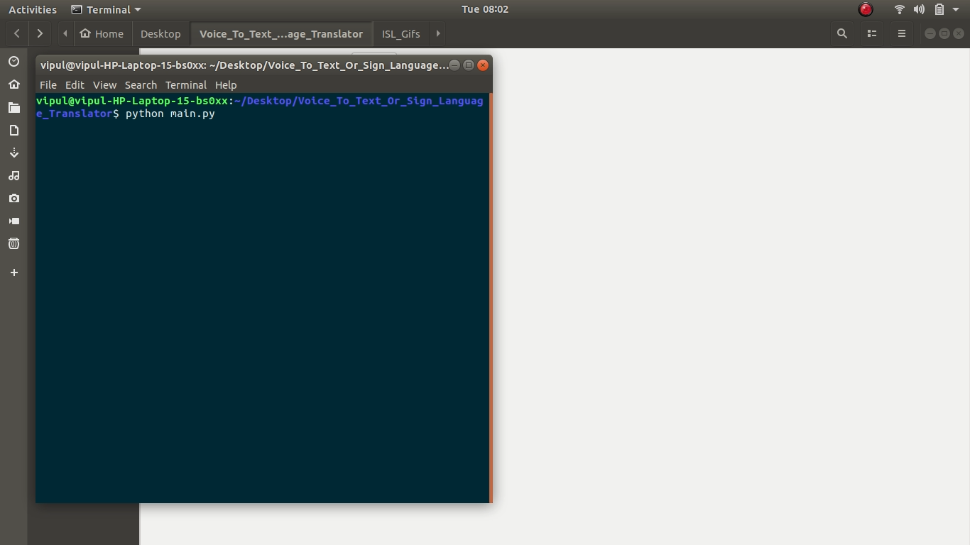

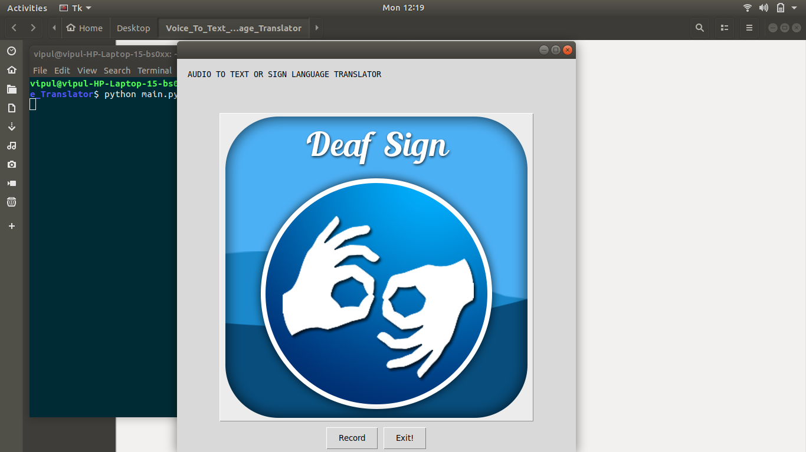

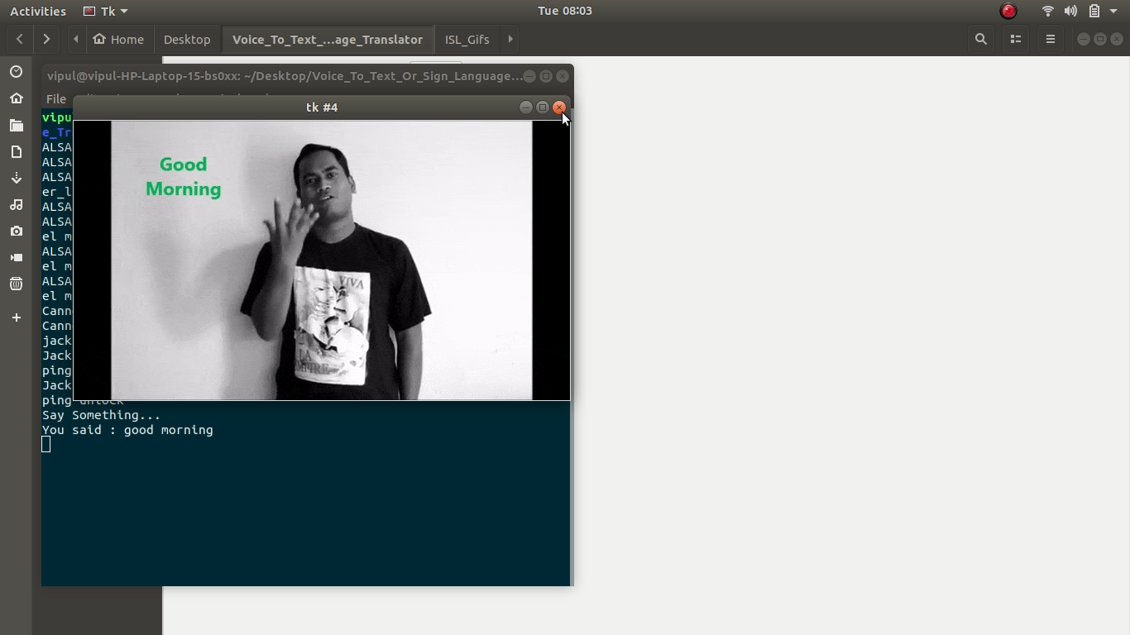

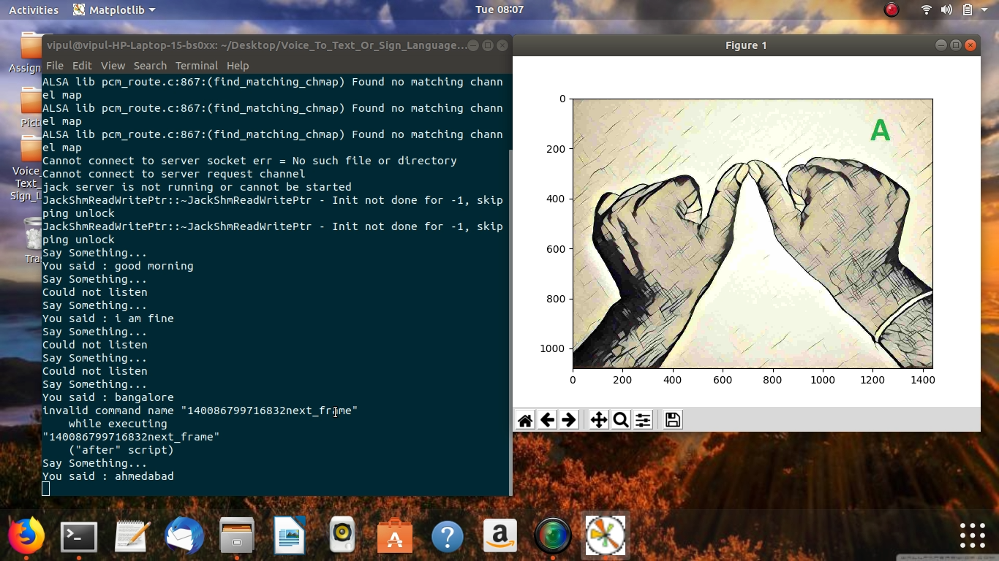

**THANK YOU SO MUCH**