AWS VPC ENDPOINT

Amazon Web Services VPC Endpoint lets your resources inside a VPC connect privately to AWS services without using the internet, NAT Gateway, or Internet Gateway.
Traffic stays on the AWS private network, improving security, performance, and often cost.

Why it’s used (in simple terms)
- More secure: No public IPs or internet exposure
- Better performance: Private AWS backbone
- Lower cost: Avoid NAT Gateway data charges
- Compliance-friendly: Keeps traffic private

Types of VPC Endpoints

Gateway Endpoint
- Used for: S3, DynamoDB
- Added to route tables
- Free (no hourly charge)
Example: EC2 in private subnet → S3 (no NAT)

Interface Endpoint (AWS PrivateLink)
- Used for: EC2 API, SSM, CloudWatch, SNS, many others
- Creates ENI (private IP) in your subnet
- Paid (hourly + data)
Example: EC2 → CloudWatch privately

======================Steps to Setup VPC Endpoint===========================

Network Setup

Step 1 →Setup VPC

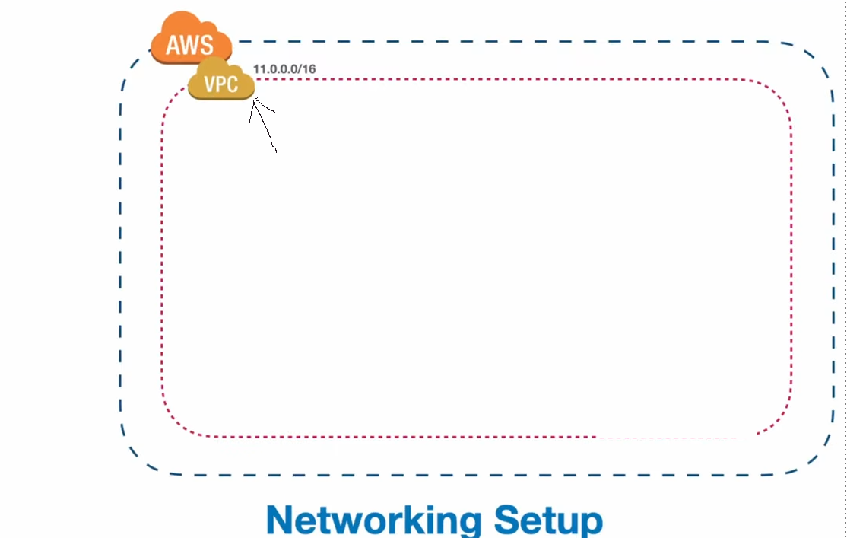
Step 2 →Create Subnet
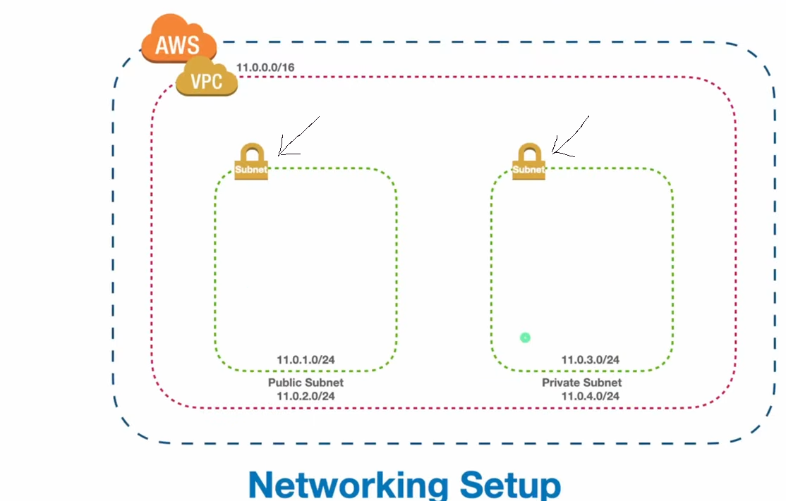
Step 2 →Create Internet Gateway, Route Table,
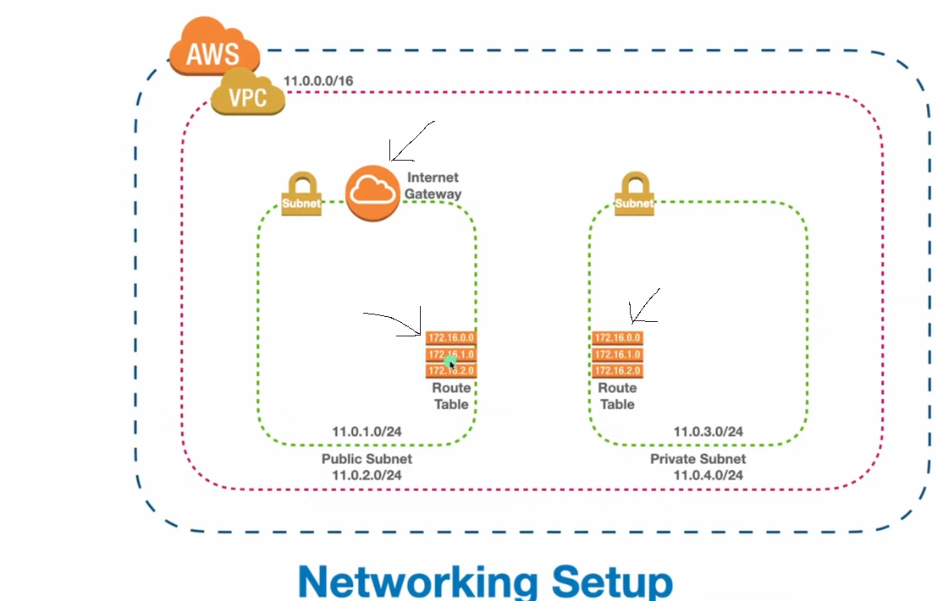
Step 2 →Setup EC2 Instance
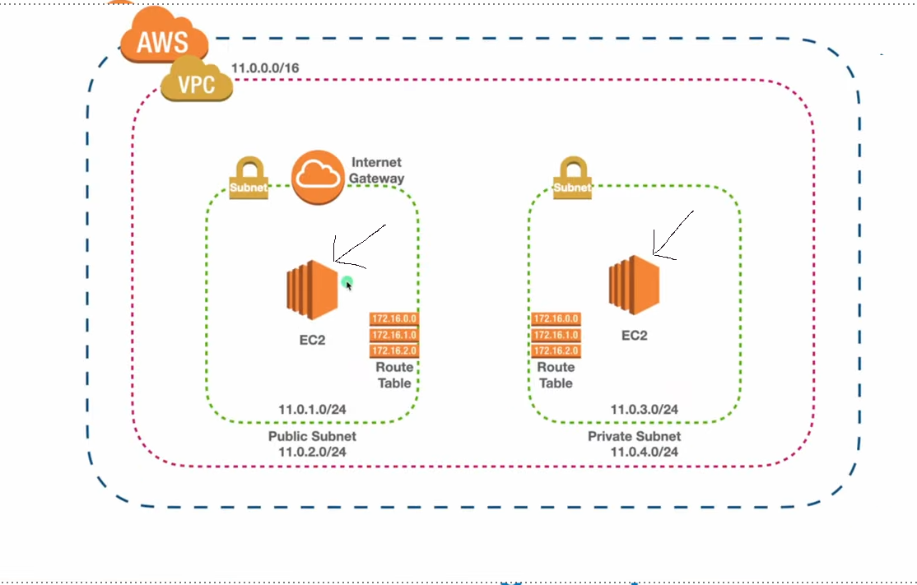

Step 2 →Create S3 in VPC
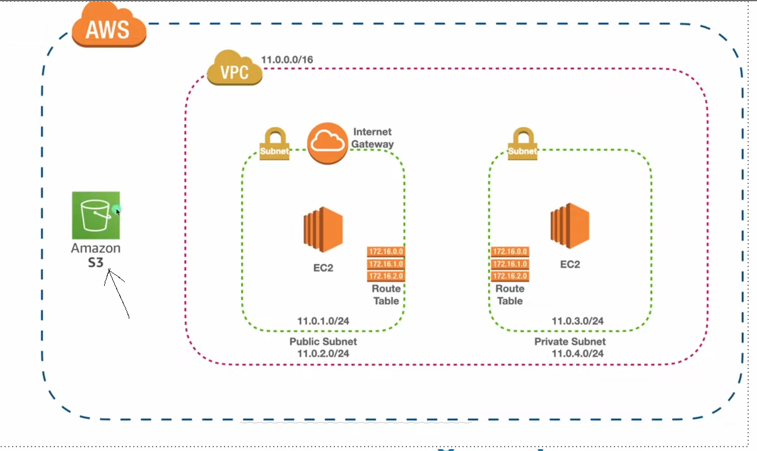

Step 2 →Create VPC ENDPOINT
