Step by step process

First I created a SQL database using MySQL workbench and created a database named pets. I then made a table called products and added 4 pets to it (partially shown below).



Next I created a dynamic web project on Eclipse and added the mySQL jar file to the path. I then created index.html and added an href, text box, and submit button to the page.

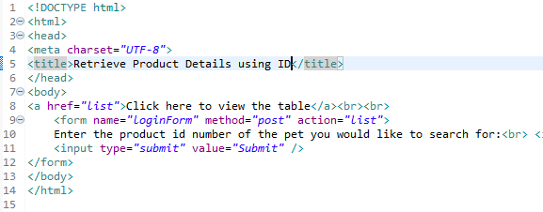

I created a new class called DBConnection to establish the connection to the server. Then I created a new class called ProductDetails which uses JDBC to perform actions on the webpage. I modified the doGet method to query the table and get the information, then find what the user typed into the box. If the search box contents were null then the contents of the table are displayed on the page. Otherwise the row corresponding to the id number is printed to the page.

