# How to Install Pimcore on Windows Using Xampp

## Installation steps:

1. Install Xampp greater than 5.6.10 (as it provides you php,mysql,apache with versions required for Installing pimcore)
2. After Installing Xampp You need to copy pimcore Extracted folder to c:\xampp\htdocs\pimcore
3. Once copied is done you need to add following lines to the file vhosts.conf which is under C:\xampp\apache\conf\extra

<VirtualHost *:8080>

DocumentRoot "C:/xampp/htdocs/pimcore"

ServerName pimcore.local

</VirtualHost>

1. Once the above step is done add the following lines to hosts file residing under C:\Windows\System32\drivers\etc
   * + 1. pimcore.local

If you don’t have admin permissions then changes can't be made under C:\Windows\System32\drivers\etc so just copy the hosts file to desktop then make the changes then replace this with the one present in C:\Windows\System32\drivers\etc

1. The next step is to open phpmyaadmin then select Sql tab and run the following query

UPDATE mysql.user SET Password=PASSWORD ('xyz123') WHERE User='root';

//where xyz123 is password

Now open Xampp control panel click on apache config Button then select file phpMyAdmin(config.inc.php) and find the following line

$cfg['Servers'][$i]['password'] = ‘ ’; and modify this line to

$cfg['Servers'][$i]['password'] = 'xyz123'; Use The following screenshots

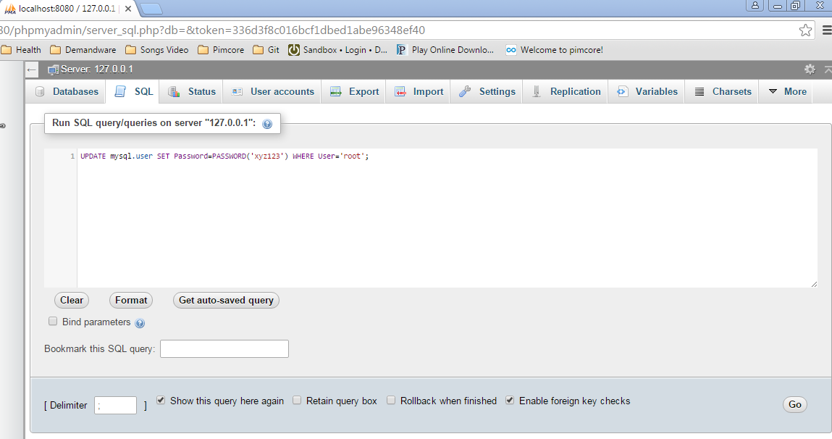

1. Now open phpMyAdmin and click on databases and create a new one

Name -Pimcore

Under collation column choose utf8_general_ci

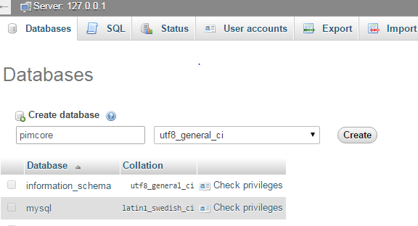

1. Now type local host on your Browser doing So pimcore Install page will be shown fill the form with

"pimcore" as a database name

"root" as user (root was user name for which you set the password by executing query)

"xyz123" password for MySQL Section (this is password you set on phpMyAdmin)

And enter any password in admin section to log in to pimcore

Then click on install.

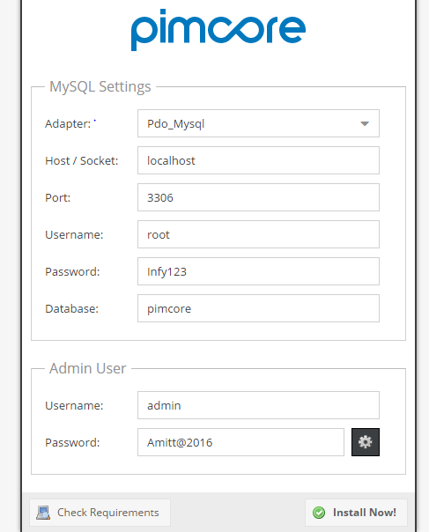

# Troubleshooting While Installing Pimcore

1. Make sure your pimcore folder within htdocs should follow the right path and contain the following things as shown in screen shot.

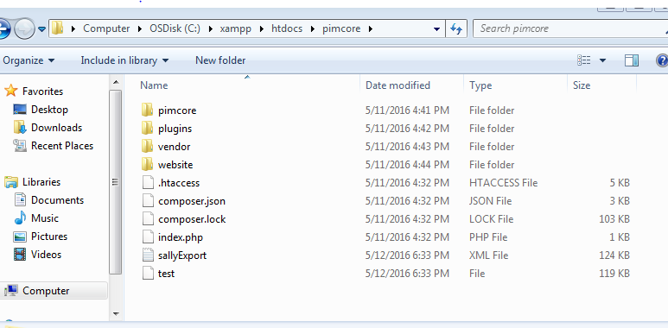

1. If you are getting error that port 80 is blocked on Xampp then Follow the steps:-

How To change apache port Number in Xampp.

* Click on the apache config button in Xampp Control Panel and open the file Apache(httpd.cnf)
* Find the below line

Listen 80

and change this to

Listen 8080 (where 8080 is new port number you want to specify to apache to work on)

* Now open your browser and type http://localhost:8080/ Now you will see the page for pimcore Installation If you have followed the above steps after changing port number.