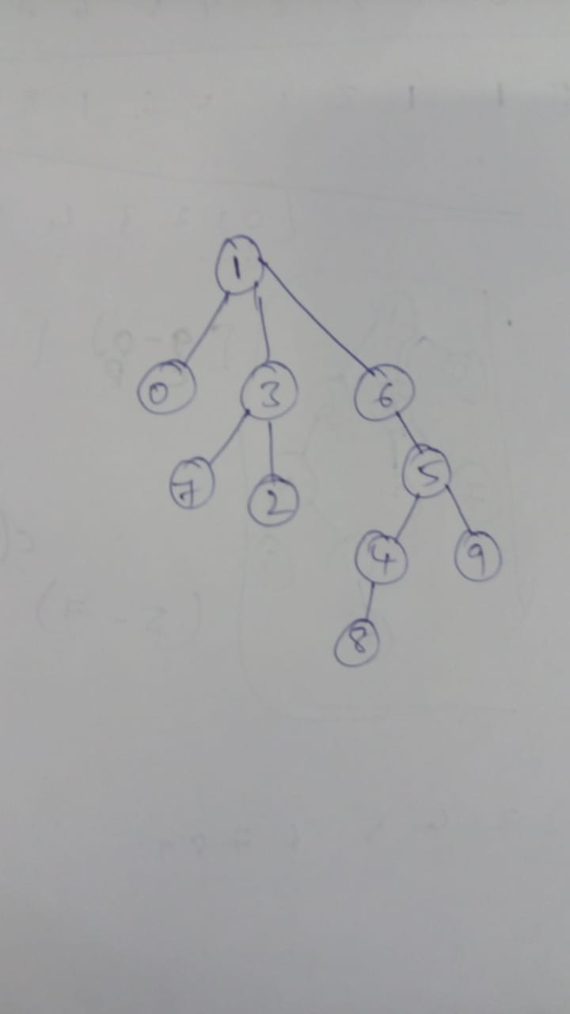

The tree diagram for weighted quick union agorithm.