**OSI layers**

Application Provide user interface to send or receive data  
Presentation Encrypt, format and compress data for transmission

Session Initiate and terminate the session with a remote system

Transportation Break data stream in smaller segments and provide delivery

Network Provide logical addressing

Data Link Prepare data for transmission  
Physical Move data between devices

**The Data Link Layer**  
The Data Link Layer is the second layer of the OSI model. This layer defines how networking components access the media and what transmission methods they use. This layer has two sub-layers; MAC and LLC.  
  
**MAC (Media Access Control)**  
This sublayer defines how the data packets are placed in media. It also provides physical addressing. The physical address is known as MAC address. Unlike logical addresses which need to be configured, physical addresses are pre-configured in NIC. MAC address is used to uniquely identify a host in the local network.  
  
**LLC (Logical Link Control)**  
This sublayer identifies the network layer protocol. On sending computer, it encapsulates the information of the Network Layer protocol in LLC header from which the Data Link layer receives the data packet. On receiving a computer, it checks the LLC header to get the information about the network layer protocol. This way a data packet is always delivered to the same network layer protocol from which it was sent.

Examples - switch and bridge.

**Network layer:**

Defining logical addresses and finding the best path to reach the destination is the main function of this layer. The router works in this layer. Routing also takes place in this layer. IP, IPX and AppleTalk are the examples of this layer.

**The Transport Layer**

Main functionalities of the transport layer are segmentation, data transportation, and connection multiplexing. For data transportation, it uses TCP and UDP protocols. TCP is a connection-oriented protocol. It provides reliable data delivery.

* The session layer is responsible for establishing, managing, and terminating communications between two computers. RPC and NFS are the examples of the session layer.
* Presentation layer - Convert, compress and encrypt are the main function which presentation layer performs in sending computer while in receiving computer there are reconvert, decompress and decrypt. ASCII, BMP, GIF, JPEG, WAV, AVI, and MPEG are few examples of standards and protocols used in this layer.
* Application layer - op layer of the OSI model is the application layer. It provides the protocols and services required by network-aware applications to connect to the network. FTP, TFTP, POP3, SMTP, and HTTP are the few examples of standards and protocols used in this layer.

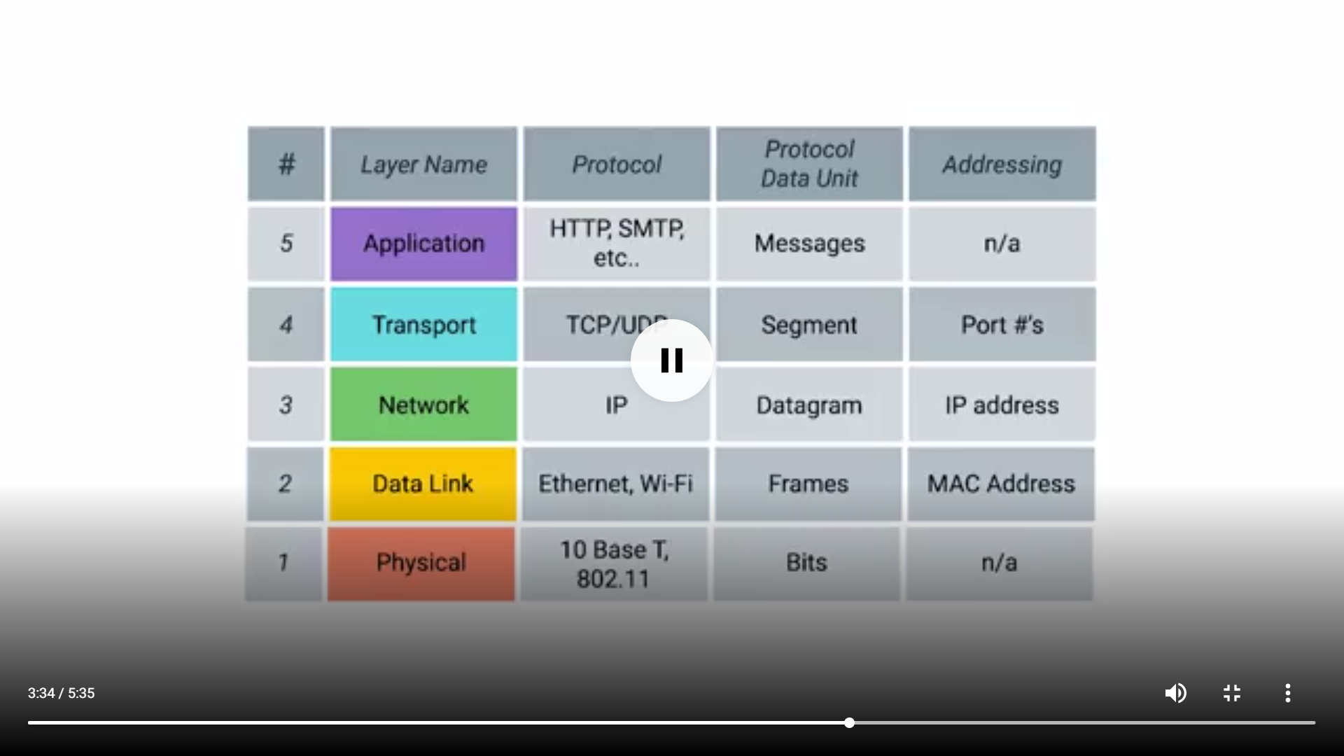

**Ethernet frame:**

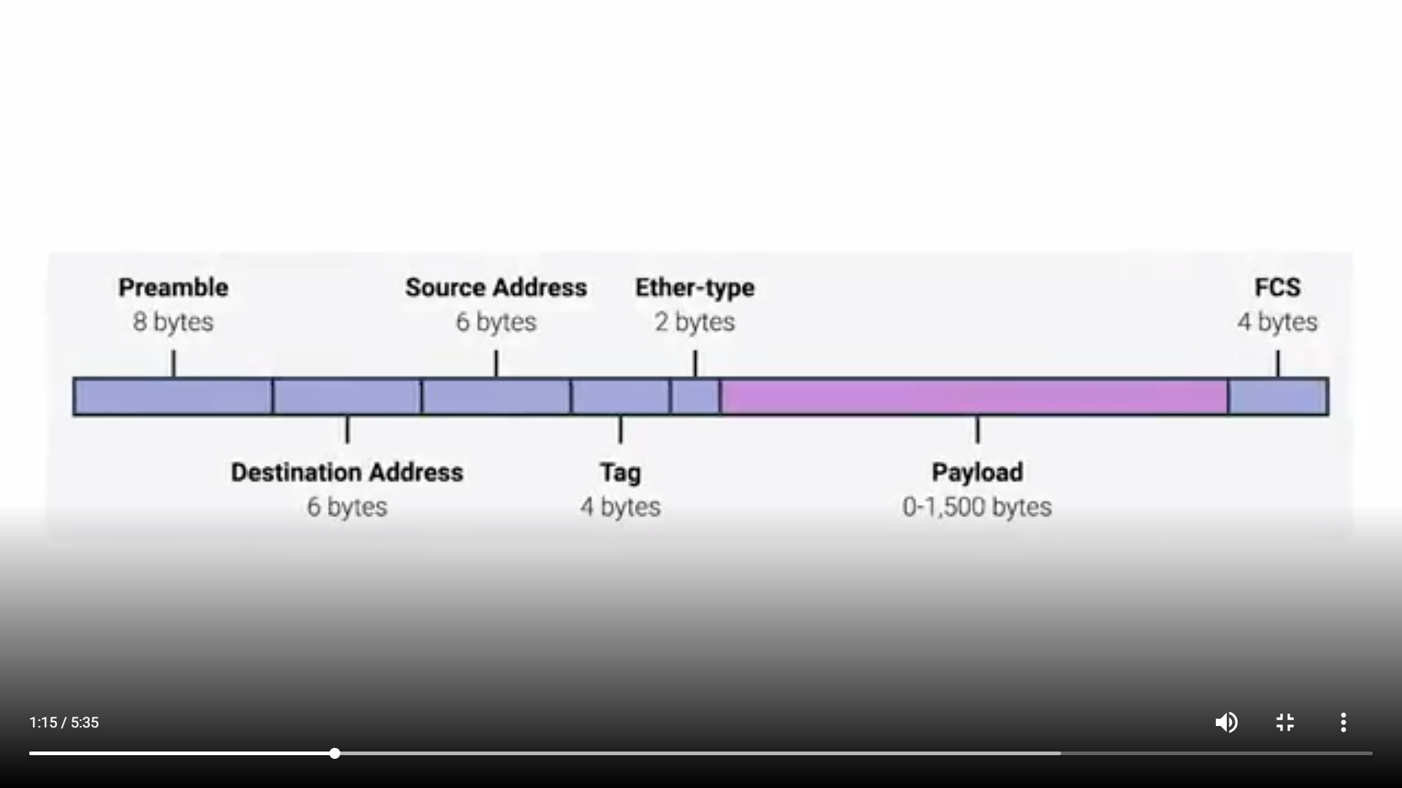

Tag means VLAN header - virtual LAN.

The payload is a max of 1500 bytes.

**IP:**

* An IP address is a numeric identifier of an interface. Just like a postal address provides a unique identity to a house, an IP address provides a unique identity to an interface.
* An IP address is the combination of two addresses, network address, and host address. The network address is the group address of all hosts which belong to a particular network and host address is the unique address of a specific host in that network.

**Subnet mask:**

* The subnet mask is used to separate the network address from the host address in IP address
* Subnet mask assigns an individual bit for each bit of IP address. If IP bit belongs to network portion, assigned subnet mask bit will be turned on. If IP bit belongs to host portion, assigned subnet mask bit will be turned off.

**The range of IP for different classes:**

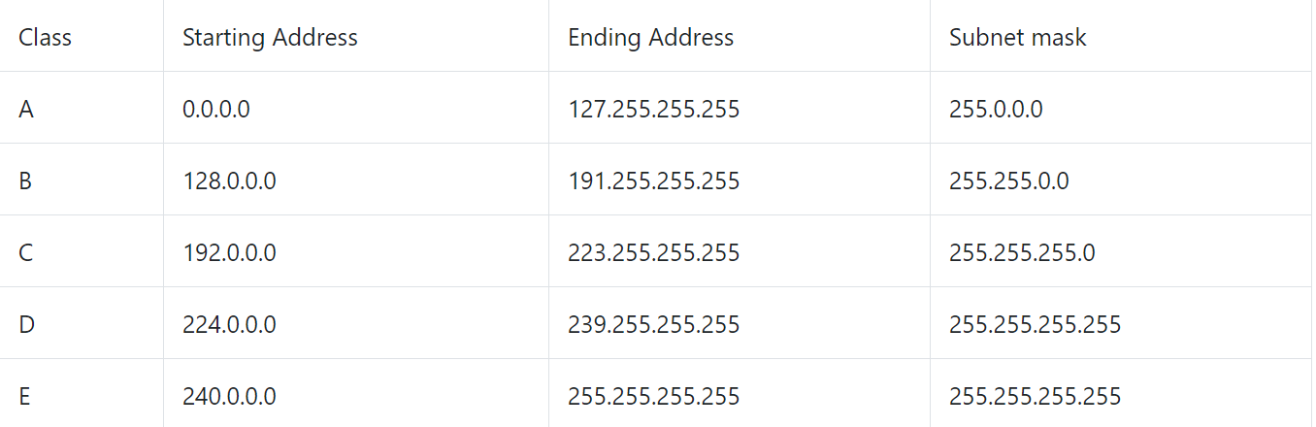

**IP datagram:**

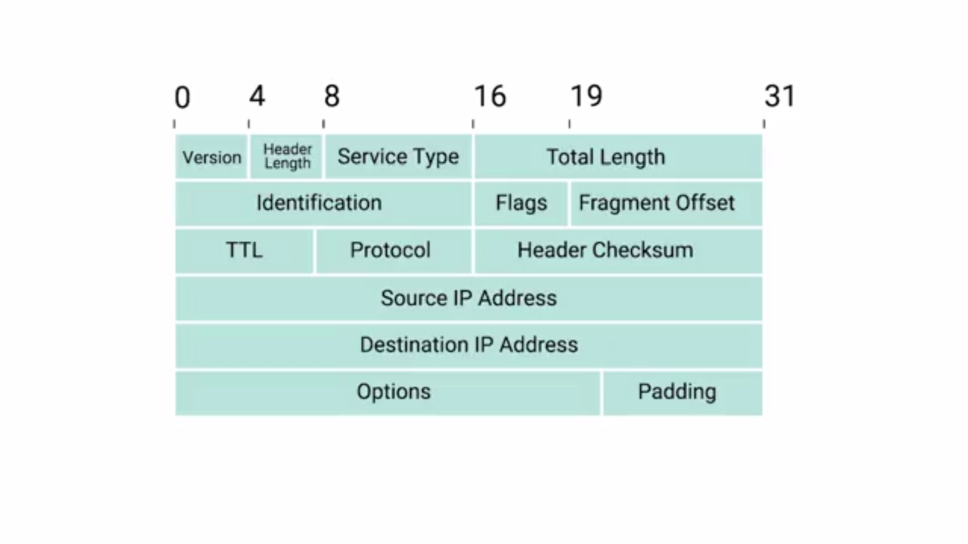

**Port:**

Port is a 16-bit number used to direct the traffic.

**CIDR:**

Classless inter-domain routing (CIDR) is a set of Internet protocol (IP) standards that is used to create unique identifiers for networks and individual devices. The IP addresses allow particular information packets to be sent to specific computers.

**TCP HEADER:**

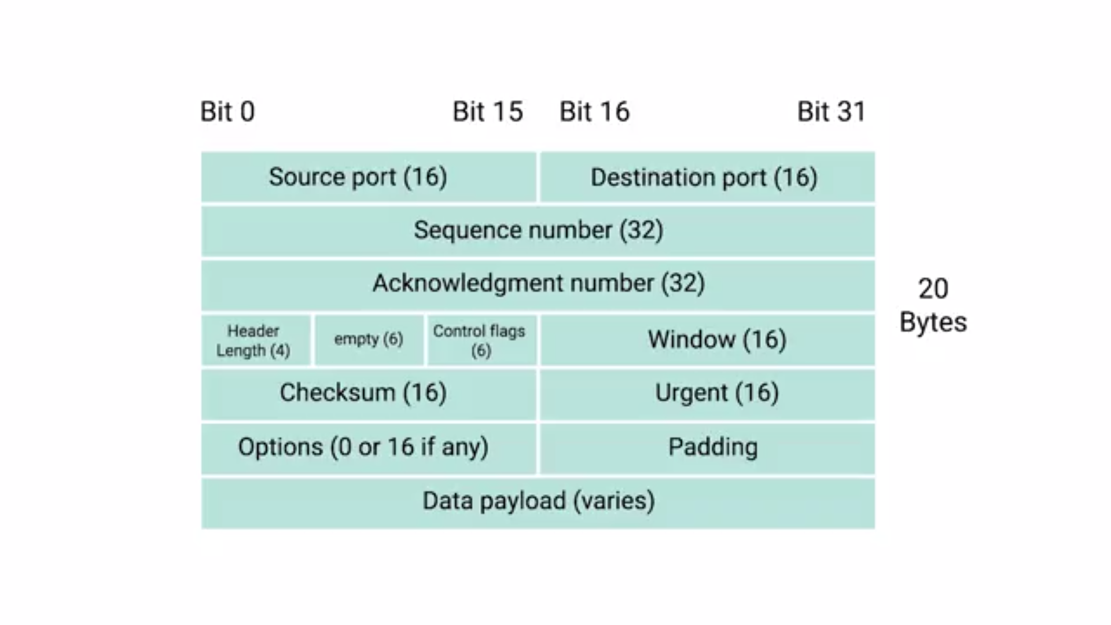

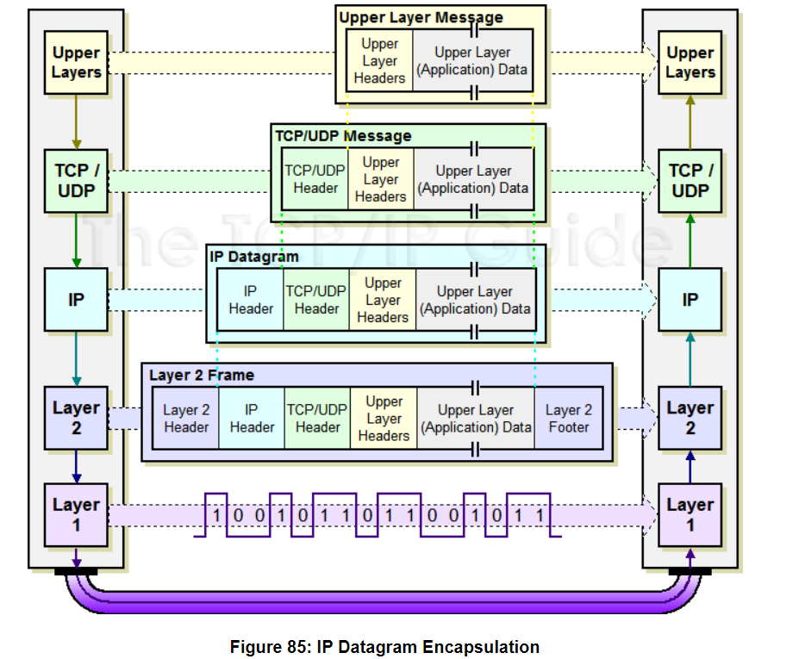

**Control flags:**

1. URG
2. ACK
3. PSH
4. RST
5. SYN
6. FIN

**Socket states:**

1. Listen
2. Syn-sent
3. Syn-received
4. Established
5. Fin-wait
6. Close-wait
7. closed