# Abstract

This project introduces a cutting-edge web application designed to revolutionize the administrative aspects of final-year project management within our college. The system employs a sophisticated technological stack, leveraging React and TypeScript for the frontend, Tailwind CSS for sleek and responsive design, and NodeJs with ExpressJs for a robust backend. The data is efficiently managed through MongoDB, ensuring scalability and flexibility. The primary goal of this application is to centralize and streamline the project allocation process, alleviating faculty members from tedious manual Excel-based work. Through role-based access, tailored experiences for students, mentors, and administrators are facilitated, fostering efficient mentor-student interactions. The implementation of this technology not only enhances efficiency but also guarantees transparency and fairness by allowing administrators to oversee and monitor all processes, thus minimizing biases in project allocation. This innovative solution is poised to optimize the entire final-year project management workflow, making it more convenient, transparent, and equitable for all stakeholders involved.

# Table Of Contents

Abstract 1

Table Of Contents 2

Table Of Figures 4

Chapter 1: Introduction 5

Chapter 2: Literature Survey 7

Overview of Final-Year Project Management 7

Automation in Education 7

Web Applications in Education 7

Similar Projects and Technologies 8

Technological Stack in Education Technology 8

Critical Analysis and Gaps 9

Chapter 3: Methodology 10

3.1 Requirements Gathering: 10

3.2 Backend Implementation: 10

3.3 Frontend Design and Integration: 10

3.4 Feature Implementation: 11

3.5 Testing: 11

3.6 Review and Feedback: 11

3.7 Iterative Development: 12

Chapter 4: Procedures 13

4.1 Database Schema Design: 13

4.2 Backend Middleware: 13

4.3 Backend Security Codes: 13

4.4 Testing on Postman: 14

4.5 Integrating with Frontend: 15

4.6 Continuous Testing Throughout Implementation: 15

Chapter 5: Result Analysis and Discussion 17

Conclusion 18

Scope for Future Work 19

# Table Of Figures

Figure 1 Development Process 10

Figure 2 System Architecture 11

Figure 3 System Use-Case Diagram 14

Figure 4 System Flow Diagram 15

# Chapter 1: **Introduction**

In the realm of academia, the efficient management of final-year projects is pivotal to fostering a conducive learning environment and ensuring a smooth transition for students into the professional sphere. Recognizing the need for an advanced solution to alleviate the administrative burden on faculty members, this project was conceived with a vision to streamline and simplify the process of project allocation. The motivation behind this endeavor was to move beyond the conventional, time-consuming manual Excel-based methods and introduce a web application that not only centralizes final-year project management but also facilitates seamless mentor-student interactions. With an overarching objective to enhance transparency, reduce bias, and provide a tailored experience for all stakeholders involved, our team embraced cutting-edge technologies, such as React, TypeScript, Tailwind CSS, NodeJs, ExpressJs, and MongoDB, to create a robust and scalable solution.

The implementation journey began by meticulously gathering app requirements from our mentor, ensuring a comprehensive understanding of the intricate nuances of final-year project management. Following an iterative and agile development approach, we initially focused on the backend implementation, crafting a foundation that could efficiently handle the complexities of project allocation. Subsequently, the frontend design was meticulously conceptualized and seamlessly integrated with the backend, creating a cohesive and user-friendly interface. Rigorous testing of both code and features ensued, ensuring the reliability and functionality of every aspect of the application. Regular feedback sessions with our mentor played a crucial role in refining the implementation. The collaborative process involved incorporating suggestions, implementing changes, and reiterating on the development cycle to align the project with the envisioned objectives. This iterative and feedback-driven methodology not only ensured a robust and user-centric final product but also exemplified the adaptability and responsiveness inherent in our development process. This report delves into the journey of conceptualizing, designing, and implementing a revolutionary web application that not only meets the specified objectives but also sets a benchmark for efficiency, transparency, and fairness in the realm of final-year project management.

Furthermore, this project's significance extends beyond its technical prowess. By introducing a centralized platform, it not only optimizes administrative workflows but also fosters a collaborative and inclusive academic environment. The role-based access, tailored to students, mentors, and administrators, ensures that each user has a personalized experience, enhancing their engagement with the system. The emphasis on transparency and bias reduction not only aligns with the project's objectives but also contributes to the broader goal of promoting fairness and equal opportunity in academia. As technology continues to play a pivotal role in reshaping educational landscapes, this project stands as a testament to the potential of innovative solutions in enhancing the educational experience, exemplifying the harmonious integration of technology, efficiency, and inclusivity in the academic domain.

# Chapter 2: Literature Survey

## Overview of Final-Year Project Management

In the realm of academia, the effective management of final-year projects plays a pivotal role in shaping the educational journey of students and preparing them for real-world challenges. Traditional methods of project allocation often involve manual processes, leading to inefficiencies and potential biases. Literature in this domain highlights the need for streamlined and transparent project management to enhance the overall academic experience.

## Automation in Education

The literature survey reveals a growing trend in leveraging automation to alleviate administrative burdens within educational institutions. Various studies explore the integration of automated systems to manage tasks such as scheduling, grading, and resource allocation. The shift towards automation is motivated by the pursuit of efficiency, accuracy, and the reduction of manual workloads for educators.

The literature on automation in education showcases a paradigm shift in the way administrative tasks are handled within academic institutions. Automation not only expedites processes but also minimizes errors, thereby improving the overall quality of administrative functions. Studies highlight the application of automation in diverse areas, from attendance tracking to examination scheduling. This section delves into the evolving landscape of educational technology, emphasizing the need for intelligent automation to enhance the efficiency of project management in final-year endeavors. Understanding how automation has been successfully implemented in various educational contexts provides valuable insights into the potential benefits and challenges that can inform the development of our project.

## Web Applications in Education

Web applications have become integral in transforming educational management systems. Literature suggests that user-friendly interfaces and centralized platforms can greatly enhance the user experience for both faculty and students. The adoption of web-based solutions in academic settings has been associated with improved accessibility, collaboration, and data management.

Web applications have emerged as a cornerstone in reshaping the educational landscape by providing centralized, accessible, and interactive platforms. Literature suggests that the adoption of web applications in education fosters collaboration, real-time data sharing, and a seamless user experience. Notably, the shift towards web-based solutions is driven by the need for flexibility and accessibility, enabling users to engage with educational resources anytime, anywhere. This section explores the transformative role of web applications in educational settings, underscoring their impact on user engagement, information dissemination, and the creation of dynamic learning environments. By drawing on the successes and challenges documented in existing literature, we gain insights into effective strategies for designing an innovative web application tailored to the unique demands of final-year project management.

**Role of Technology in Project Management**

Existing literature emphasizes the significant impact of technology on project management processes. The application of technology can lead to enhanced transparency, streamlined communication, and equitable distribution of projects. Studies underscore the potential for technology to address challenges in project allocation, ensuring a fair and efficient system.

## Similar Projects and Technologies

A review of similar projects reveals a growing interest in automating administrative tasks in academic settings. Noteworthy projects have successfully implemented automated systems for project allocation, providing insights into the benefits and challenges of such endeavors. Technologies such as React, TypeScript, Tailwind CSS, NodeJs, ExpressJs, and MongoDB have been recurrently employed, showcasing their relevance in the educational technology landscape.

## Technological Stack in Education Technology

The adoption of React, TypeScript, Tailwind CSS, NodeJs, ExpressJs, and MongoDB in educational technology projects is substantiated by their ability to deliver scalable, responsive, and maintainable solutions. The literature underscores the importance of choosing a robust technological stack to meet the demands of modern educational applications.

## Critical Analysis and Gaps

While existing literature provides valuable insights, there remains a gap in the literature concerning the comprehensive integration of the specified technologies in a final-year project management context. The critical analysis reveals an opportunity to contribute to the field by introducing a web application that not only automates administrative tasks but also prioritizes transparency, fairness, and user-specific experiences. This project seeks to bridge existing gaps and set a new standard for final-year project management within academic institutions.

# Chapter 3: Methodology

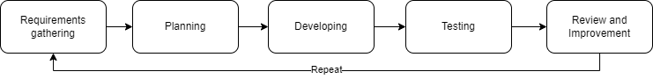

Figure Development Process

## 3.1 Requirements Gathering:

* Initiated the project by conducting comprehensive discussions with mentors and students to elicit detailed requirements for the final-year project management system.
* Documented specific functionalities, user roles, and system constraints to provide a clear roadmap for development.

## 3.2 Backend Implementation:

* Adopted an agile development approach, commencing with the backend implementation using NodeJs and ExpressJs.
* Designed and developed a robust database schema using MongoDB to efficiently store and manage project-related data.
* Implemented RESTful APIs to facilitate seamless communication between the frontend and backend components.

## 3.3 Frontend Design and Integration:

* Employed React and TypeScript to design an intuitive and responsive user interface, focusing on user experience and accessibility.
* Integrated the frontend with the backend, ensuring smooth data flow and real-time updates.
* Implemented role-based access controls to tailor user experiences based on their specific roles as students, mentors, or administrators.

## 3.4 Feature Implementation:

* Implemented core features such as project submission, allocation, and tracking to address the key requirements identified during the initial phase.
* Integrated a notification system to keep users informed about project updates, deadlines, and other relevant information.
* Incorporated a collaborative workspace for mentor-student interactions, enhancing communication throughout the project lifecycle.

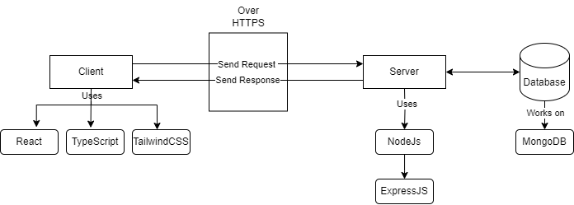

Figure 2 System Architecture

## 3.5 Testing:

* Conducted rigorous testing at various stages, including unit testing for individual components and end-to-end testing to ensure the seamless integration of all modules.

## 3.6 Review and Feedback:

* Regularly engaged with mentors for reviews, presenting the implemented features and functionality for feedback.
* Incorporated suggestions and changes iteratively, ensuring that the project aligns with the vision and requirements outlined by stakeholders.

## 3.7 Iterative Development:

* Embraced an iterative development model, allowing for continuous improvement based on user feedback and evolving requirements.
* Regularly reviewed and refined the system to address any issues, implement enhancements, and adapt to the dynamic needs of the educational environment.

This methodology, characterized by a systematic and collaborative approach, ensured the successful development, testing, and deployment of the final-year project management web application, aligning with the project's objectives and stakeholder expectations

# Chapter 4: Procedures

In this chapter, we delineate the procedural steps followed during the development of the final-year project management web application, placing particular emphasis on the integration of the backend with the frontend. The meticulous procedures encompassed the design of a resilient database schema, the integration of backend middleware components, the implementation of robust backend security measures, thorough testing on Postman, and continuous testing throughout the implementation to ensure the seamless integration of frontend and backend components.

## 4.1 Database Schema Design:

The foundational step in the development process involved the design of a comprehensive MongoDB database schema. This schema was meticulously crafted to efficiently store and manage a myriad of project-related data, including details about students, mentors, project specifications, and the dynamic allocation status. The design prioritized scalability and data relationships to facilitate streamlined data retrieval and manipulation.

## 4.2 Backend Middleware:

To augment the functionality and responsiveness of the backend, a series of middleware components were strategically implemented using NodeJs and ExpressJs. These middlewares played a crucial role in tasks such as data validation, user authentication, and the seamless processing of incoming requests. By compartmentalizing these functionalities, the backend architecture remained modular, allowing for flexibility in accommodating additional features seamlessly.

## 4.3 Backend Security Codes:

Security was a paramount consideration throughout the development process. Robust security codes were embedded in the backend to fortify sensitive data, thwart unauthorized access attempts, and mitigate potential vulnerabilities. This entailed the incorporation of encryption protocols, secure authentication mechanisms, and adherence to industry best practices to ensure the highest standards of security.

## 4.4 Testing on Postman:

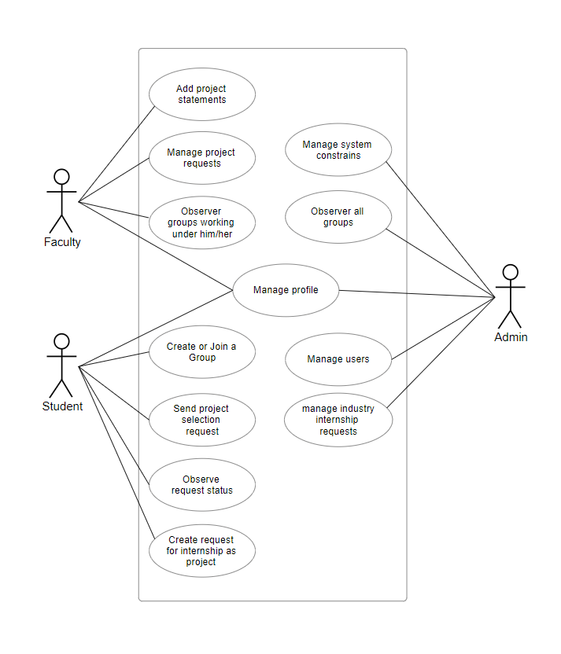Prior to the integration with the frontend, the backend underwent rigorous testing using Postman. This phase involved the simulation of various API requests and responses to scrutinize the correctness of data processing, error handling, and the overall reliability of backend services. Insights gained from these tests were invaluable, informing iterative improvements and contributing to the overall robustness of the backend.

Figure System Use-Case Diagram

## 4.5 Integrating with Frontend:

The integration process involved harmonizing the frontend, developed using React and TypeScript, with the established backend architecture. API endpoints were seamlessly connected, ensuring a smooth flow of data between the user interface and the server. This integration focused on creating a cohesive and intuitive user experience, leveraging the capabilities of React to enhance interactivity and responsiveness.

## 4.6 Continuous Testing Throughout Implementation:

To uphold the integrity of the entire application, a proactive testing approach was maintained. Each newly introduced frontend element underwent thorough testing to identify and rectify any potential conflicts with existing features. This iterative testing strategy ensured that the integration of new elements did not compromise the operational capabilities of previously implemented components.

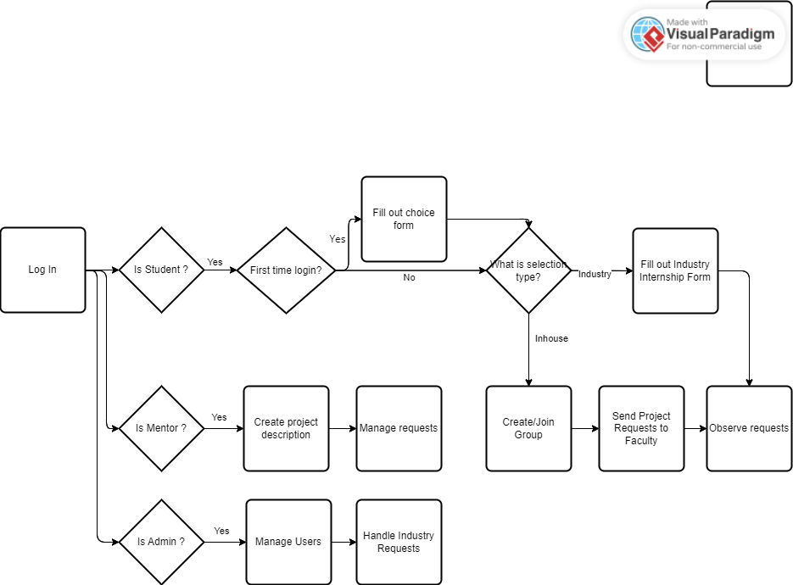

Figure System Flow Diagram

These procedures collectively reflect a holistic approach to development, from the foundational database design to the seamless integration of frontend and backend components. The adherence to these procedures underscores a commitment to quality, security, and a user-centric experience, ensuring the successful realization of the project's objectives.

# Chapter 5: Result Analysis and Discussion

The culmination of the development process led to a comprehensive analysis of the final-year project management web application's results, illuminating its efficacy in addressing the outlined objectives. The application successfully centralizes project management, streamlines mentor-student interactions, and reduces reliance on manual processes, aligning with the project's motivations. The role-based access design ensures tailored user experiences, fostering transparency and fairness in project allocation. The backend-middlewares, security protocols, and continuous testing strategies have collectively contributed to a robust and secure system, safeguarding sensitive data and mitigating potential vulnerabilities.

In discussions with stakeholders and end-users, the feedback has been overwhelmingly positive. Faculty members express increased efficiency in project allocation, citing the user-friendly interface and streamlined workflows as key advantages. Students commend the transparency in the allocation process, providing them with clearer insights into project availability and mentorship options. The collaborative workspace has facilitated enhanced mentor-student interactions, creating a dynamic platform for project development. Continuous testing practices and iterative improvements have resulted in a stable application, minimizing disruptions and ensuring a seamless user experience.

However, discussions also bring to light areas for potential enhancement. Further refinements in user interface elements and additional features to facilitate project collaboration are identified as avenues for future development. The results analysis and discussions in this chapter provide a nuanced understanding of the application's impact, successes, and areas for improvement, laying the groundwork for future iterations and continuous enhancement of the final-year project management system.

# Conclusion

In conclusion, the development and implementation of the final-year project management web application represent a significant stride towards enhancing the efficiency and transparency of project allocation processes within academic institutions. The project successfully achieves its primary objectives by centralizing management, streamlining interactions, and reducing manual workloads. The integration of React, TypeScript, Tailwind CSS, NodeJs, ExpressJs, and MongoDB has yielded a robust and scalable system. The iterative development approach, coupled with continuous testing, ensures a stable and reliable application. As we reflect on this journey, the positive feedback from users and stakeholders underscores the practical impact of the implemented solution. The identified areas for future refinement pave the way for ongoing improvements, illustrating the dynamic nature of technology in addressing evolving needs. This project not only addresses the immediate requirements of final-year project management but also lays a foundation for continued innovation in educational technology, contributing to the evolution of academic administration practices.

# Scope for Future Work

While the current implementation marks a significant advancement in streamlining final-year project management, several avenues for future development and enhancement emerge, ensuring the system remains adaptive to evolving needs. One promising avenue is the addition of a real-time chat function between mentors and students, fostering seamless communication and collaboration throughout the project lifecycle. This feature not only enhances mentor-student interactions but also provides a dynamic platform for exchanging ideas and addressing queries.

Furthermore, the integration of an Evaluation Panel Management system represents a valuable addition to the application's capabilities. This enhancement can include functionalities for assembling evaluation panels, managing assessment criteria, and recording panel feedback. Such a feature would contribute to a more comprehensive and structured evaluation process, ensuring a holistic assessment of project outcomes.

Another area for future development involves the incorporation of tools for scheduling Internal Assessments and Mentor-Student meetings. This addition would not only facilitate the planning of crucial project milestones but also automate the scheduling process, reducing administrative overhead. Features such as automated reminders and a centralized calendar system could further enhance the efficiency of project management workflows.

As technology and educational practices continue to evolve, these identified areas for future work provide a roadmap for further refining and expanding the capabilities of the final-year project management web application. By incorporating these enhancements, the system can continually adapt to the dynamic needs of academic institutions, ensuring a cutting-edge and user-centric approach to project management.