**AUSHADX- MEDICINE MADE SIMPLE..!**



**"Aushad" means medicine in Marathi, and AushadX is designed to make medicine management simple and hassle-free. From identifying medicines to setting reminders, this app ensures you never miss a dose or take an expired pill.**

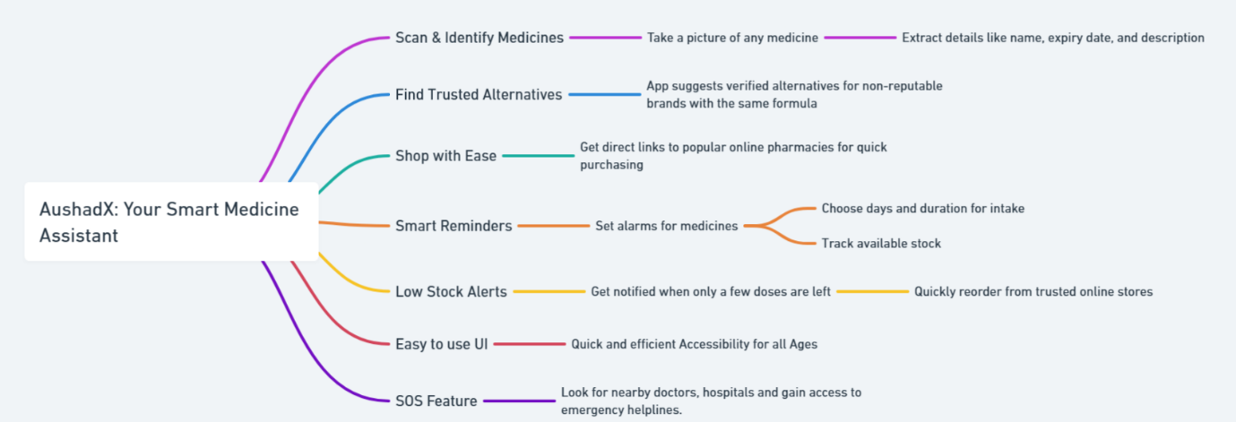

**Key Features:**

* **Scan & Identify Medicines – Take a picture of any medicine, and the app extracts details like the name, expiry date, and description.**
* **Find Trusted Alternatives – If the scanned medicine isn’t from a reputable brand, the app suggests verified alternatives with the same formula.**
* **Shop with Ease – Get direct links to popular online pharmacies for quick and convenient purchasing.**
* **Smart Reminders – Set alarms for your medicines, choose the days and duration for intake, and track available stock.**
* **Low Stock Alerts – Get notified when only a few doses are left and quickly reorder from trusted online stores.**
* **Doctor Prescription Scanner – Scan your doctor’s prescription, and the app automatically adds medicines to your schedule with the correct dosage and timing.**
* **Overdose Alerts – If a user tries to take more than the prescribed dosage within a short period, the app sends an alert to warn against potential overdose risks.**
* **Multi-Language Support – AushadX is available in multiple languages to cater to a diverse audience, ensuring accessibility for non-English speakers.**
* **User-Friendly UI – Designed for users of all ages, from grandparents to grandkids, with an intuitive interface that makes navigation effortless.**
* **SOS Feature – In case of emergency, the app provides location-based information about nearby hospitals and doctors. It also allows you to dial emergency services directly for immediate assistance.**
* **Family Medicine Tracker – Manage medications for multiple family members in a single app, ensuring that everyone’s health is well-monitored.**
* **Health Profile Integration – Maintain a digital record of past prescriptions, allergies, and chronic conditions for easy reference during doctor visits.**

**Why AushadX?**

* **Saves Time – No more struggling to read medicine labels or searching for expiry dates.**
* **Enhances Safety – Avoid expired medicines and ensure you’re taking trusted brands.**
* **Perfect for Everyone – Whether managing personal medication, assisting a family member, or caring for the elderly, AushadX keeps everything organized.**
* **Prevents Medical Errors – With overdose warnings and prescription scanning, users can avoid mistakes in their medication routine.**
* **Accessible & Inclusive – Multi-language support ensures that users from diverse backgrounds can navigate the app with ease.**

**Why AushadX?**

* **Saves Time** – No more struggling to read medicine labels or searching for expiry dates.
* **Enhances Safety** – Avoid expired medicines and ensure you’re taking trusted brands.
* **Perfect for Everyone** – Whether managing personal medication, assisting a family member, or caring for the elderly, AushadX keeps everything organized.

AushadX brings **convenience, safety, and efficiency** to every household, making medicine management effortless and reliable.