JP : Experiment – 1

Q] Print multiplication table of a number.

import java.util.Scanner;

class NumberTable {
public static void main(String args[]) {
Scanner sc = new Scanner (System.in);
System.out.println("Enter a number to display it's number table:");
int n = sc.nextInt();
for(int i = 0; i < 10; i++) {
System.out.println(n + " * " + i + " = " + n*i);
}
}
}
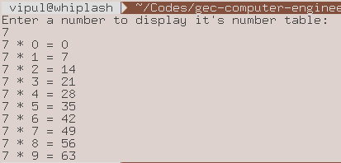

Q] Program to print average of N numbers.

import java.util.Scanner;

class Average {
public static void main(String args[]) {
Scanner sc = new Scanner (System.in);
System.out.println("Enter number of numbers:");
int n = sc.nextInt();
int num[] = new int[n];
for(int i = 0; i < n; i++) {
System.out.println("Enter #" + (i+1) + " :");
num[i] = sc.nextInt();
}
int sum = 0;
for(int i = 0; i < n ;i++) {
sum += num[i];
}
int average = sum / n;
System.out.println("Average = " + average );
}
}
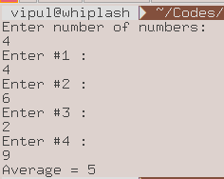

Q] Program to implement Linear search.

import java.util.Scanner;

class LinearSearch {
public static void main (String args[]) {
int arr[] = {10, 23, 44, 52, 23, 4};
Scanner sc = new Scanner (System.in);
System.out.println("Enter number to be searched:");
int num = sc.nextInt();
for(int i = 0; i < arr.length; i++) {
if (num == arr[i]) {
System.out.println(num + " was found at location " + (i+1));
}
}
}
}
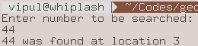

Q] Program to implement Binary search.

import java.util.Scanner;

class BinarySearch {
public static void main (String args[]) {
int arr[] = {-21, -10, 4, 0, 1, 10, 23, 44, 52, 69, 404};
Scanner sc = new Scanner (System.in);
System.out.println("Enter number to be searched:");
int num = sc.nextInt();
int low = 0, high = arr.length - 1, mid = (low + high) / 2;
while(low < high) {
mid = (low + high) / 2;
if(arr[mid] == num) {
System.out.println(num + " found at location " + (mid+1));
System.exit(1);
}
else if (arr[mid] > num)
high = mid - 1;
else
low = mid + 1;
}
System.out.println(num + " was not found.");
}
}
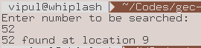

Q] Program to accept first name and last name and print it.

import java.util.Scanner;

class FirstLastName {
public static void main (String args[]) {
Scanner sc = new Scanner (System.in);
System.out.println("Enter first name and last name:");
String firstName = sc.next();
String lastName = sc.next();
System.out.println("Full Name: " + firstName + " " + lastName);
}
}

