// Queue
#include<stdio.h>
#include<stdlib.h>
#define MAX 50
int queue[MAX];
int f = -1;
int r = -1;
int isEmpty();
int isfull();
void insert(int);
int delete();
int peek();
void display();
int main() {
int ch, item;
while(1) {
printf("\n---------------------\n");
printf("1. Insert an item\n");
printf("2. Delete an item\n");
printf("3. Display\n");
printf("4. Display the top item\n");
printf("5. Exit\n");
printf("Enter ur choice: ");
scanf("%d", &ch);
switch(ch)
{
case 1:

printf("\nEnter an item: ");
scanf("%d", &item);
insert(item );
break;

case 2:
printf("The item popped is %d\n", delete());
break;
case 3:
display();
break;
case 4:
printf("The top element is %d\n", peek());
break;
case 5:
exit(1);
}
}
return 0;
}
int isfull() {
if(r == MAX-1)
return 1;
else
return 0;
}
int isEmpty() {
if(f == -1 || f == r+1)
return 1;
else
return 0;
}
int peek() {
if(isEmpty())
printf("Queue underflow\n");
else
return(queue[r]);

}
void insert(int i) {
if(isfull()){
printf("Queue overflow\n");
return;
}
if(f == -1)
f = 0;
r = r+1;
queue[r] = i;
}
int delete() {
int i;
if(isEmpty()) {
printf("Queue underflow\n");
return 0;
}
else
i = queue[f];
f = f+1;
return (i);
}
void display() {
if(isEmpty())
printf("Queue is empty\n");
else
for(int i = f; i <= r; i++)
printf("%d\t", queue[i]);
}

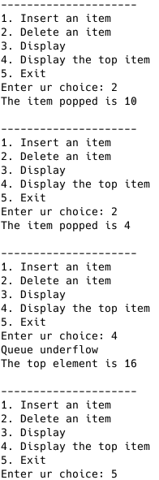
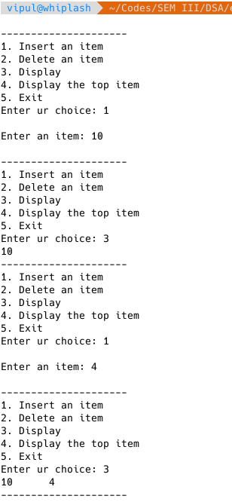

// Stack
#include<stdio.h>
#include<stdlib.h>
#define MAX 50
int stack[MAX];
int top = -1;
int isempty();
int isfull();
void push(int);
int pop();
int peek();
void display();
int main() {
int ch, item;
while(1) {
printf("1. Push an item\n");
printf("2. Pop an item\n");
printf("3. Display\n");
printf("4. Display the top item\n");
printf("5. Exit\n");
printf("Enter ur choice: ");
scanf("%d", &ch);
switch(ch) {
case 1:
printf("\nEnter an item: ");
scanf("%d", &item);
push(item);
break;
case 2:
printf("The item popped is %d\n", pop());
break;
case 3:
display();
break;
case 4:
printf("The top element is %d\n", peek());
break;
case 5:
exit(1);
}
}
return 0;
}
int isfull() {
if(top == MAX)
return 1;
else
return 0;
}
int isempty() {
if(top == -1)
return 1;
else
return 0;
}
int peek() {
if(isempty())
printf("Stack underflow\n");
else
return(stack[top]);
}
void push(int i) {
if(isfull()) {
printf("Stack overflow\n");
return;
}
else
top++;
stack[top] = i;
}
int pop() {
int i;
if(top == -1) {
printf("Stack underflow\n");
return 0;
}
else
i = stack[top];
top--;
return(i);
}
void display() {
int i;
if(top == -1)
printf("Stack is empty\n");
else
for(i = top;i >= 0;i--)
printf("%d\t", stack[i]);
}

