// Circular Queue
#include<stdio.h>
#include<stdlib.h>
#include<string.h>
#define MAX 5
char item[10];
char *cqueue[MAX];
int f = -1;
int r = -1;
void display() {
int i;
i=f;
if(f <= r) {
while(i<=r)
printf("%s\t", cqueue[i++]);
}
else {
while(i<=MAX-1)
printf("%s\t", cqueue[i++]);
i = 0;
while(i<=r)
printf("%s\t", cqueue[i++]);
}
}
int isEmpty() {
if(f == -1 && r == -1)
return 1;
else
return 0;
}
int isfull() {
if(f == 0 && r == MAX-1||f == r+1)
return 1;

else
return 0;
}
void insert(char item []) {
if(f == -1 && r == -1)
{
f++;
r++;
}
else if(r == MAX-1)
r=0;
else
r++;
cqueue[r]=(char*)malloc(sizeof(char)*strlen(item));
strcpy(cqueue[r], item);

}
void delete() {
//strcpy(item, cqueue[f]);
//item=cqueue[f];
if(f==r)
f=r=-1;
else if(f == MAX-1)
f=0;
else
f++;
}
int main() {
int ch, i;
while(1) {
printf("\n 1. Insert\n 2. Delete\n 3. Display\n 4. Exit\n\t Enter Choice: ");
scanf("%d", &ch);
switch(ch) {
case 1:
if(isfull()) {
printf("\nCircular Queue Overflow\n");
break;
}
else {
printf("\nEnter the string: ");
scanf("%s", &item);
insert(item);
}
break;
case 2:
if(isEmpty())
printf("\nCircular Queue Underflow\n");
else
printf("\nthe element is %s", cqueue[f]);
delete();
break;
case 3:
display();
break;
case 4:
exit(1);
}
}}
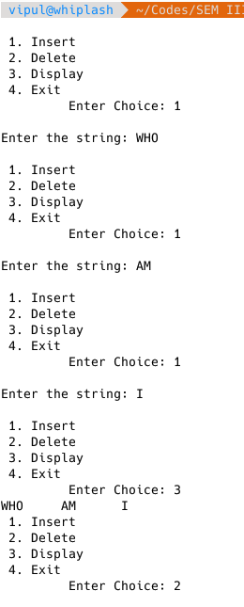
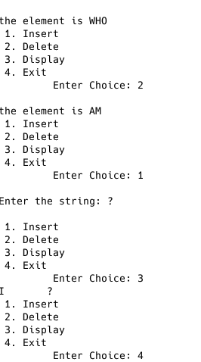
// Dequeue
#include<stdio.h>
#include<stdlib.h>
#include<string.h>
#define MAX 5
char item[10];
char *arr[MAX];
int f=-1;
int r=-1;
void display() {
int i;
i=f;
if(f <= r) {
while(i <= r)
printf("\n%s\t", arr[i++]);
}
else {
while(i <= MAX-1)
printf("\n%s\t", arr[i++]);

i=0;
while(i <= r)
printf("\n%s\t", arr[i++]);

}}
int isEmpty() {
if(f == -1 && r == -1)
return 1;
else
return 0;
}
int isfull() {
if(f == 0 && r == MAX-1||f == r+1)
return 1;
else
return 0;
}
void insertfront(char item []) {
if(f == -1 && r == -1) {
f++;
r++;
}
else if(f == 0)
f=MAX-1;
else
f--;
arr[f]=(char*)malloc(sizeof(char)*strlen(item));
strcpy(arr[f], item);
printf("\n\tf=%d\tr=%d\n", f, r);
}
void insertrear(char item []) {
if(f == -1 && r == -1) {
f++;
r++;
}
else if(r == MAX-1)
r=0;
else
r++;
arr[r]=(char*)malloc(sizeof(char)*strlen(item));
strcpy(arr[r], item);
printf("\n\tf=%d\tr=%d\n", f, r);
}
void deletefront() {
printf("\nThe item deleted is %s\n", arr[f]);
if(f == r)
f=r=-1;
else if(f == MAX-1)
f=0;
else
f++;
printf("\n\tf=%d\tr=%d\n", f, r);
}

void deleterear() {
printf("\nThe item deleted is %s\n", arr[r]);
if(f == r)
f=r=-1;
else if(r == 0)
r=MAX-1;
else
r--;
printf("\n\tf=%d\tr=%d\n", f, r);
}

int main() {
int ch, i;
while(1) {
printf("\n1.-Insert\t2.-Delete\t3.-Display\t4.-Exit\n\tEnter choice:");
scanf("%d", &ch);
switch(ch) {
case 1:
if(isfull()) {
printf("\nCircular Queue Overflow\n");
break;
}
else {
int a;
printf("\n1.Insert at front\t2.Insert at rear\n");
scanf("%d", &a);
printf("\nEnter the string\n");
scanf("%s", &item);
if(a == 1)
insertfront(item);
else
insertrear(item);
}
break;
case 2:
if(isEmpty())
printf("\nCircular Queue Underflow\n");
else {
int a;
printf("\n1.Delete from front\t2.Delete from rear\n");
scanf("%d", &a);
if(a == 1)
deletefront(item);
else
deleterear(item);}
break;
case 3:
display();
break;
case 4:
exit(1);
}
}
}

