// Unsigned Binary Multiplication

#include<stdio.h>

int main() {
printf("Enter number of bits: \t");
int n, c, i;
scanf("%d", &n);
int a[n], q[n], m[n];

printf("Enter bits of the multiplicand: \t");
for(i=0;i<n;i++)
scanf("%d", &m[i]);

printf("Enter bits of the multiplier: \t");
for(i=0;i<n;i++)
scanf("%d", &q[i]);

for(i=0;i<n;i++)
a[i]=0;

int j=0;
while(j < n){
c=0;

if(q[0] == 1) {
for(i=0;i<n;i++){
if(m[i] == 1 && a[i] == 1) {
if(c == 1)
a[i]=1;

else{
a[i]=0;
c=1; //changed here
}
}
else if(m[i] == 0 && a[i] == 0) {
if(c == 1) {
a[i]=1;
c=0;
}
else
a[i]=0;
}
else {
if(c == 1) {
a[i]=0;
c=1;
}
else
a[i]=1;
}
}
}

int k;
k=a[0];
for(i=0;i<n-1;i++)
a[i]=a[i+1];

a[n-1]=c;
for(i=0;i<n-1;i++)
q[i]=q[i+1];

q[n-1]=k;

printf("Cycle %d : C: %d", j+1, c);
printf("\tA:-");
for(i=n-1;i>=0;i--)
printf("%d", a[i]);

printf("\t Q:-");
for(i=n-1;i>=0;i--)
printf("%d", q[i]);

printf("\n");
j++;
}

printf("Answer = ");
for(i=n-1;i>=0;i--)
printf("%d", a[i]);

for(i=n-1;i>=0;i--)
printf("%d", q[i]);
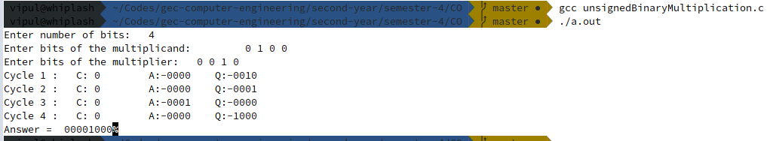
}
// Booth's Algorithm

#include<stdio.h>

int main() {
printf("Enter number of bits:\t");
int i, n, q1=0;
scanf("%d", &n);
int a[n], q[n], m[n];
printf("Enter bits of the multiplicand:\t");
for(i=n-1;i>=0;i--)
scanf("%d", &m[i]);

printf("Enter bits of the multiplier:\t");
for(i=n-1;i>=0;i--)
scanf("%d", &q[i]);

for(i=0;i<n;i++)
a[i]=0;

int j=0, c;
while(j<n){

if(q[0] == 1 && q1 == 0) {
c=0;
for(i=0;i<n;i++) {
if(m[i] == 1 && a[i] == 1||m[i] == 0 && a[i] == 0) {
if(c == 1)
a[i]=1;
else {
a[i]=0;
if(m[i] == 1)
c=1;
}
}
else if(m[i] == 0 && a[i] == 1) {
if(c == 1){
a[i]=0;
c=0;
}
else
a[i]=1;
} else {
if(c == 1)
a[i]=0;

else{
a[i]=1;
c=1;
}
}
}
}
else if(q[0] == 0 && q1 == 1)
{
c=0;
for(i=0;i<n;i++) {
if(m[i] == 1 && a[i] == 1) {
if(c == 1)
a[i]=1;
else {
a[i]=0;
c=1; //Changed here
}
}
else if(m[i] == 0 && a[i] == 0) {
if(c == 1) {
a[i]=1;
c=0;
}
else
a[i]=0;
}
else {
if(c == 1) {
a[i]=0;
c=1;
}
else
a[i]=1;
}
}
}
int k, x;
k=a[0];
for(i=0;i<n-1;i++)
a[i]=a[i+1];

x=q[0];
for(i=0;i<n-1;i++)
q[i]=q[i+1];

q1=x;
q[n-1]=k;

printf("Cycle %d : A: ", j+1);
for(i=n-1;i>=0;i--)
printf("%d", a[i]);

printf("\tQ: ");
for(i=n-1;i>=0;i--)
printf("%d", q[i]);

printf("\t Q[-1]: %d", q1);
printf("\n");
j++;
}
printf("Answer = ");
for(i=n-1;i>=0;i--)
printf("%d", a[i]);

for(i=n-1;i>=0;i--)
printf("%d", q[i]);

printf("\n\n");
}

