JP : Experiment – 4

Q] /* Write a Java program that checks whether a given string is
a palindrome or not. E.g: RACECAR is a palindrome? */

import java.util.Scanner;

class Palindrome {
public static void main (String args[]) {
Scanner sc = new Scanner(System.in);
System.out.println("Enter a string to check for palindrome: ");
String str = sc.next().trim().toLowerCase();

int i = 0, j = str.length() - 1;
boolean check = false;

while(i < j){
if(str.charAt(i) == str.charAt(j)) {
check = true;
} else {
check = false;
break;
}
i++; j--;
}

if(check)
System.out.println(str + " is a palindrome.");
else
System.out.println(str + " is not a palindrome.");
}
}

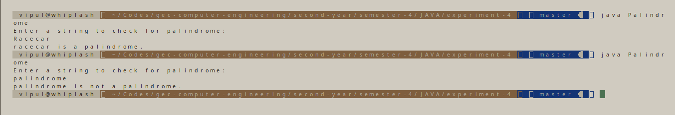

Q] /* Write a Java program to practice using String
class and its methods.*/

import java.util.Scanner;

class StringPractice {
public static void main (String args[]) {
Scanner sc = new Scanner(System.in);
System.out.print("Enter a string: ");
String str = sc.nextLine();
String trimmedString = str.trim();
String lowerCaseString = trimmedString.toLowerCase();
String upperCaseString = trimmedString.toUpperCase();
String concatenatedString = lowerCaseString.concat(upperCaseString);

System.out.println ("Trimmed String: " + trimmedString);
System.out.println ("Lower Case String: " + lowerCaseString);
System.out.println ("Upper Case String: " + upperCaseString);
System.out.println ("Concatenated String: " + concatenatedString);
System.out.println ("is Lower Case String equal to Upper Case String?: " + (lowerCaseString.equals(upperCaseString)?"Yes":"No"));
}
}

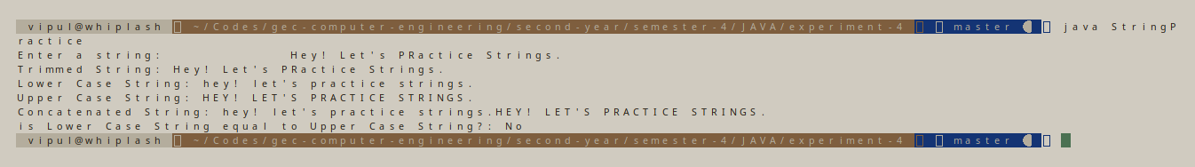
Q] /* Create a flat file “StudentNames.txt” containing the list of student names.

Each student name has first name and last name.
Display total number of student names in the file.
Also display the number of students having same first name.
Also, display the number of students having same first name and lat name.
Display the name of the student having the longest name. */

import java.util.Scanner;
import java.io.FileWriter;
import java.io.IOException;
import java.io.BufferedReader;
import java.io.FileReader;

class Student {
public static void main(String args[]) throws IOException {
Scanner sc = new Scanner (System.in);
System.out.print("Enter number of students: ");
int num = sc.nextInt();
try {
FileWriter fw = new FileWriter("StudentNames.txt");
for(int i = 0; i < num; i ++) {
System.out.print("Enter Student " + (i+1) + "'s First Name: ");
String firstName = sc.next();
System.out.print("Enter Student " + (i+1) + "'s Last Name: ");
String lastName = sc.next();
fw.write(firstName + " " + lastName + "\n");
}
fw.close();
} catch (IOException e) {
System.out.println("An error occurred.");
e.printStackTrace();
}
// End of file writing
System.out.println("\n - End of writing file - ");
try {
BufferedReader br = new BufferedReader (new FileReader("StudentNames.txt"));
String name = br.readLine();
int numberOfStudents = 0;
while(name!= null){
numberOfStudents++;
// System.out.println("Found: " + name);
name = br.readLine();
}
System.out.println("Total Number of Students: " + numberOfStudents);
br.close();

br = new BufferedReader (new FileReader("StudentNames.txt"));
String names[] = new String[numberOfStudents+1];
int i = 0;
names[i]=br.readLine().trim();
while(names[i]!= null){
i++;
names[i] = br.readLine();
}

// Code to get longest name
{
String longestName = names[0];
for(int j = 0; j < numberOfStudents; j++) {
if(longestName.length() < names[j].length())
longestName = names[j];
}
System.out.println("The longest name: " + longestName);
}

// Code to check for same full name
{
int numberOfStudentsHavingSameFullName = 0;
for(int j = 0; j < numberOfStudents; j++) {
for(int k = j + 1; k < numberOfStudents; k++) {
if(names[j].equalsIgnoreCase(names[k])) {
// System.out.println("Full Name check: " + names[j] + " " + names[k]);
numberOfStudentsHavingSameFullName++;
}
}
}
System.out.println("Number of students with same full name: " + numberOfStudentsHavingSameFullName);
}

// Code to check for same first name
{
int numberOfStudentsHavingSameFirstName = 0;
String firstName1[] = new String[2];
String firstName2[] = new String[2];
for(int j = 0; j < numberOfStudents; j++) {
firstName1 = names[j].split(" ", 2);
// if(j > 0 && firstName1[j].equalsIgnoreCase(firstName1[j-1]));
for(int k = j + 1; k < numberOfStudents; k++) {
firstName2 = names[k].split(" ", 2);
if(firstName1[0].equalsIgnoreCase(firstName2[0])) {
// System.out.println("First Name check: " + firstName1[0] + " " + firstName2[0]);
numberOfStudentsHavingSameFirstName++;
}
}
}
System.out.println("Number of students with same first name: " + numberOfStudentsHavingSameFirstName);
}

br.close();
} catch (IOException e) {
System.out.println("An error occurred.");
e.printStackTrace();
}
}
}

