JP : Experiment – 2

Q]
//Find the area and perimeter of a circle taking a value of radius from user
// If rad <= 0 then print message to enter non zero postitive number

import java.util.Scanner;
import java.lang.Math;

class Circle {
public static void main (String args[]) {
Scanner sc = new Scanner (System.in);

System.out.println("Enter the value of radius:");
double radius = sc.nextDouble();

while(radius <= 0) {
System.out.println("Enter non zero postitive number");
radius = sc.nextDouble();
}

double perimeter = 2 * Math.PI * radius;
double area = Math.PI * radius * radius;
System.out.println("Area of circle = " + area + " sq. units\nPerimeter of circle = " + perimeter + " units");
}
}
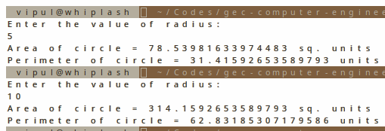

Q]
//Consider first n even numbers starting from 0, complete the input and calculate the sum of all numbers divisible by 3 and print sum
// IF n = 10, then 2, 4, 6, 8, 10
import java.util.Scanner;

class SumA {
public static void main (String args[]) {
Scanner sc = new Scanner (System.in);
System.out.println("Enter value of n:");
int n = sc.nextInt();
int sum = 0;

for(int i = 0, j = 0; i <= n; i++ ) {
if(i % 2 == 0 && i % 3 == 0) {
sum += i;
}
}

System.out.println("Sum of even numbers divisible by 3 upto " + n + " = " + sum);
}
}
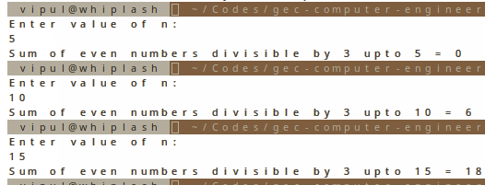

Q]
// Accept value n from user and consider first n even numbers and calculate the sum of all numbers divisible by 3 and print sum
// IF n = 5, then 2, 4, 6, 8 ,10.
import java.util.Scanner;

class SumB {
public static void main (String args[]) {
Scanner sc = new Scanner (System.in);
System.out.println("Enter value of n:");
int n = sc.nextInt();
int arr[] = new int[n];

for(int i = 0, j = 0; 1 == 1; i++ ) {
if(i % 2 == 0) {
arr[j] = i;
j++;
if(j == n)
break;
}
}

int sum = 0;
for(int i = 0; i < arr.length; i++ ) {
if(arr[i] % 3 == 0)
sum += arr[i];
}

System.out.println("Sum of even numbers divisible by 3 upto " + n + " = " + sum);
}
}
