JP : Experiment – 3

Q]
/* Write a program that uses length property for displaying the number of command line arguments.
If length is greater equal to 2, display the summation
if input has numbers else display the concatenated result. */

class AddCMDArgs {
public static void main (String args[]) {
Boolean numCheck = false;
if(args.length >= 2) {
// Iterate over all command line arguments and return false if a non-number is encountered.
for(int i = 0; i < args.length; i++) {
numCheck = numberCheck(args[i]);
if(!numCheck)
break;
}

// If even a single argument is not a number then add them.
if (numCheck) {
double sum = 0;
for(int i = 0; i < args.length; i++)
sum += Double.parseDouble(args[i]);
System.out.println("Sum of all the command line arguments = " + sum);
}

else if (!numCheck) {// If even a single argument is not a number then concatenate them.
String newString = "";
for(int i = 0; i < args.length; i++)
newString += args[i];
System.out.println("Concatenated command line arguments string = " + newString);
}
} else if (args.length == 1) {
System.out.println("Command Line argument passed: " + args[0]);
} else {
System.out.println("No Command Line arguments passed!");
}
}

public static Boolean numberCheck(String str) {
try {
Double.parseDouble(str);
return true; // Return true if number can be parsed to double
} catch(NumberFormatException e){
return false; // Return true if number can't be parsed to double; is a string.
}
}
}

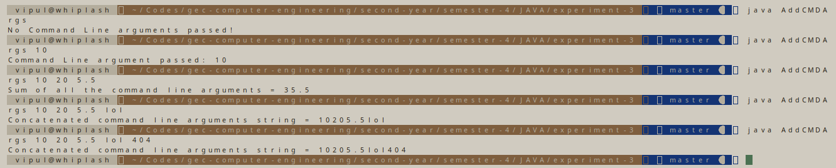

Q]
/* Write a program that describes a class Person.
It should have instance variables to record name, age and salary.
Create a person object and save the person transaction in employee.txt */

import java.io.FileWriter;
import java.io.IOException;
import java.util.Scanner;

class Person {
private String name;
private int age;
private double salary;

public static void main (String args[]) throws IOException {
Scanner sc = new Scanner (System.in);

Person personObject = new Person ();

System.out.println("Enter Person's Name:");
personObject.name = sc.next().trim();

System.out.println("Enter Person's Age:");
personObject.age = sc.nextInt();

System.out.println("Enter Person's Salary");
personObject.salary = sc.nextDouble();

try {
FileWriter fw = new FileWriter("employee.txt");
fw.write(personObject.name + "," + personObject.age + "," + personObject.salary);
fw.close();
} catch (IOException e) {
System.out.println("An error occurred.");
e.printStackTrace();
}
}
}

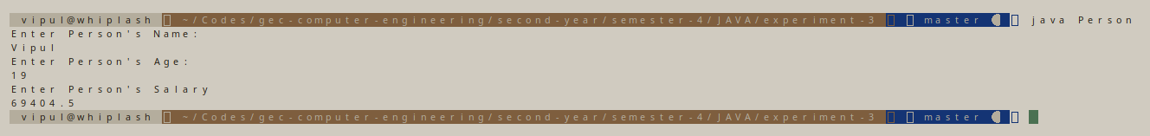
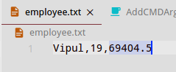

Q]
/* Write a program that accepts numbers as command line arguments.
Create a report (report.txt) reporting if the entered number is even or odd.
Display the contents of report.txt */

import java.io.FileWriter;
import java.io.IOException;

class OddEvenReport {
public static void main(String args[]) throws IOException {
try {
FileWriter fw = new FileWriter("report.txt");
for(int i = 0; i < args.length; i++) {
if(numberCheck(args[i])) {
if(Integer.parseInt(args[i]) % 2 == 0) {
fw.write(args[i] + " is even\n");
System.out.println(args[i] + " is even");
} else {
fw.write(args[i] + " is odd\n");
System.out.println(args[i] + " is odd");
}
} else {
System.out.println("* " + args[i] + " is not a number, skipping. *");
}
}
fw.close();
} catch (IOException e) {
System.out.println("An error occurred.");
e.printStackTrace();
}
}

public static Boolean numberCheck(String str) {
try {
Double.parseDouble(str);
return true; // Return true if number can be parsed to double
} catch(NumberFormatException e){
return false; // Return true if number can't be parsed to double; is a string.
}
}
}

