JP : Experiment – 5

Q] /* Read a string containing a word and 2 numbers, the word is one of the following: add, sub, mul, div. The program outputs the sum of the given numbers if the word is add. Similarly, for the other words. Use CMD args. */

class CMDOperations {
public static void main(String args[]) {
if(numberCheck(args[1]) && numberCheck(args[2])){
double num1 = Double.parseDouble(args[1]);
double num2 = Double.parseDouble(args[2]);

switch(args[0].toLowerCase().substring(0, 3)) {
case "add":
System.out.println((num1+num2)); break;
case "sub":
System.out.println((num1-num2)); break;
case "mul":
System.out.println((num1*num2)); break;
case "div":
System.out.println((num1/num2)); break;
default:
System.out.println("Please enter a valid operation i.e. add, sub, mul, div"); break;
}
}
else
System.out.println("Please enter Valid Numbers.");

}

public static Boolean numberCheck(String str) {
try {
Double.parseDouble(str);
return true; // Return true if number can be parsed to double
} catch(NumberFormatException e){
return false; // Return true if number can't be parsed to double; is a string.
}
}
}

Q] // WAP to demonstrate that the strings in string buffer class are mutable.

import java.lang.StringBuffer;

class MutableStringBuffer {
public static void main(String args[]) {
StringBuffer s = new StringBuffer("Hello World.");

System.out.println("Initial Value: " + s);
s.replace(0, s.length(), "Goodbye World :(");
System.out.println("Mutated Value: " + s);
}
}

Q] // WAP to accept a string and check for palindrome.

import java.util.Scanner;
import java.lang.StringBuffer;

class PalindromeStringBuffer {
public static void main(String args[]) {
Scanner sc = new Scanner(System.in);

System.out.println("Enter a string: ");
StringBuffer str = new StringBuffer(sc.nextLine().toLowerCase().trim());
StringBuffer strBackup = new StringBuffer(str) ;

str.reverse();

if(strBackup.compareTo(str) == 0)
System.out.println(str + " is a palindrome.");
else
System.out.println(strBackup + " is not a palindrome.");

sc.close();
}
}

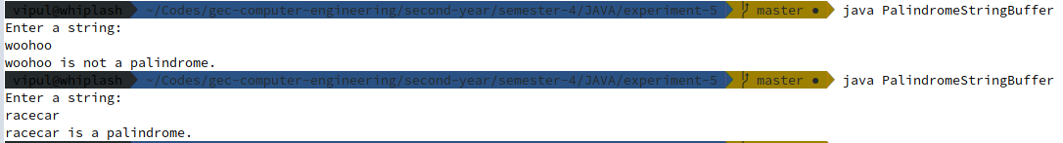

Q] // Read 2 strings and print the bigger string first and smaller later,

import java.util.Scanner;
import java.lang.StringBuffer;

class PrintOrderStringBuffer {
public static void main(String args[]) {
Scanner sc = new Scanner(System.in);

System.out.println("Enter first string: ");
StringBuffer str1 = new StringBuffer(sc.nextLine());

System.out.println("Enter second string: ");
StringBuffer str2 = new StringBuffer(sc.nextLine());

if(str1.length() > str2.length()) //First string is bigger
System.out.println("\n" + str1 + "\n" + str2);
else if((str1.length() < str2.length()) ) //Second string is bigger
System.out.println("\n" + str2 + "\n" + str1);
else if(str1.length() == str2.length()) { //Both strings are equal in length
if(str1.compareTo(str2) >= 0)
System.out.println("\n" + str1 + "\n" + str2);
else
System.out.println("\n" + str2 + "\n" + str1);
}

sc.close();
}
}

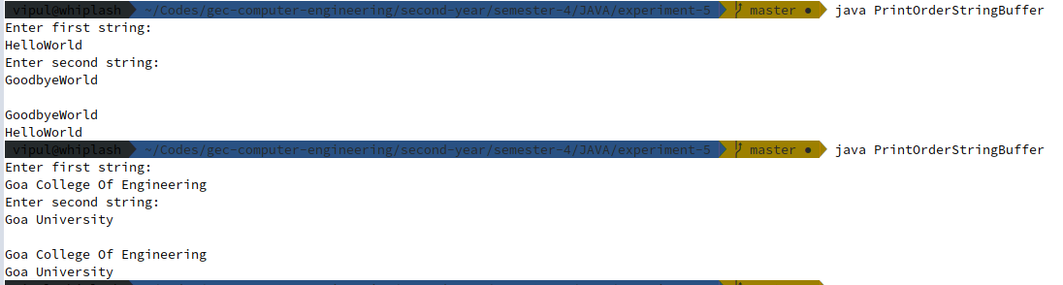

Q] // WAP to practice string buffer class and it's methods.

import java.lang.StringBuffer;

class StringBufferPractice {
public static void main(String args[]) {
StringBuffer s = new StringBuffer("Hello");
System.out.println("Initial value: " + s);

s.append("World");
System.out.println("Value after appending \"World\": " + s);

s.replace(0, 5, "Goodbye");
System.out.println("Value after replacing \"Hello\": " + s);

System.out.println("Index of \"World\": " + s.indexOf("World"));

System.out.println("Length of \"" + s + "\" = " + s.length());

s.reverse();
System.out.println("Value after reversing: " + s);
}
}

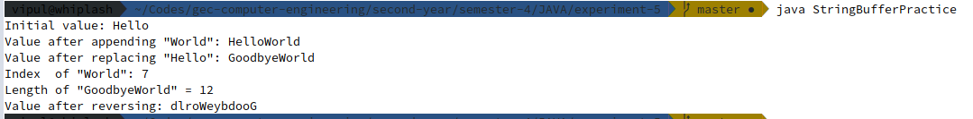

Q] /* Create a flat file "StudentsNames.txt", the file contains - names of students, where each student name
is listed using first name and last name. Read "StudentsNames.txt" and display names of students.
Search for a particular student name.
Allow update of student name. (Not using file handling) */

import java.util.Scanner;
import java.lang.StringBuffer;
import java.io.FileWriter;
import java.io.IOException;
import java.io.BufferedReader;
import java.io.FileReader;

class Students {
public static void main(String args[]) throws IOException {
Scanner sc = new Scanner (System.in);

System.out.print("Enter number of students: ");
int num = sc.nextInt();

try {
FileWriter fw = new FileWriter("StudentNames.txt");
for(int i = 0; i < num; i ++) {
System.out.print("Enter Student " + (i+1) + "'s First Name: ");
StringBuffer firstName = new StringBuffer(sc.next());

System.out.print("Enter Student " + (i+1) + "'s Last Name: ");
StringBuffer lastName = new StringBuffer(sc.next());

fw.write(firstName + " " + lastName + "\n");
}
fw.close();
} catch (IOException e) {
System.out.println("An error occurred.");
e.printStackTrace();
}

// End of file writing

System.out.println("\n - End of writing file - ");
try {
System.out.println("Enter student name to be searched");
sc.nextLine();
StringBuffer key = new StringBuffer(sc.nextLine());

BufferedReader br = new BufferedReader (new FileReader("StudentNames.txt"));
try {
StringBuffer name = new StringBuffer(br.readLine());
while(name!= null){
if(key.compareTo(name) == 0) {
System.out.println("Found: " + name);
System.out.println("Enter new name: ");
key.replace(0, key.length(), sc.nextLine());
System.out.println("Updated!");
}
name.replace(0, name.length(), br.readLine());
}
}
catch(NullPointerException e) {
System.out.print("NullPointerException Caught");
}

br.close();
} catch (IOException e) {
System.out.println("An error occurred.");
e.printStackTrace();
}

sc.close();
}
}

