Program 1

#include<stdio.h>
#include<string.h>
int main(){
int n,i;

printf("Enter number of students:\n");
scanf("%d",&n);

struct student{
char name[20];
int rollno,age;
}s[n];

for(i=0;i<n;i++){
printf("\nEnter Student #%d's name, rollno and age:\n",i+1);
scanf("%s %d %d",&s[i].name,&s[i].rollno,&s[i].age);
}

for(i=0;i<n;i++){
printf("\nStudent #%d's name = %s\nRollno = %d\nAge = %d\n\n",i+1,s[i].name,s[i].rollno,s[i].age);
}
}
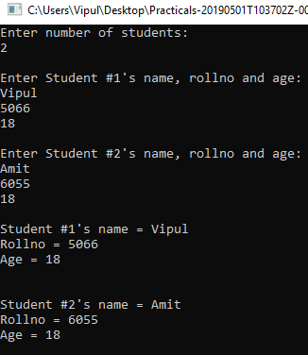
Program 2

#include<stdio.h>
struct doctor{
char dr[25],q[10];
int age,salary;
}d[50];
int main(){
int i,n;
printf("Enter the number of doctors: \n");
scanf("%d",&n);
for(i=0;i<n;i++){
printf("\nName: ");
scanf("%s",&d[i].dr);
printf("Qualification: ");
scanf("%s",&d[i].q);
printf("Age: ");
scanf("%d",&d[i].age);
printf("Salary: ");
scanf("%d",&d[i].salary);
}
int high=d[0].salary;
for(i=0;i<n;i++){
printf("\nName:%s\nQualification:%s\nAge:%d\nSalary:%d\n",d[i].dr,d[i].q,d[i].age,d[i].salary);
if(high<d[i].salary)
high=d[i].salary;
}
printf("\nHighest Salary: %d",high);
}

Program 3

#include<stdio.h>
struct employee{
char name[25],q[10];
int age,salary;
}d[50];
int main(){
int i,n;
printf("Enter the number of employees: \n");
scanf("%d",&n);
for(i=0;i<n;i++){
printf("\nName: ");
scanf("%s",&d[i].name);
printf("Qualification: ");
scanf("%s",&d[i].q);
printf("Age: ");
scanf("%d",&d[i].age);
printf("Salary: ");
scanf("%d",&d[i].salary);
}
for(i=0;i<n;i++)
if(d[i].salary>20000)
printf("\nName: %s\nQualification: %s\nAge: %d\nSalary: %d\n",d[i].name,d[i].q,d[i].age,d[i].salary);
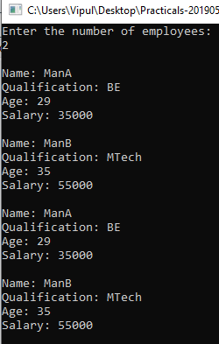
}
Program 4

#include<stdio.h>
struct book{
char name[25];
int price,no,sno;
}b[10];
int main()
{
int i,n;
printf("Enter the number of books:\n");
scanf("%d",&n);
for(i=0;i<n;i++){
printf("\nName: ");
scanf("%s",&b[i].name);
printf("Price: ");
scanf("%d",&b[i].price);
printf("Serial No.: ");
scanf("%d",&b[i].sno);
printf("Number: ");
scanf("%d",&b[i].no);
}
int low=b[0].price;
for(i=0;i<n;i++){
printf("\nName: %s Price: %d Serial No.: %d Number: %d\n",&b[i].name,b[i].price,&b[i].sno,&b[i].no);
if(low>b[i].price)
low=b[i].price;
}
printf("\nLowest Price:%d\n",low);
}
