**Rendering Excel data on a Webpage using ASP.NET MVC**

* Screenshots

1.Webpage containing html controls

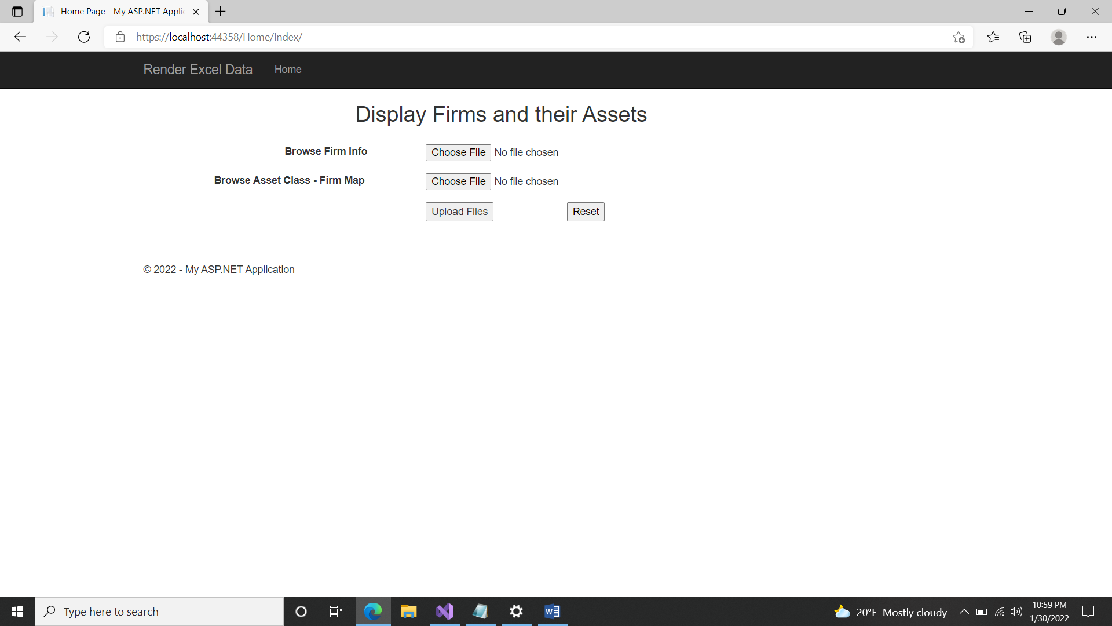

2. Browse Firm Info excel file

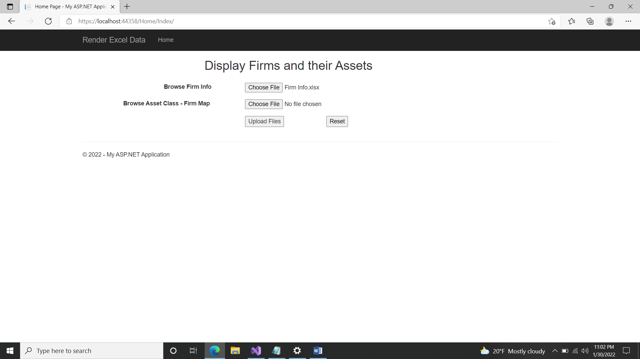

3. Browse Asset Class-Firm Map excel file

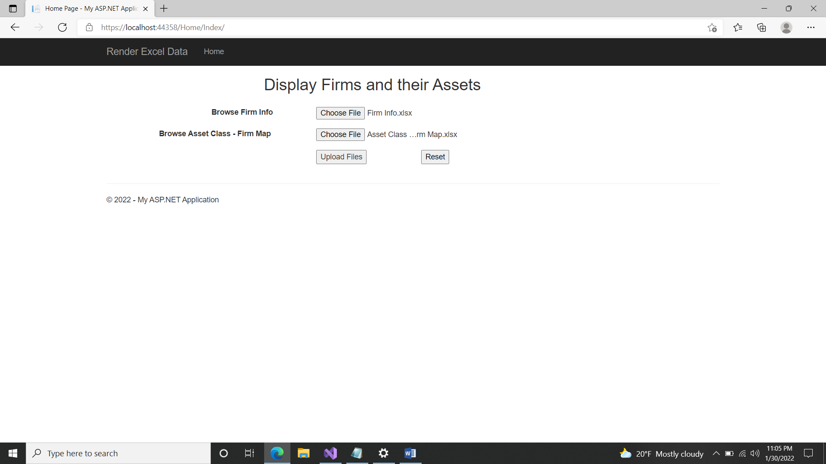

4.Click on “Upload files” button to generate data-table. This will generate data-table with row and column data. A success message with “File Uploaded Successfully!” is displayed.

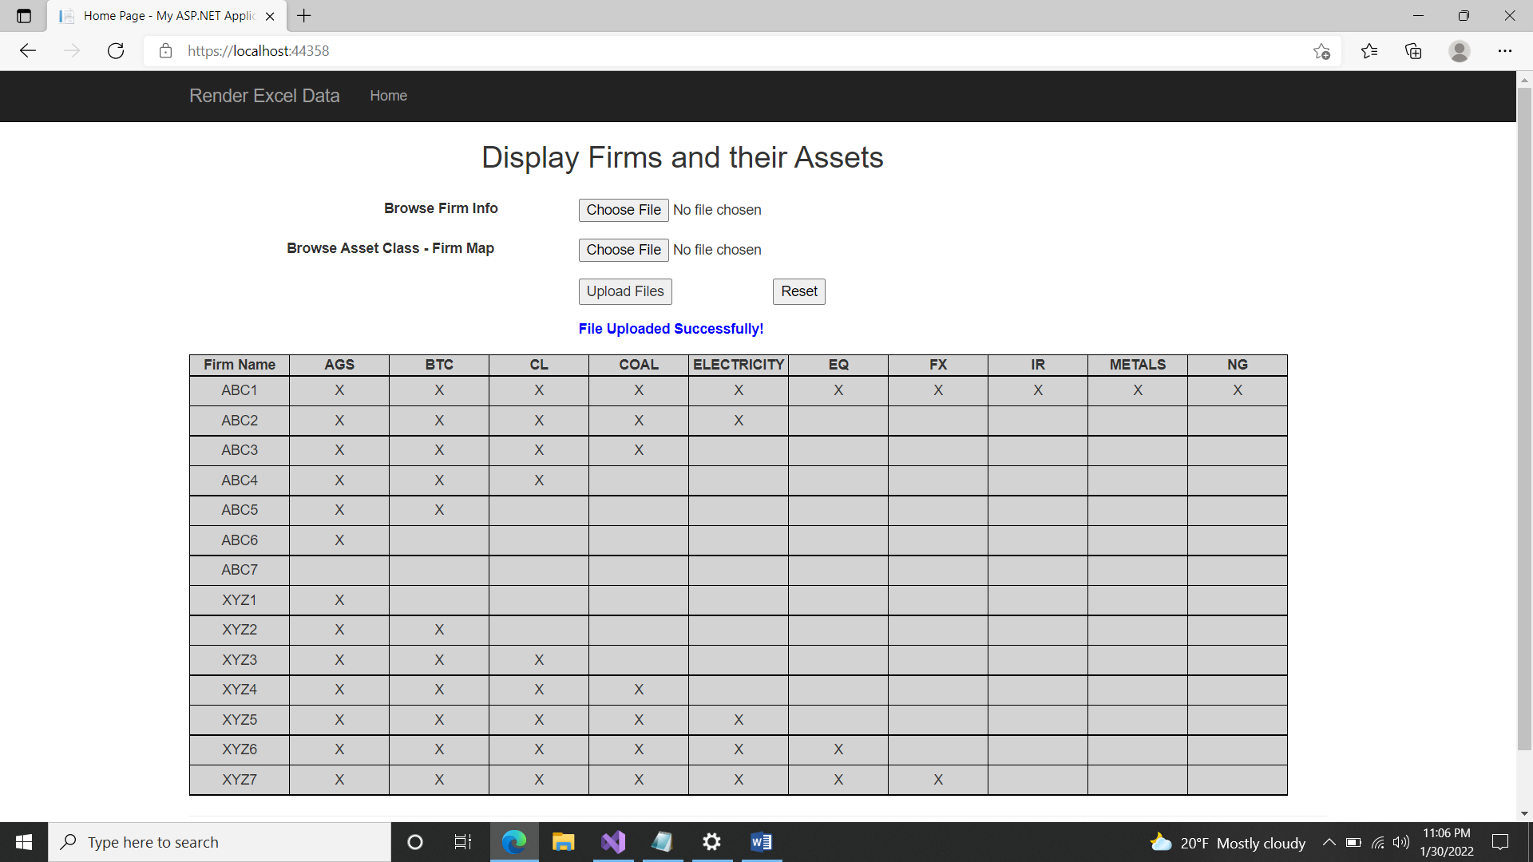

5.Click on Reset button to reset the web application.

