Interim project report on

**DEVELOPMENT OF NOVEL DIGITAL IC TESTER AND IDENTIFIER**

*Submitted to Indian School of Mines in partial   
fulfillment of the requirement for   
the award of degree of*  
**Bachelor of Technology**  
in  
**Electronics and Communication Engineering**  
by  
*Vipul Gupta (2013JE0147)*

*Yash Patidar (2013JE692)*



Department of Electronics Engineering  
  
Under the guidance of  
  
***Dr. Mukul Kumar Das (Associate Professor)***

Interim project report on

**DEVELOPMENT OF NOVEL DIGITAL IC TESTER AND IDENTIFIER**

*Submitted to Indian School of Mines in partial   
fulfillment of the requirement for   
the award of degree of*  
**Bachelor of Technology**  
in  
**Electronics and Communication Engineering**  
by  
*Vipul Gupta (2013JE0147)*

*Yash Patidar (2013JE692)*



Department of Electronics Engineering  
  
Under the guidance of  
  
***Dr. Mukul Kumar Das (Associate Professor)***

**Abstract**

The Digital IC Tester and Identifier is basically used to test Integrated Circuits (ICs). We can easily test any digital IC (74xx series) using this kind of an IC tester. Unlike other IC testers, this is more reliable and easier since we don’t need to rig up different kind of circuits for different kind of ICs, each time we need to test them. The novelty of this device is it also identifies the IC before testing and tests each gate individually and displays the result. It also comes with an Android support application, communicating with the device using Bluetooth interface, which downloads the Circuit diagram as well the truth table (datasheet). This device is suitable for application in Digital Circuit lab or basic electronics lab in any educational institute or for electronics hobbyist looking for economical IC tester.

**Acknowledgement**

I would like to express my deep gratitude to Associate Professor Dr. Mukul Kumar Das, Department of Electronics Engineering, ISM Dhanbad for granting me with an opportunity to work on the project “Digital IC Tester and Identifier” for 6th  Semester under his guidance. I would be always indebted to my project guide Assistant Professor Jaisingh Thangaraj, Department of Electronics Engineering, ISM Dhanbad whose proper guidance helped me to proceed with this project in the right direction. This progress would not be possible without his proper mentorship. Lastly, I would like to thank my family and friends for their help and support in this project.

**Table of Contents:**

1. Introduction
2. Block diagram
3. PCB layout
4. Circuit diagram
5. Hardware design and functionality
6. Usability
7. Source Code and Algorithm
8. **Introduction**

An Integrated Circuit tester (IC tester) is used to test Integrated Circuits (ICs). We can easily test any digital IC using this kind of an IC tester. For testing an IC, we need to use different hardware circuits for different ICs; like we need a particular kind of tester for testing a logic gate and another for testing flip flops or shift registers which involves more complication and time involved will also be more. So here’s an IC tester to overcome this problem. Unlike other IC testers, this is more reliable and easier since we don’t need to rig up different kind of circuits for different kind of ICs, each time we need to test them.

Unlike the IC testers available in the market today which are usually expensive, this IC tester is affordable and user-friendly and also **identifies the particular IC** before testing. This IC tester is constructed using Arduino Mega (Atmega 1286) microcontroller along with a bluetooth module and a display unit. It can test digital ICs having 14 pins (7400 series). Since it is programmable, any number of ICs can be tested within the constraint of the memory available. This IC tester can be used to test a wide variety of ICs which includes simple logic gates and also sequential and combinational ICs like flip-flops, counters, shift registers etc. It is portable and easy to use.

The block diagram of the programmable digital IC tester is as shown in the next page. It consists of Arduino Mega (Atmega 1286), 14-pin ZIF IC socket, display unit, Test and Indentify buttons,Bluetooth Module (HC-05).

To test a particular digital IC, one needs to insert the IC into the ZIF IC socket and press the “INDENTIFY” button.The IC number and name gets displayed on the LCD display unit.

Then to test individual gates,one need to press the “ TEST” button. If all the gates of the IC are fine then the green LED’s will grow and if any of the gates is damaged then the red LED’s will glow.Individual status of each gate can be seen on LCD display.

1. **Block Diagram :-**

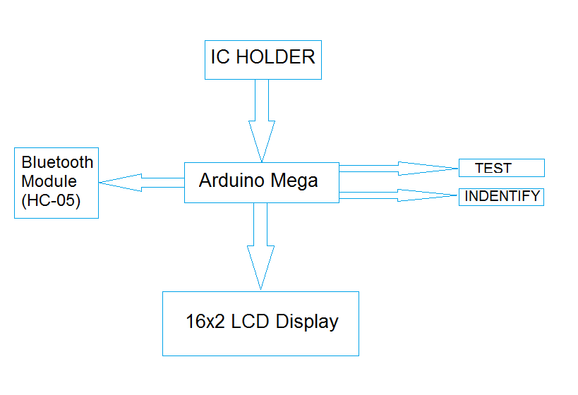

1. **PCB Layout**

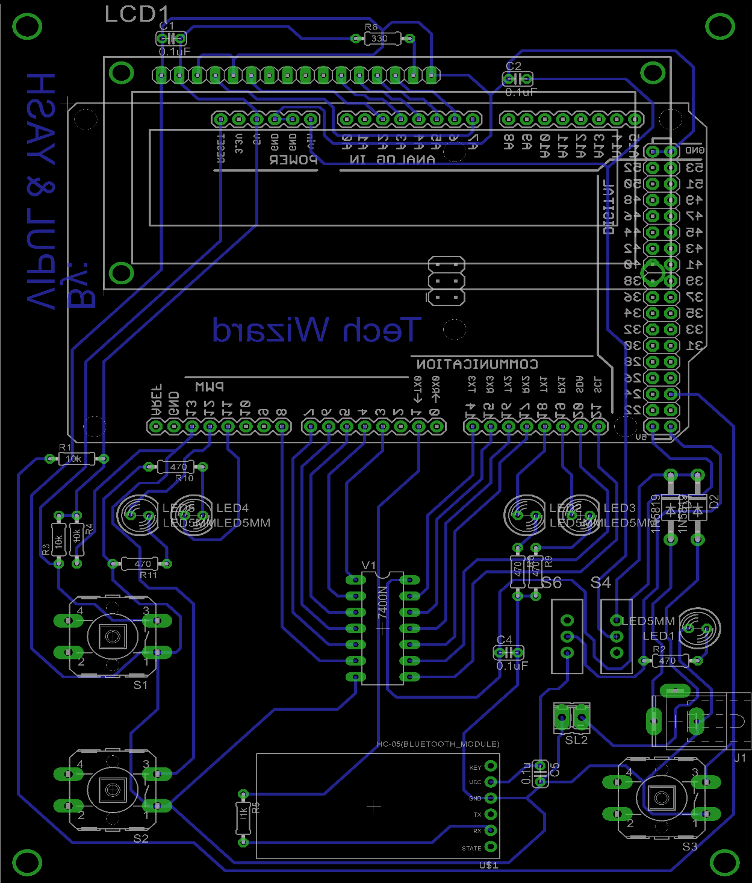

1. **Circuit Diagram**



1. **Hardware Design and functionality:**
2. **Display Unit:** To display the result and for interaction with the user an HD44780 Liquid Crystal Display is used. This is a 2 line LCD with 16 input pins.

Pin Specifications of HD44780 LCD:

• Pin 1, 2, 3: Used for controlling brightness and contrast of the LCD .

• Pin 4: Register Select (RS) RS = 0; Select command register RS = 1; Select data register.

• Pin 5: Read/ Write (R/W) R/W = 0; Write R/W = 1 ; Read

• Pin 6: Enable (E): A high to low pulse is needed at this pin for the LCD to read its inputs

• Pin 7 to Pin 14: Data lines

• Pin 15: Vcc i.e. 5V, used for glowing the backlight.

• Pin 16: Ground i.e. 0V.

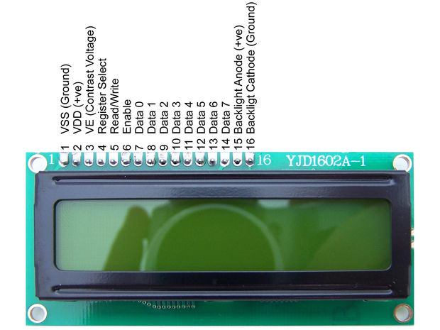

1. **Bluetooth Module (HC-05) :** To display the result on android application Bluetooth module is used.

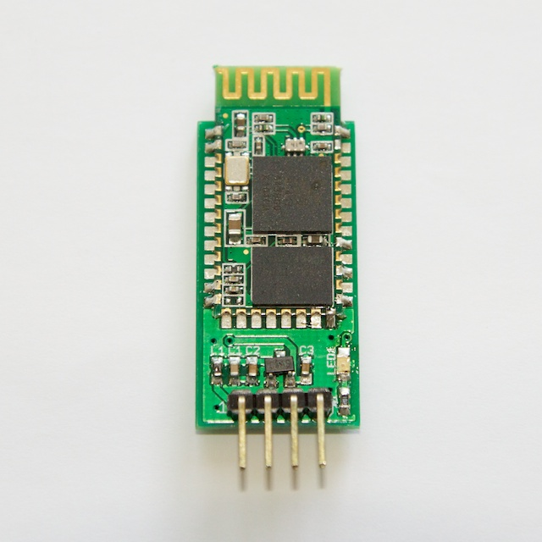

1. **Microcontroller :** The Arduino Mega is a microcontroller board based on the ATmega1280. It has 54 digital input/output pins (of which 14 can be used as PWM outputs), 16 analog inputs, 4 UARTs (hardware serial ports), a 16 MHz crystal oscillator, a USB connection, a power jack, an ICSP header, and a reset button. It contains everything needed to support the microcontroller; simply connect it to a computer with a USB cable or power it with a AC-to-DC adapter or battery to get started.

|  |  |
| --- | --- |
| Operating Voltage | 5V |
| Input Voltage (recommended) | 7-12V |
| Input Voltage (limits) | 6-20V |
| Digital I/O Pins | 54 (of which 15 provide PWM output) |
| Analog Input Pins | 16 |
| DC Current per I/O Pin | 40 mA |
| DC Current for 3.3V Pin | 50 mA |
| Flash Memory | 128 KB of which 4 KB used by bootloader |
| SRAM | 8 KB |
| EEPROM | 4 KB |
| Clock Speed | 16 MHz |

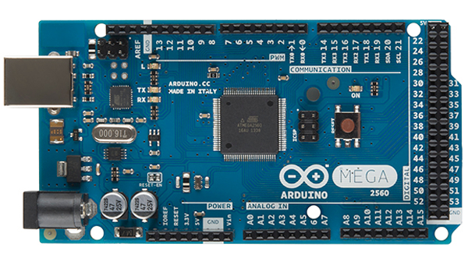

The ATmega1280 has 128 KB of flash memory for storing code (of which 4 KB is used for the bootloader), 8 KB of SRAM and 4 KB of EEPROM (which can be read and written with the [EEPROM library](http://www.arduino.cc/en/Reference/EEPROM)).

**FUTURE EXTENSIONS**

This Integrated Circuit Tester is only programmed for the ICs of 7400 series. However, this device can be easily extended for a large no. of ICs as long as memory permits. No rewiring is required. Only editing the source code accordingly will be needed.

1. **Usability**