**FULL STACK II**

**PROJECT**

**(2020-2021)**

**UV WhatsApp**

**SYNOPSIS**



**Department of Computer Engineering & Applications**

**Team Members:**

Harshita Bhardwaj (181500261)

Vipul (181500801)

Umesh Pratap Singh (181500767)

**Supervised By:**

**Mr. Pankaj Kapoor**

**Asst. Professor**

**Department of Computer Engineering &Applications**

**Introduction**

We are going to make an chat application that help us to chat with other person which is far away from us or anywhere in the corner. We can create rooms in the webapp and chat with other group members using google authentication. The chats are public and stored in google firebase database. The **UV-WhatsApp** is an webapp in which user can create rooms and chat with that webapp. In this we are using API for avatars for the room icon.

**Objective**

The main objective to build this chat application is to reduce the management of chats and easily accessible to others as there are rooms which is use for chat and also google authentication for login to webapp. To build this chat application using React.js, Firebase, HTML, CSS and JavaScript.

**Methodology**

**Expected Design**

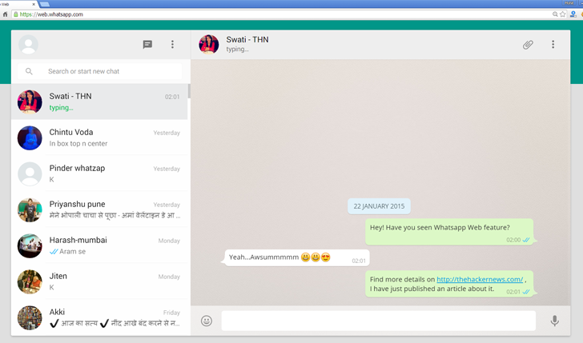

**Contributions**

**Harshita Bhardwaj**: Designing.

**Vipul**: Scripting and Designing.

**Umesh Pratap Singh**: Scripting and Designing.

**Limitations**

Chats are not private. User cannot be able use other functions except chatting and creating rooms. We are working to add others functions to be fully workable webapp.

**Repository Link**

* <https://github.com/vipulgupta22/UV_Whatsapp>

**Implementations**

1. Front-end: for front-end we are using HTML, CSS and JavaScript.
2. Back-end: for back-end we are using React.js and Google Firebase for storage.
3. API: for api we are using avatars dicebear api’s.

**Tools**

**Visual Studio Code:**

Microsoft Visual Studio is a powerful IDE that ensures quality code throughout the entire application lifecycle, from design to deployment. Whether you’re developing applications for SharePoint, the web, Windows, Windows Phone, and beyond, Visual Studio is your ultimate all-in-one solution.

**Technology**

* HTML
* CSS
* React.js
* JavaScript
* Google Firebase (storage)
* API (avatar dicebear)

**Conclusion**

Explore and Chat with other people which is anywhere in the world by creating a room.

**References**

* https://www.youtube.com/watch?v=pUxrDcITyjg&t=12419s&ab_channel=CleverProgrammer
* https://www.tortilla.academy/Urigo/WhatsApp-Clone-Tutorial/master