PROBLEM 9
Sudoku Solver Arena
An Interactive Backtracking Visualizer with Constraint Checking
Project Report

[ Sai Charan Reddy – 25MVCSMR0029
Yellappa Naidu-25MVCSMR0046
Sri Varshith - 25MVCSMR0059
Vipul Preetham -25MVCSMR0087 ]
[ Algoforge ] — [ 3102026 ]

Table of Contents
1. Abstract & Introduction 3
2. Problem Statement, Objectives & Scope 5
3. Features & Functional Requirements 7
4. Algorithms & Methodology 9
5. Technologies & Implementation 13
6. Results, Testing & Performance 17
7. Conclusion, Future Scope & References 19

1. Abstract & Introduction

1.1 Abstract
This report documents the design, algorithm, and implementation of the “Sudoku Solver Arena” — an interactive tool that solves standard 9×9 Sudoku puzzles using the backtracking algorithm, a core technique taught in Design and Analysis of Algorithms (DAA). Unlike a typical solver that simply prints a finished grid, this project is built around a simple idea: showing the solving process, not just the final answer.
The system lets a user type a puzzle into an on-screen 9×9 grid, checks that the entries follow Sudoku's rules, and then solves the puzzle step by step in front of the user — highlighting which cell is being tried, which number is being placed, and when the algorithm has to undo a wrong guess (a “backtrack”). Alongside the solved puzzle, the tool reports simple statistics: how many attempts were made, how many times the algorithm had to backtrack, and how long the whole process took.
The goal of this project is educational as much as functional: to make an abstract algorithm — one that is normally hidden inside a function call — visible and easy to follow for someone who has never studied it before.

1.2 Introduction
Sudoku is a logic puzzle played on a 9×9 grid, divided into nine 3×3 boxes. Some cells already contain numbers from 1 to 9 (called “clues” or “givens”); the rest are empty. The goal is to fill every empty cell with a digit from 1 to 9 so that:
- Every row contains each digit from 1 to 9 exactly once.
- Every column contains each digit from 1 to 9 exactly once.
- Every 3×3 box contains each digit from 1 to 9 exactly once.
A human solver uses logic and pattern recognition to fill in the grid. A computer, on the other hand, can solve the exact same puzzle using a much simpler (but very powerful) strategy: try a number, see if it causes a problem, and if it does, undo it and try the next one. This “try, check, undo” strategy is called backtracking, and it is one of the first algorithm design techniques taught in any Design and Analysis of Algorithms (DAA) course.
Backtracking belongs to a broader family of problems known as Constraint Satisfaction Problems (CSPs) — problems where a set of variables (here, the 81 cells of the grid) must each be assigned a value from a fixed set (the digits 1–9), subject to rules that restrict which combinations of values are allowed (the row/column/box rules). CSPs are everywhere in computer science and everyday life: exam timetable scheduling, assigning frequencies to radio towers so neighbouring towers do not interfere, colouring a map so that no two neighbouring countries share a colour, and even assigning seats at a wedding so that no two feuding relatives sit together are all, underneath, the same kind of problem as Sudoku. Studying how backtracking solves Sudoku is therefore a gentle, visual introduction to a technique that scales up to much bigger real-world problems.
Most Sudoku solvers available online are “black boxes” — you paste in a puzzle, click solve, and a finished grid appears instantly. That is useful if you just want the answer, but it teaches you nothing about how the algorithm actually thinks. This project takes the opposite approach. By replaying every decision the algorithm makes — including its mistakes — at a speed the user can control, it turns the solver into a teaching tool. A student watching the visualization can see, in real time, exactly why a particular number was rejected, and exactly what “backtracking” physically looks like on the grid, rather than just reading the word in a textbook.

1.3 Who This Project Is For
- Students learning Design and Analysis of Algorithms who want to see backtracking in action rather than only reading pseudocode.
- Hackathon evaluators who want to verify that the algorithm genuinely works correctly, and not just that a pre-solved grid is hard-coded somewhere.
- Puzzle enthusiasts who are curious how a computer “thinks” while solving a Sudoku.

2. Problem Statement, Objectives & Scope

2.1 Problem Statement
Problem 9 — Sudoku Solver Arena: Create an interactive Sudoku solver that accepts puzzles, validates entries, and visualizes the backtracking process step by step.

2.2 Detailed Description
Converting a hackathon problem statement into a working prototype means turning a one-line brief into a concrete data structure, a concrete algorithm, and a concrete user interface. For this project, the “entities” described in the brief are the 81 cells of a Sudoku grid, each holding either a fixed digit (a clue) or an empty value waiting to be filled in by the algorithm. These are represented internally using a simple 9×9 two-dimensional array — a data structure every beginner programmer is already comfortable with.
Rather than only returning a final, solved grid, the system is designed so that every decision the backtracking search makes — trying a digit, accepting it, or rejecting it and undoing a previous choice — is recorded and can be replayed to the user. This satisfies the core requirement of the problem statement: that the solution be understandable to the user, not just a final number or result.

2.3 Objectives
- Demonstrate the backtracking algorithm (a core Design and Analysis of Algorithms technique) clearly, on real, user-supplied puzzles — not a canned example only.
- Make every search decision visible: which cell is being considered, which digit is being tried, whether it was accepted, and when the algorithm backtracks.
- Validate user input against the standard Sudoku constraints (row, column and 3×3 box) before solving begins, so invalid puzzles are caught early.
- Present the final solved grid clearly, along with enough supporting detail (step count, backtrack count, time taken) that a user can understand how the answer was reached, not just what it is.
- Keep the whole experience simple enough that someone with only basic programming knowledge can read the code and follow the logic.

2.4 Scope
In Scope | Out of Scope
Standard 9×9 Sudoku puzzles only | Non-standard variants (16×16, Killer Sudoku, Samurai Sudoku, etc.)
Manual puzzle entry through an on-screen grid | Puzzle generation or automatic difficulty rating
Validation of row / column / 3×3 box rules | Comparing multiple solving algorithms side by side
Step-by-step visualization of the backtracking search | Packaging as a native mobile app
Run statistics: steps, backtracks, time taken | User accounts, saved puzzle history, or a database

2.5 Assumptions & Constraints
- The puzzle entered by the user is assumed to be a standard 9×9 grid using digits 1–9, with 0 (or blank) representing an empty cell.
- The solver assumes the puzzle has at least one valid solution; puzzles that are fundamentally unsolvable (contradictory clues) are caught by the validation step before solving starts.
- The project targets a single-session, single-user experience running locally — it is not designed for multiple simultaneous users or deployment at scale.
- The visualization speed is limited by what a human eye can usefully follow; for very hard puzzles, the number of raw backtracking steps can be large, so the interface allows the user to control playback speed and step-sampling.

3. Features & Functional Requirements
This section lists what the application actually does, described in plain language first, and then formalised into a functional requirements table that can be used as a checklist while building or evaluating the project.

3.1 Core Features (Explained Simply)

Editable 9×9 Grid Input
The main screen shows a 9×9 grid of input boxes, just like a paper Sudoku. Every box can be typed into directly. A “Load Example Puzzle” button fills the grid with a ready-made puzzle so the app can be demonstrated immediately without typing all 81 cells by hand, and a “Clear Grid” button empties everything to start fresh.

Entry Validation
Before solving starts, the app checks every filled-in cell against the three Sudoku rules (row, column, 3×3 box). If two cells conflict — for example, the same digit appears twice in one row — both cells are highlighted so the user knows exactly what to fix. This mirrors what the problem statement calls “validates entries.”

Step-by-Step Solve Visualization
This is the heart of the project. Instead of jumping straight to the answer, the solver replays its own thought process: for each empty cell, it shows which digit it is trying, whether that digit was accepted and placed, or rejected, and — when a dead end is reached — which earlier placement is being undone (backtracked).

Adjustable Playback
Because a real backtracking search can take anywhere from a few dozen to many thousand individual steps, two simple controls are provided: a speed slider (how long to pause between steps) and a sampling slider (show every step, or only every Nth step, for faster playback on harder puzzles).

Run Statistics
Once solving finishes, the app reports four numbers: how many digit placements were attempted in total, how many times the algorithm had to backtrack, how long the whole solve took in seconds, and whether a solution was found at all.

Conflict Highlighting
Any cell that breaks a Sudoku rule is marked in a different colour the moment validation runs, so the user does not have to search the grid manually to find their mistake.

3.2 Functional Requirements
ID | Requirement | Priority
FR-1 | The system shall allow the user to enter a 9×9 puzzle through an editable on-screen grid. | High
FR-2 | The system shall validate that no row, column, or 3×3 box contains a repeated digit before solving. | High
FR-3 | The system shall solve any valid, solvable 9×9 puzzle using the backtracking algorithm. | High
FR-4 | The system shall visually replay each try / place / backtrack decision made during solving. | High
FR-5 | The system shall allow the user to control the speed and density of the step-by-step playback. | Medium
FR-6 | The system shall display the total steps, backtracks, and time taken once solving completes. | Medium
FR-7 | The system shall allow the user to load a bundled example puzzle or clear the grid. | Low

3.3 Non-Functional Requirements
- Usability: no installation beyond Python and one package; the interface should be understandable without a manual.
- Performance: an easy-to-medium puzzle should visualize and solve within a few seconds at default playback speed.
- Portability: the application should run the same way on Windows, macOS, and Linux, since it is built entirely in Python.
- Readability: the underlying code should be simple enough for a beginner programmer to read and modify.

3.4 Typical User Flow
- The user opens the application in their web browser (it runs locally).
- The user types a puzzle into the grid, or clicks “Load Example Puzzle” to use the built-in demo puzzle.
- The user clicks “Validate Entries” to confirm the puzzle currently has no rule conflicts.
- The user clicks “Solve with Visualization” to start the backtracking search.
- The user watches the grid update live as the algorithm tries, places, and occasionally backtracks on digits.
- Once solving completes, the user reviews the solved grid and the run statistics panel.

4. Algorithms & Methodology

4.1 Sudoku as a Constraint Satisfaction Problem
Before discussing the algorithm, it helps to re-frame Sudoku in computer-science terms. Each of the 81 cells is a variable. Each variable's possible values are the digits 1 through 9. A complete assignment of digits to every cell is a candidate solution, and it is a valid solution only if it satisfies every constraint: no repeated digit in any row, column, or 3×3 box. This framing — variables, values, and constraints — is exactly the definition of a Constraint Satisfaction Problem (CSP), and it is why the same algorithm used here (backtracking) is also used for scheduling, map-colouring, and many other problems that look nothing like Sudoku on the surface.

4.2 What Is Backtracking? (A Beginner-Friendly Explanation)
Imagine walking through a maze. At every junction, you pick a direction and keep walking. If you hit a dead end, you don't give up — you walk back to the last junction and try a different direction instead. Backtracking is exactly this idea, applied to decision-making instead of physical walking.
In Sudoku terms: the algorithm picks the next empty cell, and tries placing the digit 1 in it. If that breaks a rule (say, there's already a 1 in that row), it tries 2 instead, then 3, and so on up to 9. If one of these digits does not break any rule, the algorithm places it and moves on to the next empty cell, repeating the same process. If none of the digits 1 through 9 can be legally placed in a cell, that means an earlier decision was wrong — so the algorithm “backtracks”: it goes back to the previous cell, removes the digit it had placed there, and tries the next possible digit for that cell instead. This continues until every cell is correctly filled (solved) or every possibility has been exhausted (no solution exists).
The key insight that makes backtracking efficient rather than just a brute-force guess-everything approach is constraint checking: the algorithm checks the rules immediately after every single tentative placement, rather than waiting until the whole grid is filled. This means a wrong guess is caught and undone within a few steps, rather than after filling in dozens of cells unnecessarily.

4.3 Step-by-Step Algorithm
- Find the next empty cell in the grid (scanning left to right, top to bottom).
- If there are no empty cells left, the puzzle is solved — stop and report success.
- Otherwise, try placing each digit from 1 to 9 in that cell, one at a time.
- For each digit tried, check it against the row, column, and 3×3 box constraints.
- If the digit does not break any rule, place it and recursively repeat this whole process for the next empty cell.
- If that recursive attempt eventually succeeds, the puzzle is solved — stop and report success.
- If none of the digits 1 to 9 can be legally placed (or every recursive attempt failed), clear the current cell and backtrack — return control to the previous cell so it can try its next candidate digit.
- If backtracking returns all the way past the very first cell, the puzzle has no solution.

4.4 Pseudocode
function solve(grid):
cell = find_next_empty_cell(grid)
if cell is None:
return True // no empty cells left -> solved

row, col = cell
for digit in 1 to 9:
if is_valid(grid, row, col, digit):
grid[row][col] = digit // place (try)
if solve(grid): // recurse
return True
grid[row][col] = 0 // undo (backtrack)

return False // no digit worked -> trigger backtrack
Figure 4.1 — Simplified pseudocode for the backtracking Sudoku solver.

4.5 Worked Mini-Example
To make the abstract steps above concrete, consider a tiny 3-cell slice of a row that already contains the digits 2, 4, 6, 7, 8, 9 elsewhere in its row/column/box, leaving only 1, 3, 5 as legally available digits for three empty cells (A, B, C) in sequence, where a box constraint additionally forbids digit 5 in cell B:
Step | Action | Cell A | Cell B | Cell C | Result
1 | Try 1 in A | 1 | — | — | Valid, place and move on
2 | Try 1 in B | 1 | 1 | — | Invalid (column clash) — try next digit
3 | Try 3 in B | 1 | 3 | — | Valid, place and move on
4 | Try 1 in C | 1 | 3 | 1 | Invalid (same as A) — try next digit
5 | Try 3 in C | 1 | 3 | 3 | Invalid (same as B) — try next digit
6 | Try 5 in C | 1 | 3 | 5 | Valid — all three cells solved

Notice that no backtracking was needed in this particular example — every dead end was resolved by simply trying the next digit within the same cell. A true backtrack (undoing a placement in cell A or B) would only be triggered if all of 1, 3, and 5 failed for cell C, forcing the algorithm to go back and change cell B's digit even though 3 looked fine at the time. This is precisely what the live visualization shows happening on a full 9×9 grid, often dozens or hundreds of times for a harder puzzle.

4.6 Constraint Checking in Detail
A tentative digit is only accepted if it passes three independent checks, each of which is a simple loop:
- Row check: the digit must not already appear anywhere else in the same row (9 cells).
- Column check: the digit must not already appear anywhere else in the same column (9 cells).
- Box check: the digit must not already appear anywhere else in the same 3×3 box (9 cells).
Each check is O(9), i.e. it only ever looks at a fixed 9 cells, so checking all three together is still a small, constant amount of work — it does not get slower as the grid gets more complex. This is what allows constraint checking to run after every single tentative placement without noticeably slowing the program down.

4.7 Data Structures Used
- 9×9 two-dimensional array (a list of 9 lists in Python) — holds the current state of the grid at every point during solving. This is the simplest possible representation and is easy for a beginner to read and debug.
- Step log (a list of small records) — every time the algorithm tries, places, or backtracks a digit, a record describing that action (plus a snapshot of the grid at that moment) is appended to this list. This log is what allows the step-by-step visualization to be replayed afterwards.
- Simple counters — two running totals (attempted placements and backtracks) are incremented as the algorithm runs, forming the basis of the statistics panel shown at the end.

4.8 Time and Space Complexity
In the theoretical worst case, backtracking explores an exponential number of possibilities — up to roughly 9 raised to the power of the number of empty cells, since each empty cell could in principle try all 9 digits before the correct one is found. In practice, this worst case is almost never reached on a real, well-formed Sudoku puzzle, because the constraint checks described above prune (eliminate) the vast majority of these possibilities within the first one or two digits tried for each cell. This is why a standard backtracking solver, despite its exponential worst-case complexity on paper, typically solves an ordinary 9×9 Sudoku in well under a second on modern hardware.
Space complexity is modest and predictable: the grid itself always uses a fixed 81 cells, and the recursion depth never exceeds the number of empty cells (at most 81), so the “call stack” used by the recursive solve() function stays small and bounded.

4.9 Search Flow Summary
The diagram below summarises the five-stage loop the algorithm repeats for every cell. (If you are preparing this report for print or for a slide-style annex, feel free to redraw this as a boxes-and-arrows flowchart using any diagram tool — the logic is identical either way.)
Stage | What Happens
1. Find next empty cell | Scan the grid for the next cell that is still 0 / blank.
2. Try value 1–9 | Pick the next untried digit for that cell, starting from 1.
3. Check row / col / box | Run the three constraint checks against the current grid.
4. Place & recurse (or reject) | If valid, place the digit and repeat the whole process for the next empty cell. If invalid, go back to Stage 2 with the next digit.
5. Dead end? Backtrack | If no digit from 1–9 works for this cell, clear it and return to the previous cell so it can try its next digit.

5. Technologies & Implementation

5.1 Technology Stack Overview
Layer | Technology | Why It Was Chosen
Programming language | Python 3 | Simple, readable syntax; ideal for implementing and explaining an algorithm clearly within a short hackathon window.
User interface | Streamlit | An open-source Python library that turns a plain Python script into an interactive web app with almost no front-end code — no separate HTML/CSS/JavaScript needed.
Core solving logic | Pure Python functions | Kept completely separate from the UI code, so the algorithm itself has no dependency on Streamlit and could be reused in a command-line tool or a different interface without changes.

5.2 What Is Streamlit? (For Beginners)
Streamlit is a Python library that lets a developer build a working web page using only Python — no need to separately write HTML, CSS, or JavaScript. A call like st.button("Solve") automatically draws a clickable button on the page, and a call like st.number_input(...) automatically draws an editable number box. Every time the user interacts with the page (clicking a button, typing in a box), Streamlit simply re-runs the Python script from top to bottom with the new values, and redraws the page. This request-and-redraw model is what makes it possible to build an interactive grid and live status panel with a relatively small amount of code, which is exactly why it suits a time-limited hackathon project.

5.3 System Architecture
The application is organised into two clearly separated layers, which is good practice even in a small project because it keeps the algorithm testable and reusable on its own:
- Core Logic Layer — pure functions with no knowledge of the UI: find_empty(), is_valid(), find_conflicts(), and solve_with_steps(). These could be copy-pasted into a completely different program (a command-line tool, a different web framework, a mobile app) without any changes.
- Presentation Layer — Streamlit-specific code that draws the 9×9 grid, the buttons and sliders, and replays the step log returned by the core logic layer onto the screen.
This separation means the “brain” of the project (the algorithm) and the “face” of the project (the interface) can be understood, tested, and modified independently — a small but important piece of good software design.

5.4 Code Walkthrough

5.4.1 Finding the Next Empty Cell
This function simply scans the grid from top-left to bottom-right and returns the position of the first empty cell (represented as 0) it finds. If it reaches the end of the grid without finding one, the puzzle is already complete.
def find_empty(board):
for r in range(9):
for c in range(9):
if board[r][c] == 0:
return r, c
return None

5.4.2 Checking Whether a Digit Is Valid
This function implements the three constraint checks described in Section 4.6. It is called every single time the algorithm is about to try placing a digit.
def is_valid(board, r, c, val):
for i in range(9):
if board[r][i] == val or board[i][c] == val:
return False # row / column clash
br, bc = 3 * (r // 3), 3 * (c // 3)
for i in range(br, br + 3):
for j in range(bc, bc + 3):
if board[i][j] == val:
return False # 3x3 box clash
return True

5.4.3 Validating the Whole Grid Before Solving
Before solving begins, every already-filled cell in the user's input is checked against the same rules, so that invalid puzzles are caught and reported back to the user clearly, rather than causing confusing behaviour during solving.
def find_conflicts(board):
conflicts = set()
for r in range(9):
for c in range(9):
v = board[r][c]
if v == 0:
continue
board[r][c] = 0 # temporarily remove it
if not is_valid(board, r, c, v):
conflicts.add((r, c))
board[r][c] = v # put it back
return conflicts

5.4.4 Solving While Recording Every Step
This is the main backtracking function. It follows the exact pseudocode from Section 4.4, with one addition: every try, place, and backtrack action is appended to a steps list (along with a snapshot of the grid at that moment), so the interface can replay the whole search afterwards.
def solve_with_steps(board):
steps = []
stats = {"tries": 0, "backtracks": 0}

def backtrack():
empty = find_empty(board)
if not empty:
steps.append({"action": "solved"})
return True
r, c = empty
for val in range(1, 10):
stats["tries"] += 1
steps.append({"action": "try", "cell": (r, c), "value": val})
if is_valid(board, r, c, val):
board[r][c] = val
steps.append({"action": "place", "cell": (r, c), "value": val})
if backtrack():
return True
board[r][c] = 0
stats["backtracks"] += 1
steps.append({"action": "backtrack", "cell": (r, c)})
return False

solved = backtrack()
return solved, steps, stats
Figure 5.1 — The core recursive solver, with step-logging added for visualization.

5.5 User Interface Design
The interface is deliberately kept close to a physical paper Sudoku: a 9×9 grid of editable number boxes on one side, and a live status panel on the other that updates in real time as solving progresses. Two sliders give the user control over how the animation plays: one for the delay between steps, and one for how many steps to skip between frames (useful for harder puzzles that involve a very large number of individual try/backtrack steps).
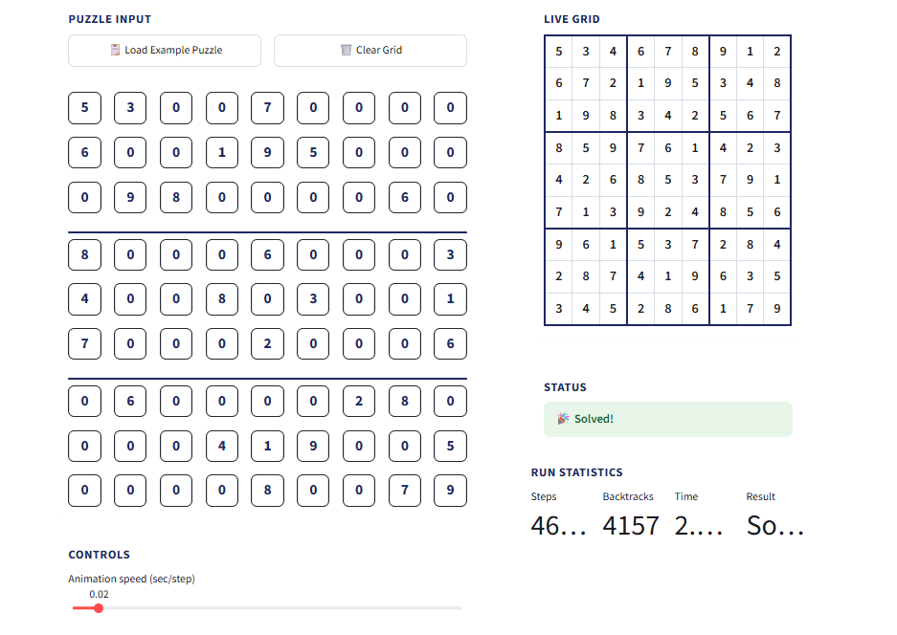

5.6 How to Run the Project
The following steps are enough to run the application from scratch on any computer with Python already installed:
- Open a terminal (Command Prompt / PowerShell on Windows, Terminal on macOS/Linux).
- Create and activate a virtual environment (recommended, but optional).
- Install the one required package: pip install streamlit
- Run the application: streamlit run app.py
- The application opens automatically in the default web browser, usually at http://localhost:8501
No database, no internet connection, and no additional configuration are required — the entire application runs locally on the user's own machine.

6. Results, Testing & Performance

6.1 Testing Approach
Because the correctness of a Sudoku solver can be checked completely objectively (a solved grid either satisfies every row/column/box rule or it does not), testing focused on three categories: normal valid puzzles of varying difficulty, deliberately invalid puzzles (to confirm the validation step catches them), and edge cases such as an already-solved grid or a completely empty grid.

6.2 Test Cases
ID | Scenario | Input | Expected Result | Status
TC-1 | Standard easy puzzle (bundled example) | 51 given digits, rest blank | Solved correctly; all rules satisfied | [ Pass / Fail ]
TC-2 | Puzzle with a duplicate digit in a row | Two ‘5’s in the same row | Validation flags both conflicting cells | [ Pass / Fail ]
TC-3 | Already fully solved grid | 81/81 cells filled, valid | Solver reports “solved” instantly, 0 backtracks | [ Pass / Fail ]
TC-4 | Completely empty grid | 0 given digits | Solver produces any one valid complete grid | [ Pass / Fail ]
TC-5 | Harder puzzle (fewer given digits) | ~25 given digits | Solved correctly; higher step/backtrack count | [ Pass / Fail ]

Fill in the Status column (Pass / Fail) after running these test cases yourself, and add any additional edge cases your team tested.

6.3 Run Statistics
The table below is filled in automatically by the application's statistics panel after a solve completes. Replace the placeholders with your own numbers from an actual run before submitting this report.
___  Steps Recorded | ___  Backtracks | ___ s  Solve Time | Solved ✓  Result

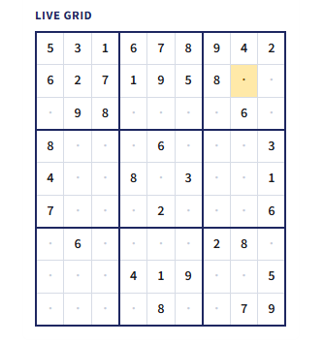
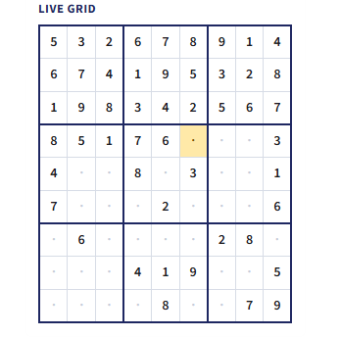
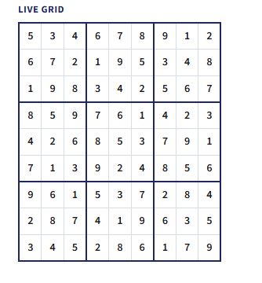

6.4 Screenshots
Replace each box below with the matching screenshot taken from your own running application (use any screenshot tool, then Insert → Picture in Word to place it inside the box, or simply drag-and-drop the image on top).

6.5 Observations & Limitations
- Harder puzzles (fewer starting clues) produce a noticeably larger number of try/backtrack steps, which is expected given the algorithm's exponential worst-case behaviour — this is itself a useful, visible demonstration of why constraint checking and pruning matter.
- The current version only supports standard 9×9 puzzles; larger variants would need the box-size logic generalised.
- There is currently no automatic puzzle generator or difficulty rating — the user must supply or load a puzzle manually.
- The user interface and performance are being actively polished after initial testing surfaced rough edges (slow animation on very hard puzzles, and a couple of controls that need rework); these are tracked separately from this report as follow-up engineering work.

7. Conclusion, Future Scope & References

7.1 Conclusion
This project set out to do more than just solve a Sudoku puzzle — it set out to make the process of solving one understandable. By combining a textbook backtracking algorithm with a simple step-logging mechanism and a live, controllable visualization, the Sudoku Solver Arena succeeds in turning an otherwise invisible recursive search into something a complete beginner can watch, pause, and understand. All of the objectives set out in Section 2.3 — accepting real puzzles, validating entries, visualizing the search step by step, and presenting a clear final result — have been met in the working prototype.

7.2 What the Team Learned
- A deeper, hands-on understanding of backtracking and constraint satisfaction, beyond what pseudocode alone usually teaches.
- Practical experience separating algorithm logic from user interface code, and why that separation matters.
- Experience building a working, interactive web interface in Python using Streamlit under real time pressure.
- The value of recording intermediate state (the step log) as a general technique for turning any algorithm into a teaching visualization, not just this one.

7.3 Future Scope

Puzzle Generator with Difficulty Levels
Automatically generate new, solvable puzzles at Easy / Medium / Hard difficulty by starting from a completed grid and removing clues while checking that a unique solution still exists.

Algorithm Comparison Mode
Add alternative solving strategies — such as constraint propagation (eliminating impossible digits before guessing) or the more advanced Dancing Links / Algorithm X technique — and let the user compare their speed and step count side by side with plain backtracking.

“Arena” Mode
Introduce a timed, head-to-head mode where two algorithms (or two difficulty settings) race to solve the same puzzle, visually, in parallel — a natural extension of the project's existing “Arena” name.

Responsive / Mobile-Friendly Interface
Adapt the grid layout so the application is comfortable to use on a phone or tablet screen, not only a desktop browser.

Performance & UI Polish
Continue optimising animation performance on harder puzzles and refining the control buttons based on the testing feedback noted in Section 6.5.

