- Dependencies :

To run PlanetSasha you need a working installation for :
- grass-6.5.svn
- ossim svn (ossim-executable, ossimplanetQt)
- python (numpy, scipy, psycopg2, pysqlite, pyserial, pyqt)

- Download the PlanetSasha source code from the svn repository :

- svn co http://svn.osgeo.org/ossim/trunk/gsoc/PlanetSasha PlanetSasha

- copy the grass scripts :

- ossim/gsoc/PlanetSasha/grass_script/d.png.legend
- ossim/gsoc/PlanetSasha/grass_script/ogrTovrt.py
- ossim/gsoc/PlanetSasha/grass_script/r.planet.py
- gsoc/PlanetSasha/grass_script/v.planet.py

in the grass scripts directory
(usually it is : /usr/local/grass-6.5.svn/scripts/)

- Start Grass
- As test-case start grass and use the spearfish location avaiable here [1])
[1] : http://grass.itc.it/sampledata/spearfish_grass60data-0.3.tar.gz

- Start PlanetSasha :

- from the grass shell, type :
python2.6 /path/to/PlanetSasha/PlanetSasha.py &

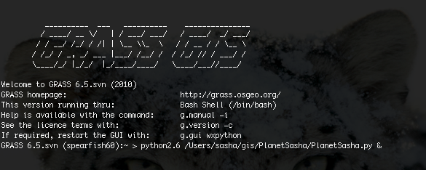

- this will open the PlanetSasha main gui:

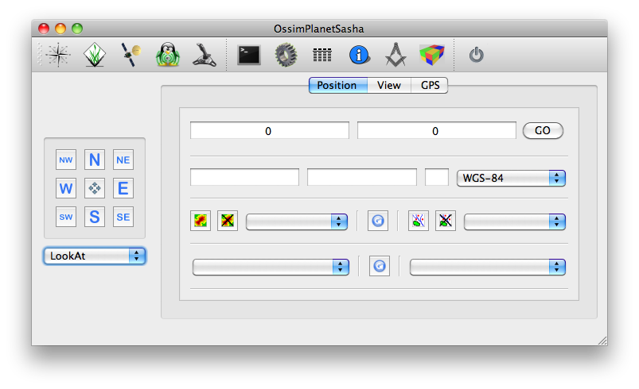

- Configure PlanetSasha :

- on the top, in the menu-bar, select the preference menu

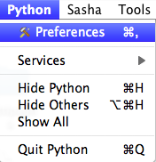

- set-up the needed files/path (*) :
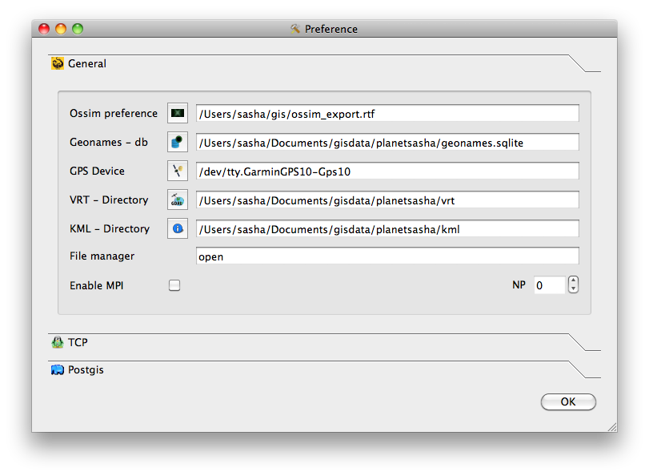
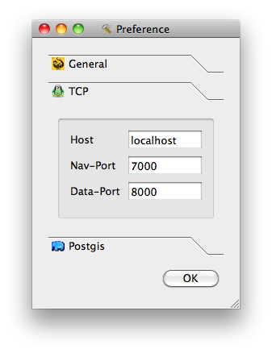

- Set up OssimPlanetQt TCP listner :
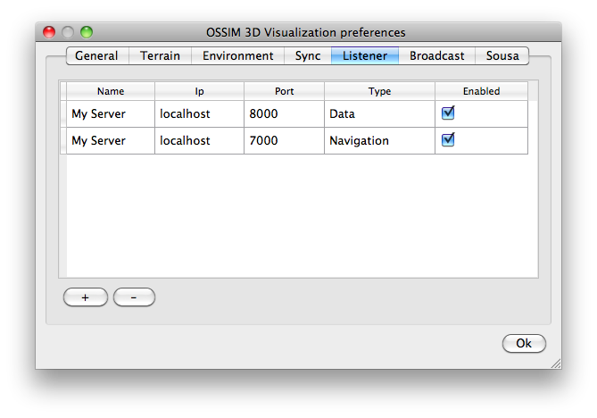

- First usage :

- From the PlanetSasha main window
– check the "grass icon" (1) on the toolbar (it will sincronize the pan-toolbox with the active grass region)
– Press the refresh button (3) to refresh the list of available layers in the active
mapset
Press the refresh button (4) to refresh the data from the spatialite db
– Click on the "recenter button" (2) to center the ossimplanet camera to the grass region.

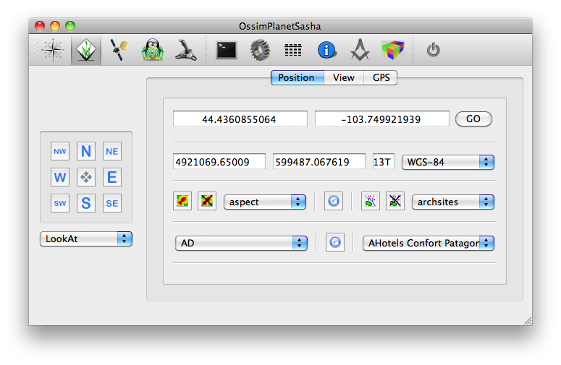
1
2
3
4

