1. What is software? What is software engineering?

* Software is a set of instructions, written in computer code , that tells a computer how to behave or how to perform a specific task.
* The term **software engineering** is the product of two words, **software**, and **engineering.**
* The **software** is a collection of integrated programs.
* **Engineering** is the application of **scientific** and **practical** knowledge to **invent, design, build, maintain**, and **improve frameworks, processes, etc**.

1. Explain types of software.

* **Application Software:-** It can be defined as end-user programs that help you perform tasks or achieve a desired outcome. The end-user is the person who is actually using a product or program. For Example a photo-editing software like Adobe or Lightroom, or a word processing application like Microsoft Word
* **System Software** :- System software helps the user, the computer or mobile device, and an application all work together seamlessly. software is always running in the background of your device, but it is never something you will use directly For Example:- Apple’s iOS & Microsoft Windows.
* **Programming Software**:- Programming software is for computer programmers and developers who are writing code. These are programs that are used to write, develop, test, and debug other software programs. they take programming languages like Laravel, Python, C++, and more and translate them into something a computer or phone will understand.

1. What is SDLC? Explain each phase of SDLC.

* Software Development Life Cycle (SDLC) is a process followed for a software project consists of a detailed plan describing how to develop, maintain, replace and alter or enhance specific software.
* Phases Of SDLC.
* Requirement:- During this phase, all the relevant information is collected from the customer to develop a product as per their expectation.

Once the requirement is clearly understood, the SRS (Software Requirement Specification) document is created.

* Analysis:- After preparation of SRS analysis made by developers for making proper architecture as per requirement.

Language Selection :-As per Architecutre language selection is made by FEND(front end developer) & BEND(Back end developer)

**Flow chart:-Graphical interfaces also used for better understanding & presentation of data.**

* **Design:-** The next phase is about to bring down all the knowledge of requirements, analysis, and design of the software project. This phase is the product of the last two, like inputs from the customer and requirement gathering.Its mainly done by software like FIGMA,PHOTOSHOP.
* **Implementaion :-** Coding starts once the developer gets the Design document. The Software design is translated into source code. All the components of the software are implemented in this phase.
* **Testing:-** Testing starts once the coding is complete and the modules are released for testing. In this phase, the developed software is tested thoroughly and any defects found are assigned to developers to get them fixed. Retesting is done until the point at which the software is as per the customer’s expectation.
* **Deployment:-** Once the product is tested, it is deployed in the production environment or first [UAT (User Acceptance testing)](https://www.softwaretestinghelp.com/what-is-user-acceptance-testing-uat/) is done depending on the customer expectation.
* **Maintenance:-** After the deployment of a product if any issue comes up and needs to be fixed or any enhancement is to be done is taken care by the developers.
* Some types of maintenance
  1. **Corrective Maintenance:-Repairing A defect**
  2. **Perfective Maintenance :-For Adding New Features**
  3. **Adaptive Maintenance :-For transforming one environment to other**

1. What is DFD? Create a DFD diagram on Flipkart.

* A data-flow diagram is a way of representing a flow of data through a process or a system. The DFD also provides information about the outputs and inputs of each entity and the process itself. A data-flow diagram has no control flow — there are no decision rules and no loops
* DFD diagram on flipkart shown below.

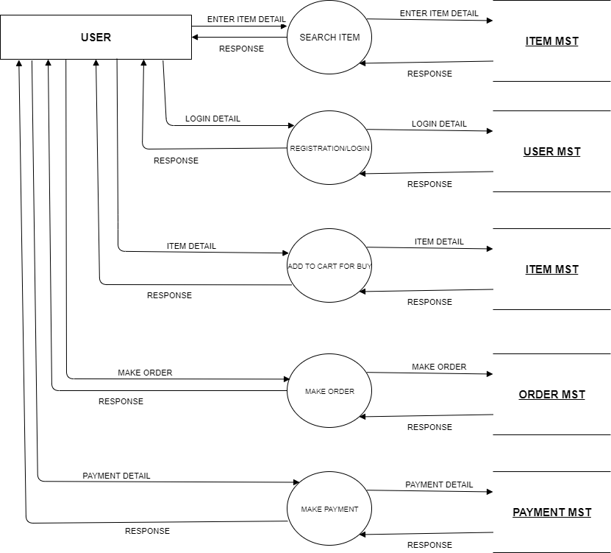

1. **What is Flow chart? Create a flowchart to make addition of two numbers.**

* Flowcharts are visual diagrams that use symbols to outline the separate steps of a process in sequential order.
* Flowchart for Addition of two number shown below

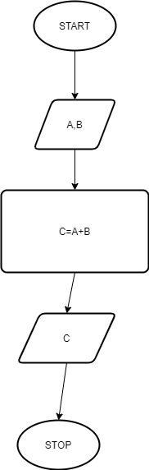

1. **What is Use case Diagram? Create a use-case on bill payment on paytm.**

* A use case diagram is a behaviour diagram and visualizes the observable interactions between actors and the system under development.
* Use case diagram of bill payment on paytm shown below.

