Docker
- docker ps -a
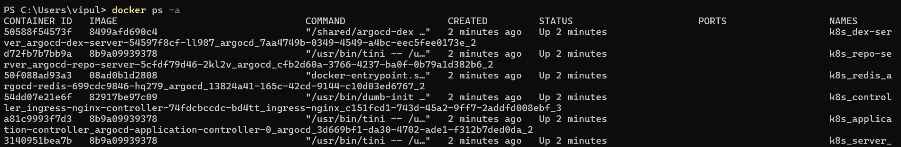
- docker container run hello-world
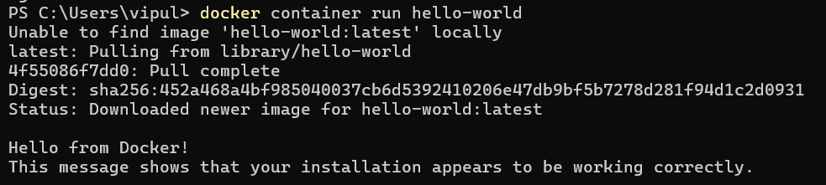
- docker image pull alpine
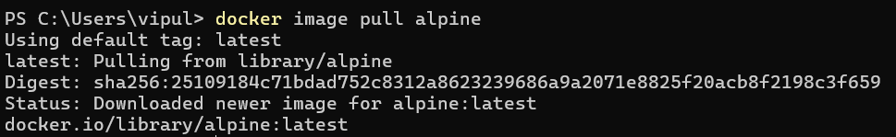
- docker image ls
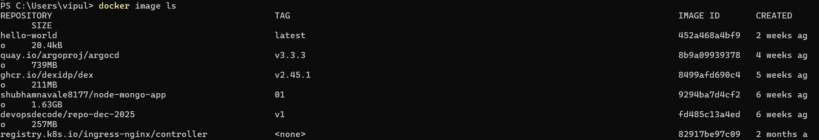
- docker container run alpine ls -l
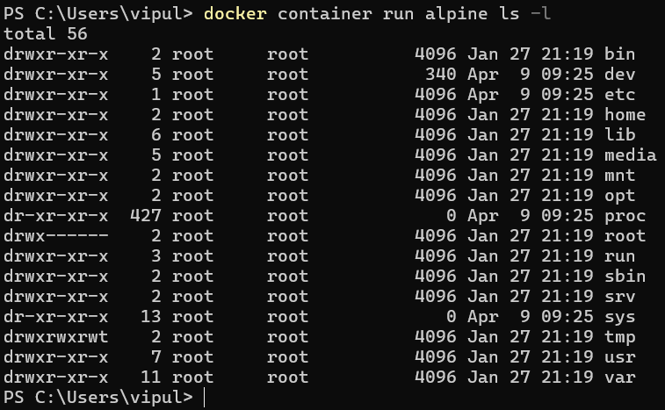
- docker node ls
- docker network ls
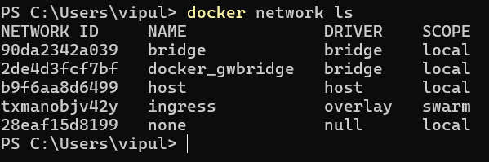
- docker network inspect bridge
