

Faculty of Technology, Department of Computer Engineering

B. Tech. Semester VI

Subject : Software Development Project
Project Title: Hasky Spot

By: Vyas Vipul(17CEUBG009)(CE145)

Guided By: Prof. Ankit P. Vaishnav

Faculty of Technology, Department of Computer Engineering

This is to certify that Advanced Technologies Project entitled “Hasky Spot” is the bonafied report of work carried out by
Vipul Vyas (17CEUBG009)
Of Department of Computer Engineering ,Semester VI , academic year 2020-2021, under our supervision and guidance.

Guid HOD

Prof. Ankit P.Vaishnav  Assistant Professor of Department of Computer Engineering, Dharmsinh  Desai University, Nadiad |  | Dr. C. K. Bhensdadia  Head of Department of Computer Engineering, Dharmsinh Desai  University, Nadiad

Table Of Contant

- Abstract
- Introduction
            - Brief Introduction
            - Technologies / Platform / Tools
- Software Requirement Specifications
- Design
            - Use case Diagram
- Implementation Detail
            - Module Brief Description
            - Function Prototypes
            - Tree Map
- Testing
- Screen Shot
- Conclusion
- Limitations and Future Extension
- Bibliography

Abstract

In Today’s world Security is on question for everyone.
And some of company which can not afford penetration Tester for Penetration testing for his or her company. So, Hasky Spot is help to Developer as well as penetration tester to test his or her system by himself. Hasky spot is Open Source Penetration Testing Tool so anyone can use it.

Hasky Spot is penetration testing tool which is use for automate the varies task like Information Gathering, Scanning , Social Engineering, Sniffing, DOS etc.

Hasky Spot Contain varies technique so penetration Tester no need to change the tool for different Tasks so it is help to save the time for penetration testing. At this time Hasky spot is support the linux Operating system.

@Hasky Spot
https://github.com/vipulvyas/HaskySpot

Brief Introduction

Hasky spot Framework is for testing the security issue in system.

Tools/Technologies Used

Technologies : Python2, Python3

Tools : Visual Studio Code

Platform : Linux (Debian base)

Application Scope

Our System is allow Penetration Tester or Developer to test the system automate .

Types of Users:-

Testers

Software Requirement Specifications

R1. Information Gathering

Description : Information Gather From Internet about Domain and use This Information to Find Bug or Vulnerability in Victim System.

R1.1 : Email Foot printing

INPUT : Enter Email
OUTPUT : Return URL In Which This Email is Used
PROCESS : Find Data From Internet

R1.2 : Whois Information

INPUT : Enter Domain Name
OUTPUT : Return Detail About Domain
PROCESS : API Call

R1.3 : Sub Domain Finder

INPUT : Enter Domain Name
OUTPUT : List Of Valid Sub Domain
PROCESS : Find Sub Domain From Internet

R1.4 : DNS Foot printing

INPUT : Enter Domain Name
OUTPUT : Domain Information
PROCESS : API Call

R2. Scanning

Description : Scan The Network Securely with Proxy ,changing Mac Address,Fire Wall Checking, Different Type of Scan to Check Which System Running on System.

R2.1 : Prepare Proxy

INPUT : User Selection
OUTPUT : Connection Message
PROCESS : Start Tor Service

R2.2 : Mac Spoofing

INPUT : User Selection
OUTPUT : Change Mac Address

R2.3 : Network Scanning

R2.3.1 : Available Machines

INPUT : Enter Network IP Address
OUTPUT : List Of IP Address

R2.3.2 : OS Finger Printing

INPUT : Enter IP Address
OUTPUT : OS Type

R2.3.3 : Port Scanning

INPUT : Enter IP Address
OUTPUT : List Of Open Port

R2.4 Fire-Wall Checking

INPUT : Enter Domain
OUTPUT : Response Message
R3. Social Engineering

Description : Social Engineering Contain Google Dorking or Google Hacking Technique , Hidden Field, Email Dump, Send Spoofed Email.

R3.1 : Google Hacking (Google Dorking)

INPUT : User Selection
OUTPUT : Show Data In Browser

R3.2 : Find Hidden Field

INPUT : Enter URL
OUTPUT : List Of Hidden Field

R3.3 : Email Spoofing

INPUT : Enter Credential
OUTPUT : Success Message

R4. Sniffing

Description : Network Traffic Analysis Tool

R4.1 : Sniffer

INPUT : Enter Interface
OUTPUT : Sniffed Traffic

R4.2 : Credential Sniffer

INPUT : Enter Interface
OUTPUT : Credential

R5. Denial Of Service

Description : Basic Idea is Send Large Traffic on Victim System than if system don‘t have load balance mechanism than it could be slow some time.

R5.1 : Ping Of Death

INPUT : Enter IP Address
OUTPUT : Response

R5.2 : Memcrashed DDOS

INPUT : Enter IP Address
OUTPUT : Response

R5.3 : Port Changing Attack

INPUT : Enter IP Address
OUTPUT : REsponse

Design

Use Case Diagram :
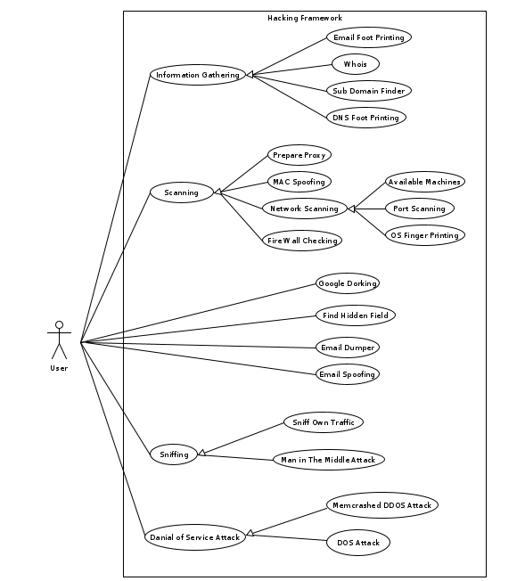
Module Description

Information Gathering :
in this module we are gathering information from different different ways. Like Email find from the website, DNS information, Subdomain, Whois information etc. it is the first part of the penetration testing it is vary important for the testing.

Scanning :
In this module we are scanning the whole network so wee can figure out what is the way attacker can enter in system so we can protect from the attacker. It contain proxy with tor so it is for anonymity, mac spoofing this is for test the Man In The Middle or for security(anonymity), network scanning it is in two part one is manually and second is automate in first part it give good document for NMAP so it help for beginner and second is some kind of secure way like not DOS so system can not detect. And we use wafw00f for firewall checking.

Social Engineering :
In this module we are performing social engineering technique to test the system. It contain Google Dorking which is search technique in google with google search query, Hidden Field Finder, Email spoofing it spoof the email or we can say that Fake email for that we need sendgrid API.

Sniffing :
In this module we are performing sniffing on given interface are testing what is the traffic incoming and outgoing .it use for the analysis of the system that no threat present in the system threat can be malware, DOS or DDOS attack etc. it also contain credential sniffer for that we need to add username and password id parameter from the website and past in the cred section this sniffer work for http traffic only if you want to use for https than you needs to downgrade the https to http for that you can use SSLStrip.

DOS Attack :
In this module we performing the DOS and DDOS attack on system. It is vary risky so don’t try if you are not permitted for this attack. It contain Memcrashed DDOS in this attack use different different Memcrashed server for attack the targeted system for that we needs to find the memcrashed server from internet or from shodan for shodan you need the API key. Ping of Death dos attack this use ICMP protocol for attack and send large number of ICMP packet so server give reply back but it can not receive the replay so other user get late reply, port Change attack In this attack only port is changing but IP is same so server think that user send request to me because port can be anything from request And it produce large traffic on server so server is being busy.

Function Prototypes :
Limited technique for every module for all but Useful technique for penetration testing.
- information Gathering
- Scanning
- Social Engineering
- Sniffing
- DOS
Tree Map :

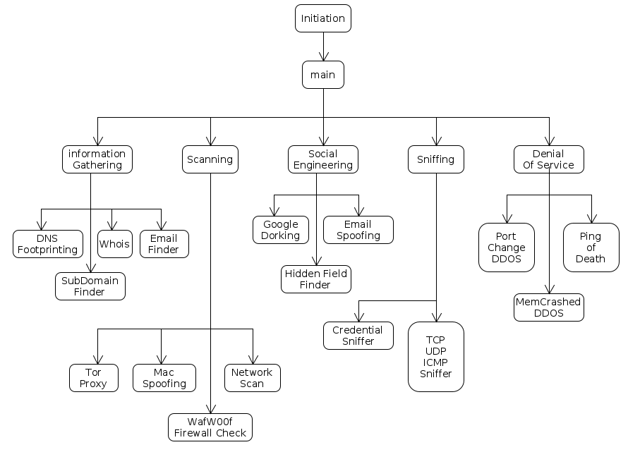

Testing

For the Testing of this tool we use Unit testing we take one by one module for test and check for validation like API key validation,
Data Formatting etc. also test from user Perspective, Error handling etc.

Screen Shot

main page :

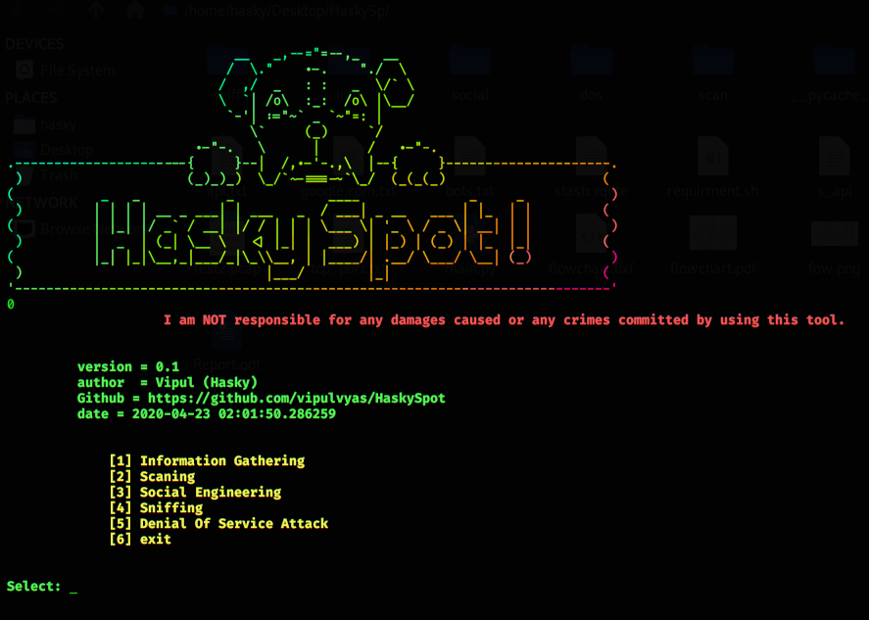

Information gathering :

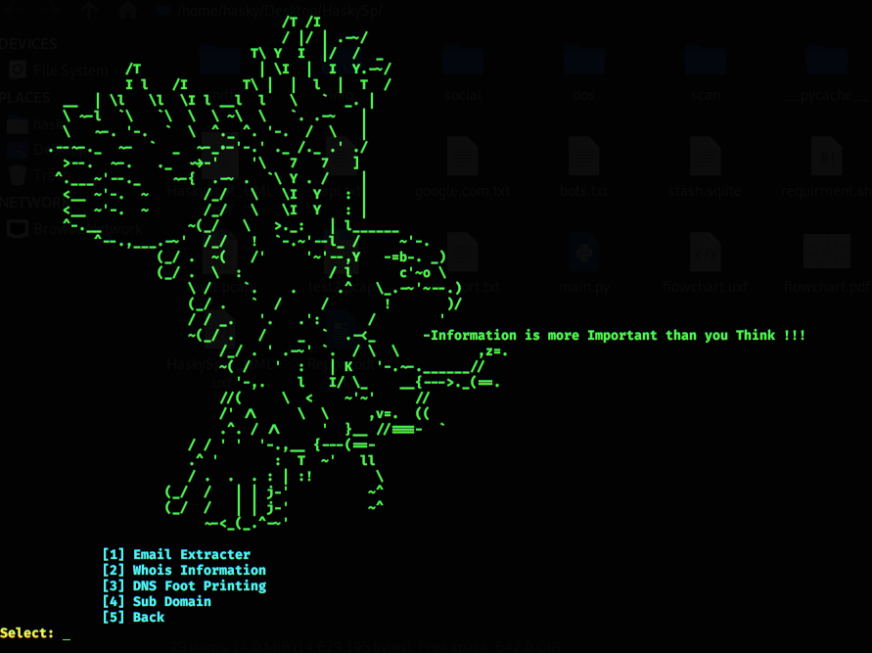
Email Extractor :

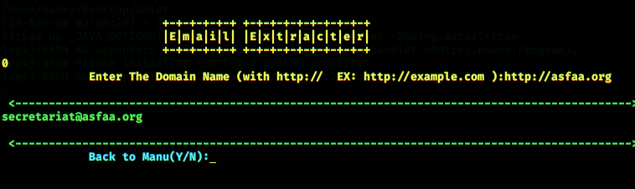

Whois Information :

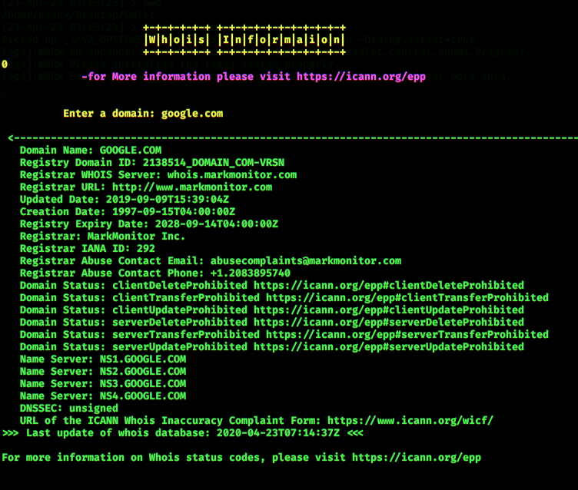
Subdomain Finder :

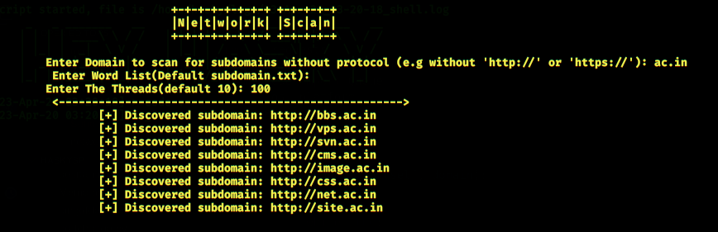

DNS Information :

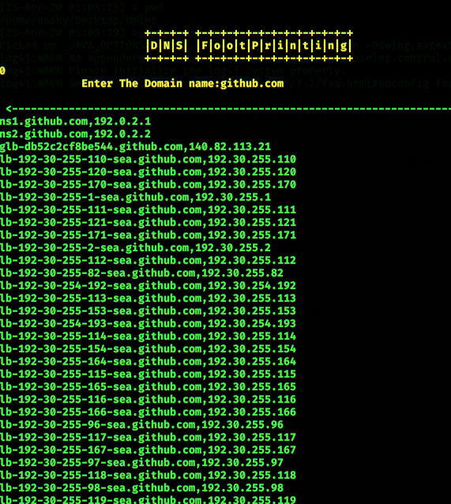

Scanning :

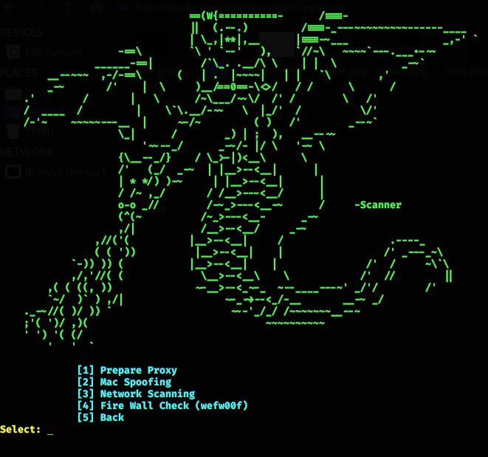

Proxy Setup :

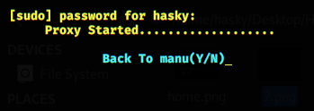

Mac Spoofing :

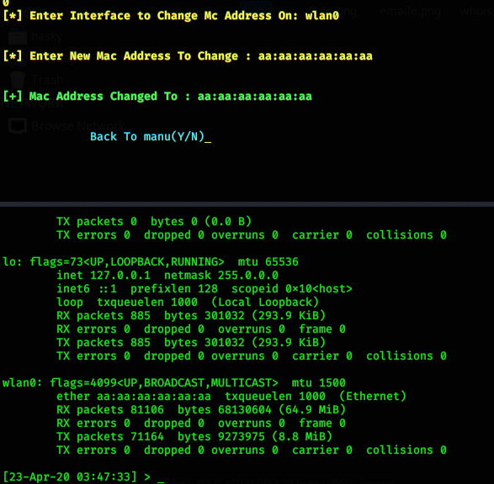
Manual Scan :

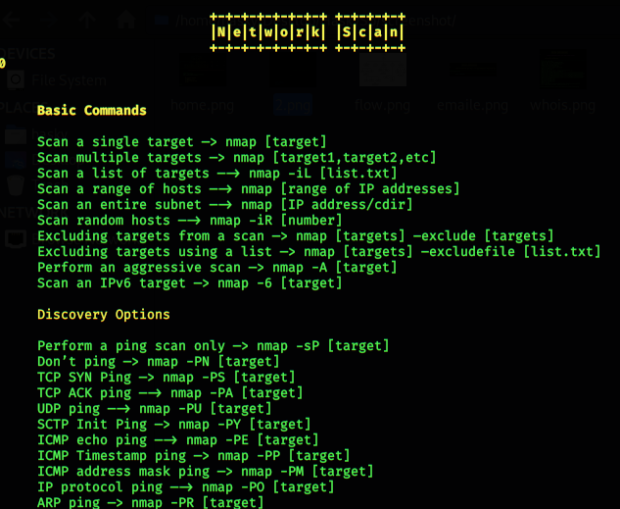
Automatic Scan :

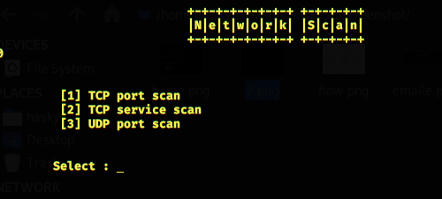
Fire-Wall Checking :

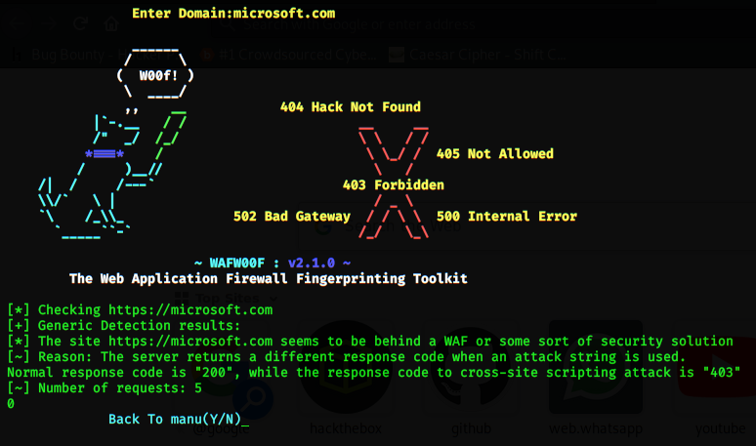

Social Engineering :

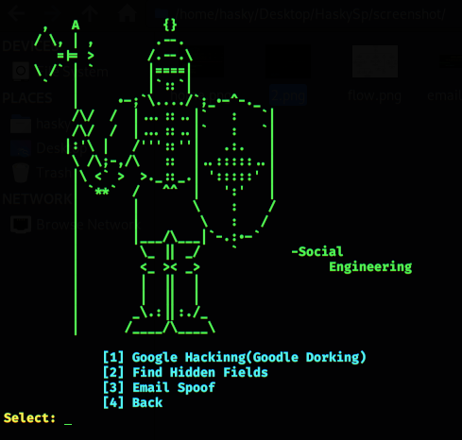

Google Hacking :
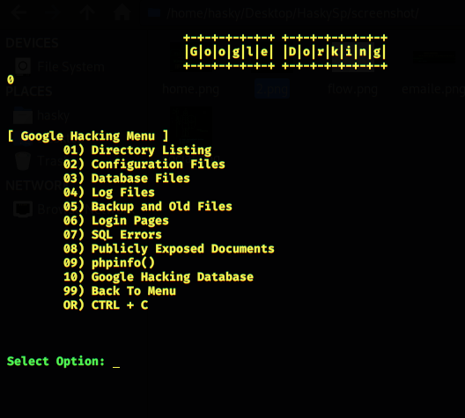

Email Spoofing :

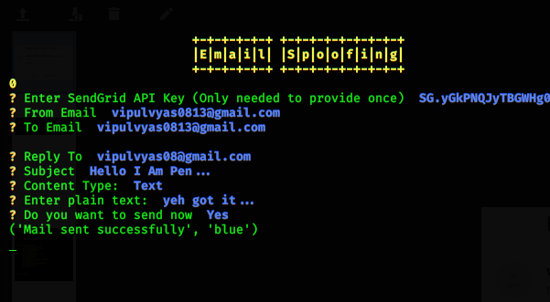


Sniffer :

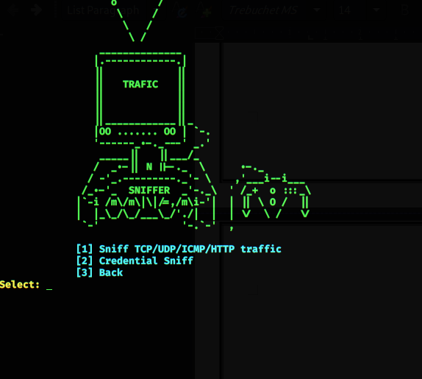

Sniffer 1 :

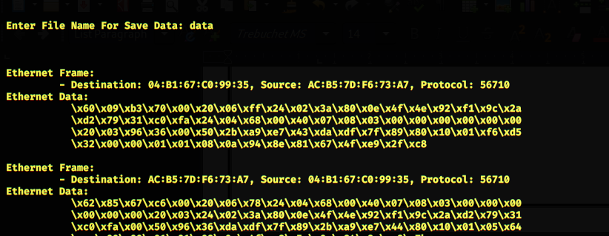
credential Sniffer :

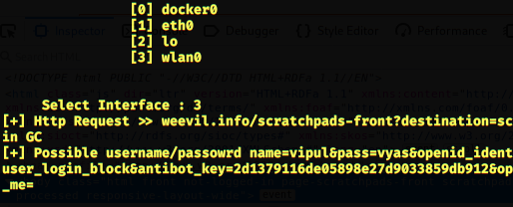

DOS :

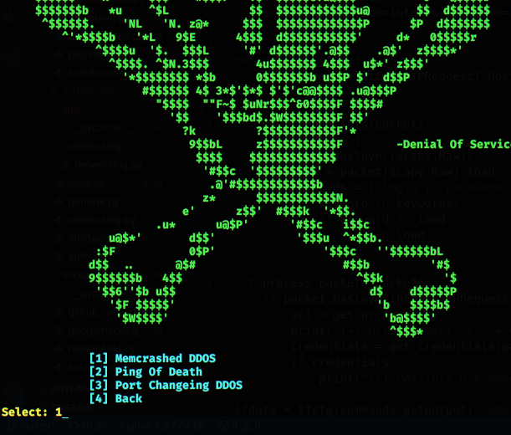

Memcrashed Attack :

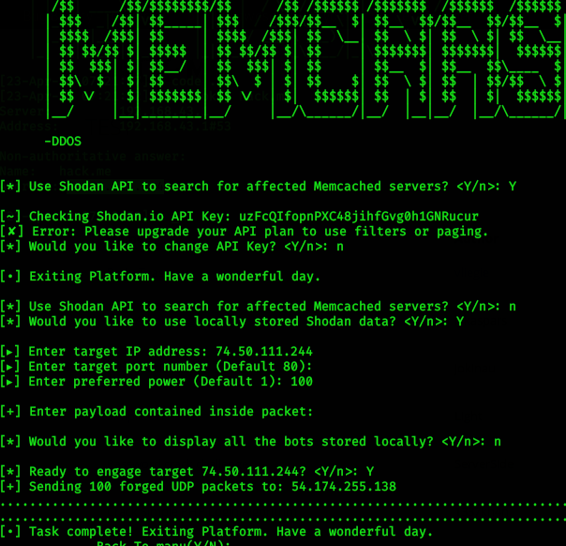

Ping of Death :

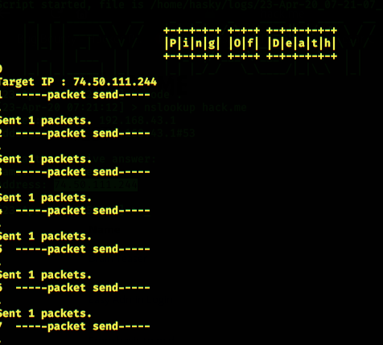

Port Changing Attack :

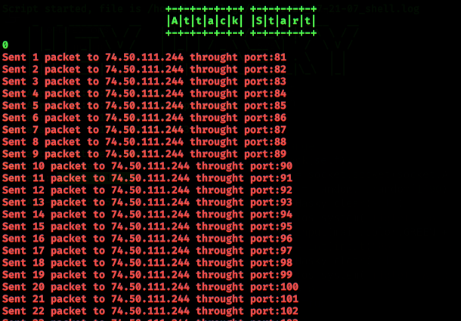

Conclusion

In this project We done following functionalities which is very important for Testers.

Function :
- information Gathering
- Scanning
- Social Engineering
- Sniffing
- DOS

Limitations and Future Extension

Limitations :
- All module not cover all Techniques
- Linux OS only
- Sniffer For Limited Protocols

Future Extension :
- Platform Independent
            - I am working on to build docker image of this tool so any os use can use this tool.
- Add Mode protocol in sniffer

Bibliography

- https://google.com/
- https://github.com/
- https://docs.python.org/
- https://youtube.com/

Ref. : https://github.com/vipulvyas/HaskySpot

