From dev.sql find out the max date ( say its 5/12/2017)

Go to <https://finance.yahoo.com/quote/SPY/history?period1=1494648000&period2=1495252800&interval=1d&filter=history&frequency=1d>

Set Time period to 5/13/2017 to present

Click Apply

Right click on Download Data and copy link address – get the value of period1 and period2

Open developer tools, click on Network tab then Doc. Locate the query which starts with ticker symbol like so:

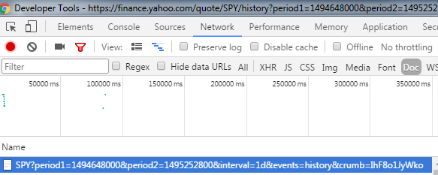

Copy the entire cookie string like so:

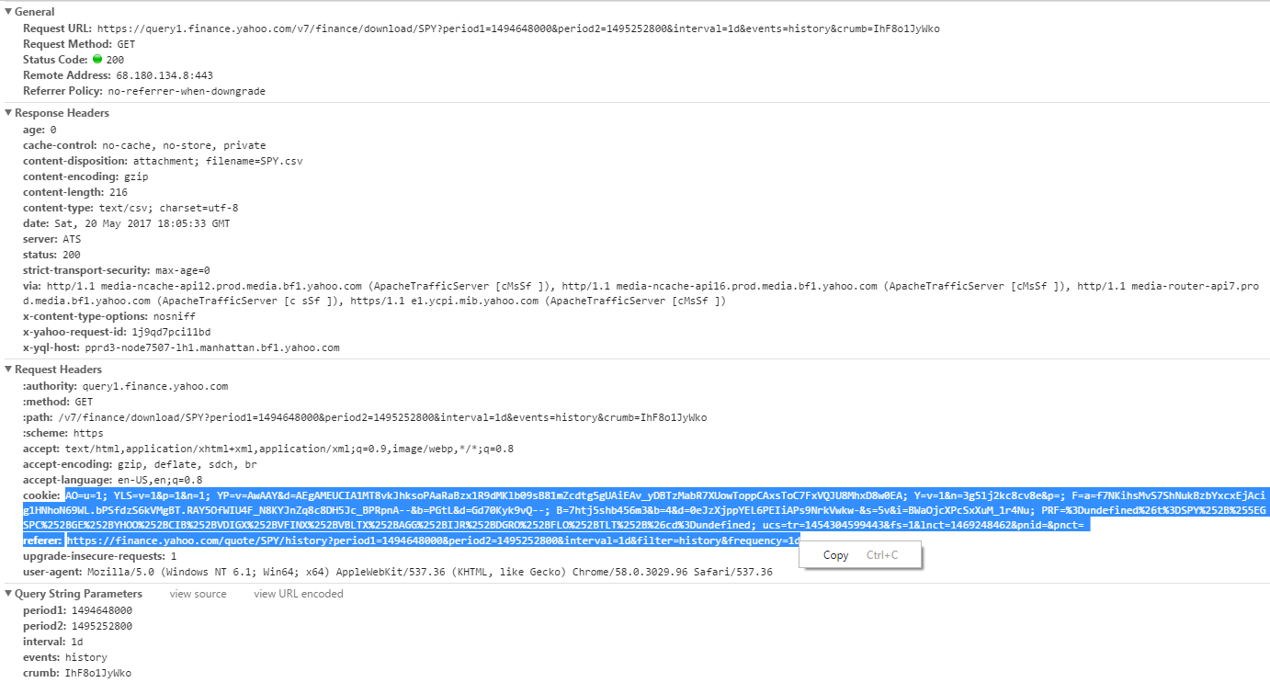

Paste P1, P2 & Cookie in cookie.txt like so each in a separate line

1494648000

1495252800

AO=u=1;YLS=v=1&p=1&n=1;YP=v=AwAAY&d=AEgAMEUCIA1MT8vkJhksoPAaRaBzx1R9dMKlb09sB81mZcdtg5gUAiEAv_yDBTzMabR7XUowToppCAxsToC7FxVQJU8MhxD8w0EA; Y=v=1&n=3g51j2kc8cv8e&p=; F=a=f7NKihsMvS7ShNukBzbYxcxEjAcig1HNhoN69WL.bPSfdzS6kVMgBT.RAY5OfWIU4F_N8KYJnZq8c8DH5Jc_BPRpnA--&b=PGtL&d=Gd70Kyk9vQ--; B=7htj5shb456m3&b=4&d=0eJzXjppYEL6PEIiAPs9NrkVwkw-&s=5v&i=BWaOjcXPcSxXuM_1r4Nu; ucs=tr=1454304599443&fs=1&lnct=1469248462&pnct=; PRF=%3Dundefined%26t%3DSPY%252B%255EGSPC%252BGE%252BYHOO%252BCIB%252BVDIGX%252BVFINX%252BVBLTX%252BAGG%252BIJR%252BDGRO%252BFLO%252BTLT%252B%26cd%3Dundefined

Run the application.