Oracle project | 1

Table of contents

Table of contents 1

Database modeling 2

Data generation 9

Data import 11

PLSQL functions 17

NoSQL database 19

NoSQL queries 20

Appendix 21
Oracle project | 2

Vitalii Naumov

FY46IN

Data Models and DB

May 24, 2020

Oracle project

Database modeling

First step was to decide which project to work on. Since I have a little under-standing in a car rental field, I decided to stick with that idea. Next, I was relying on the given criteria of 10 tables.

The modeling of the Data Base I decided to start in SQL Developer Data Model-er as you suggested. The model I ended up with have the following structure:
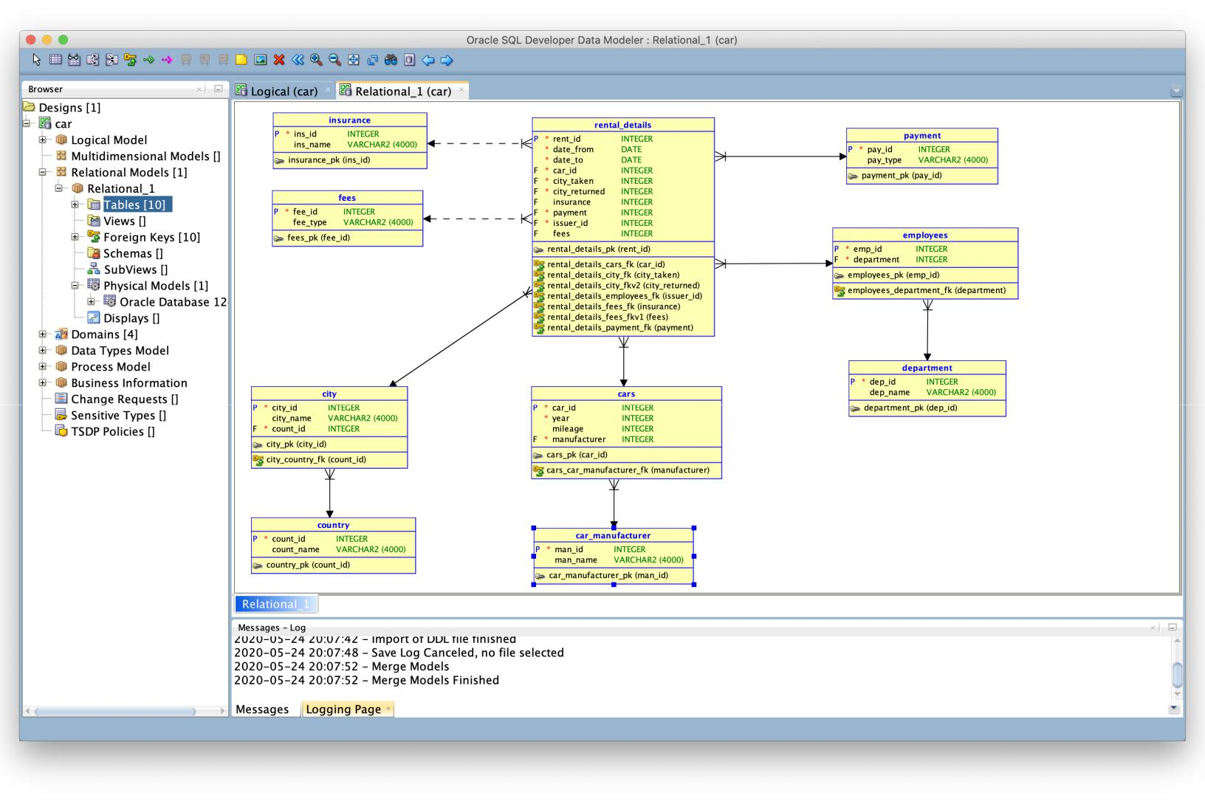
Oracle project | 3

As you can see one of the most important tables is RENTAL_DETAILS. It con-tains following columns: Rent_id - integer, obligatory, primary key of the table, basically incrementing counter of the rows; Date_from - date type, obligatory, information when the booking has started, to simplify the data I gave up on the time which will be quite important on a real world solution; Date_to - date type, obligatory, similarly to the pre-vious one but indicates when the car was returned; Car_id - integer, obligatory, foreign key, references to Cars table with the car data; City_taken - integer, obligatory, foreign key, references to City table with city names; City_returned - integer, obligatory, foreign key, similar to the previous one; Insurance - integer, optional, foreign key, indicates whether a client selected any insurance, references to Insurance table with all kinds of insurance; Payment - integer, obligatory, foreign key, indicates the type of payment client choose, references to table Payment; Issuer_id - integer, obligatory, foreign key, indicates which employee was operating this rental, references to Employees table; Fees - integer, optional, foreign key, depending on the result of rental which caused any problems might refer to the table Fees with description of the problem.
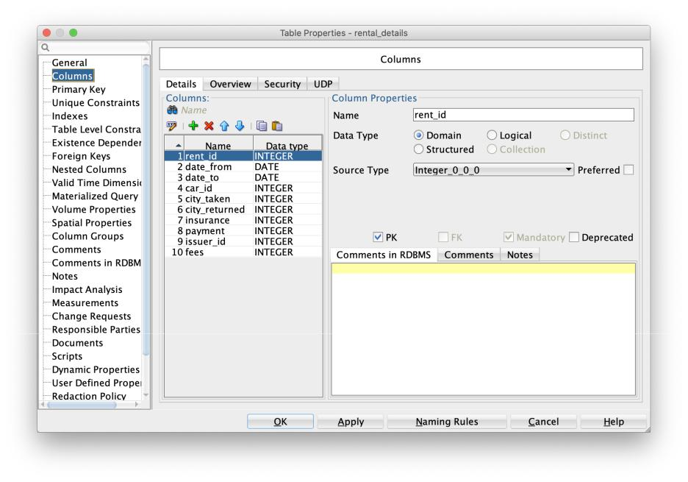
Oracle project | 4

Next is an Insurance table which contains Ins_id - integer, obligatory, primary key - ID of insurance and Ins_name - varchar2, obligatory, description of the insurance a client might have purchased.
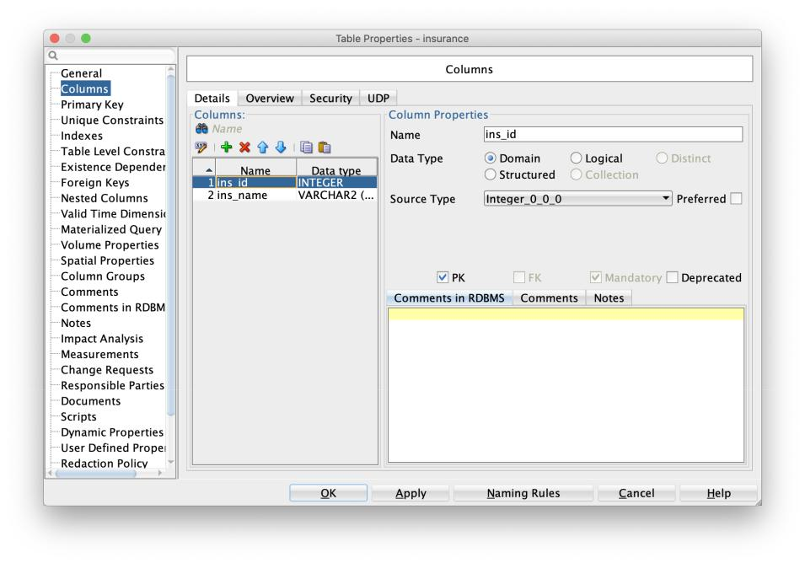

After that is Fees table. It has Fee_id - integer, obligatory, primary key, an ID of the fee might be applied for the rental and Fee_type - varchar2, obligatory - description of the fee applied.
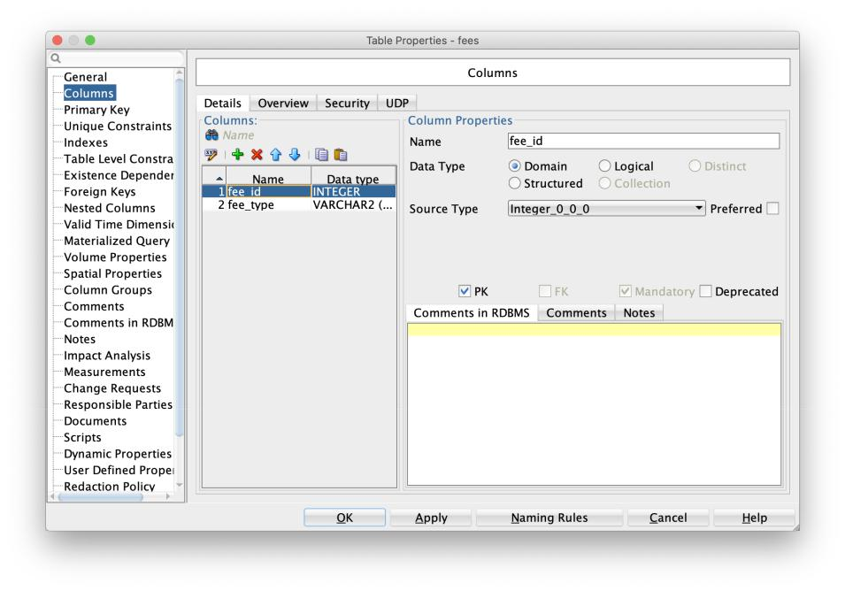
Oracle project | 5

Follows up City table including columns: City_id - integer, obligatory, primary key, an ID of the city; City_name - varchar2, obligatory, basically a name of the city; Count_id - integer, obligatory, foreign key, references to Country table, which is saying in which country this city is.
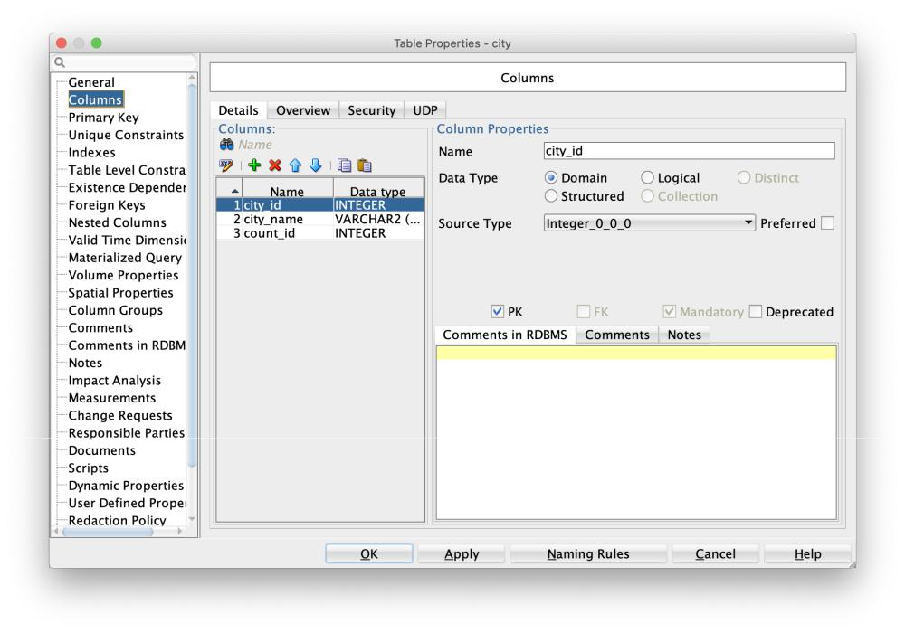

Next is Country table. It has: Count_id - integer, obligatory, primary key, an ID of the country, Count_name - varchar2, obligatory, a name of the country.
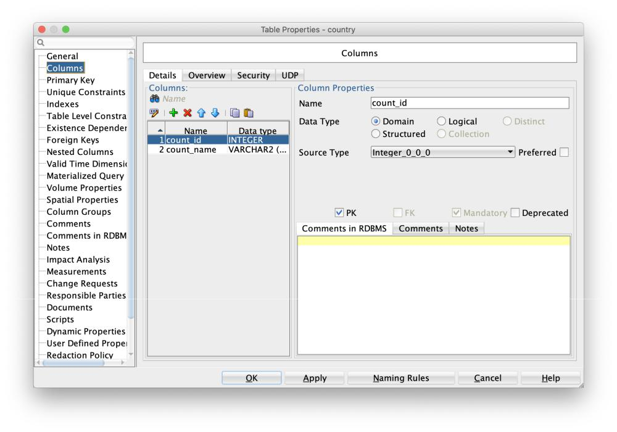
Oracle project | 6

After that is Cars table with the following columns: Car_id - integer, obligatory, primary key, an ID of each car in rental; Year - integer, obligatory, a year of manufacture of the car; Mileage - integer, obligatory, a number miles this car ran; Manufacturer - in-teger, obligatory, foreign key - references to the Car_manufacturer table with the names of manufacturers.
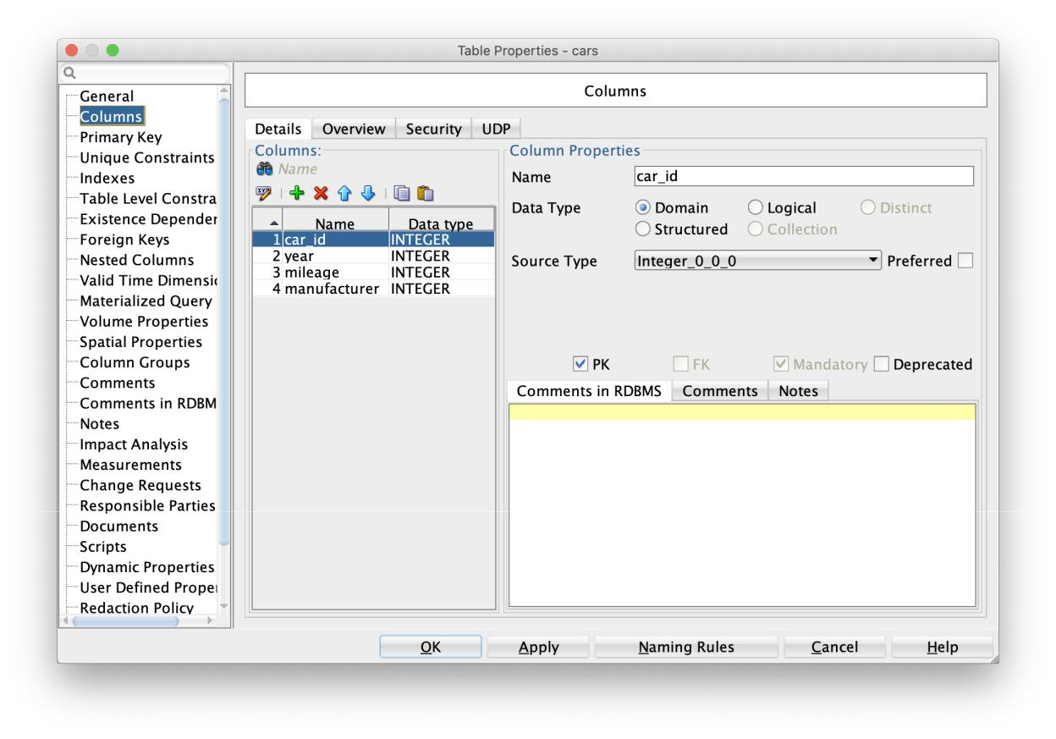

Next is Car_manufacturer table. Two columns are in here: Man_id - integer, obligatory, primary key, an ID of the manufacturer; Man_name - varchar2, obligatory, a name of manufacturer.
Oracle project | 7
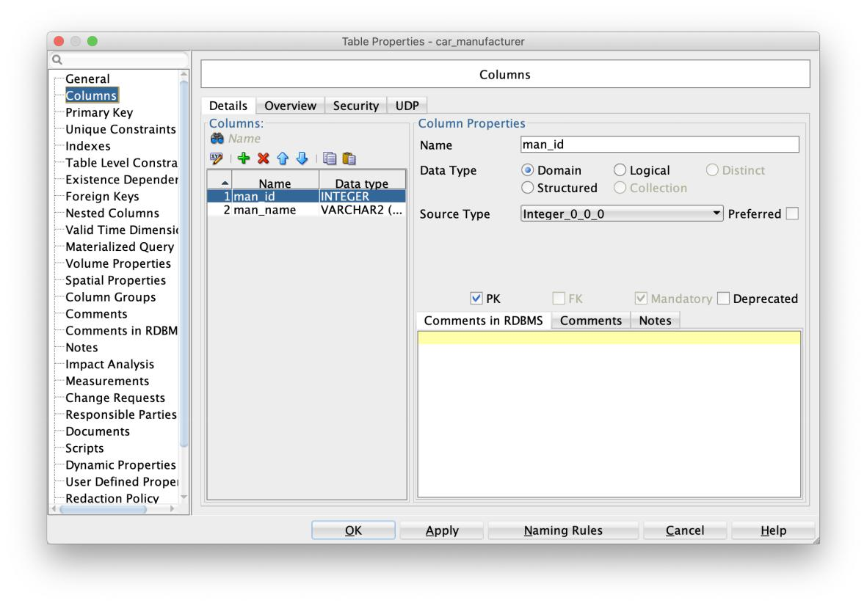

Payment table contains of Pay_id - integer, obligatory, primary key, an Id of type of payment; Pay_type - varchar2, obligatory, explains what type of payment has been used by customer.
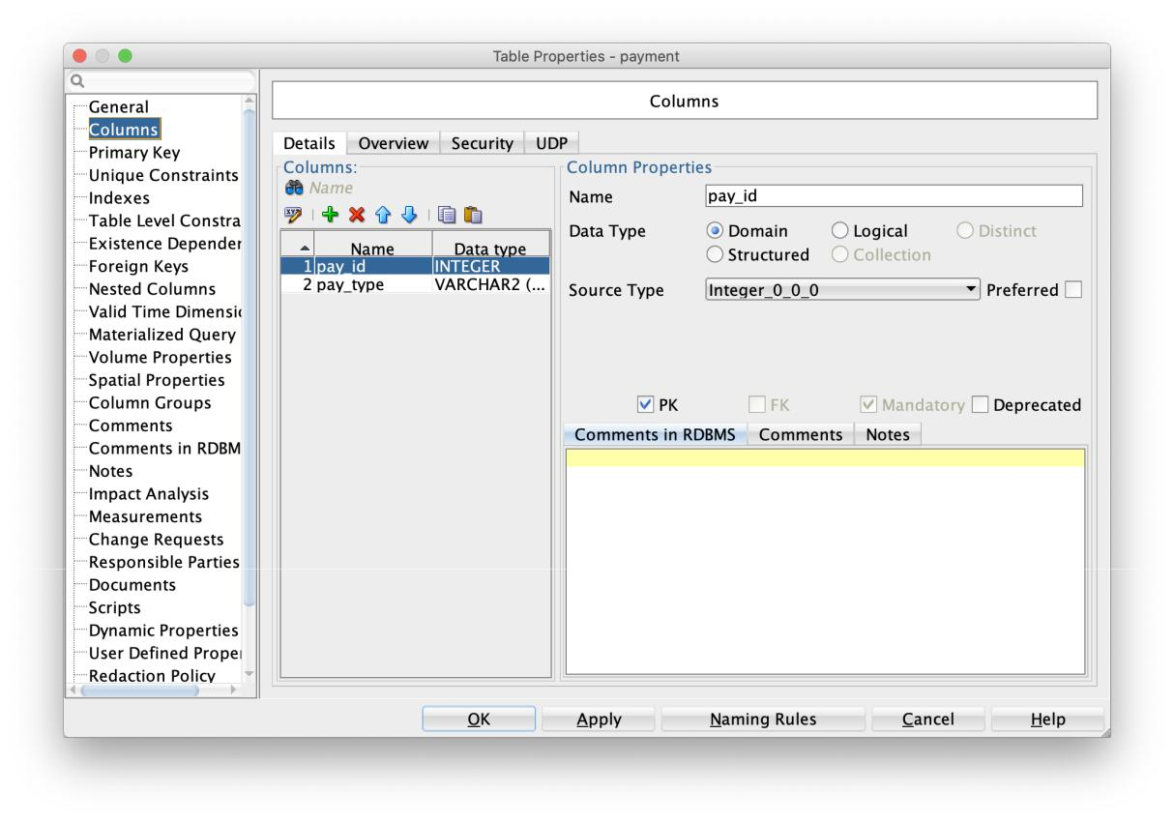
Oracle project | 8

Employees table: Emp_id - integer, obligatory, primary key, an ID of each em-ployee; Department - integer, obligatory, foreign key, references to Department table
and indi- cates in which department person works.
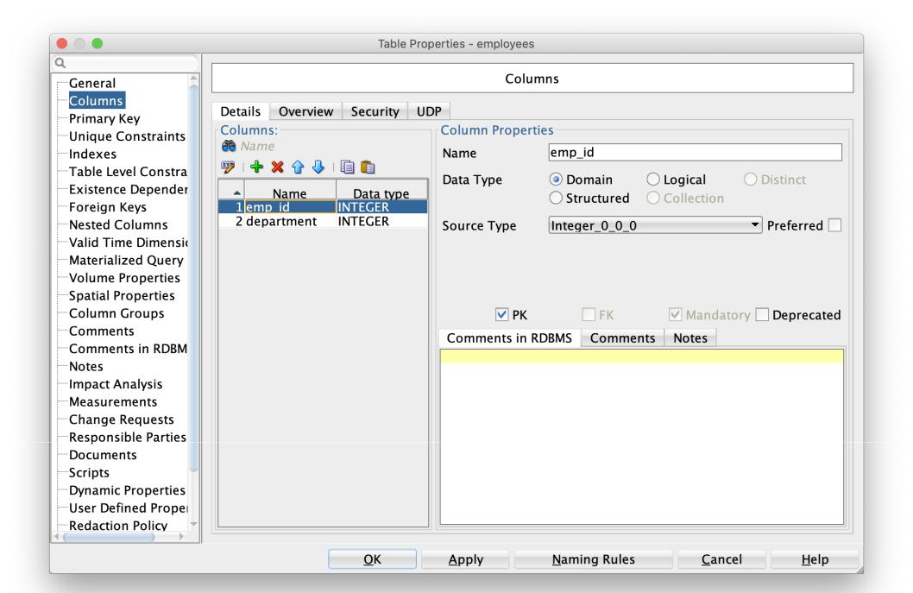

The last table is Departments one. It has Dep_id - integer, obligatory, primary key, an ID of each department; Dep_name - varchar2, obligatory, unique list of name related to each department.
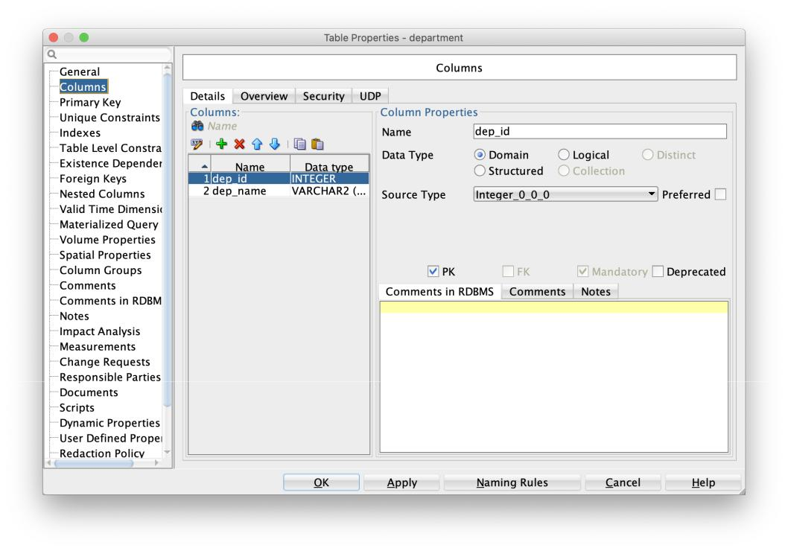
Oracle project | 9

Data generation

For this step I decided to generate data using Python.

Beneath is the code I used for generation data for Cars table:
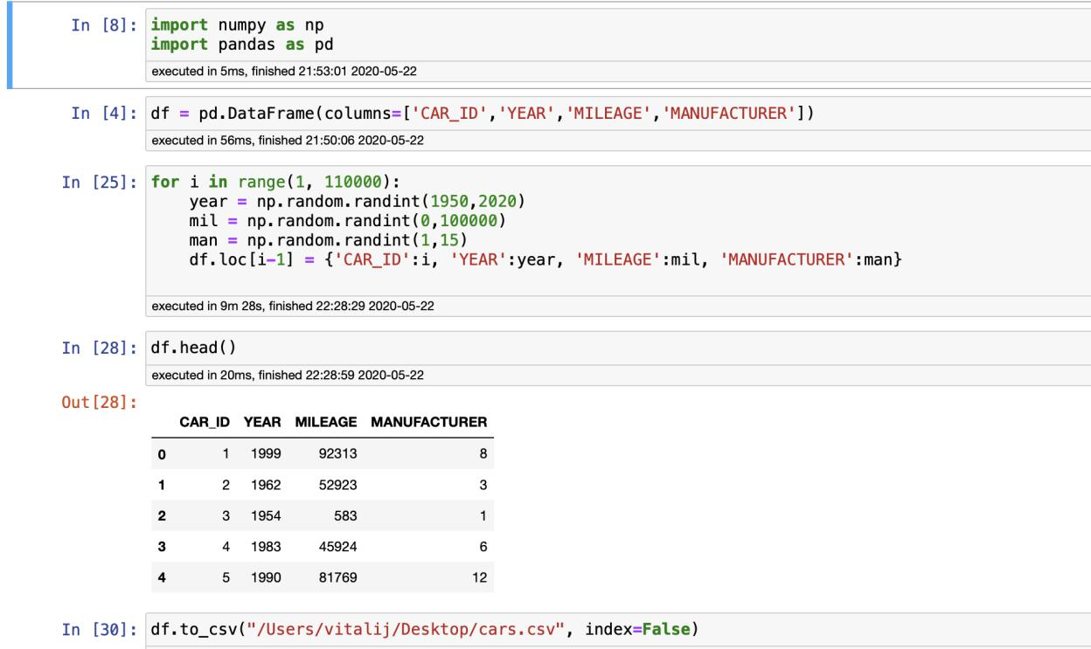

Similarly for Employees table:
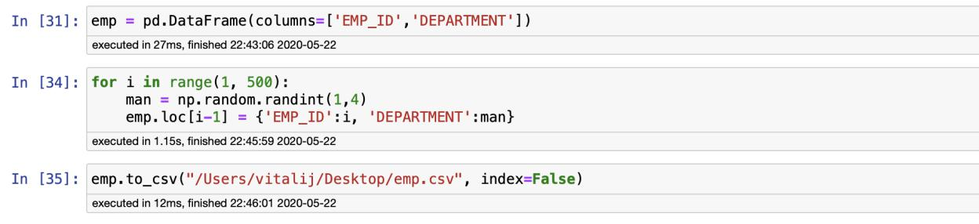

The most diﬃcult generating was for Rent_details table because it has data type columns:

Oracle project | 10
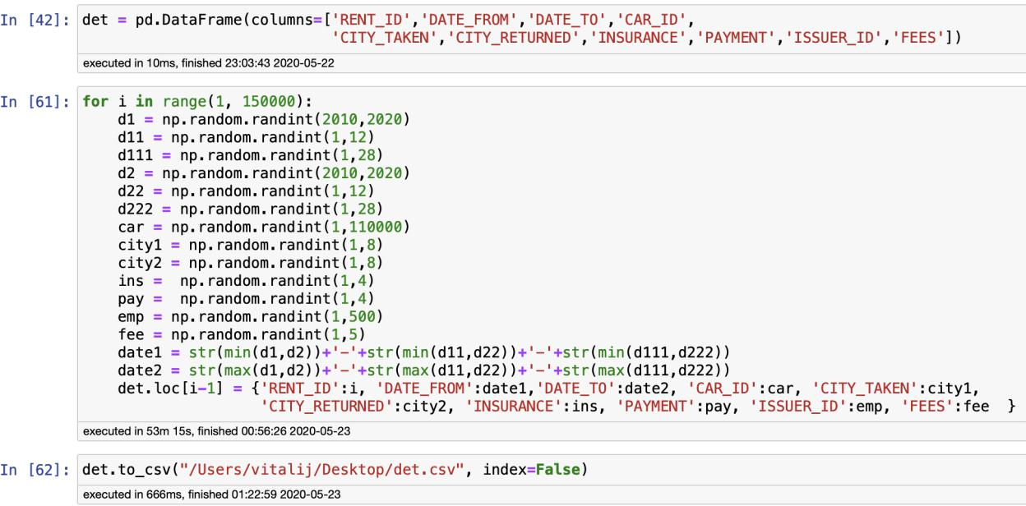
Oracle project | 11

Data import

Next step was to import all the data. First, from SQL Modeler to SQL Developer using import as DDL:
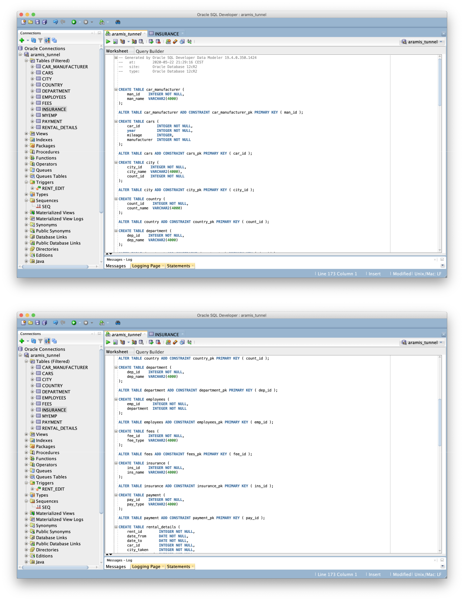
Oracle project | 12
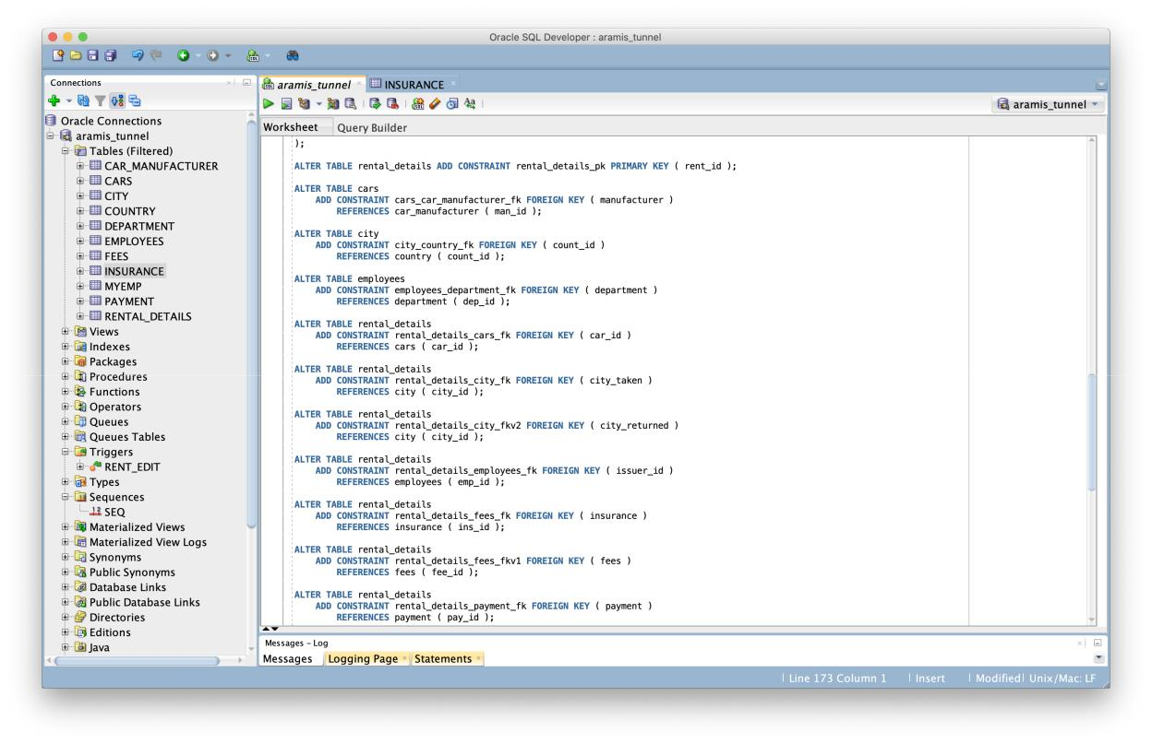

Next step is to import csv files I have generated before using Import Data by the right click on the newly generated tables Cars, Rental_details, Employees:
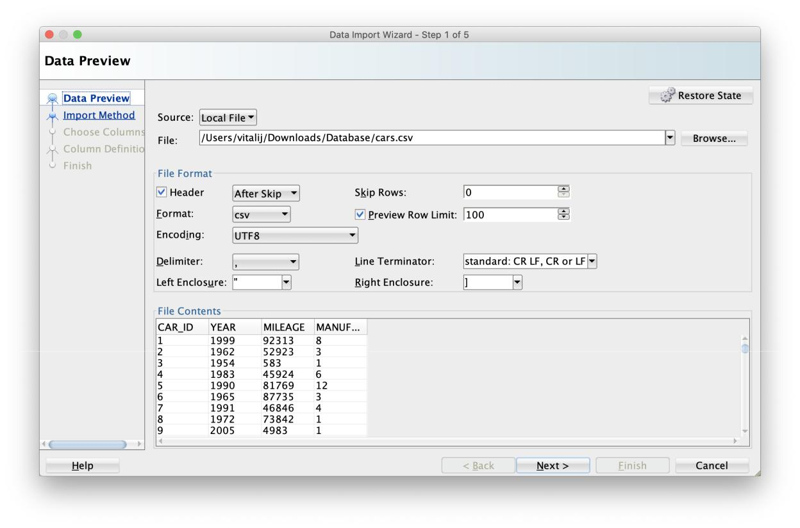
Oracle project 13

For all other tables I added data manually:
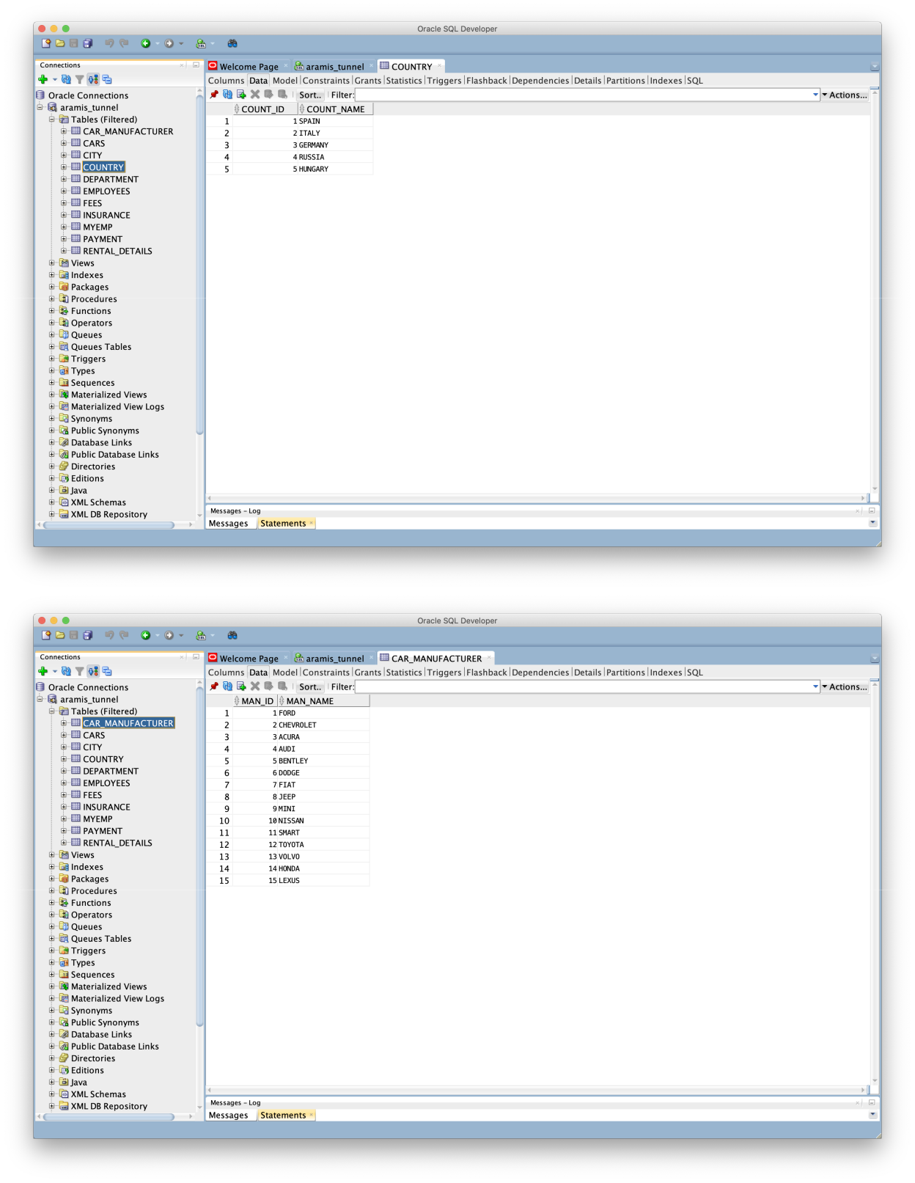

Oracle project | 14
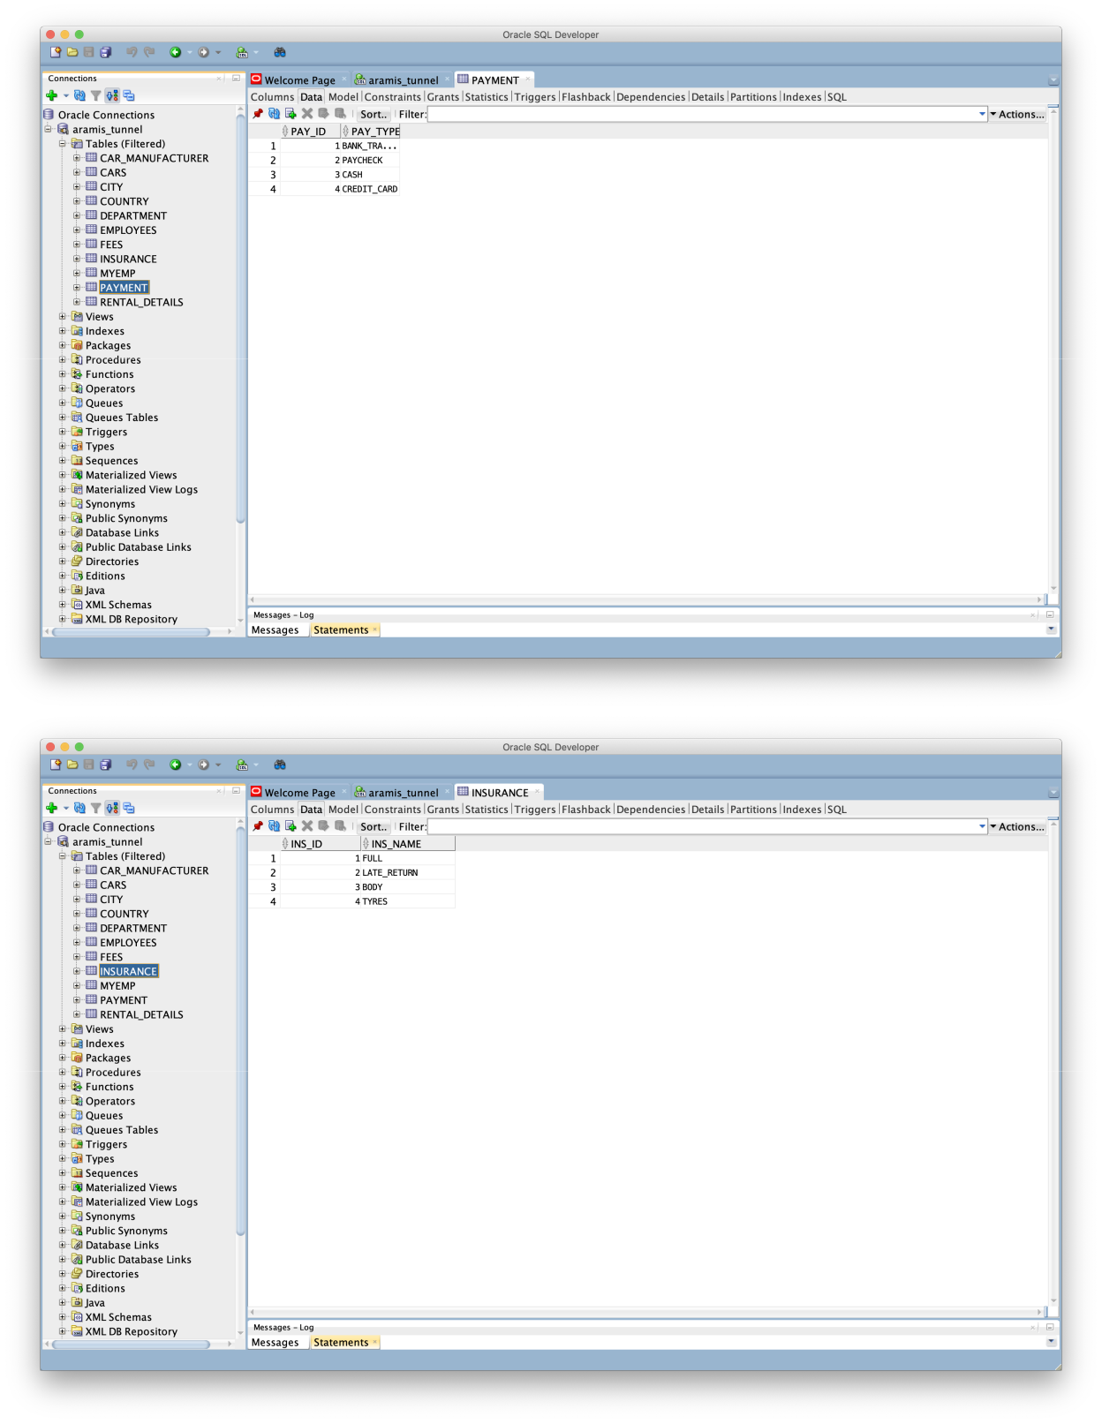
Oracle project | 15
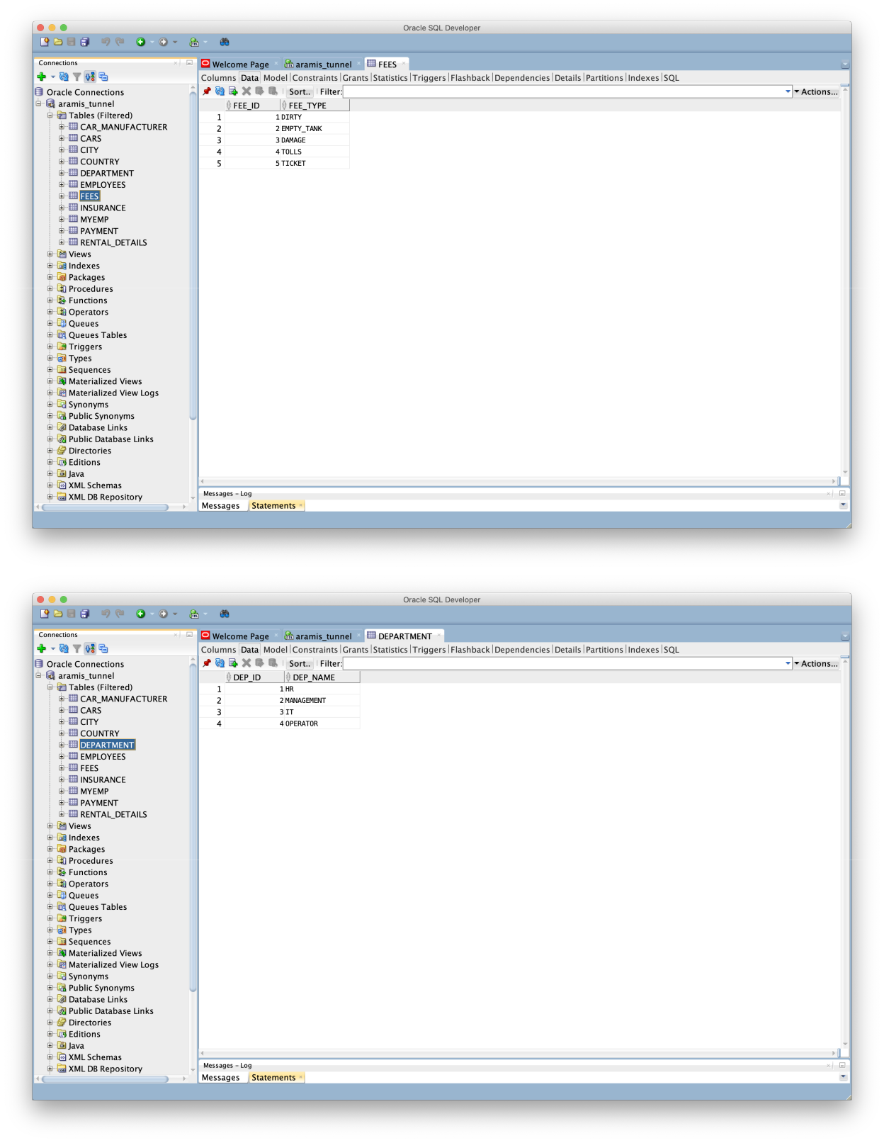
Oracle project 16
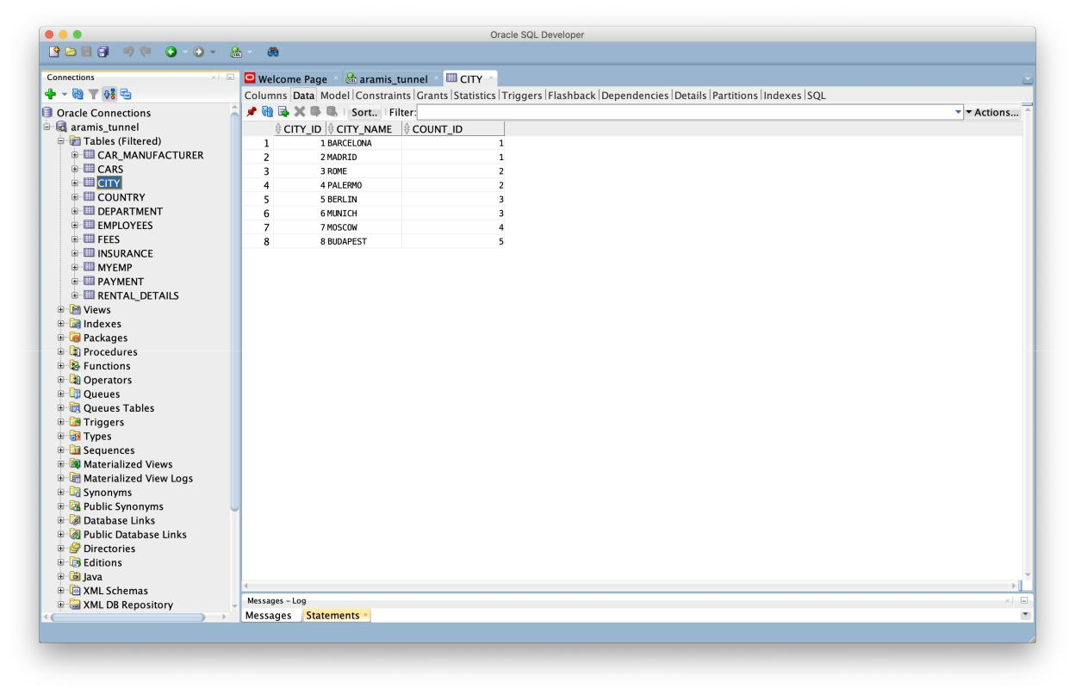

And some triggers and sequences:
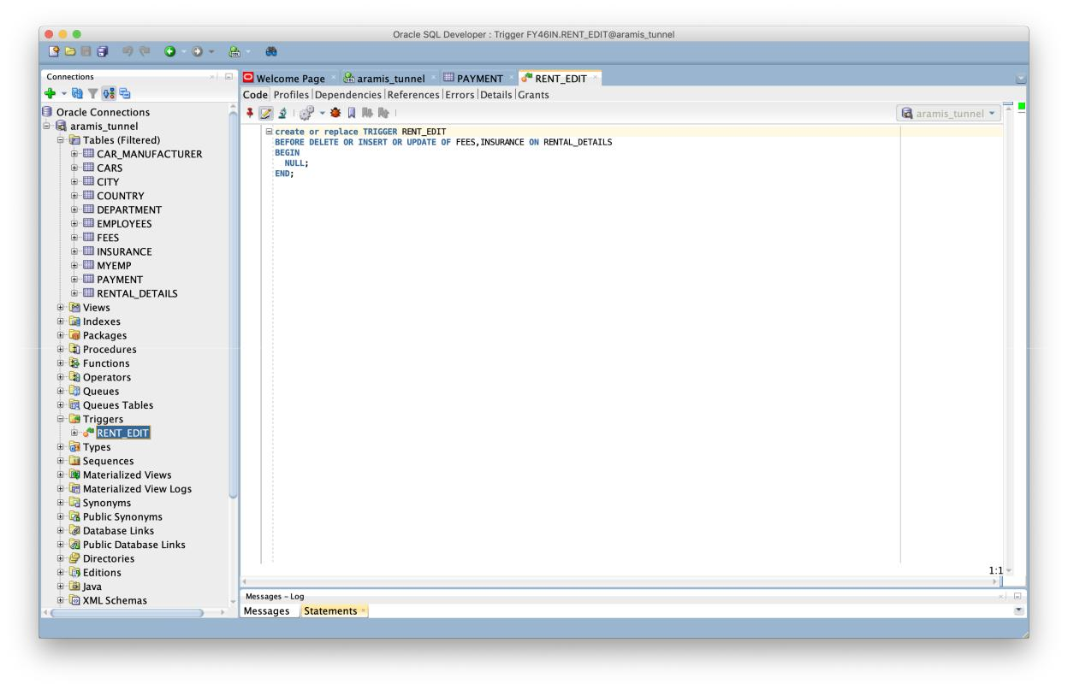

Oracle project | 17
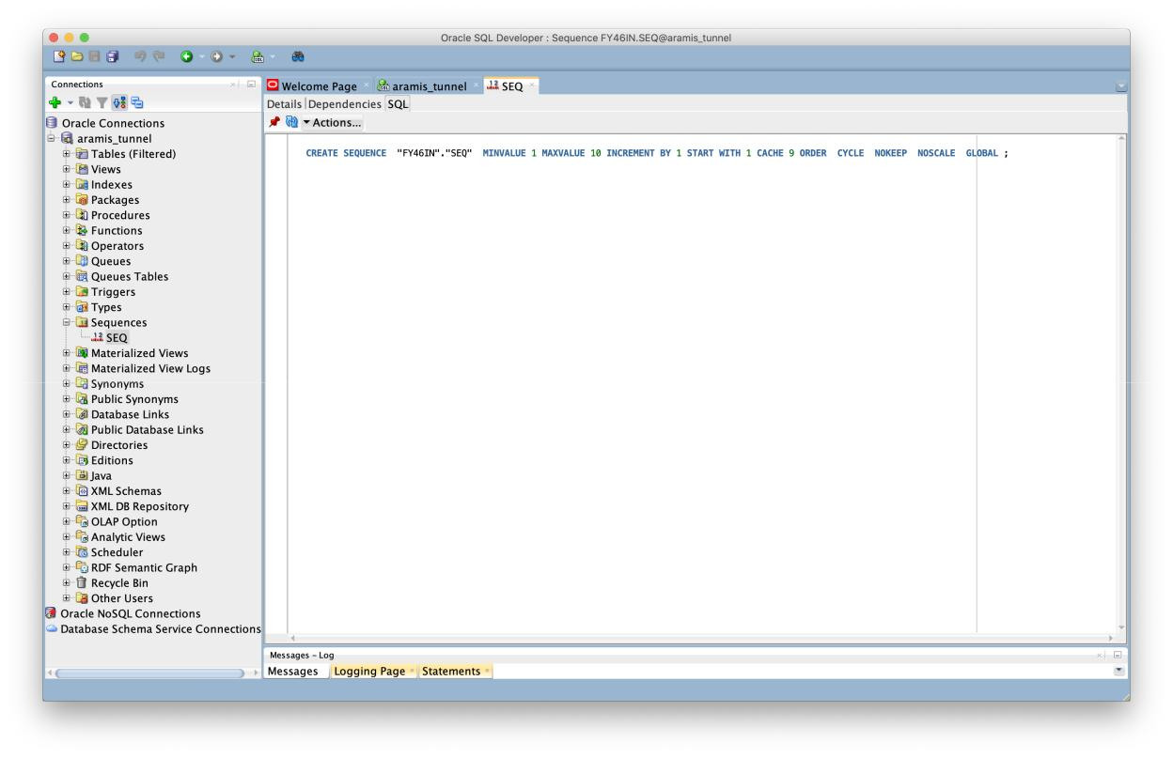

PLSQL functions
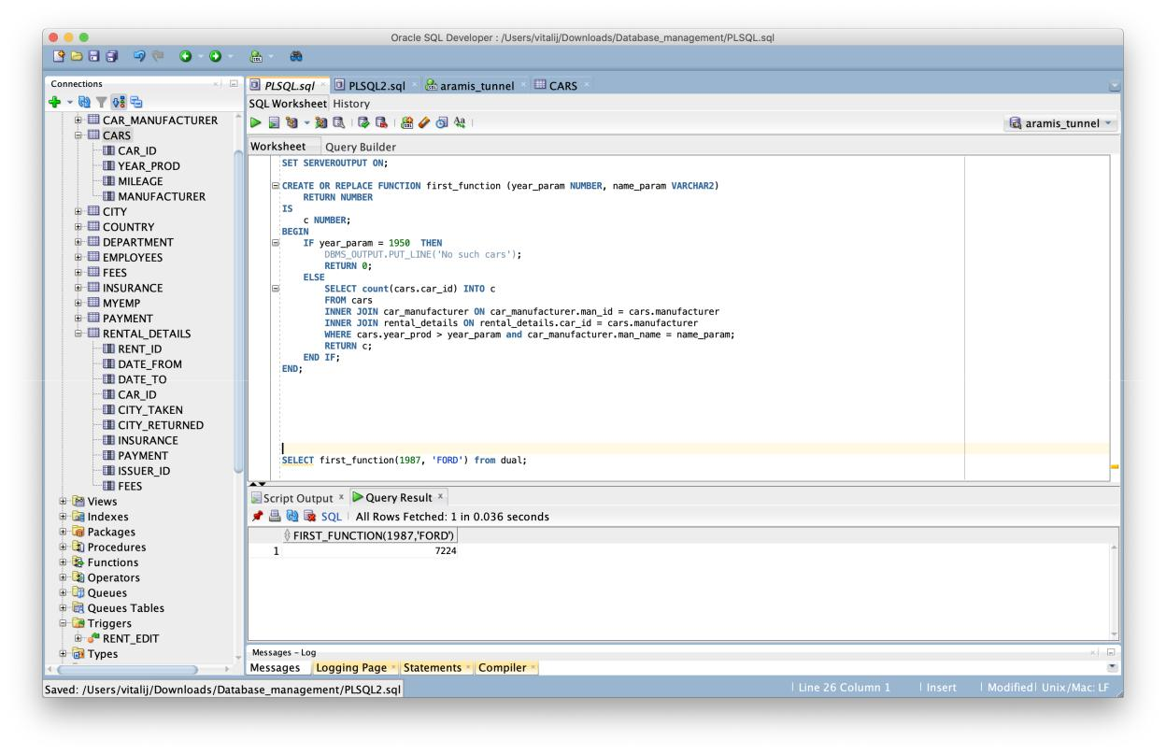
Oracle project | 18

This function accepts year and name as parameters and looking in Cars table for a quantity of the cars which are newer than given year and also these cars should be from the manufacturer given as name parameter.
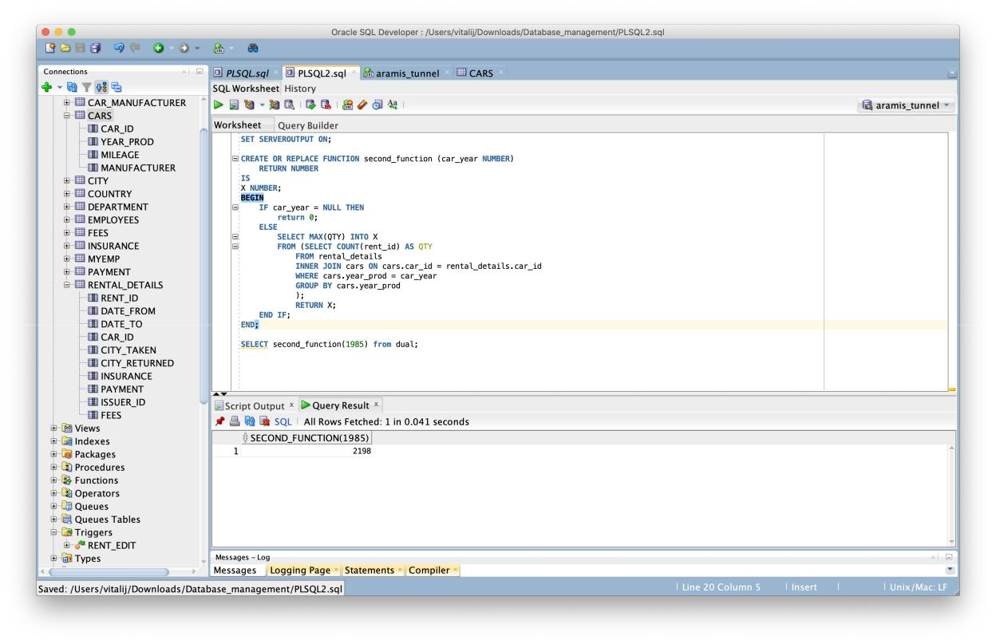

The second function calculates the maximum quantity of usage of the cars pro-duced in given year which are in Rental_details table.
Oracle project | 19

NoSQL database

I decided to work with MongoDB as NoSQL Database because it is very easy to install and setup the MongoDB, the very basic feature of MongoDB is that it is a schema-less database compare to Oracle one. Also one of the main factor was a good amount of available documentation and MongoDB does not require a VM to be run. Since, it is a NOSQL database, then it is obviously secure because no sql injection can be made.

First step after installation is to load the data into DB:
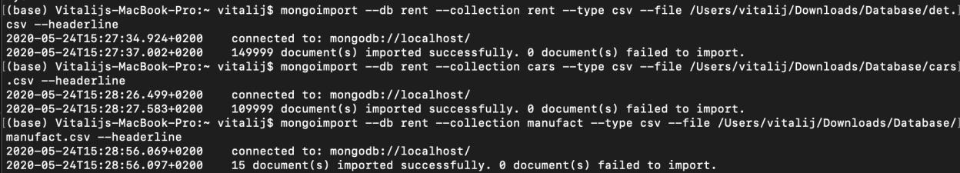

I have uploaded 3 collections (tables) from the previous exercise. And I had to switch to the current DB I was going to work with:
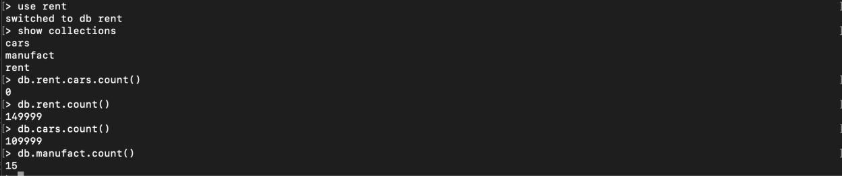

Looks like everything was loaded.
Oracle project | 20

NoSQL queries

- Counting number of cars which were taken or returned from city with index 2

- Picking one row where city the car was taken from has index 5
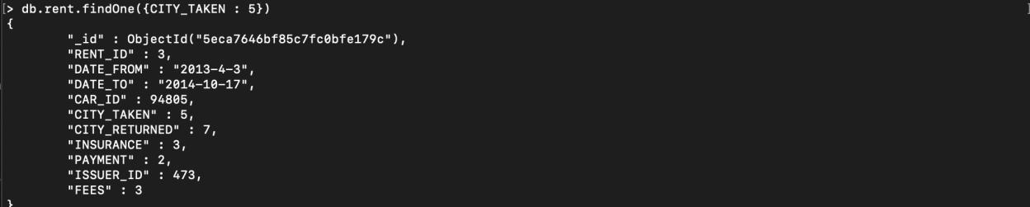

- Counting number of cars with a mileage more than 90000 km

- Counting number of cars older than 2000 and with a manufacturer index 8

- The following aggregation operation selects documents with INSURANCE equal to 1 and sorts the results by the FEES field in descending order
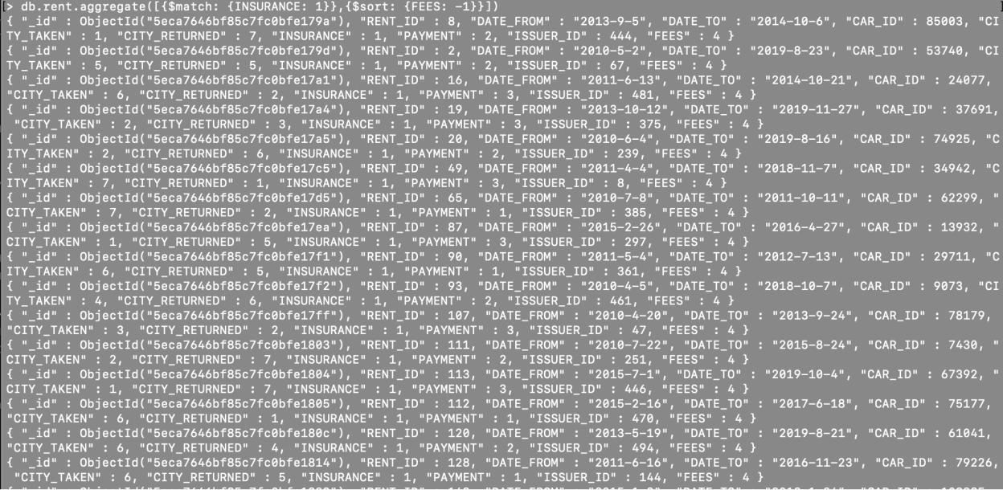
Oracle project | 21

- Groups the documents by the PAYMENT field and calculates the total for each FEES field from the sum of the amount field

- Groups the cars by YEAR which calculates the total age of cars which were manufactured in the same year in ascending order

- Finds one row with YEAR = 2000 and MANUFACTURER = 8 and delete it

- Finds one row with the.given query YEAR=2019 and then resets the MILEAGE field to 0

- Finds one row with MANUFACTURER = 8 and replaces with new attributes such as CAR_ID, YEAR, resets MILEAGE and MANUFACTURER
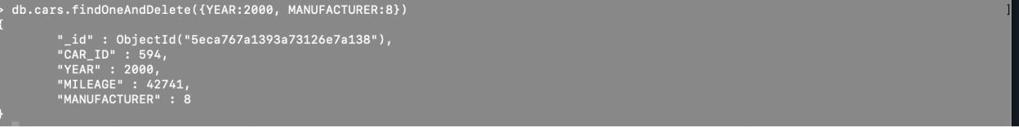

Appendix

Oracle project | 22

Script to create tables:

CREATE TABLE car_manufacturer (

man_id INTEGER NOT NULL,

man_name VARCHAR2(4000)

);

ALTER TABLE car_manufacturer ADD CONSTRAINT car_manufacturer_pk PRI-MARY KEY ( man_id );

CREATE TABLE cars (

car_id INTEGER NOT NULL,

year INTEGER NOT NULL,

mileage INTEGER,

manufacturer INTEGER NOT NULL

);

ALTER TABLE cars ADD CONSTRAINT cars_pk PRIMARY KEY ( car_id );

CREATE TABLE city (

city_id INTEGER NOT NULL,

city_name VARCHAR2(4000),

count_id INTEGER NOT NULL

);
Oracle project | 23

ALTER TABLE city ADD CONSTRAINT city_pk PRIMARY KEY ( city_id );

CREATE TABLE country (

count_id INTEGER NOT NULL,

count_name VARCHAR2(4000)

);

ALTER TABLE country ADD CONSTRAINT country_pk PRIMARY KEY ( count_id );

CREATE TABLE department (

dep_id INTEGER NOT NULL,

dep_name VARCHAR2(4000)

);

ALTER TABLE department ADD CONSTRAINT department_pk PRIMARY KEY ( dep_id );

CREATE TABLE employees (

emp_id INTEGER NOT NULL,

department INTEGER NOT NULL

);
Oracle project | 24

ALTER TABLE employees ADD CONSTRAINT employees_pk PRIMARY KEY ( emp_id );

CREATE TABLE fees (

fee_id INTEGER NOT NULL,

fee_type VARCHAR2(4000)

);

ALTER TABLE fees ADD CONSTRAINT fees_pk PRIMARY KEY ( fee_id );

CREATE TABLE insurance (

ins_id INTEGER NOT NULL,

ins_name VARCHAR2(4000)

);

ALTER TABLE insurance ADD CONSTRAINT insurance_pk PRIMARY KEY ( in-

s_id );

CREATE TABLE payment (

pay_id INTEGER NOT NULL,

pay_type VARCHAR2(4000)

);
Oracle project | 25

ALTER TABLE payment ADD CONSTRAINT payment_pk PRIMARY KEY ( pay_id

);

CREATE TABLE rental_details (

rent_id | INTEGER NOT NULL,
date_from | DATE NOT NULL,
date_to | DATE NOT NULL,
car_id | INTEGER NOT NULL,
city_taken | INTEGER NOT NULL,

city_returned INTEGER NOT NULL,

insurance INTEGER,

payment INTEGER NOT NULL,

issuer_id INTEGER NOT NULL,

fees INTEGER

);

ALTER TABLE rental_details ADD CONSTRAINT rental_details_pk PRIMARY KEY ( rent_id );

ALTER TABLE cars

ADD CONSTRAINT cars_car_manufacturer_fk FOREIGN KEY ( manufacturer ) REFERENCES car_manufacturer ( man_id );
Oracle project 26

ALTER TABLE city

ADD CONSTRAINT city_country_fk FOREIGN KEY ( count_id )

REFERENCES country ( count_id );

ALTER TABLE employees

ADD CONSTRAINT employees_department_fk FOREIGN KEY ( department ) REFERENCES department ( dep_id );

ALTER TABLE rental_details

ADD CONSTRAINT rental_details_cars_fk FOREIGN KEY ( car_id )

REFERENCES cars ( car_id );

ALTER TABLE rental_details

ADD CONSTRAINT rental_details_city_fk FOREIGN KEY ( city_taken )

REFERENCES city ( city_id );

ALTER TABLE rental_details

ADD CONSTRAINT rental_details_city_fkv2 FOREIGN KEY ( city_returned ) REFERENCES city ( city_id );

ALTER TABLE rental_details

ADD CONSTRAINT rental_details_employees_fk FOREIGN KEY ( issuer_id )

Oracle project | 27

REFERENCES employees ( emp_id );

ALTER TABLE rental_details

ADD CONSTRAINT rental_details_fees_fk FOREIGN KEY ( insurance )

REFERENCES insurance ( ins_id );

ALTER TABLE rental_details

ADD CONSTRAINT rental_details_fees_fkv1 FOREIGN KEY ( fees )

REFERENCES fees ( fee_id );

ALTER TABLE rental_details

ADD CONSTRAINT rental_details_payment_fk FOREIGN KEY ( payment ) REFERENCES payment ( pay_id );

Script to create triggers:

create or replace TRIGGER RENT_EDIT

BEFORE DELETE OR INSERT OR UPDATE OF FEES,INSURANCE ON RENTAL_DETAILS
BEGIN

NULL;

END;

Script to create sequences:

Oracle project | 28

CREATE SEQUENCE "FY46IN"."SEQ" MINVALUE 1 MAXVALUE 10 INCRE-

MENT BY 1 START WITH 1 CACHE 9 ORDER CYCLE NOKEEP NOSCALE GLOBAL ;

