**Issues with Project 6**

1. Staging.didlgrading.com/admin/GraderClass.aspx (#1 on project 6). The previous program has the ability to sort by the column headings. We lost that ability. We need that ability back.
2. Staging.didlgrading.com/SchoolsAdmin/GraderClass.aspx (#2 on project 6). The previous program has the ability to sort by the column headings. We lost that ability. We need that ability back.

Also, there is a problem with the header on the page on

Below is what it was before the changes.

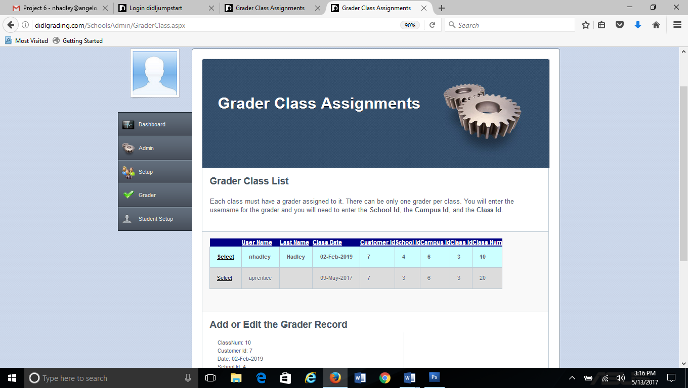

Below is what it is now with the changes in Project 6. There should not be the light blue strip in the header. Also, I don’t know what this white strip at the bottom is. It is probably the background box.

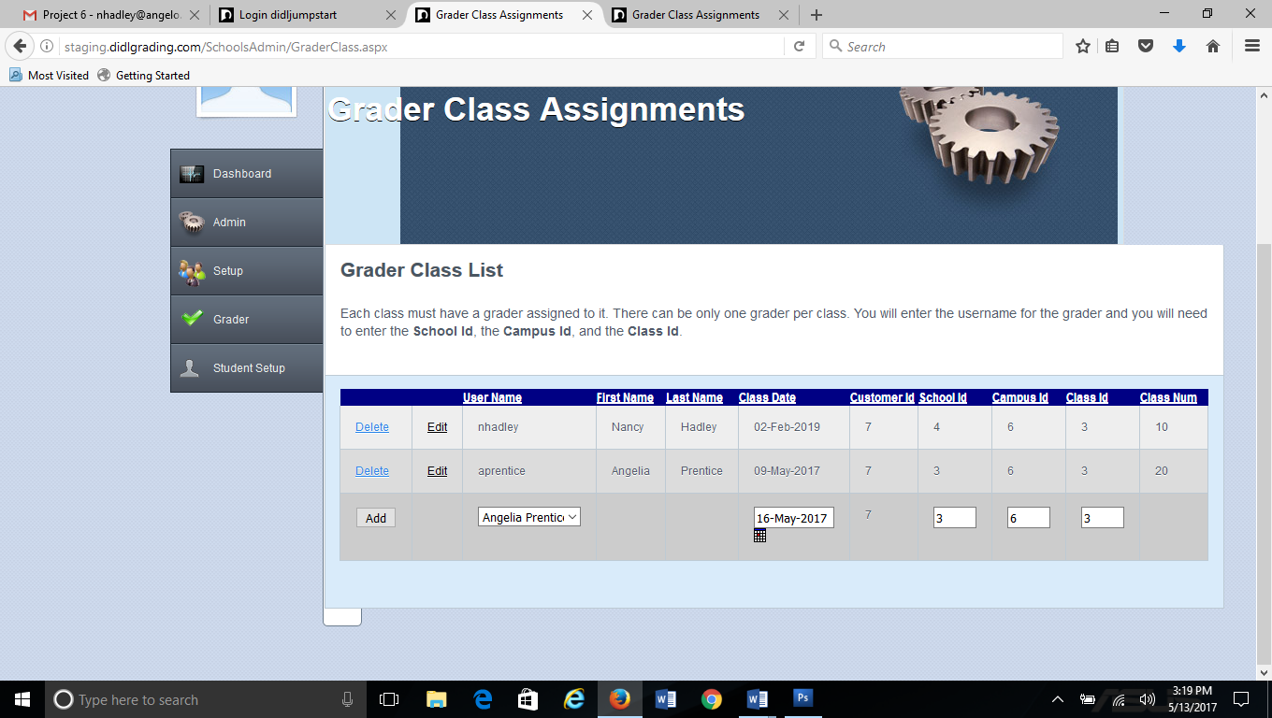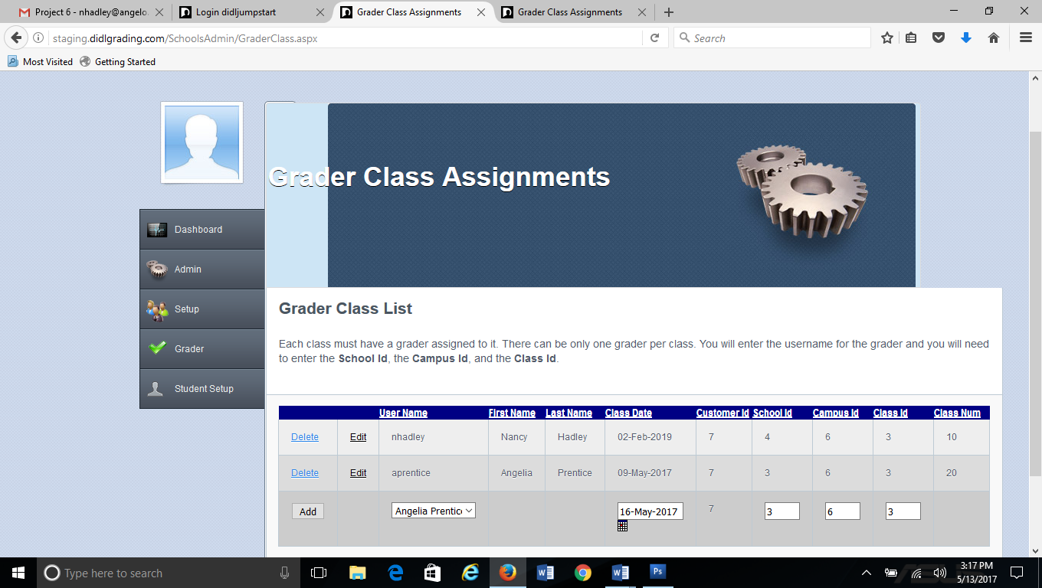

1. <http://staging.didlgrading.com/SchoolsAdmin/EnrollClass.aspx> (#3 on Project 6). The previous program had the ability to sort by the column headers, so the page could be ordered. The program needs to still have that capability. Also, the last name, first names that appear in the box should be filtered by customer Id of the username. This program filters by customerid =users customerid, so the names provide should also be filtered by customerid=users customerid. Also the list of names provided should be in last name, first name order and should be sorted by last name ascending.
2. <http://staging.didlgrading.com/admin/EnrollClass.aspx> (#4 on Project 6). The previous program had the ability to sort by the column headers, so the page could be ordered. The program needs to still have that capability. The list of names provided should be in last name, first name order and should be sorted by last name ascending.