SAM HIGGINBOTTOM UNIVERSITY OF AGRICULTURE, TECHNOLOGY AND SCIENCES
SHUATS, Prayagraj - 211007, Uttar Pradesh, India


M.Sc. GIS & REMOTE SENSING (SEMESTER-II)
Course: Advanced Spatial Statistics & GIS Analysis
SPATIAL AUTOCORRELATION & POINT PATTERN ANALYSIS

SUBMITTED BY:  N. Akshit Vinay  PID: 25MSRSGIS001  Program: M.Sc. GIS & Remote Sensing | SUBMITTED TO:  Mis. Arpita Esther  Dept. of Mathematics & Statistics

Table of Contents 2
SPATIAL AUTOCORRELATION 3
1.1 What is Spatial Autocorrelation? 3
1.2 The Dataset: 10×10 Grid 3
1.3 Spatial Weights Matrix (W) 4
1.4 Global Moran's I 4
1.5 Global Geary's C 6
1.6 Local Indicators of Spatial Association (LISA) 7
CHAPTER 2: POINT PATTERN ANALYSIS 9
2.1 Getis-Ord Gi* Hotspot Detection 9
2.2 Point Pattern Types 10
2.3 Nearest Neighbour Index (NNI) 10
2.4 Kernel Density Estimation (KDE) 11
2.5 Ripley's K and Besag's L-Function 12
KEY DEFINITIONS 13

SPATIAL AUTOCORRELATION

1.1 What is Spatial Autocorrelation?
- It measures whether similar values cluster together in space.
- Tobler's First Law:"Everything is related to everything else, but near things are more related than distant things."
- Example:Disease hotspots — high prevalence areas tend to be near other high prevalence areas.

1.2 The Dataset: 10×10 Grid
- Study Area:100 grid cells (10 rows × 10 columns)
- Variable:Disease prevalence (%)
- Pattern:One hotspot centered at cell (3,3) with values decreasing outward
- Why this pattern?:Simulated using a Gaussian (bell curve) decay from the center + random noise
Key Data Points to Remember:
- Hotspot center (3,3):81.65%
- Corner cell (0,0):28.40%
- Mean prevalence across all cells:~13.91%
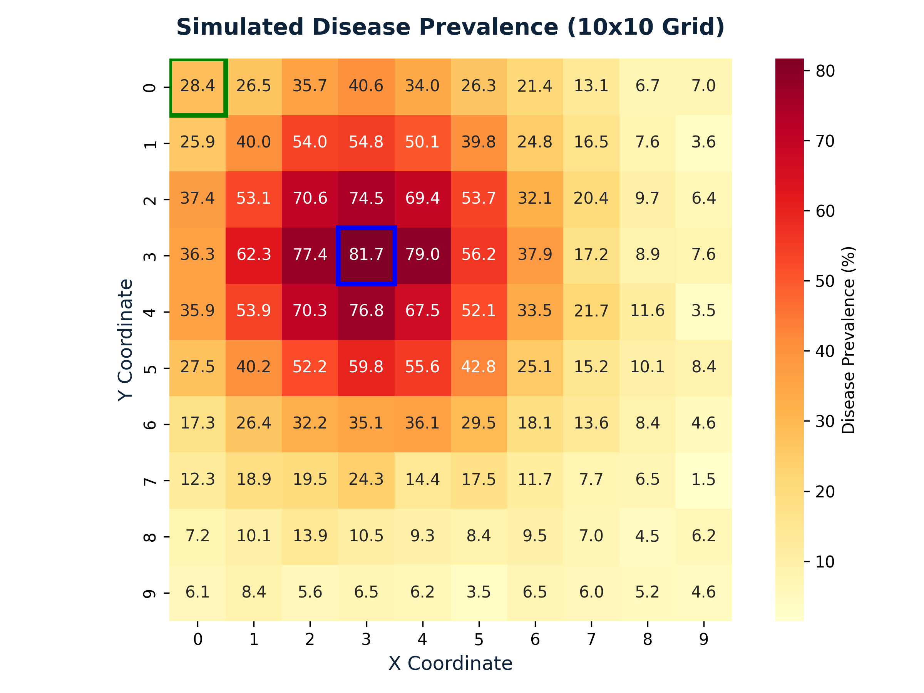
Figure 1: Simulated disease prevalence on a 10x10 grid with a clear hotspot centered at (3,3).

1.3 Spatial Weights Matrix (W)
- A table showing which cells are "neighbors" of each other
- Queen Contiguity Rule:Two cells are neighbors if they share an edge OR a corner (up to 8 neighbors)
Types of Cells:
Cell Location | Number of Neighbors | Example
Interior cells | 8 | Cell (4,4)
Edge cells (not corners) | 5 | Cell (0,4)
Corner cells | 3 | Cell (0,0)
Important Number to Remember:
- S₀ = 684:total neighbor connections in the entire grid
This number is used in ALL global statistics.
Row-Standardization:
- Rule:Each neighbor gets equal weight = 1 ÷ (number of neighbors)
- Interior cell:weight = 1/8 = 0.125
- Corner cell:weight = 1/3 = 0.333
Corner cells have fewer neighbors, so each neighbor matters more. This creates "edge effects."

1.4 Global Moran's I
Whether the entire map shows clustering, dispersion, or randomness.
Formula (simplified):
$$I=\frac{N}{S_{0}}·\frac{\sum_{i=1}^{N}{\sum_{j=1}^{N}{w_{ij}\left(x_{i}-x̄\right)\left(x_{j}-x̄\right)}}}{\sum_{i=1}^{N}{{\left(x_{i}-x̄\right)}^{2}}}$$
In Plain:
- Numerator:how much neighbors vary together
- Denominator:total variation in the data
- If neighbors are similar:Positive I (clustering)
- If neighbors are different:Negative I (dispersion)

Results from Assignment:
Statistic | Value | Meaning
Observed I | 0.360 | Positive clustering
Expected I | -0.010 | Value if random
Z-score | 7.13 | Highly significant
p-value | 1.03 × 10⁻¹² | Reject randomness
Z > 1.96 means significant at 95% confidence. Our Z = 7.13 is extremely significant!

Moran Scatterplot:
- X-axis:Prevalence at each cell (standardized)
- Y-axis:Average prevalence of neighbors
- Slope of the line:Moran's I value (~0.36)
- Most points in:upper-right (high-high) and lower-left (low-low) = clustering
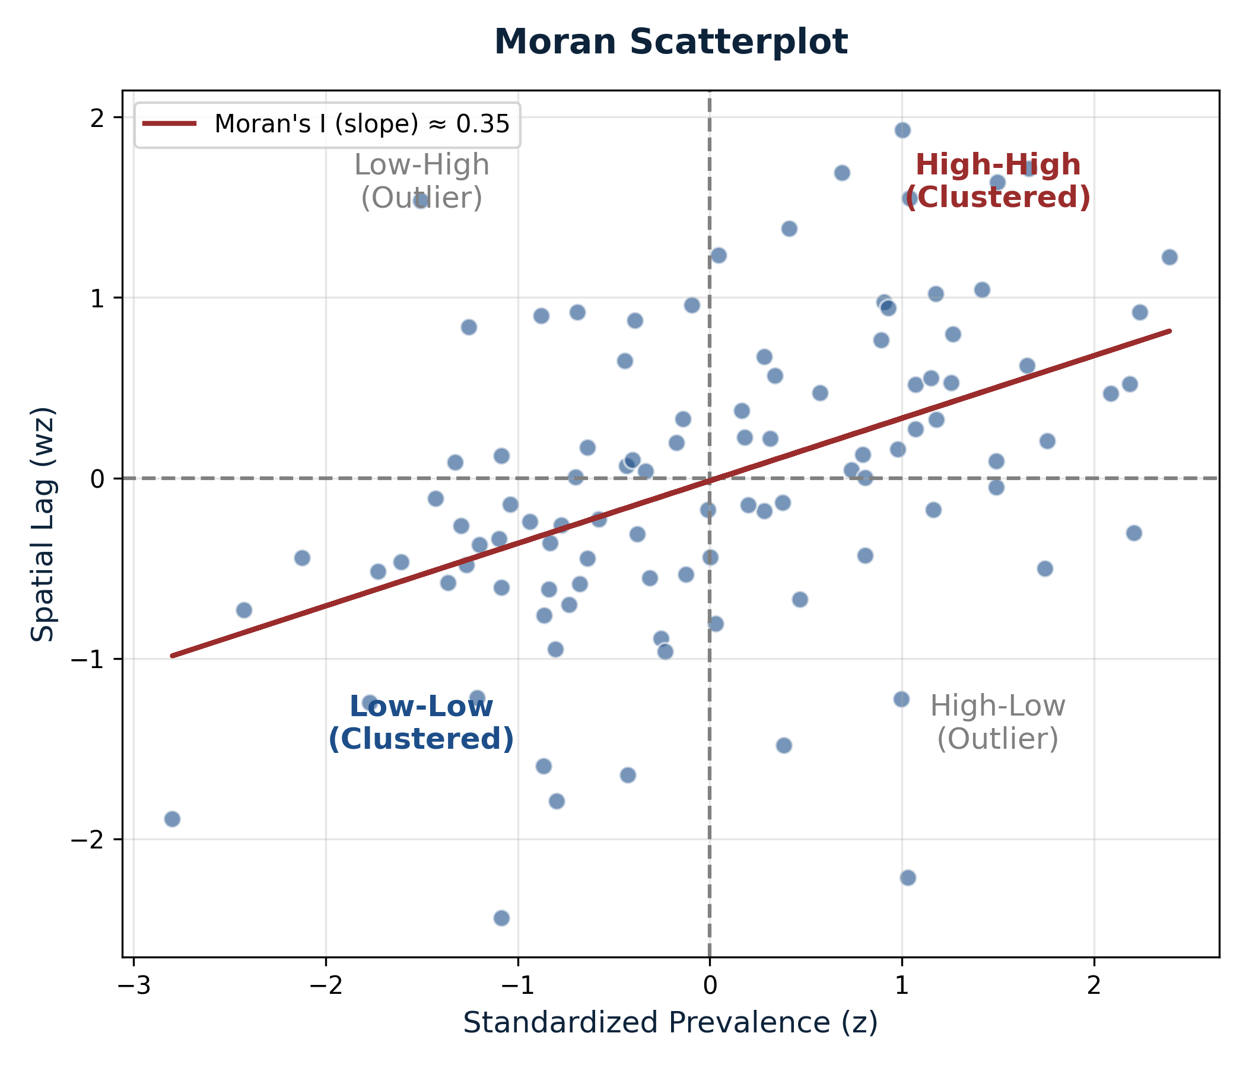
Figure 2: Moran scatterplot showing positive spatial autocorrelation (clustering).

1.5 Global Geary's C
Global Geary's C states Another way to measure spatial autocorrelation, but focuses on differences between neighbors (not deviations from mean).
Formula:
$$C=\frac{\left(N-1\right)}{2·S_{0}}·\frac{\sum_{i=1}^{N}{\sum_{j=1}^{N}{w_{ij}{\left(x_{i}-x_{j}\right)}^{2}}}}{\sum_{i=1}^{N}{{\left(x_{i}-x̄\right)}^{2}}}$$
Key Difference from Moran's I:
Feature | Moran's I | Geary's C
Focus | Deviations from mean | Differences between neighbors
Range | -1 to +1 | 0 to 2
Expected under randomness | -1/(N-1) ≈ -0.01 | 1.0
Positive autocorrelation | I > Expected | C < 1.0
Negative autocorrelation | I < Expected | C > 1.0
Results from Assignment:
Statistic | Value | Meaning
Observed C | 0.670 | < 1.0 = positive clustering
Expected C | 1.000 | Random baseline
Z-score | -6.35 | Highly significant
p-value | 1.12 × 10⁻¹⁰ | Strong clustering
C < 1 always means clustering. C > 1 means dispersion. The further from 1, the stronger the pattern.

1.6 Local Indicators of Spatial Association (LISA)

LISA tells Global statistics give one number for the whole map. LISA tells you which specific cells are part of clusters.
Local Moran's I Formula:
$$I_{i}=\frac{z_{i}}{m_{2}}·\sum_{j=1}^{N}{w_{ij}z_{j}}$$
Where:
z_i = x_i - x̄ (deviation from mean),
m_2 = variance,
Σw_ij·z_j = spatial lag (average of neighbors).
Four Cluster Types (QUADRANTS):
Type | Name | Meaning | Example in Data
HH | High-High | High value surrounded by high values | Hotspot center (3,3)
LL | Low-Low | Low value surrounded by low values | Grid corners/edges
HL | High-Low | High value surrounded by low values | Outlier
LH | Low-High | Low value surrounded by high values | Outlier

Example Calculation for Cell (3,3):
- Value = 81.65%, Mean:13.91%
- z_i:81.65 - 13.91 = 67.74
- Neighbors range:55% to 75%
- Spatial lag:≈ 52.40
- I_i:(67.74 / 335.80) × 52.40 = 10.57 → HH Cluster
LISA uses FDR (False Discovery Rate) correction because testing 100 cells creates many chances for false positives.
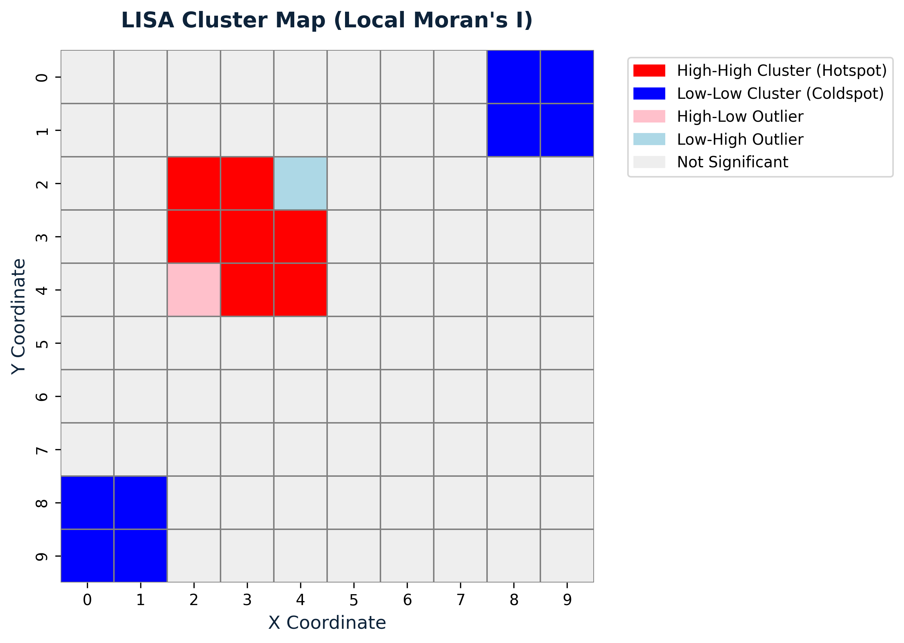
Figure 3: LISA Cluster map highlighting the High-High hotspot and Low-Low coldspots.

CHAPTER 2: POINT PATTERN ANALYSIS

2.1 Getis-Ord Gi* Hotspot Detection
What is Gi*?
- Identifies hotspots (clusters of high values) and coldspots (clusters of low values)
- Key difference from LISA:Gi* includes the cell itself (w_ii = 1), so it finds pure hotspots, NOT outliers
$$G_{i}^{*}=\frac{\sum_{j=1}^{N}{w_{ij}x_{j}}-X̄\sum_{j=1}^{N}{w_{ij}}}{S\sqrt{\frac{N\sum_{j=1}^{N}{{w_{ij}}^{2}}-{\left(\sum_{j=1}^{N}{w_{ij}}\right)}^{2}}{N-1}}}$$
Z-Score Interpretation:
Gi* Z-Score | Meaning | Confidence
> +1.96 | Hotspot | 95%
> +2.58 | Strong Hotspot | 99%
<< -1.96 | Coldspot | 95%
<< -2.58 | Strong Coldspot | 99%
Example for Cell (3,3):
- Local sum:≈ 538.5%
- Expected sum:13.91 × 9 = 125.2%
- Gi*:+7.74 → Extremely significant hotspot (99.9% confidence)
Example for Cell (0,0):
- Gi*:≈ -2.48 → Significant coldspot

2.2 Point Pattern Types
Three basic patterns for discrete points:
Pattern | Description | Cause | NNI Value
Clustered | Points grouped together | Shared resource, attraction | << 1
Random | No pattern | Independent events | = 1
Regular | Evenly spaced | Competition, repulsion | > 1

2.3 Nearest Neighbour Index (NNI)
Formula:
$$NNI=\frac{d_{obs}}{d_{exp}}$$
Where ;
d_obs = average distance to nearest neighbor,
d_exp = expected distance if random,
ρ = n/A = point density,
n = 80 points,
A = 100 units².
Calculation Steps:
1. Density:ρ = 80/100 = 0.8
2. Expected distance:d_exp = 0.5 / √0.8 = 0.559
3. Observed distance:d_obs = 0.312
4. NNI:0.312 / 0.559 = 0.558
5. Z-score:≈ -7.56
Conclusion: NNI < 1 → Significantly clustered pattern.
NNI is a "first-order" statistic — it only looks at the closest neighbor. Use Ripley's K for multiple scales.

2.4 Kernel Density Estimation (KDE)
Purpose: Converts discrete points into a smooth, continuous surface showing where points are concentrated.
Gaussian KDE Formula:
$$\hat{f}\left(x\right)=\frac{1}{nh}\sum_{i=1}^{n}{K\left(\frac{x-x_{i}}{h}\right)}$$
- Key Parameter (Bandwidth h):
- Small h:sharp peaks (shows detail but noisy)
- Large h:smooth surface (hides local patterns)
- This study:uses h = 1.5 units
Result: Density surface peaks at the bottom-left hotspot, matching the prevalence cluster.
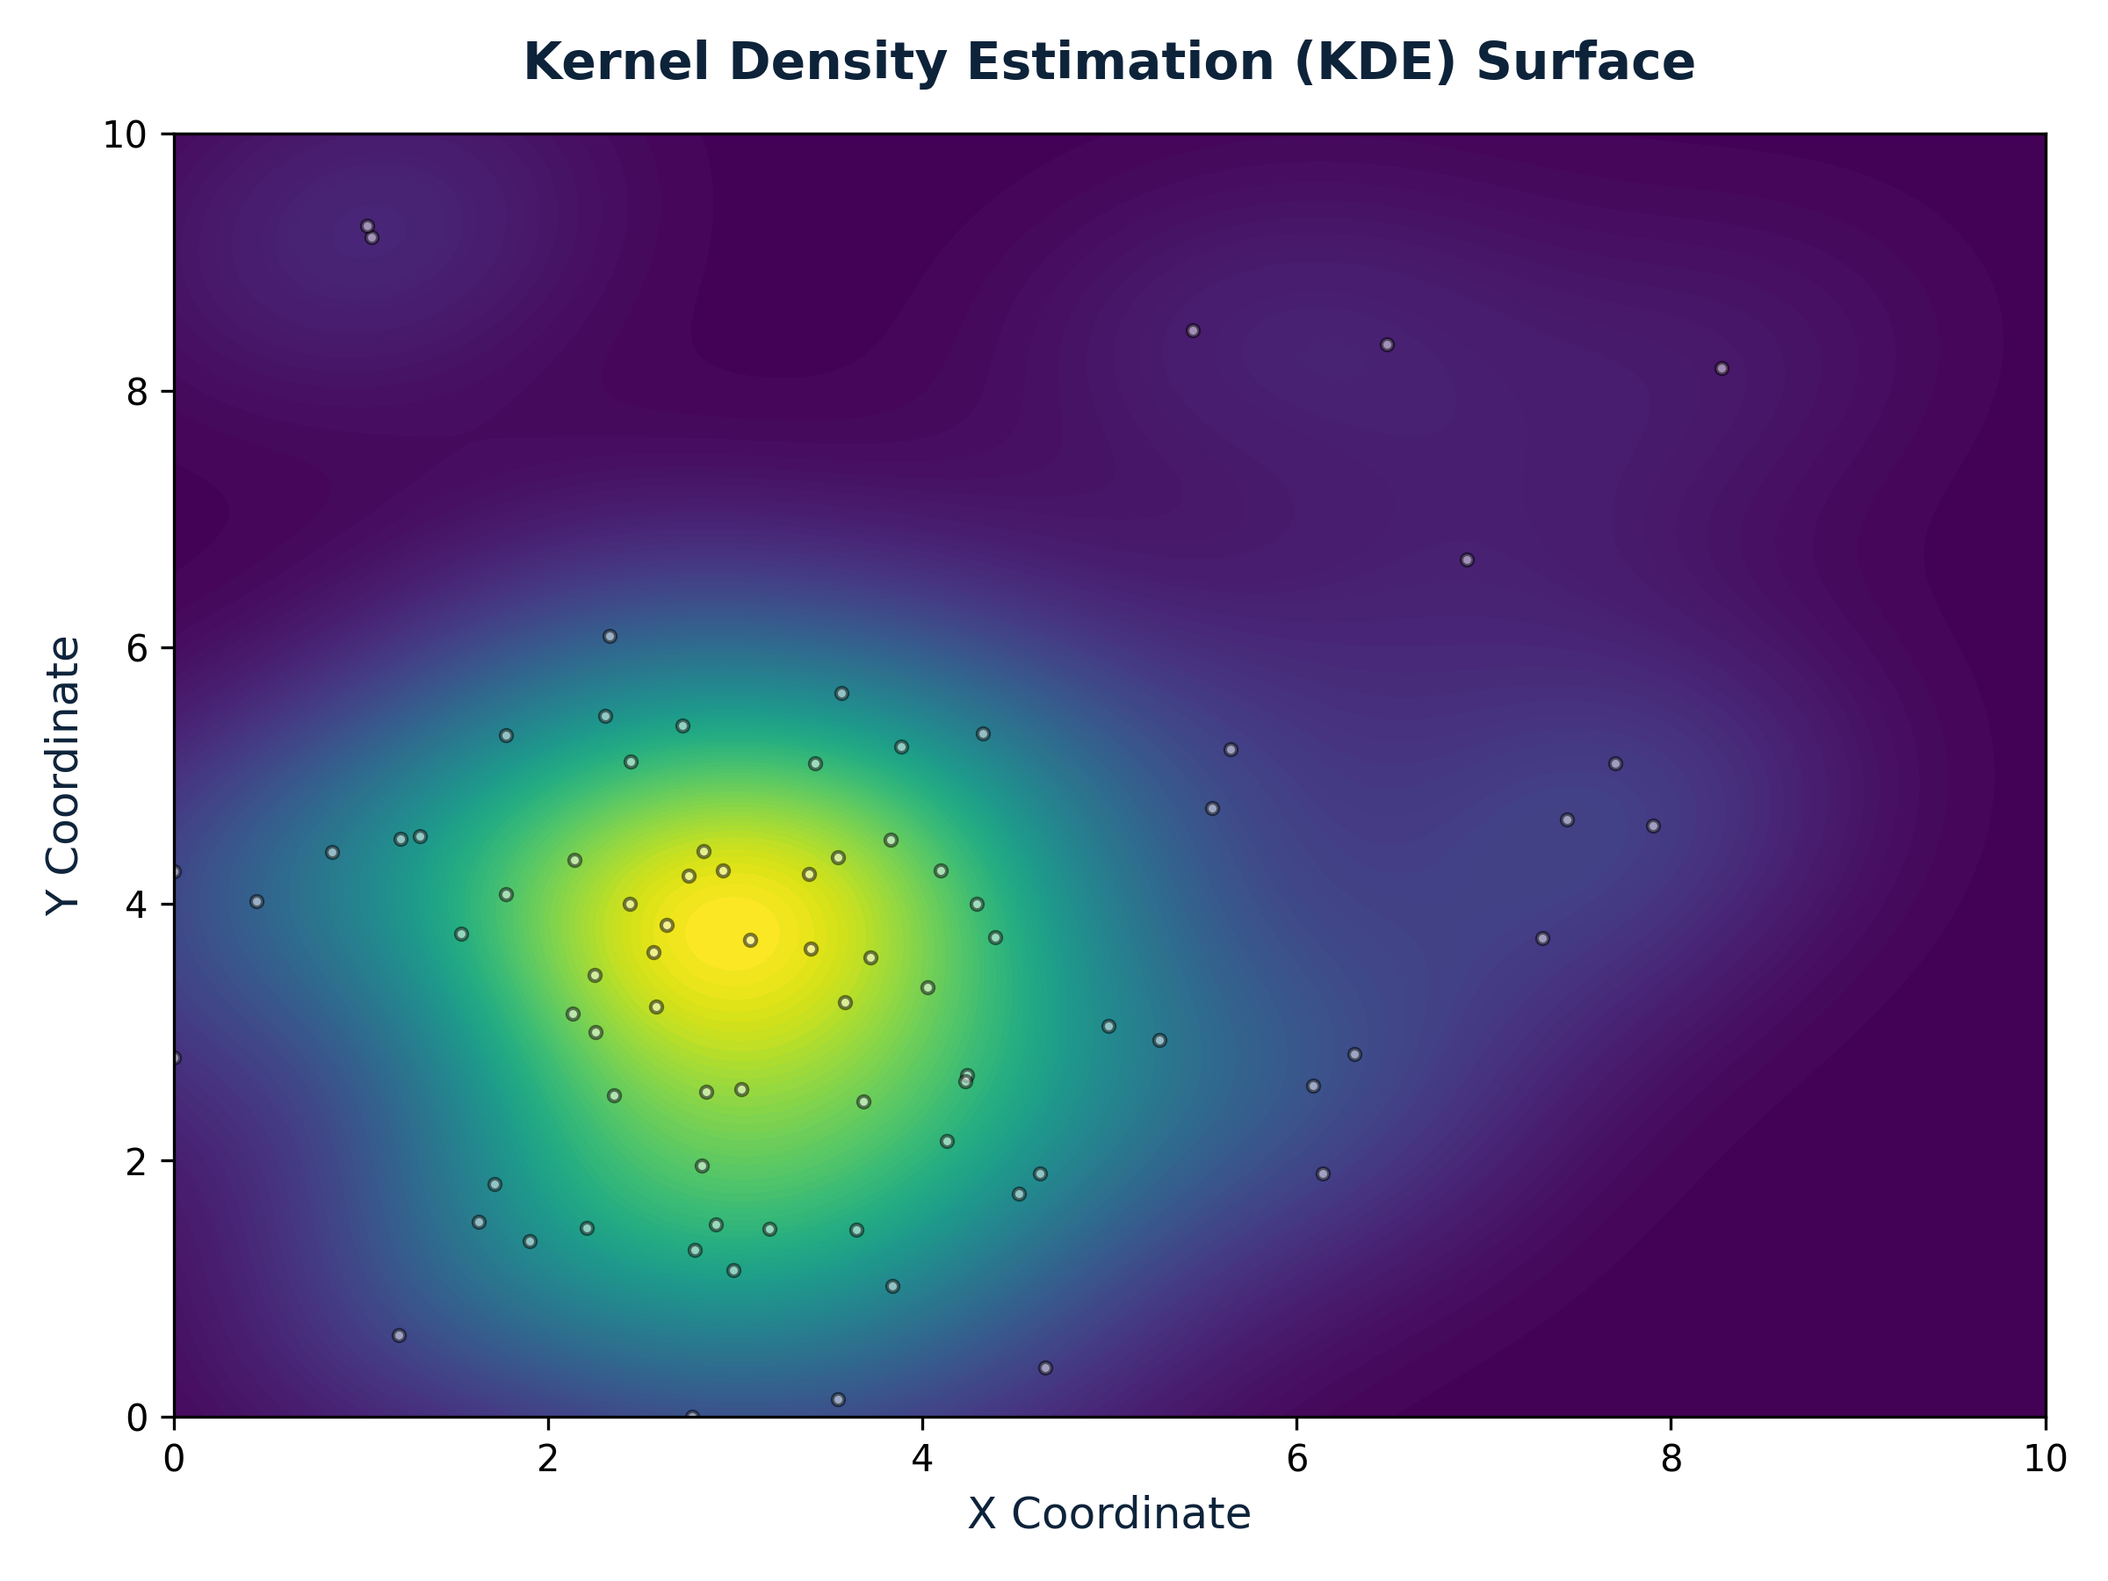
Figure 4: Kernel Density Estimation surface showing continuous hotspot concentration.

2.5 Ripley's K and Besag's L-Function
NNI only checks one distance. Ripley's K checks all distances (multi-scale analysis).
Formulas:
$$K\left(r\right)=\frac{A}{n^{2}}·\sum_{i=1}^{n}{\sum_{j≠i}^{n}{w_{ij}·I\left(d_{ij}≤r\right)}}$$
$$L\left(r\right)=\sqrt{\frac{K\left(r\right)}{π}}-r$$
Interpretation of L(r):
L(r) Value | Meaning
L(r) = 0 | Complete Spatial Randomness
L(r) > 0 | Clustering at distance r
L(r) < 0 | Dispersion at distance r
Results from Assignment:
At r = 1.0:L(r) = +0.42 → Significant small-scale clustering
At r = 2.5:L(r) = +1.28 (peak) → Main clustering scale
At r > 4.0:Still above envelope → Global clustering pattern
The peak at r = 2.5 tells us the hotspot is about 2.5 units wide. Edge correction (w_ij) is needed because circles near boundaries are cut off.
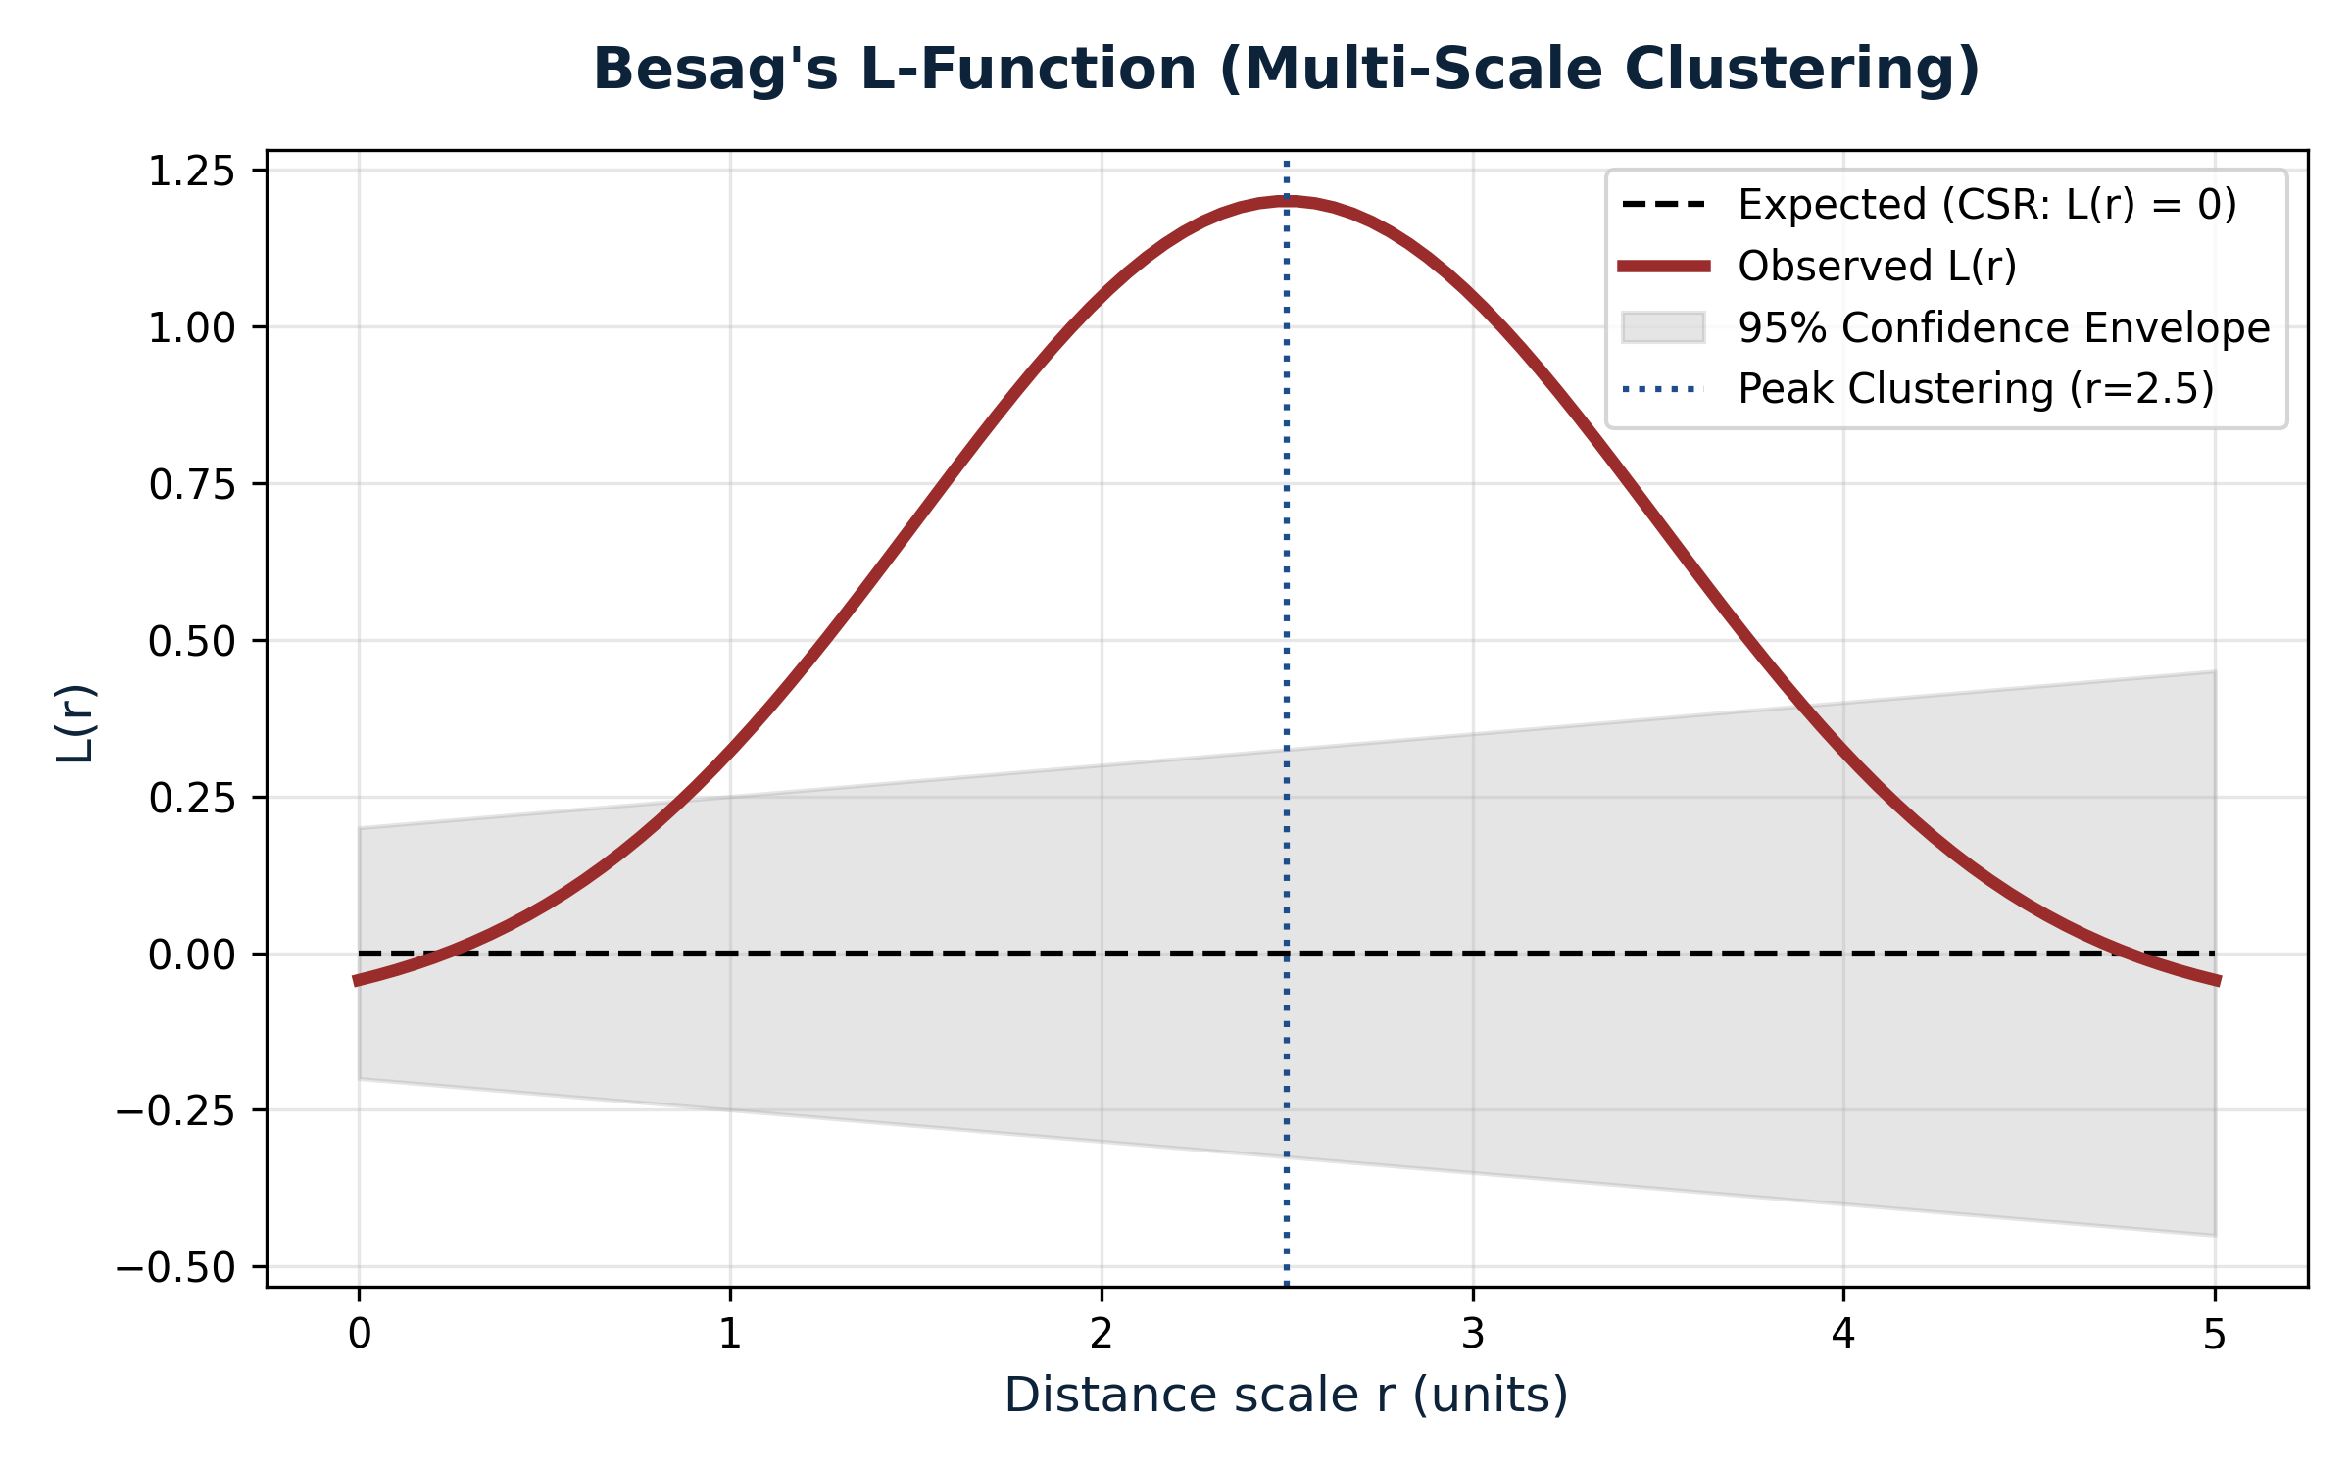
Figure 5: Besag's L(r) function showing significant multi-scale clustering peaking at r = 2.5

KEY DEFINITIONS
Term | Simple Definition
Spatial Autocorrelation | Correlation of a variable with itself across space
Queen Contiguity | Neighbors share edge OR corner (up to 8)
Rook Contiguity | Neighbors share only edge (up to 4)
Spatial Lag | Weighted average of neighbor values
Row-Standardization | Dividing weights so each row sums to 1
Hotspot | Statistically significant cluster of high values
Coldspot | Statistically significant cluster of low values
LISA | Local Indicator of Spatial Association
FDR Correction | Adjusts p-values for multiple testing



