HEART DISEASE DIAGNOSTIC-ANALYSIS

# DETAILED PROJECT REPORT

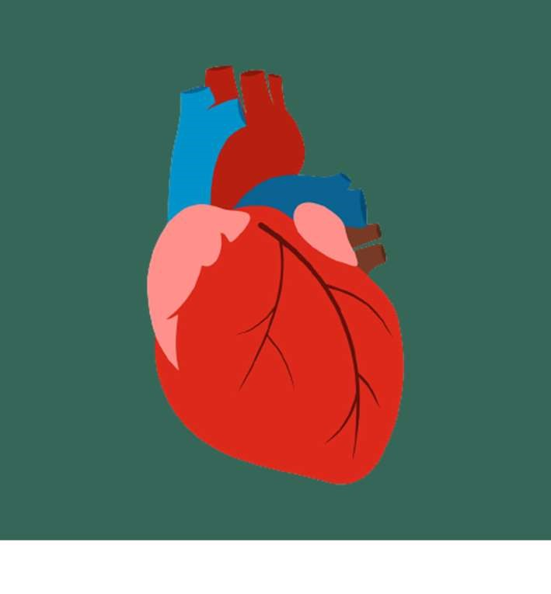

Viraj 21csu341

# PROJECT DETAIL

|  |  |
| --- | --- |
| Project Title | Heart Disease Diagnostic – Analysis |
| Technology | Business Intelligence |
| Domain | Healthcare |
| Project Difficulty Level | Advanced |
| Programming Language Used | Python |
| Tools Used | Jupyter Notebook, MS-Excel, MS- Power BI |

# OBJECTIVE

○ The goal of this project is to analyse the heart disease occurrence, based on a combination of features that describes the heart disease.

# PROBLEM STATEMENT

➢Health is real wealth in the pandemic time we all realized the brute effects of covid-19 on all irrespective of any status. You are required to analyse this health and medical data for better future preparation.

➢ A dataset is formed by taking into consideration some of the information of 303 individuals.

# ARCHITECTURE

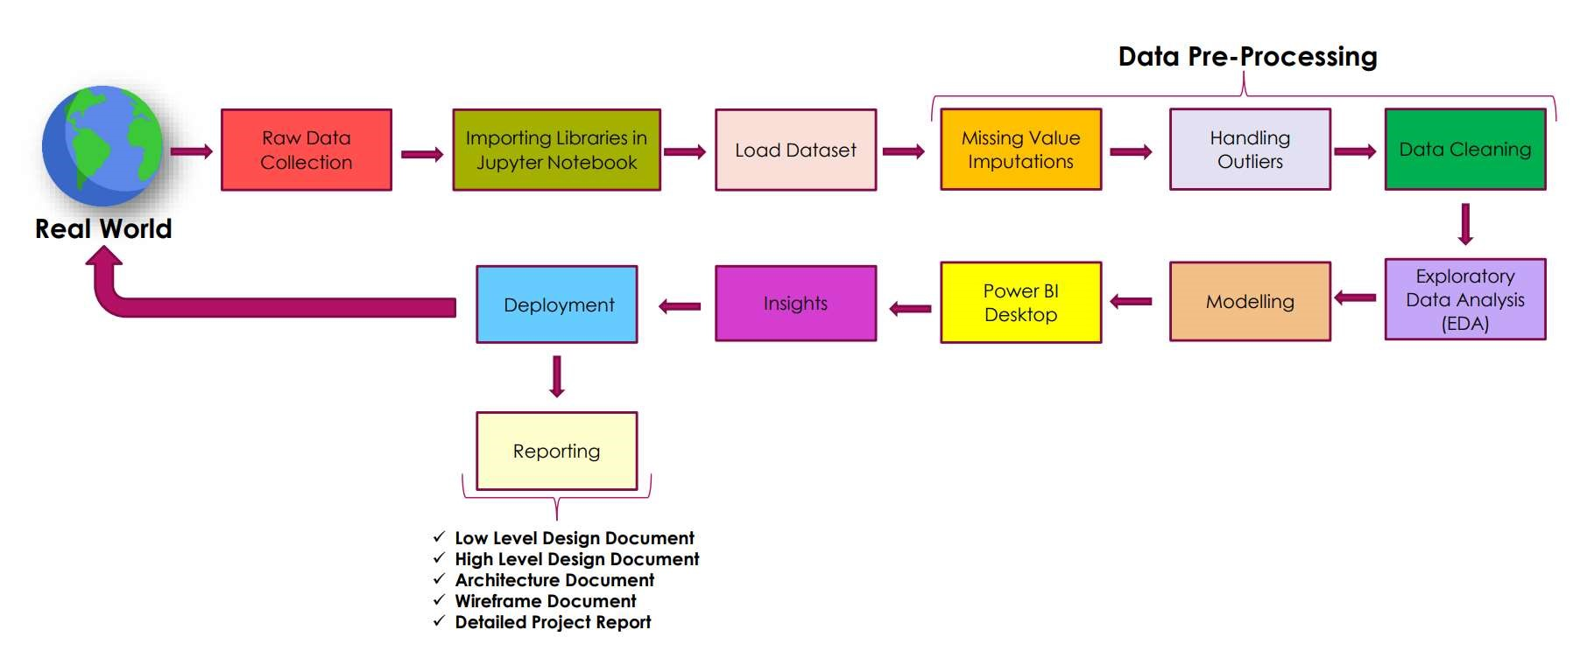

# DATASET INFORMATION

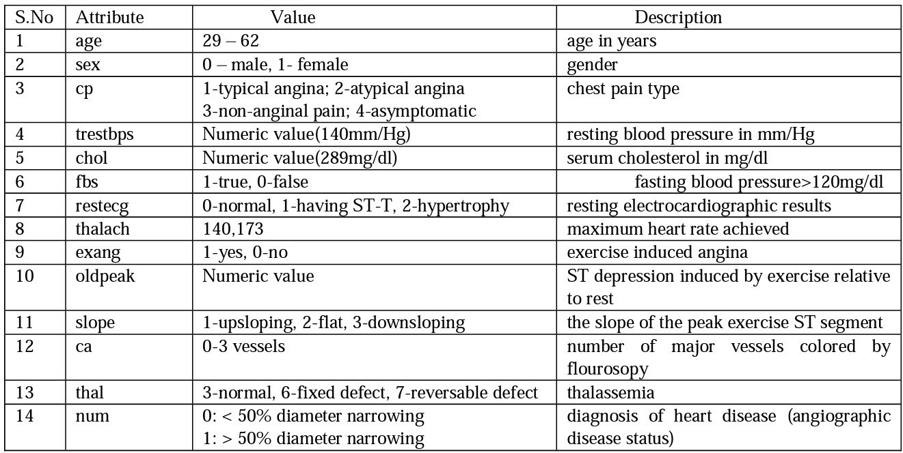

# INSIGHTS

What kind of population do we have ?

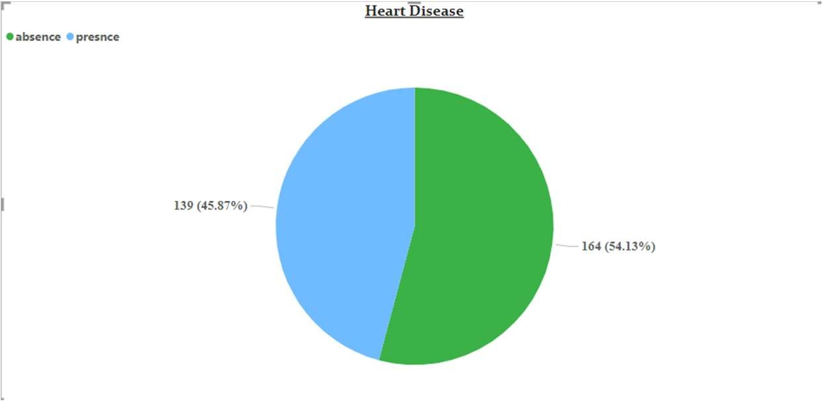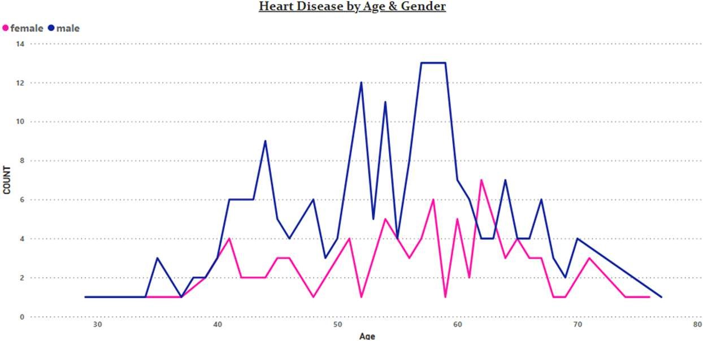

✓

45.87

% People are suffering from heart disease.

✓

Old Aged Men are more (50 to 60 Years) and Females

are more in 55 to 65 Years Category.

Who Suffers from Heart Disease?

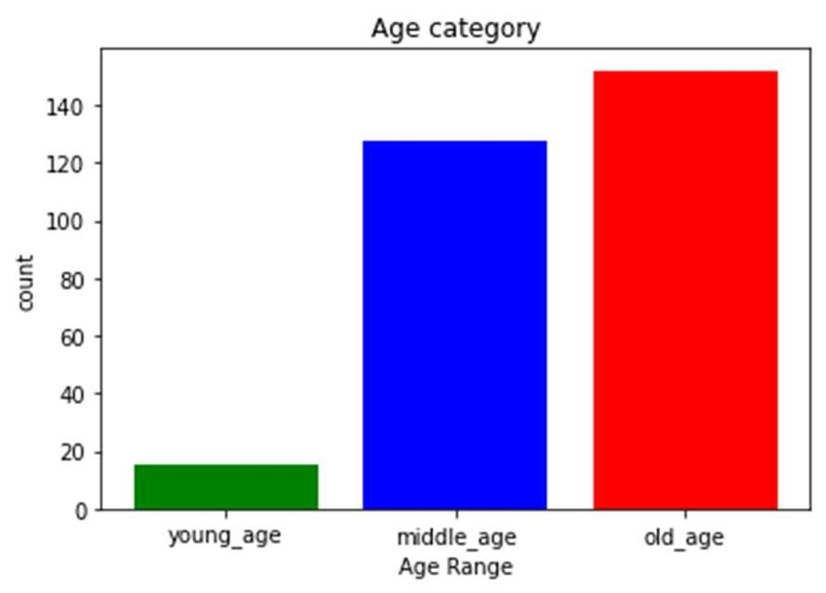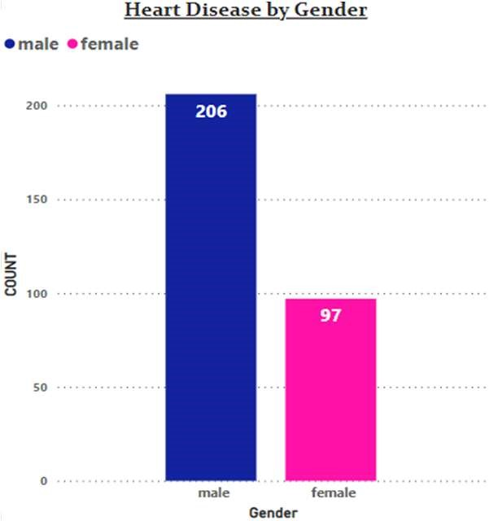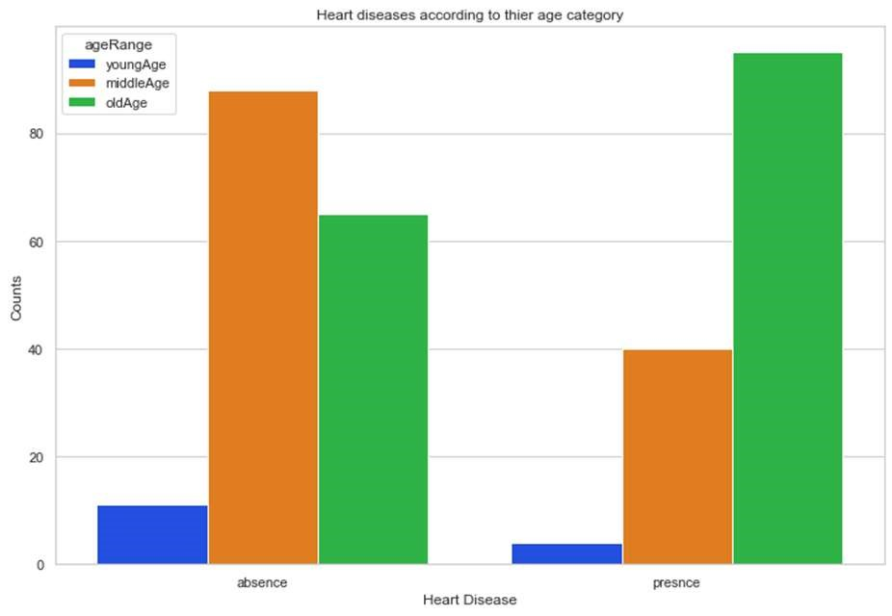

✓

Elderly Aged People (>55) are

✓

Elderly Aged People (>55) are

✓

Males are more prone

more in our population to heart disease. more prone to heart disease.

## Chest Pain Experienced By Patients

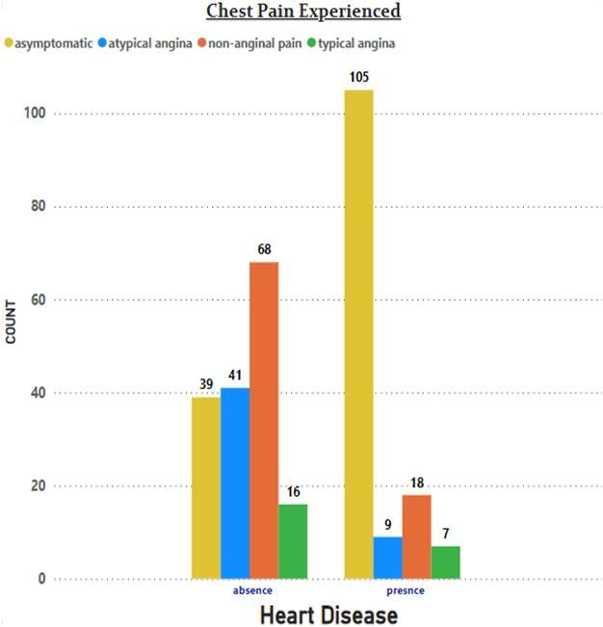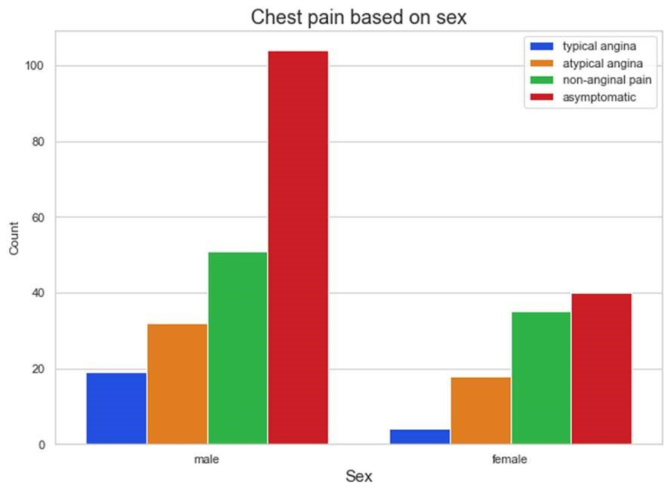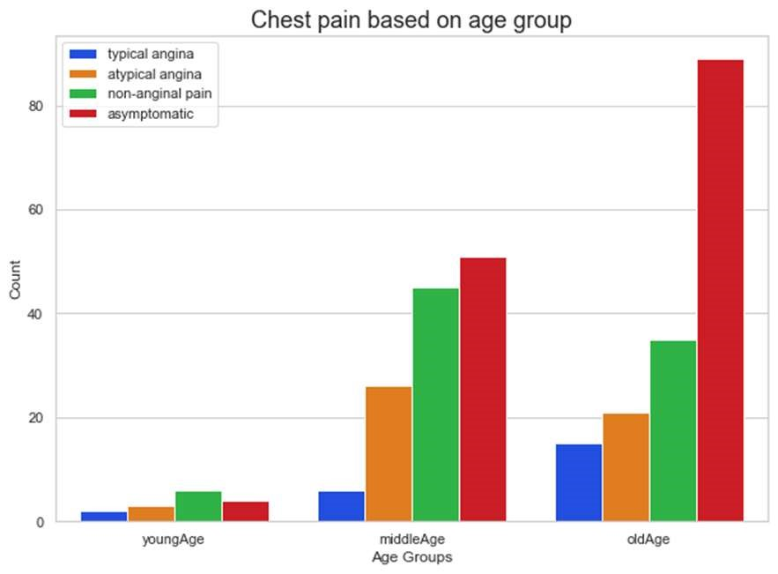

✓

It

seems

people

having

asymptomatic chest pain

✓

We can see that a higher number of men

✓

There

is

very

high

number

of

are suffering from Asymptomatic type Asymptomatic Pain in Elderly age

have a higher chance of

of Chest Pain Category

heart disease.

Asymptomatic Chest pain means neither causing nor exhibiting symptoms of heart disease.

### Other symptoms people experience in heart disease

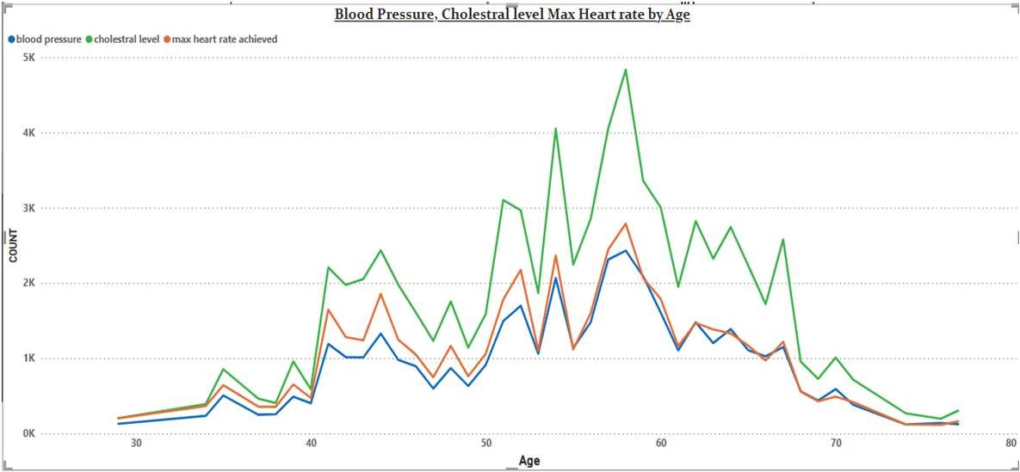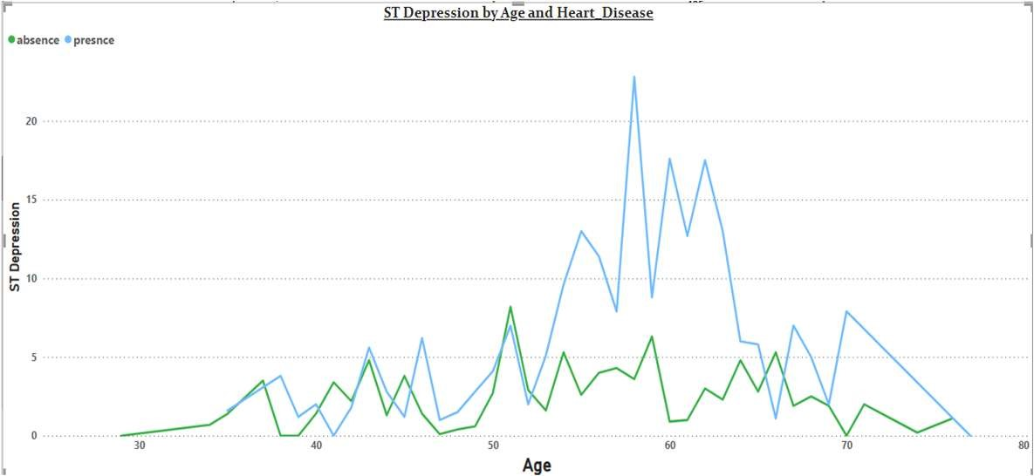

1

. Here we can observe that Blood Pressure increases

between age of 50 to 60 and somehow continue the

pattern till 70.

2

. Similarly,

Cholesterol

and

maximum

heart

rate

Increasing in the age group of 50-60.

1

. we can observe from here that ST depression mostly

increases between the age group of 30-40.



ST

depression

refers

to

a

finding

on

an

electrocardiogram, wherein the trace in the ST

segment is abnormally low below the baseline.

# KEY PERFORMANCE INDICATOR (KPI)

1. Percentage of People Having Heart Disease.
2. Heart Disease based on Age and Gender.
3. Gender Distribution Based on Heart Disease.
4. Chest Pain Experienced by People Suffering from Heart Disease.
5. Blood Pressure, Cholesterol Level and Maximum Heart Rate of People According to their Age and Heart Disease Patients.
6. ST Depression Experienced by People According to their age and Heart Disease.

# CONCLUSION

* 45.87% People suffering from heart disease.
* Elderly Aged Men are more (50 to 60 Years) and Females are more in 55 to 65 Years Category ➢ Males are more prone to heart disease.
* Elderly Aged People are more prone to heart disease.
* People having asymptomatic chest pain have a higher chance of heart disease.
* High number of cholesterol level in people having heart disease.
* Blood Pressure increases between age of 50 to 60 and somehow continue till 70.
* Cholesterol and maximum heart rate Increasing in the age group of 50-60.
* ST depression mostly increases between the age group of 30-40.

# Q & A

Q1) What’s the source of data?

Ans) The Dataset was taken from iNeuron’s Provided Project Description Document.

https://www.drive.google.com/drive/folders/165Pjmfb9W9PGy0rZjHEA22LW0Lt3Y-Q8

Q2) What was the type of data?

Ans) The data was the combination of numerical and Categorical values.

Q 3) What’s the complete flow you followed in this Project?

Ans) Refer slide 5th for better Understanding

Q4) What techniques were you using for data?

Ans) -Removing unwanted attributes :-

* Visualizing relation of independent variables with each other and output variables
* Removing outliers
* Cleaning data and imputing if null values are present.
* Converting Numerical data into Categorical values.

Q 6) What were the libraries that you used in Python?

Ans) I used Pandas, NumPy, Matplotlib and Seaborn libraries in Pandas.