Low Level Design (LLD)

# Heart Disease Diagnostics Analysis



Viraj 21csu341

Document Version Control

|  |  |  |  |  |  |  |
| --- | --- | --- | --- | --- | --- | --- |
| TABLE OF CONTENTS |  |  |  |  |  | PAGE NO. |

|  |  |
| --- | --- |
| DOCUMENT VERSION CONTROL | 2 |
| 1.0 INTRODUCTION | 5 |
| 1.1 What is Low Level Design Document?  1.2 Scope  1.3 Project Introduction |  |
| 2.0 PROBLEM STATEMENT |  |
|  |  |
| 3.0 DATASET INFORMATION |  |
|  |  |
| 4.0 ARCHITECTURE |  |

4.1 Architecture Description

## 1.0 Introduction

1.1 What is Low Level Design Document?

The goal of the Low-level design document (LLDD) is to give the internal logic design of the actual program code for the Heart Disease Diagnostic Analysis dashboard. LLDD describes the class diagrams with the methods and relations between classes and programs specs. It describes the modules so that the programmer can directly code the program from the document.

1.2 What is Scope?

Low-level design (LLD) is a component-level design process that follows a stepby-step refinement process. The process can be used for designing data structures, required software architecture, source code and ultimately, performance algorithms. Overall, the data organization may be defined during requirement analysis and then refined during data design work.

1.3 Project Introduction

Heart disease is a term covering any disorder of the heart. Heart diseases have become a major concern to deal with as studies show that the number of deaths due to heart diseases have increased significantly over the past few decades in India it has become the leading cause of death in India. A study shows that from 1990 to 2016 the death rate due to heart diseases have increased around 34% from 155.7 to 209.1 deaths per 1 lakh population in India.

Thus, preventing heart diseases has become more than necessary. Good datadriven systems for predicting heart diseases can improve the entire research and prevention process, making sure that more people can live healthy lives.

## 2.0 Problem Statement

Health is real wealth in the pandemic time we all realized the brute effects of covid-19 on all irrespective of any status. You are required to analyse this health and medical data for better future preparation. A dataset is formed by taking into consideration some of the information of 303 individuals.

## 3.0 Dataset Information

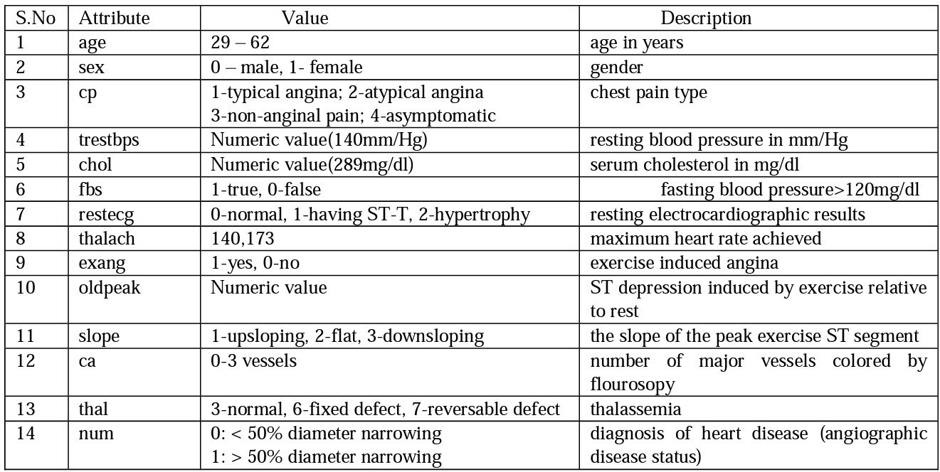

## 4.0 Architecture

|  |
| --- |
| Raw Data  Collection |

|  |
| --- |
| Data  Cleaning |

|  |
| --- |
| Deployment |



Real World



Data Pre-

processing

Modelling

Exploratory

Data



Reporting

## 4.1 Architecture Description

1.0 Raw Data Collection

The Dataset was taken from iNeuron’s Provided Project Description Document. https://drive.google.com/drive/folders/165Pjmfb9W9PGy0rZjHEA22LW0Lt3YQ8

### 2. Data Pre-Processing

Before building any model, it is crucial to perform data pre-processing to feed the correct data to the model to learn and predict. Model performance depends on the quality of data feed to the model to train.

This Process includes-

1. Handling Null/Missing Values
2. Handling Skewed Data
3. Outliers Detection and 0Removal

### 3. Data Cleaning

Data cleaning is the process of fixing or removing incorrect, corrupted, incorrectly formatted, duplicate, or incomplete data within a dataset.

1. Remove duplicate or irrelevant observations
2. Filter unwanted outliers
3. Renaming required attributes

### 4. Exploratory Data Analysis (EDA)

Exploratory Data Analysis refers to the critical process of performing initial investigations on data to discover patterns, spot anomalies, test hypothesis and to check assumptions with the help of summary statistics and graphical representations.

### 5. Reporting

Reporting is a most important and underrated skill of a data analytics field. Because being a Data Analyst you should be good in easy and self-explanatory report because your model will be used by many stakeholders who are not from technical background.

1. High Level Design Document (HLD)
2. Low Level Design Document (LLD)
3. Architecture
4. Wireframe
5. Detailed Project Report
6. Power Point Presentation

### 6. Modelling

Data Modelling is the process of analysing the data objects and their relationship to the other objects. It is used to analyse the data requirements that are required for the business processes. The data models are created for the data to be stored in a database. The Data Model's main focus is on what data is needed and how we have to organize data rather than what operations we have to perform.

### 7. Deployment

We created a Power BI Dashboard

