Wireframe Document

# Heart Disease Diagnostics Analysis



Viraj 21csu341

Document Version Control

We Performed Exploratory Data Analysis on Jupyter Notebook and then created a Power BI Desktop Dashboard.

1.

What Kind of Population do we have?

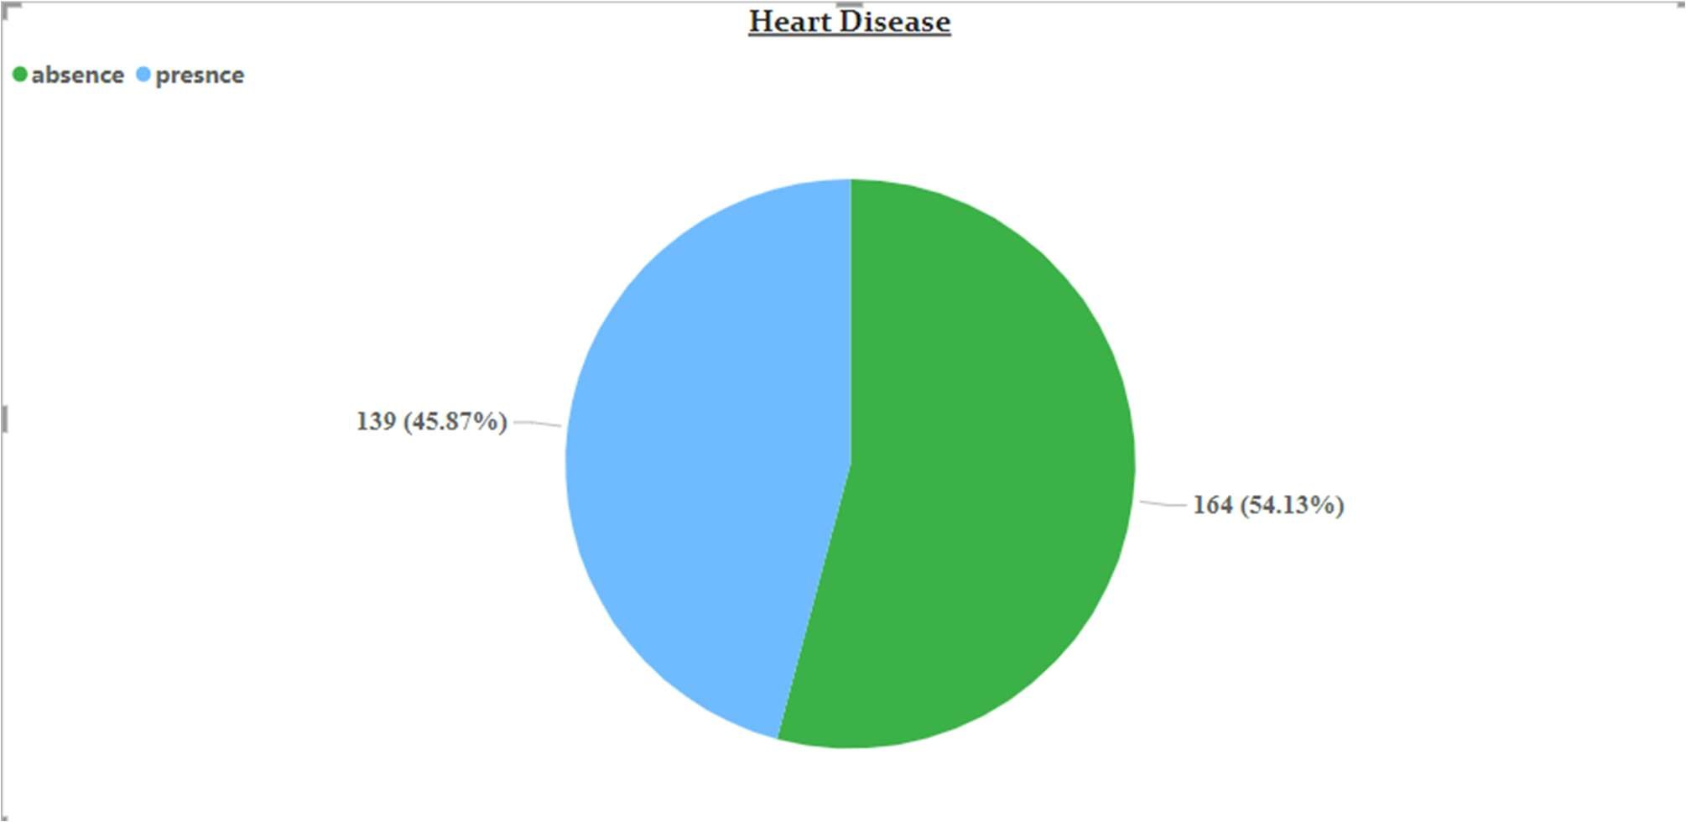

* 45.87% People are suffering from heart disease.

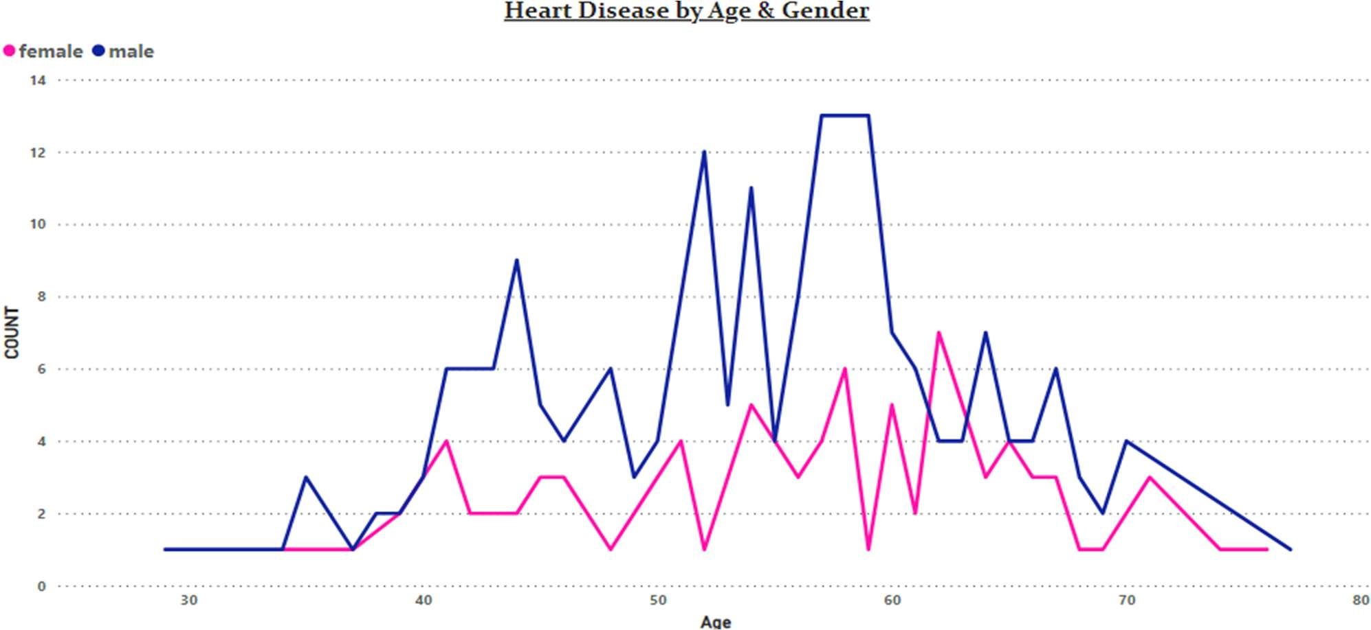

* Old Aged Men are more (50 to 60 Years) and Females are more in 55 to 65 Years

Category.

2. Who Suffer from Heart Disease?

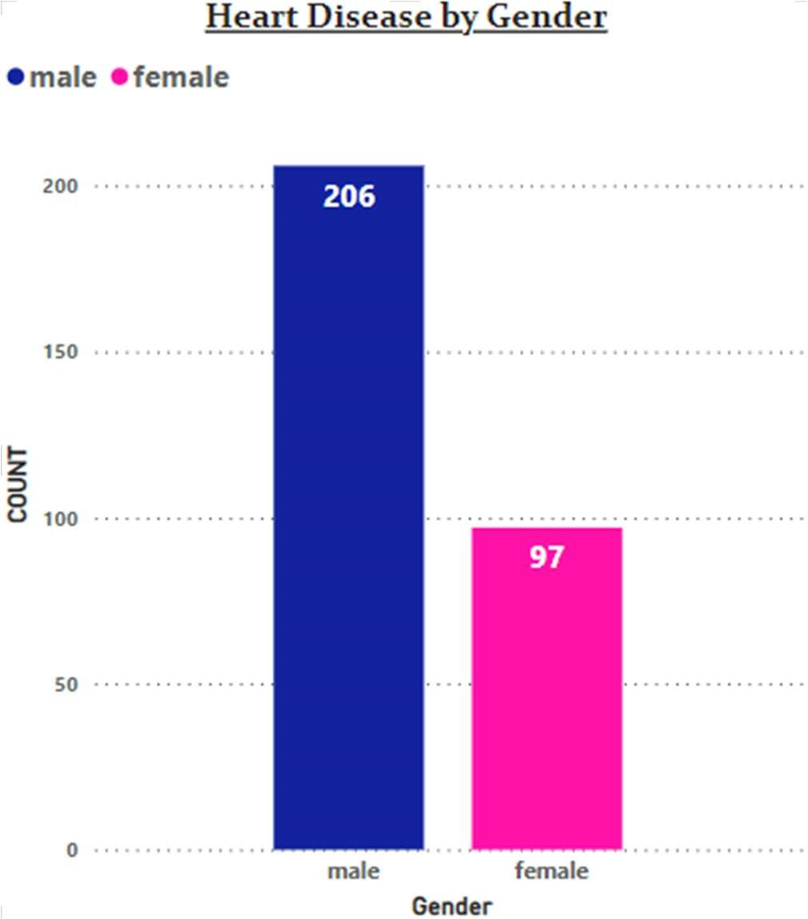

* Males are more prone to heart disease.

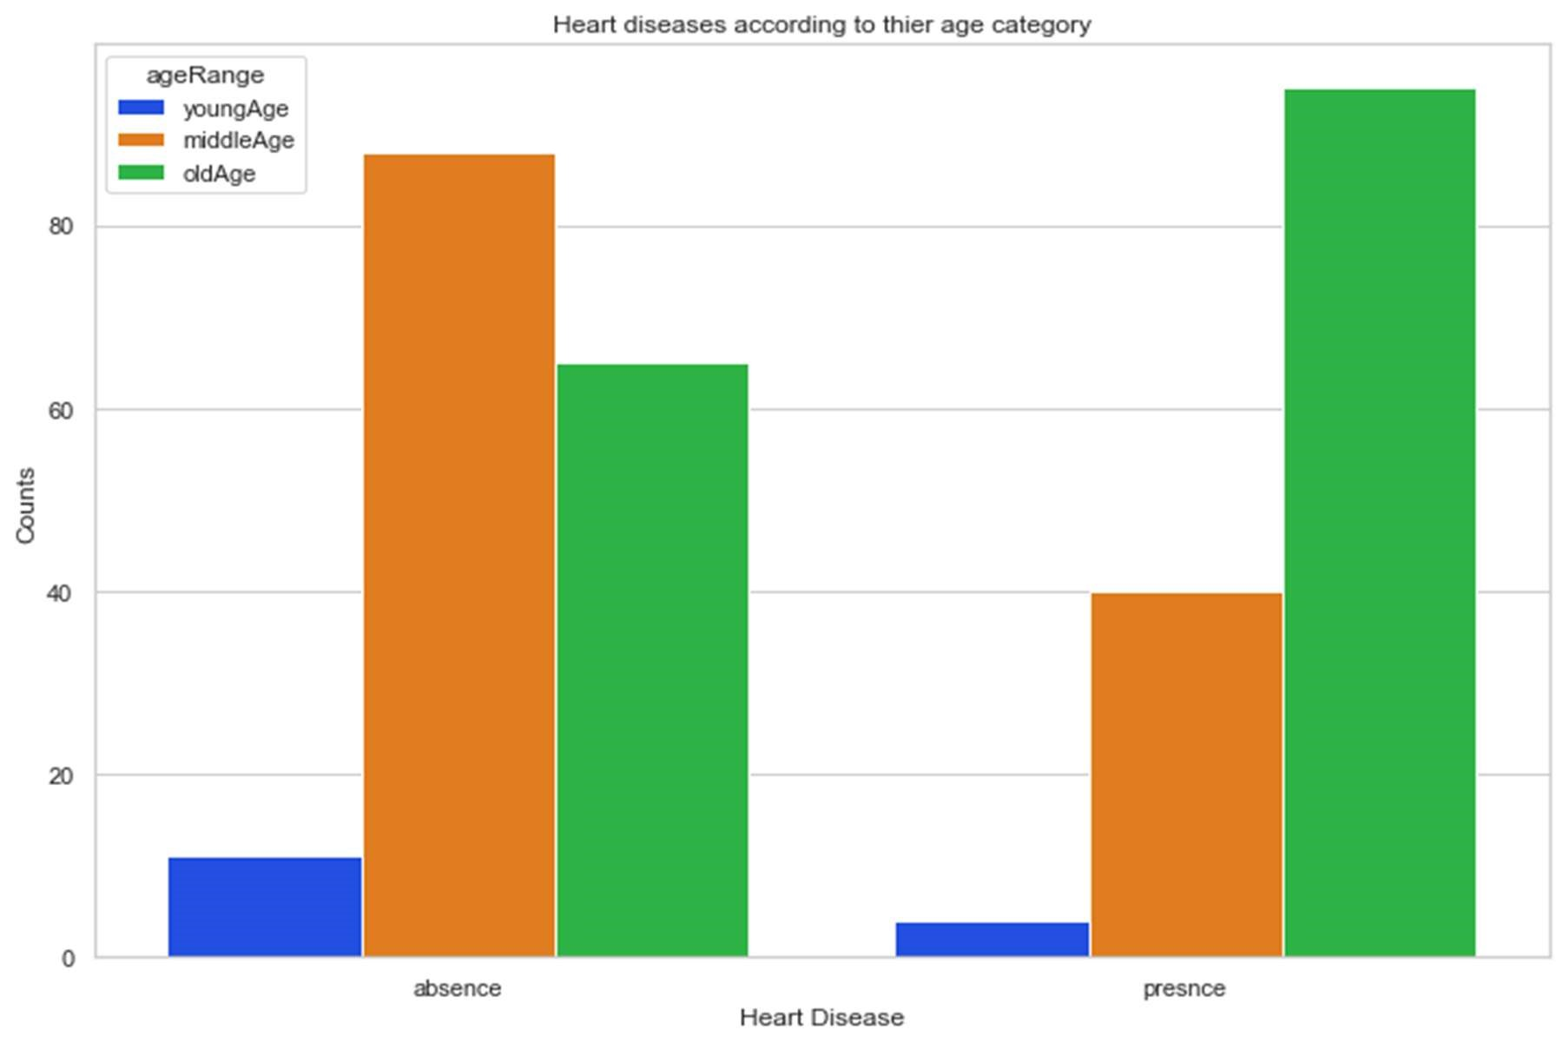

* Old Aged people are more prone to heart disease.

3. What symptoms people experience in heart disease?

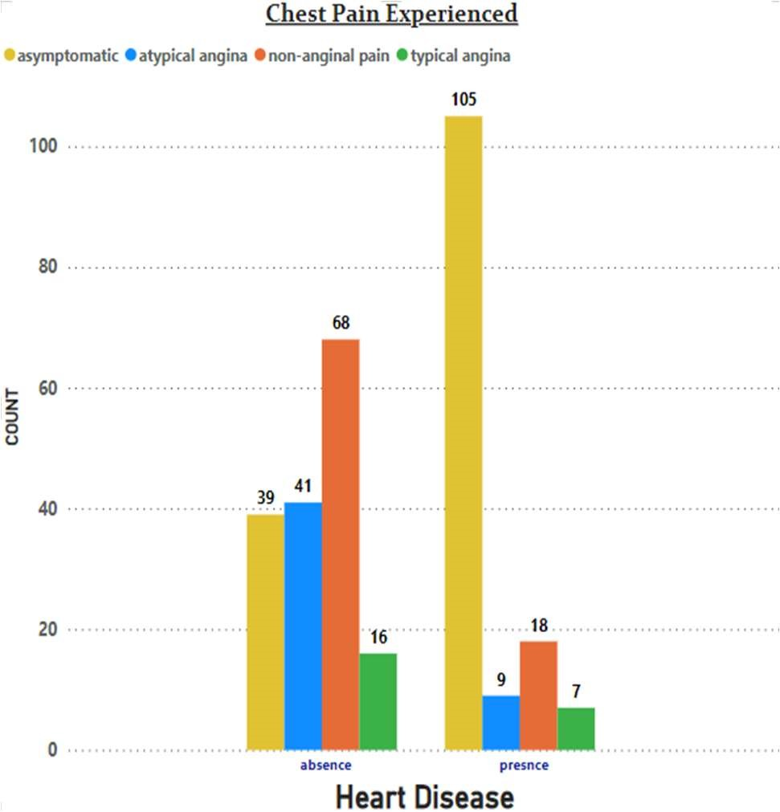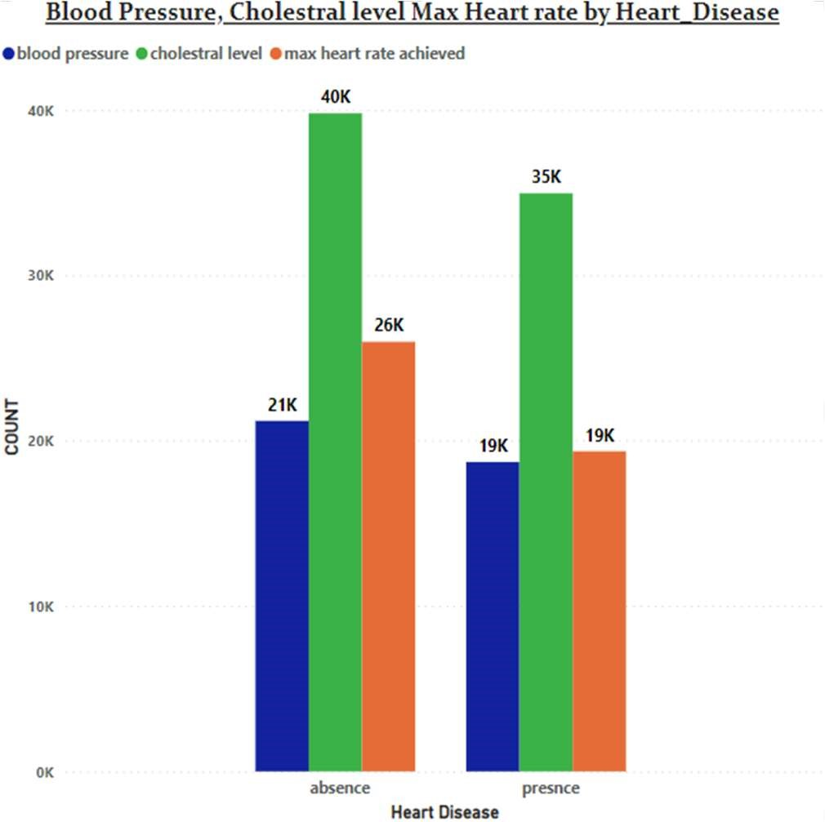

* It seems people having asymptomatic chest pain have a higher chance of heart disease.
* Asymptomatic Chest pain means neither causing nor exhibiting symptoms of heart disease.
* It seems high number of cholesterol level in people having heart disease.

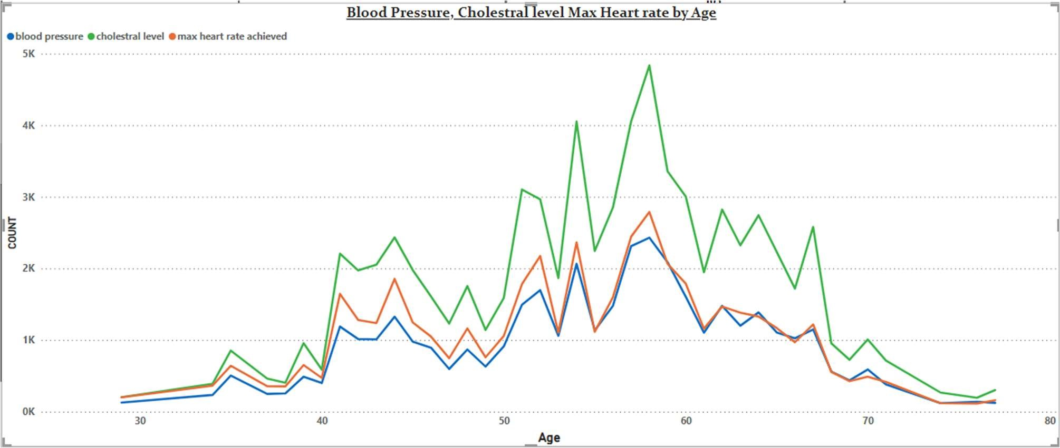

* Here we can observe that Blood Pressure increases between age of 50 to 60 and somehow continue the pattern till 70.
* Similarly, Cholesterol and maximum heart rate Increasing in the age group of 50-60.

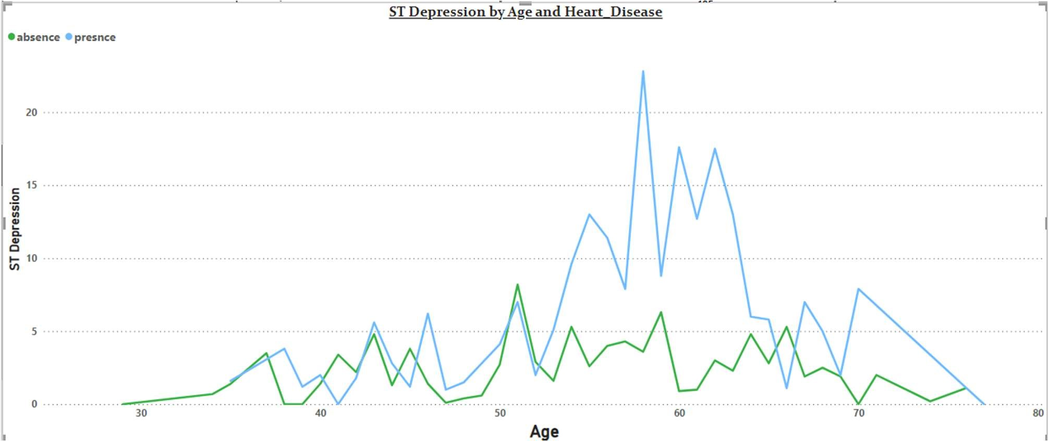

* we can observe from here that ST depression mostly increases between the age group of 30-40.
* ST depression refers to a finding on an electrocardiogram, wherein the trace in the ST segment is abnormally low below the baseline.