CUSTOMER SUPPORT AND TICKETING SYSTEM
CAPSTONE PROJECT
ACTIVITY DOCUMENT
SUBMITTED BY
VIRAJ
YEAR: III
DEPARTMENT OF INFORMATION TECHNOLOGY - B
J.J COLLEGE OF ENGINEERING AND TECHNOLOGY
INDEX PAGE
S.No | CONTENTS | PAGE NO.
1 | Traditional ER Diagram | 2
2 | Traditional ER Diagram Explanation | 3
3 | Schema Mapping Rules | 4
4 | Data Dictionary | 5 onwards

TRADITIONAL ER DIAGRAM
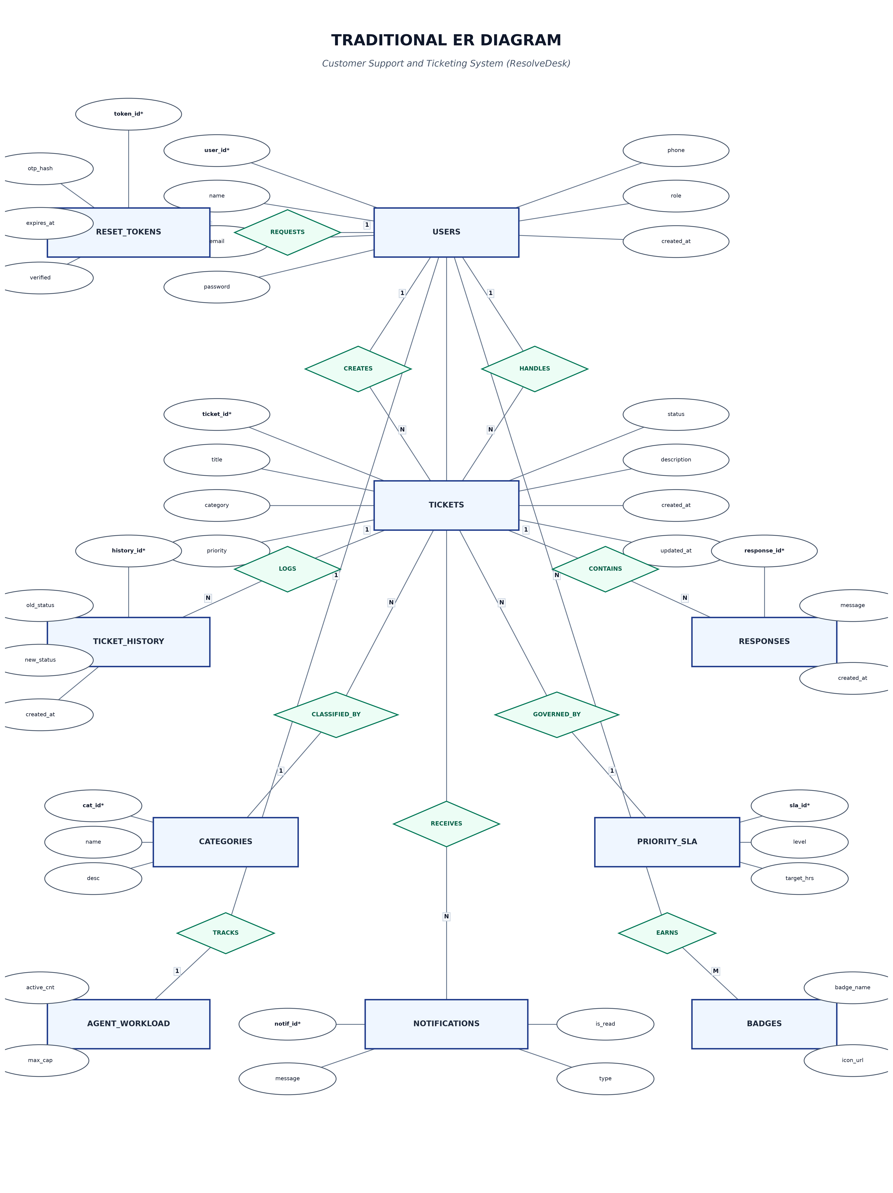

TRADITIONAL ER DIAGRAM EXPLANATION
The Traditional Entity Relationship (ER) Diagram represents the overall database structure of the Customer Support and Ticketing System (ResolveDesk). It illustrates the major entities, their attributes, relationships, and cardinalities used in the system. The ER Diagram helps in understanding how different entities are connected before converting the design into relational database tables.
The USERS entity is one of the main entities in the system. It stores information such as user ID, name, email, password hash, role (customer, agent, admin), and account creation details. Users can act as customers submitting tickets, support agents resolving issues, or system administrators managing workloads and user permissions.
The TICKETS entity forms the central part of the Customer Support Platform. It stores information related to issues raised by users. Each ticket includes details such as ticket ID, title, category, priority level, description, status (open, assigned, in_progress, resolved, closed), assigned agent ID, and creation/update timestamps. A customer can create multiple tickets over time.
The RESPONSES entity manages communication threads for support tickets. It connects the USERS entity with the TICKETS entity. Each response record contains the response ID, associated ticket ID, sender ID, message content, and creation timestamp. Both customers and agents can post multiple response comments to maintain a complete history of the issue resolution.
The TICKET_STATUS_HISTORY entity tracks all status transitions occurring throughout a ticket's lifecycle. It stores the history ID, ticket ID, previous status, new status, ID of the user who performed the change, and the transition date/time. This entity provides complete auditability for support compliance and SLA monitoring.
The PASSWORD_RESET_TOKENS entity manages security authentication for password recovery workflows. It includes token ID, user ID, hashed OTP code, expiration time, verification attempt counts, verification status flags, and token usage flags. Each user can generate password reset requests when required.
The CATEGORIES entity categorizes support tickets into functional domains (e.g., Billing, Technical, Account Access, Feature Request). This entity helps organize tickets for efficient assignment and reporting.
The PRIORITY_SLA entity defines target response and resolution timeframe expectations based on priority levels (e.g., Low, Medium, High, Urgent). It establishes clear service level agreements for support agent teams.
The AGENT_WORKLOAD entity tracks current ticket load and status metrics for each support agent. It stores agent ID, active ticket counts, resolved ticket counts, and total capacity limits to facilitate balanced ticket assignment.
The NOTIFICATIONS entity stores alerts and messages generated for users. A user can receive notifications regarding ticket updates, new responses, status changes, or assignment events. Notification details include message content, type, read status, and timestamps.
The BADGES and USER_BADGES entities form a gamification and performance recognition system for support agents. The BADGES entity defines achievement metrics (e.g., Fast Resolver, Customer Favorite), while USER_BADGES connects users to their earned badges.
The AUDIT_LOGS entity records security events, login attempts, state modifications, and admin actions across the platform, ensuring compliance, security transparency, and operational tracking.
Overall, the Traditional ER Diagram provides a clear representation of the entities and relationships used in the Customer Support and Ticketing System. Primary Keys are used to uniquely identify records, while Foreign Keys establish relationships between related entities. The ER Diagram was later converted into relational tables using schema mapping rules, ensuring data integrity, consistency, and proper database organization.

SCHEMA MAPPING RULE
1. Entity to Table Mapping
Each entity in the ER Diagram was converted into a separate relational table. For example, USERS, TICKETS, RESPONSES, TICKET_STATUS_HISTORY, and PASSWORD_RESET_TOKENS were converted into database tables.
2. Attribute to Column Mapping
Each attribute of an entity was converted into a column in the corresponding table.
3. Primary Key Mapping
Each table was assigned a Primary Key to uniquely identify every record.
4. Relationship Mapping
Relationships between entities were implemented using Foreign Keys. For example, customer_id in the TICKETS table references the USERS table.
5. One-to-Many Relationship Mapping
For a one-to-many relationship, the Primary Key of the parent table was added as a Foreign Key in the child table.
6. One-to-One Relationship Mapping
For a one-to-one relationship, a Foreign Key with a UNIQUE constraint was used. For example, USER_PRIVACY_SETTINGS is connected to USERS using user_id.
7. Many-to-Many Relationship Mapping
Many-to-many relationships were represented using an intermediate or junction table when required. This approach helps maintain proper relationships between multiple entities and avoids data redundancy.
8. Foreign Key Mapping
Foreign Keys were used to establish relationships between related tables. For example, user_id connects USERS with TICKETS, RESPONSES, NOTIFICATIONS, and AUDIT_LOGS.
9. Referential Integrity
Referential integrity was maintained by using Foreign Key constraints. This ensures that a record in a child table cannot reference a non-existing record in a parent table.
10. Constraint Mapping
Constraints such as NOT NULL, UNIQUE, PRIMARY KEY, FOREIGN KEY, and DEFAULT were applied to maintain data accuracy, consistency, and integrity.
11. Data Type Mapping
Appropriate data types were selected based on the type of information stored. For example, VARCHAR and TEXT were used for text values, INT and BIGINT for numerical values, DATE and TIMESTAMP/TIMESTAMPTZ for date-related information, and BOOLEAN for flags.

DATA DICTIONARY
The following data dictionary describes the tables, columns, data types, keys, and constraints used in the Customer Support and Ticketing System database.
USERS Table
Column Name | Data Type | Key / Constraint
user_id / id | BIGINT / SERIAL | PRIMARY KEY
name | VARCHAR(100) | NOT NULL
email | VARCHAR(100) | UNIQUE, NOT NULL
password_hash | VARCHAR(255) | NOT NULL
phone | VARCHAR(15) | -
role | VARCHAR(20) | DEFAULT 'customer'
created_at | TIMESTAMP | DEFAULT CURRENT_TIMESTAMP

TICKETS Table
Column Name | Data Type | Key / Constraint
ticket_id / id | BIGINT / SERIAL | PRIMARY KEY
customer_id | BIGINT | NOT NULL, FOREIGN KEY
title | VARCHAR(255) | NOT NULL
category | VARCHAR(50) | NOT NULL
priority | VARCHAR(20) | DEFAULT 'medium'
description | TEXT | NOT NULL
status | VARCHAR(30) | DEFAULT 'open'
assigned_agent_id | BIGINT | FOREIGN KEY
created_at | TIMESTAMP | DEFAULT CURRENT_TIMESTAMP
updated_at | TIMESTAMP | DEFAULT CURRENT_TIMESTAMP

RESPONSES Table
Column Name | Data Type | Key / Constraint
response_id / id | BIGINT / SERIAL | PRIMARY KEY
ticket_id | BIGINT | NOT NULL, FOREIGN KEY
sender_id | BIGINT | NOT NULL, FOREIGN KEY
message | TEXT | NOT NULL
created_at | TIMESTAMP | DEFAULT CURRENT_TIMESTAMP

TICKET_STATUS_HISTORY Table
Column Name | Data Type | Key / Constraint
history_id / id | BIGINT / SERIAL | PRIMARY KEY
ticket_id | BIGINT | NOT NULL, FOREIGN KEY
old_status | VARCHAR(30) | -
new_status | VARCHAR(30) | NOT NULL
changed_by | BIGINT | NOT NULL, FOREIGN KEY
created_at | TIMESTAMP | DEFAULT CURRENT_TIMESTAMP

PASSWORD_RESET_TOKENS Table
Column Name | Data Type | Key / Constraint
token_id / id | BIGINT / SERIAL | PRIMARY KEY
user_id | BIGINT | NOT NULL, FOREIGN KEY
otp_hash | TEXT | NOT NULL
expires_at | TIMESTAMP | NOT NULL
attempts | INT | DEFAULT 0
verified | BOOLEAN | DEFAULT FALSE
used | BOOLEAN | DEFAULT FALSE
created_at | TIMESTAMP | DEFAULT CURRENT_TIMESTAMP

CATEGORIES Table
Column Name | Data Type | Key / Constraint
category_id | SERIAL | PRIMARY KEY
category_name | VARCHAR(50) | UNIQUE, NOT NULL
description | TEXT | -
created_at | TIMESTAMP | DEFAULT CURRENT_TIMESTAMP

PRIORITY_SLA Table
Column Name | Data Type | Key / Constraint
sla_id | SERIAL | PRIMARY KEY
priority_level | VARCHAR(20) | UNIQUE, NOT NULL
response_time_hours | INT | NOT NULL
resolution_time_hours | INT | NOT NULL

AGENT_WORKLOAD Table
Column Name | Data Type | Key / Constraint
workload_id | SERIAL | PRIMARY KEY
agent_id | BIGINT | NOT NULL, FOREIGN KEY
active_tickets | INT | DEFAULT 0
resolved_tickets | INT | DEFAULT 0
max_capacity | INT | DEFAULT 10

NOTIFICATIONS Table
Column Name | Data Type | Key / Constraint
notification_id | BIGINT / SERIAL | PRIMARY KEY
user_id | BIGINT | NOT NULL, FOREIGN KEY
message | TEXT | NOT NULL
type | VARCHAR(50) | -
is_read | BOOLEAN | DEFAULT FALSE
created_at | TIMESTAMP | DEFAULT CURRENT_TIMESTAMP

BADGES Table
Column Name | Data Type | Key / Constraint
badge_id | SERIAL | PRIMARY KEY
badge_name | VARCHAR(100) | NOT NULL
description | TEXT | -
icon_url | TEXT | -

USER_BADGES Table
Column Name | Data Type | Key / Constraint
user_badge_id | SERIAL | PRIMARY KEY
user_id | BIGINT | NOT NULL, FOREIGN KEY
badge_id | INT | NOT NULL, FOREIGN KEY
awarded_at | TIMESTAMP | DEFAULT CURRENT_TIMESTAMP

AUDIT_LOGS Table
Column Name | Data Type | Key / Constraint
log_id | BIGINT / SERIAL | PRIMARY KEY
user_id | BIGINT | FOREIGN KEY
action | VARCHAR(100) | NOT NULL
details | TEXT | -
ip_address | VARCHAR(45) | -
created_at | TIMESTAMP | DEFAULT CURRENT_TIMESTAMP

