Monalisa Roy

Monalisa.Roy@atos.net

Abstract

Document to specify requirement for web application which will help in tracking candidate evaluation process within organization..

**Candidate Evaluation Application**

Interview Tracker

# **Candidate Evaluation Application**

This is a web application built for inhouse usage to track all candidate evaluation and interviews being carried out by Workforce Management Team (WFM). The following are features of the application:

1. Design Database Model

* Identify the entities and design database model. Create the database.
* Load database with test data.

1. User Login

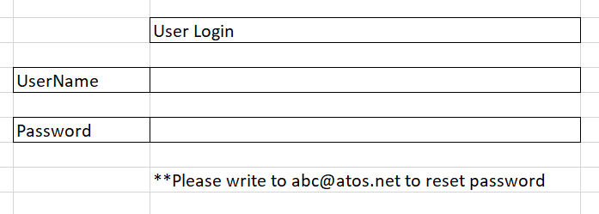

1. View Candidate Detail

* Search with Candidate name. Matching candidates displayed in search results in grid view
* Edit/Delete functionality for each candidate in search results, in every row towards right side.
* When Edit is clicked, the Candidate Edit page (4) opens and allows user to edit and submit.
* For delete, soft delete happens where Delete flag is updated in database table.

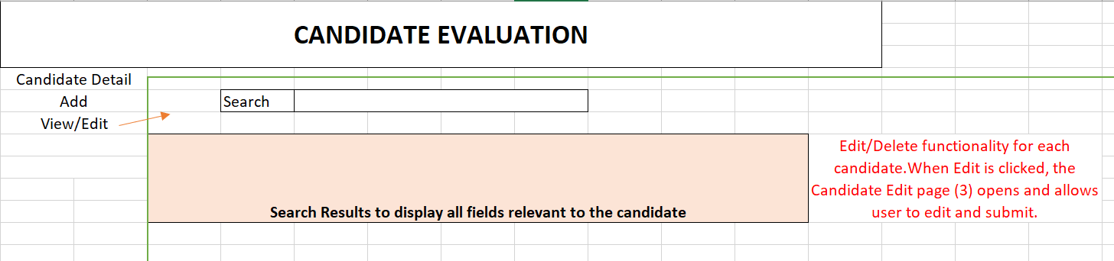

1. Add/Edit Candidate Detail

* This page opens when Add option is clicked under Candidate Detail from left menu. Or, When Edit is clicked in the candidate data row as mentioned in (3)
* All fields except ‘Comments’ are mandatory with *
* Text boxes will be editable mode only when this screen is opened for Edit or Add purpose.
* For viewing purpose, the textboxes are non-editable. Resume can be downloaded in this mode.
* Backend Candidate table should have Phone as unique column and an autogenerated CandidateID column as primary key. Candidate table holds only 6 months old data at a time. Hence need to maintain System Inserted date as well.

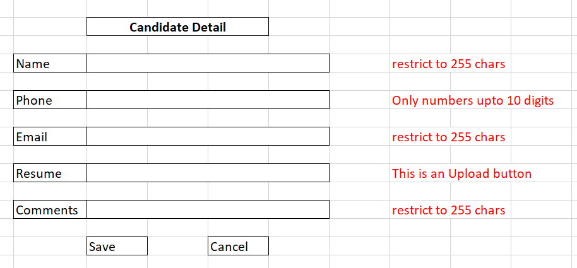

1. Interviewer data -No UI, Database table
   1. In sync with master employee data. Should not be editable from front end but maintained at backend as a Master table.
   2. Fields required are: Name, phone, email, DASID, GCM Level, Manager Name and any other date related fields
2. Schedule Evaluation/Interview Meeting
   1. This feature is not in application.
   2. Interview call to be scheduled by WFM team manually via MS Teams app.
3. Feedback
   1. Once interview is completed, Interviewer to login to this application and fill this feedback form
   2. Submit button to save the entry, Cancel button to reset the fields on this page.
   3. Feedback once submitted, cannot be changed. Hence, no separate Edit functionality for Feedback screen.
   4. Feedback can be submitted for one candidate only once for the same level (L1, L2, HR).
   5. Feedback data saved in Feedback table in database. Evaluator name and Candidate name should be maintained using referential integrity constraints.
   6. Data from this table to be deleted when corresponding candidate data is deleted from Candidate table

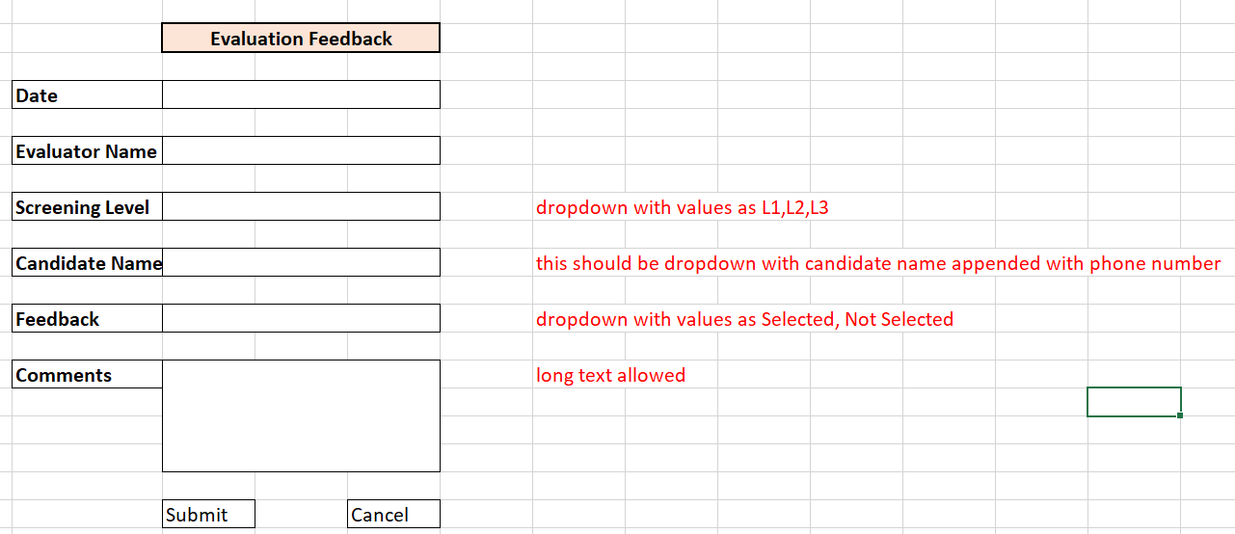

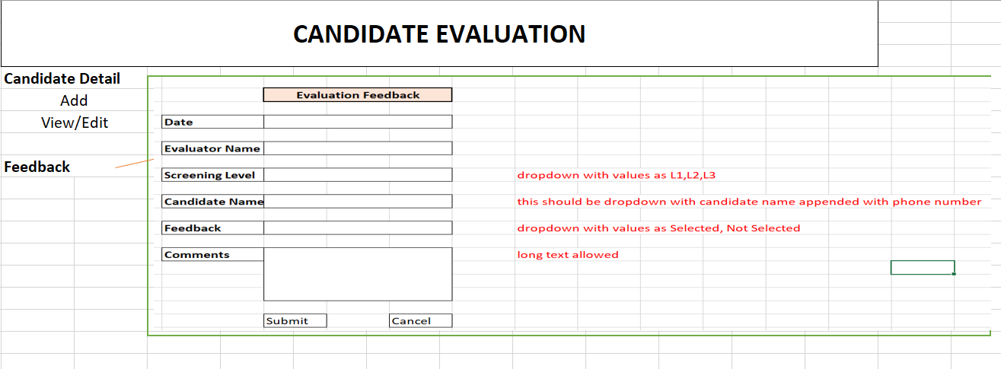

1. Reports (preferable PowerBI reports integrated with the application)
   1. Reports menu will display a dropdown with list of available reports as below. Selecting the reports with necessary parameters will load the report.
      1. Yearly/Monthly/Quaterly evaluation report level wise (L1, L2, HR). Both columnar and graphical representation. Level used as slicer
      2. Yearly/Monthly/Quaterly evaluation report based on Evaluator. Both columnar and graphical representation. Evaluator used as slicer
      3. Yearly/Monthly/Quaterly evaluation report based on Selection/rejection. Both columnar and graphical representation.

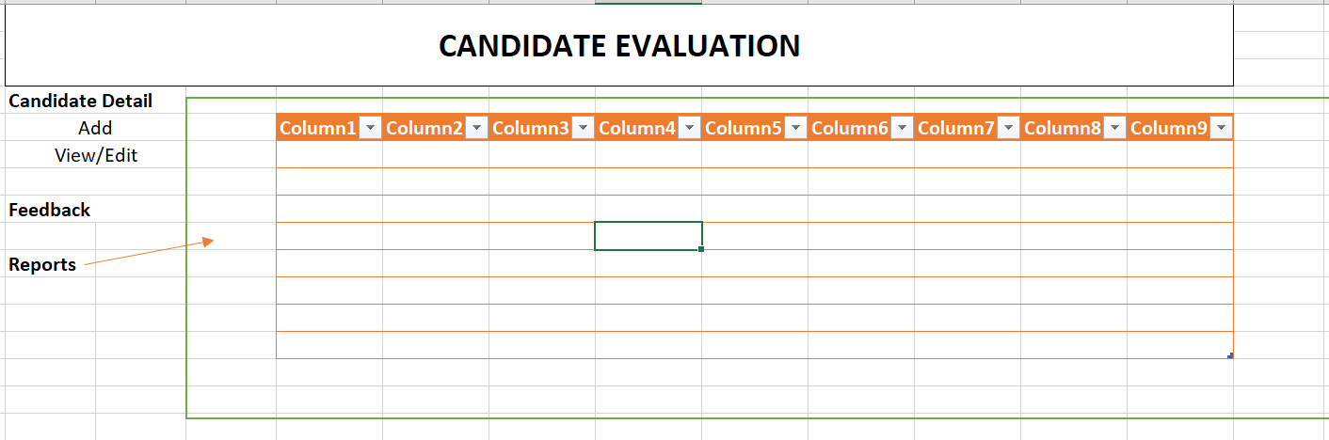

** Preferably technologies to be used are .NET, PowerBI, Any SQL database like SQL server

**The requirements are for guidance purpose, please use imagination and understanding to include/exclude parts within design to achieve the outcome.