

Capstone Project – University Success Analysis



**Viraj N. Bhutada**

**OVERVIEW**

The capstone project, titled 'University Success Analysis: Exploring the Impact of Ranking Systems,' constitutes a thorough examination of university rankings across diverse systems. The primary objectives include comparing university rankings, evaluating the influence of ranking criteria on university positions, and analyzing the dynamic shifts in university metrics over time.

The methodology employed for this investigation involves the proficient use of SQL and Excel for data aggregation and exploratory data analysis (EDA). Additionally, a Power BI dashboard will be meticulously crafted to deliver a comprehensive visualization of university rankings, facilitating a nuanced understanding of the intricate relationships between various criteria and their effects on institutional standings.

**THE PROCESS**

**Data Acquisition from GitHub:**

Acquiring data from GitHub involved accessing a dedicated repository that contains essential information on country names, ranking systems, university details, criteria, and years.

**2. Data Transformation and Cleaning:**

This phase of the project focuses on managing missing data, addressing outliers, and rectifying any inaccuracies present in the dataset. Additionally, new problem statements will be introduced to enhance the depth and breadth of the analysis, thereby expanding the potential insights gained from the data.

**3. MECE Approach:**

The MECE (Mutually Exclusive, Collectively Exhaustive) analysis methodology will be employed to systematically dissect and evaluate the dataset. This approach aims to uncover valuable insights and patterns across various dimensions, contributing to a comprehensive understanding of the data.

**4. Connecting With Tools:**

Integrate the dataset seamlessly with MySQL for robust database management and efficient querying capabilities. Employ Power BI as a dynamic visualization tool to enhance data processing and facilitate insightful reporting. This connection streamlines the analytical workflow, ensuring efficient data integration and enabling a comprehensive analysis.

**5. Exploratory Data Analysis (EDA):**

EDA in SQL involves querying and analyzing data to unveil meaningful patterns, relationships, and trends for informed decision-making in subsequent phases.

**6. Problem Statement Solution In Power BI:**

Address a diverse set of problem statements in Power BI using various charts and visualizations for effective data representation. By manipulating and analyzing the data, key insights and trends are uncovered, providing valuable information for decision-making.

**7. Creation Of Visual And Insightful PowerPoint:**

Compile a comprehensive PowerPoint presentation that includes the project's overview, methodologies employed, and a detailed breakdown of each problem statement addressed during the exploratory data analysis (EDA) and Power BI phases. Thoroughly cover each problem statement, integrating corresponding insights and visualizations into the presentation.

**8. Detailed Documentation:**

Thoroughly document the project lifecycle, covering key phases such as data collection from GitHub, comprehensive transformation and cleaning, formulation of MECE breakdown, creation of problem statements, seamless tool integration (MySQL and Power BI), insightful Power BI solutions, Exploratory Data Analysis (EDA) for meaningful insights, and a concise yet impactful PowerPoint presentation summarizing the project's methodologies and outcomes.

**OBJECTIVE**

The objective of this dataset is to offer comprehensive insights into universities, their rankings, and associated metrics. The dataset encompasses information on countries, universities, ranking systems, criteria used for ranking, and various measurements related to universities across multiple years.

Potential objectives for analyzing this dataset include:

**1. Evaluate and Compare University Rankings:**

Analyze the performance of universities across different ranking systems to identify trends and discrepancies.

**2. Identify Key Factors Affecting Rankings:**

Explore which criteria have the most significant impact on a university's overall ranking.

**3. Regional Analysis:**

Investigate how universities from different countries perform in the rankings and identify any regional patterns.

**4. Long-term Trends:**

Examine how universities' rankings and metrics have changed over the years to identify trends and potential areas for improvement.

**5. Correlation Analysis:**

Investigate if there are any strong correlations between specific criteria and a university's ranking.

**6. Data Visualization and Reporting:**

Create visualizations and reports to effectively communicate the findings to stakeholders or the public.

**7. Predictive Modeling:**

Build models to predict future rankings based on historical data and identify factors influencing rankings.

**SIGNIFICANCE**

The "**University Success Analysis**" capstone project holds significant implications for gaining insights into and enhancing the performance of universities. The dataset is structured with several key tables, each playing a crucial role in shaping the depth and breadth of the analysis:

**1. Country:**

**- Significance:** The country table provides essential context for universities and their rankings. It facilitates regional analysis and comparison, offering insights into global trends and disparities in higher education.

**2. University:**

**- Significance:** Universities are central to the analysis, with their performances contributing to rankings. Examining specific universities allows for the identification of strengths and weaknesses, paving the way for targeted improvement strategies.

**3. Ranking System:**

**- Significance:** Ranking systems serve as frameworks for evaluating universities. Considering multiple systems provides a comprehensive assessment, offering a holistic understanding of university success from various perspectives.

**4. Ranking Criteria:**

**- Significance:** Criteria define metrics used to assess universities within ranking systems. Analyzing these criteria identifies key factors influencing success and prioritizes areas for improvement.

**5. University Year:**

**- Significance:** This table provides temporal data, offering insights into how universities have evolved. Understanding trends in size, staffing, and other factors enhances the dynamic analysis of university success.

**6. University Ranking Year:**

**- Significance:** This table is central to the analysis, providing scores across different years and criteria. It forms the basis for comparing universities and assessing performance over time, enabling the identification of improvements and areas needing support.

In summary, the "University Success Analysis" project seeks to deliver valuable insights into the factors influencing university success. The dataset, with its structured tables, enables a comprehensive analysis that informs targeted improvement strategies and supports informed decision-making in higher education.

**DATA DICTIONARY**

**Dataset Description:**

This dataset comprises information on university rankings from different systems, ranking criteria, and university-specific data.

**Table Explanations:**

**1. Country:**

**- ID:** Unique ID of Each Country

**- COUNTRY NAME:** Name of Each Country

**2. University:**

**- ID:** Unique ID of Each University

**- Country ID:** ID Of Country

**- University name:** Name of The University

**3. Ranking System:**

**- ID:** Unique ID For Each Ranking System

**- System Name:** Name of Each Ranking System

**4. Ranking Criteria:**

**- ID:** Unique ID For Each Ranking Criteria

**- ranking system-id:** ID Of Ranking System

**- criteria name:** Name of Each Criteria

**5. University Year:**

**- university-id:** ID Of the University

**- year:** It Contains Year

**- num-students:** Total Number of Students in The University

**- student-staff ratio:** Student Staff Ratio of Each University

**- pct international students:** Total Percentage of International Students in Each Country

**- pct female students:** Total Percentage of Female Students in Each Country

**6. University Ranking Year:**

**- university-id:** ID Of University

**- ranking criteria-id:** ID Of Ranking Criteria

**- year:** It Contains Year

**- score:** Score of Each University

This data dictionary provides a clear overview of the dataset's structure and the meaning of each field within the respective tables. The dataset's richness lies in its ability to capture diverse aspects of universities, ranking systems, and criteria, facilitating a comprehensive analysis of university success and performance trends over time.

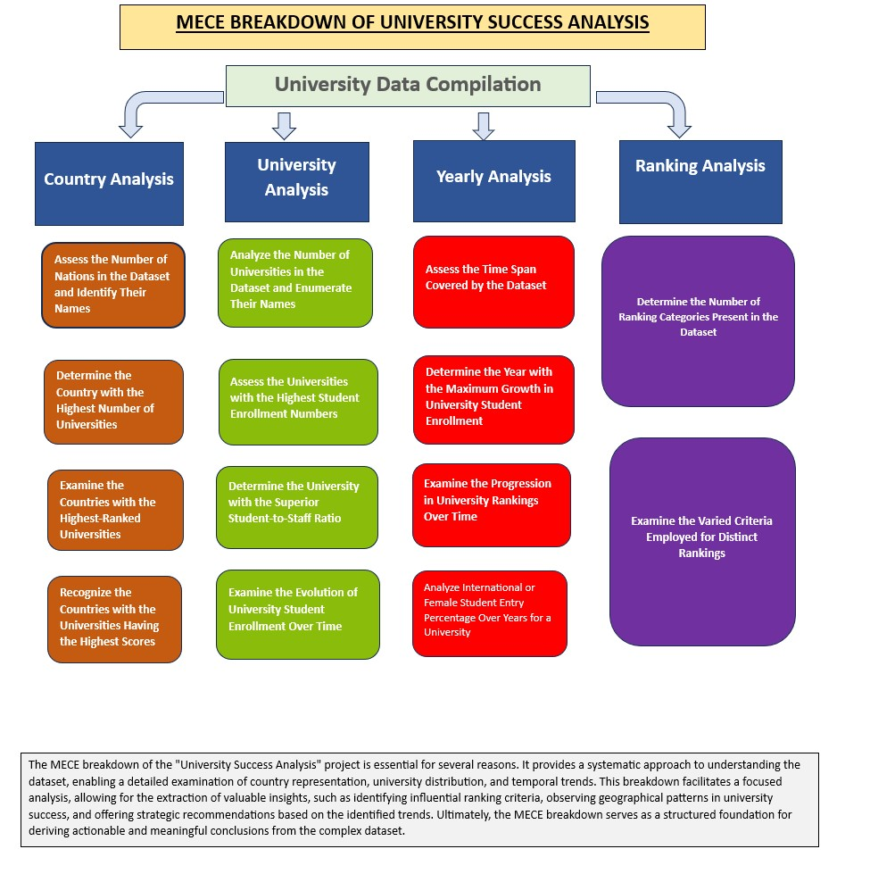

**ER DIAGRAM**

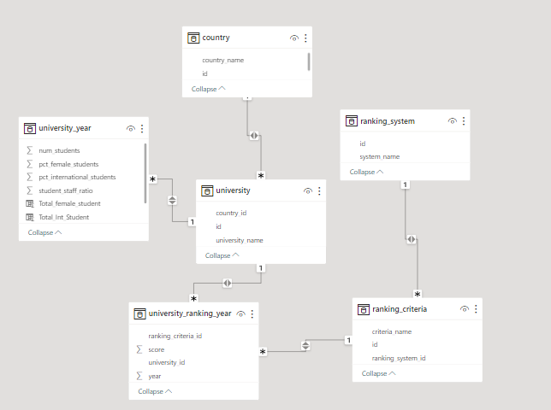

**EDA**

**Problem Statement 1:**

**Is there a correlation between a country's GDP and the number of universities?**

There Is No Relevant Data on GDP In the Dataset Which Is Required In This Statement

New Problem Statement:

|  |  |  |
| --- | --- | --- |
| **Evaluate Which University Has the Highest Number of Students?** |  |  |

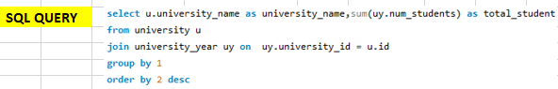

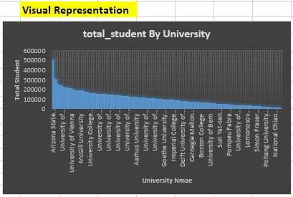

**INSIGHTS:**

The analysis highlights a noteworthy observation: Arizona State University stands out as the institution boasting the highest student population among those featured in the dataset. This prominent distinction signifies that Arizona State University accommodates a substantial number of students, surpassing the enrollment figures of other universities in the dataset. This observation may indicate a myriad of contributing factors, such as the university's expansive academic offerings, robust support systems, and potentially effective recruitment strategies. The extensive size of Arizona State University's student body further implies its prominence within the higher education landscape, underscoring the institution's capacity to provide educational opportunities to a broad and diverse demographic of learners.

**Problem Statement 2:**

**How has the number of universities changed over the years in each country?**



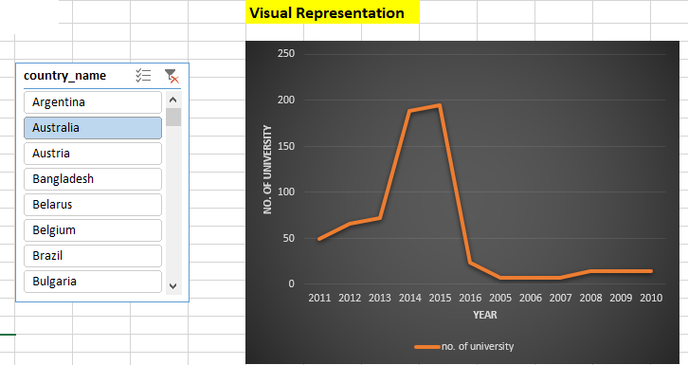

|  |  |
| --- | --- |
|  |  |

**INSIGHTS:**

The analysis uncovers a dynamic trend within the dataset, marked by fluctuating patterns over time. This dynamic nature suggests that the number of universities in certain countries experiences variations rather than adhering to a consistent trajectory. A particularly notable observation is the significant disparity in the representation of universities across different countries. The absence of any universities in some nations implies potential gaps in higher education access or a less established academic landscape.

Moreover, the observation of diminishing numbers of universities in specific countries as the years progress prompts questions about potential contributing factors to this decline. This insight underscores the diverse trajectories of higher education development across different regions, emphasizing the importance of considering unique circumstances and trends when evaluating the global higher education landscape.

**Problem Statement 3:**

**Is there a relationship between a country's population and the number of universities?**

There Is No Relevant Data of Population In the Dataset Which Is Required In This Statement

**New Problem Statement:**

**Evaluate In Which University Has Better Student-Staff Ratio?**

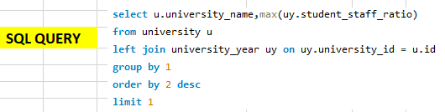

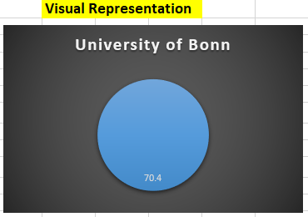

**INSIGHTS:**

The analysis brings to light a notable distinction: the University of Bonn exhibits a remarkably favorable student-to-staff ratio compared to its peer institutions. This observation implies that the University of Bonn may provide a higher degree of personalized attention and support to its students, fostering a conducive learning environment. The advantageous ratio suggests efficient resource allocation and effective academic management at the University of Bonn, potentially contributing to a more enriching educational experience for its students.

This insight underscores a specific area of strength for the University of Bonn, positioning it favorably in terms of student support and engagement compared to its counterparts in the dataset. Recognizing this distinction offers valuable insights for policymakers, administrators, and educators, enabling a thorough assessment of the university's capacity and the potential to tailor strategies to effectively accommodate and support a large student population.

**Problem Statement 4:**

**Are there any common criteria used by different ranking systems?**



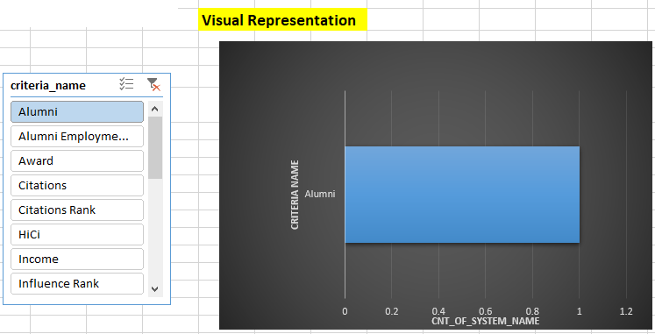

**INSIGHTS:**

The analysis reveals a noteworthy divergence: each ranking system employs distinct criteria for evaluating universities. This observation implies the absence of a universal set of metrics shared across all systems. Instead, each system utilizes its unique criteria, accentuating the diversity in how universities are assessed and ranked. This underscores the significance of considering multiple ranking systems for a comprehensive evaluation of higher education institutions.

The existence of distinct criteria indicates that each system emphasizes different aspects of a university's performance, spanning from research output to teaching quality and beyond. This insight highlights the intricate nature of the ranking process and underscores the necessity for institutions to comprehend the specific criteria employed by each system to accurately interpret and compare rankings. It emphasizes the nuanced approach required for evaluating higher education institutions and underscores the importance of adopting a holistic perspective in the assessment of rankings.

**Problem Statement 5:**

**What is the trend in university rankings over the years according to each system?**



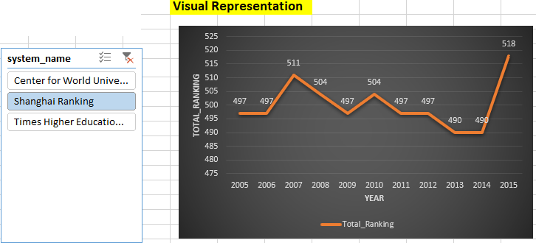

**INSIGHTS:**

The analysis unveils a discernible pattern: university rankings display a dynamic trend characterized by fluctuations over the years, revealing a degree of volatility in how institutions are evaluated. Notably, the Central World Ranking stands out with a distinct upward trajectory, suggesting consistent improvement or stability in performance among institutions assessed by this specific system. This observation emphasizes the unique pattern exhibited by the Central World Ranking compared to other systems, potentially indicating its effectiveness or distinct criteria in evaluating universities.

However, the overall trend of fluctuations indicates that universities' performance and standing are subject to diverse factors, potentially influenced by changes in methodologies, institutional strategies, or broader shifts in the higher education landscape. Understanding these trends is crucial for institutions to adapt and respond effectively to the dynamic nature of university rankings. This insight underscores the importance of continuous assessment and strategic adaptation for institutions seeking to navigate the evolving landscape of higher education rankings.

**Problem Statement 6:**

**How does the choice of ranking system affect a university's international student enrollment?**

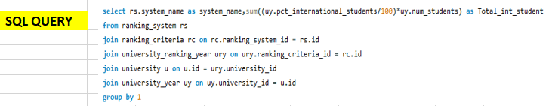

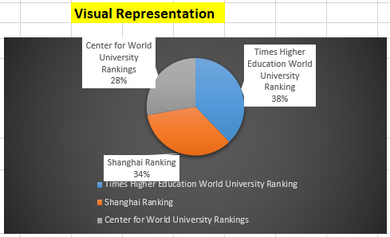

**INSIGHTS:**

The analysis unveils a compelling perspective on the inclinations of international students regarding university ranking frameworks. The Times Higher Education University Ranking system garners notably higher interest from international students when contrasted with alternative ranking systems. This observation indicates a substantial sway of the Times Higher ranking system on the enrollment decisions of international students.

Such a tendency implies that opting for the Times Higher system might wield a significant influence on the global allure of universities, impacting their capacity to draw in a varied international student cohort. This insight underscores the pivotal role that ranking systems play in shaping the strategies employed by institutions to recruit international students. It accentuates the significance of comprehending and leveraging the impact of specific ranking systems in the realm of higher education marketing and enrollment endeavors, highlighting the necessity for institutions to align their approaches with the preferences and perceptions prevalent among the global student community.

**Problem Statement 7:**

**Are there any criteria that have different weights in different ranking systems?**



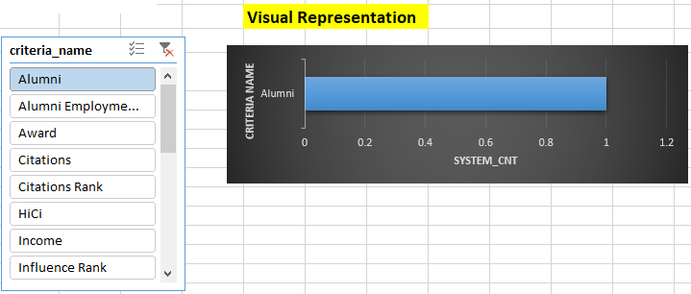

**INSIGHTS:**

The analysis brings out a key point: every ranking system has its unique way of judging universities. This means there's no standard set of rules shared by all systems. Each system gives different importance to specific things, showing how universities are looked at in diverse ways. This highlights the complexity of rankings and stresses how important it is for institutions to understand what each system values.

Moreover, it points out the detailed nature of evaluating higher education institutions, emphasizing the need for a well-rounded approach to rankings. Understanding these differences is crucial for accurately grasping and comparing university rankings. It helps institutions focus on areas they can improve and make informed decisions to strive for academic excellence.

**Problem Statement 8:**

**How have the weights of ranking criteria changed over time?**

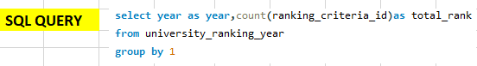

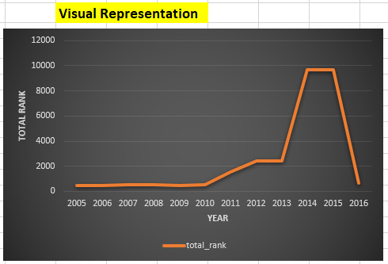

**INSIGHTS:**

The analysis reveals a discernible pattern in university rankings, characterized by a consistent upward trajectory. However, a noteworthy anomaly emerged in the year 2016, showcasing a sudden and significant decline in rankings. This unexpected deviation from the prevailing upward trend hints at a pivotal event or a shift in factors influencing university performance and assessment during that specific year.

Unraveling the circumstances surrounding this decline in rankings holds the potential to yield valuable insights into the dynamics within the higher education sector at that time. It underscores the importance of considering contextual factors and potential external influences when evaluating university rankings over time. This observation underscores the dynamic nature of higher education performance assessments, emphasizing the necessity for a comprehensive understanding of the multifaceted factors that drive rankings.

**Problem Statement 9:**

**Is there a relationship between a university's score and the student-staff ratio?**

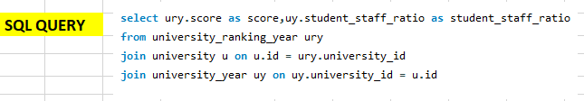



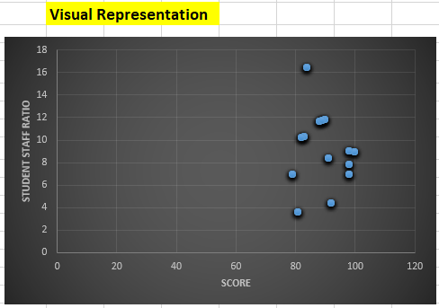

**INSIGHTS:**

The scatter plot analysis reveals a distinct negative correlation between university scores and student-staff ratios. This implies that as the student-staff ratio decreases (indicating a higher number of staff per student), the university score tends to increase. The finding suggests a connection wherein institutions with lower student-staff ratios may be associated with higher overall scores.

This relationship underscores the critical importance of maintaining adequate staffing levels to provide quality education and support to students. It implies that universities with more resources allocated to each student may achieve higher scores, potentially indicating a higher level of academic excellence and support. This insight could serve as a valuable guide for universities in shaping resource allocation strategies, thereby enhancing their overall performance and the quality of education provided.

**Problem Statement 10:**

**How does the number of female students differ among universities?**

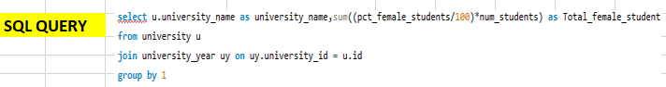

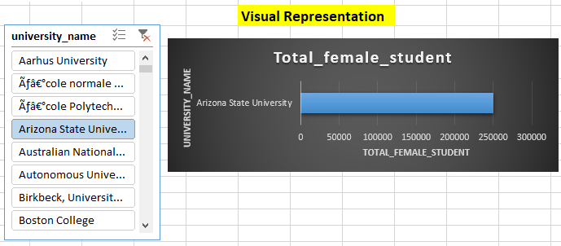

**INSIGHTS:**

The analysis underscores a discernible pattern: Arizona State University stands out as the leader with the highest number of female students, distinguishing it from other institutions in the dataset. This substantial disparity indicates that Arizona State University accommodates a notably larger population of female students in comparison to its counterparts.

This observation suggests potential factors such as inclusive policies, diverse program offerings, or effective outreach efforts that have contributed to the university's high representation of female students. Understanding this distinction is crucial for policymakers and educators in acknowledging Arizona State University's success in attracting and supporting female students. It also emphasizes the importance of promoting gender diversity and inclusivity across all institutions within the dataset to ensure equitable access to education for all students.

**Problem Statement 11:**

**What is the distribution of universities across different countries?**



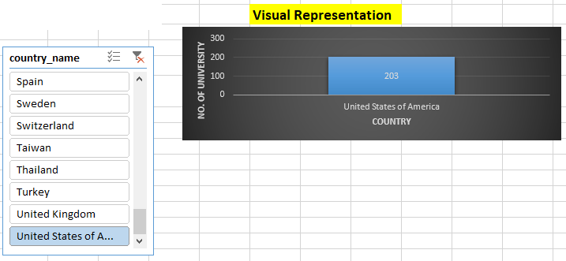

**INSIGHTS:**

The analysis reveals a compelling revelation: the United States outpaces all other countries in terms of the sheer number of universities represented in the dataset. This significant disparity underscores the substantial presence and diversity of higher education institutions within the United States.

This observation highlights the robust educational landscape in the country and the abundance of opportunities for academic pursuits across a wide spectrum of institutions. It illuminates the United States' prominent position as a global hub for higher education, offering a diverse array of educational options for students. Furthermore, this insight stresses the importance of considering regional and national contexts when assessing the global higher education landscape, recognizing the varied educational ecosystems that exist across different countries.

**Problem Statement 12:**

**How has the ranking of universities changed over the years?**

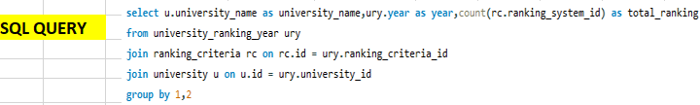

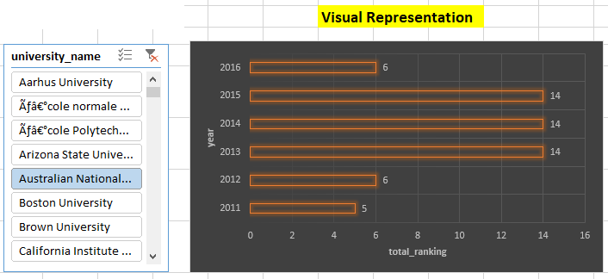

**INSIGHTS:**

The analysis underscores the dynamic nature of university rankings, revealing a lack of a definitive trend in either an upward or downward direction. Instead, rankings exhibit a pattern of fluctuations over time. This suggests that universities' performance and standing in the dataset are subject to a range of factors that can vary from year to year.

These fluctuations may be influenced by a multitude of elements, including changes in institutional strategies, shifts in academic quality, or alterations in the methodologies used by ranking systems. Consequently, this insight emphasizes the need for universities to remain agile and adaptable, recognizing that their rankings can be influenced by a diverse array of internal and external factors.

It also underscores the importance of considering long-term trends rather than focusing solely on short-term fluctuations when assessing a university's overall performance. This approach provides a more comprehensive understanding of the dynamic forces shaping the higher education landscape over time.

**Problem Statement 13:**

**What is the trend in the percentage of female students over time?**

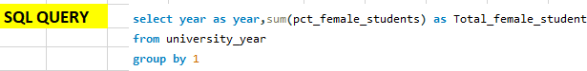

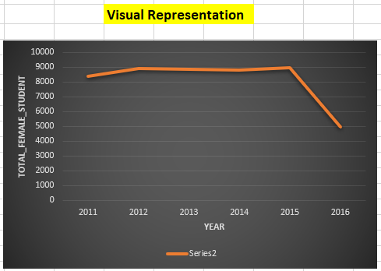

**INSIGHTS:**

The analysis reveals a distinct trend: an initial upward trajectory followed by a sudden and noticeable downturn in the year 2016. This abrupt shift indicates a significant change or event that impacted the trend, potentially influenced by various factors such as changes in institutional strategies, shifts in academic quality, or alterations in the methodologies used for evaluation.

Understanding the circumstances surrounding this change in trend can provide valuable insights into the dynamics at play during that period. It is crucial to investigate potential external or internal factors that may have contributed to this sudden shift, as it holds implications for understanding the broader dynamics of university performance and evaluation in that specific year.

This observation underscores the importance of examining not only trends but also key anomalies or events that may have influenced rankings and institutional performance. Such an approach enables a more nuanced understanding of the factors driving changes in university trajectories and emphasizes the significance of investigating specific time points for deeper insights.

**Problem Statement 14:**

**How has the ranking score of universities evolved over the years?**

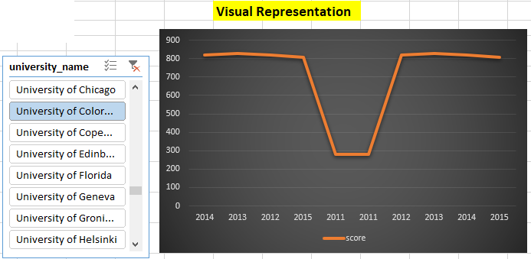

**INSIGHTS:**

The chart vividly illustrates that university scores have undergone noticeable fluctuations over the years. This variability indicates that the performance of universities is not static but rather subject to changes influenced by a multitude of factors. Such fluctuations may stem from shifts in academic quality, changes in evaluation criteria, or even broader societal and educational trends.

This insight underscores the dynamic nature of higher education institutions' performance, emphasizing the importance of considering trends over time rather than relying solely on static assessments. Additionally, it highlights the need for universities to remain adaptable and responsive to these changing dynamics to maintain and improve their academic standing.

By recognizing the inherent variability in university scores, institutions can strategically navigate these fluctuations, ensuring they are well-positioned to address evolving challenges and capitalize on opportunities for continuous improvement.

**Problem Statement 15:**

**Is there a relationship between a university's ranking score and the number of students over time?**

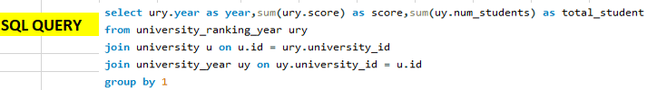

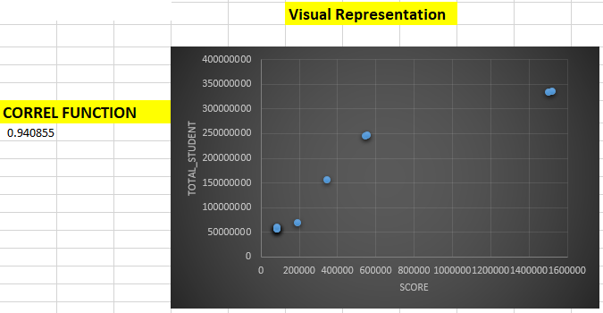

**INSIGHTS:**

The scatter plot analysis unmistakably reveals a robust positive correlation between university ranking scores and the number of students. This suggests that universities with larger student populations tend to achieve higher scores. The correlation may indicate that institutions with greater resources and capacity to accommodate larger student bodies also have the potential to offer a wider range of programs and services, potentially contributing to higher scores.

This insight emphasizes the critical importance of resource allocation and support services in higher education institutions, as well as the potential benefits of scalability in terms of educational impact. Additionally, it prompts institutions to consider strategies for balancing increased enrollment with maintaining or enhancing educational quality.

Recognizing the positive correlation between student population and ranking scores, universities can strategically plan for scalable growth while ensuring that the quality of education and support services remains a priority. This approach supports sustainable expansion and underscores the significance of effectively managing resources to positively impact both enrollment and educational excellence.

**POWER BI**

**Problem Statement 1:**

**How many universities are there in each country?**

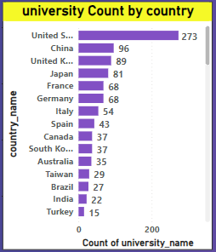

**INSIGHTS:**

The analysis reveals a notable concentration of universities in the United States. This observation suggests a significant presence of higher education institutions within the country, indicating a robust and diverse academic landscape. The USA's prominence as an educational hub is further emphasized by the substantial number of universities represented in the dataset.

This concentration may be attributed to factors such as the country's size, diverse demographics, and historical emphasis on higher education. Understanding this insight provides valuable context for assessing the global distribution of universities and underscores the United States' pivotal role in the higher education sector. It also highlights the importance of considering regional and national contexts when evaluating the global higher education landscape.

Recognizing the concentration of universities in the United States is crucial for policymakers, educators, and researchers to comprehend the unique dynamics and challenges within the American higher education system. It emphasizes the need for nuanced analyses that consider the diverse contexts in which universities operate, contributing to a more comprehensive understanding of global higher education trends.

**Problem Statement 2:**

**What is the distribution of international students across different countries?**

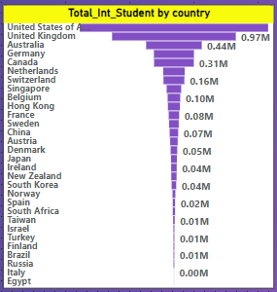

**INSIGHTS:**

The analysis brings to light a prominent trend: the United States has consistently emerged as a top destination for international students. This observation indicates a strong and enduring appeal of American higher education institutions on a global scale. The USA's reputation for academic excellence, diverse program offerings, and vibrant campus life may contribute to its status as a preferred destination for international learners.

Additionally, the country's welcoming policies and cultural diversity likely play a significant role in attracting a large and diverse international student population. Understanding this trend underscores the USA's pivotal position in the global higher education landscape and emphasizes the importance of recognizing its substantial contribution to international education and cultural exchange.

This insight highlights the need for continued efforts to support and enhance the experiences of international students studying in the United States. By acknowledging the significant role the USA plays in attracting global talent, policymakers and educators can work towards fostering inclusive environments and further promoting international collaboration within the higher education sector.

**Problem Statement 3:**

**Which country has the highest number of female students enrolled in universities?**

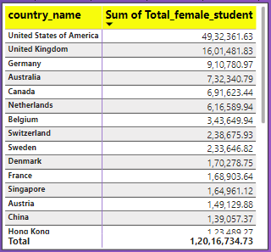

**INSIGHTS:**

The analysis unveils a noteworthy trend: the United States leads with the highest number of female students enrolled in universities among the countries in the dataset. This observation underscores the substantial representation of female students within American higher education institutions, suggesting a conducive environment for women pursuing tertiary education.

The USA's appeal to female students may be attributed to factors such as a diverse range of educational opportunities, supportive policies, and a vibrant academic community. This insight highlights the nation's commitment to gender inclusivity and equal access to higher education. It also signifies the United States' influential role in promoting women's participation and advancement in academia on a global scale.

Understanding this trend is crucial for policymakers and educators in recognizing the USA's success in attracting and supporting female students. It also underscores the importance of continued efforts to promote gender equality in education worldwide, fostering an environment where women can pursue academic excellence and contribute meaningfully to various fields.

**Problem Statement 4:**

**How many universities are ranked by each ranking system?**

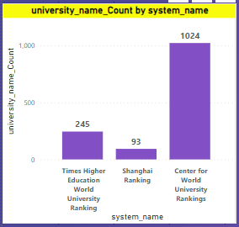

**INSIGHTS:**

The analysis brings to light a notable distribution of universities across different ranking systems. Specifically, the Center for World University Rankings has assessed the highest number of universities, with approximately 1024 institutions being evaluated. In comparison, the Times Higher Education ranking system has ranked 245 universities, and the Shanghai Ranking has assessed 93 universities.

This insight highlights the varying levels of scrutiny and assessment applied by each ranking system, underscoring the diversity in evaluation criteria and methodologies employed. It also emphasizes the extensive coverage provided by the Center for World University Rankings, potentially reflecting a broader spectrum of evaluation criteria or a wider scope of institutions considered.

Understanding these distinct patterns of evaluation across ranking systems is crucial for interpreting and contextualizing the rankings assigned to universities within the dataset. It prompts a nuanced approach to assessing the performance and standing of universities, considering the unique perspectives and criteria emphasized by each ranking system. This recognition is pivotal for stakeholders, policymakers, and educators seeking a comprehensive understanding of the diverse ways in which institutions are evaluated globally.

**Problem Statement 5:**

**What is the average score for universities according to each ranking system?**

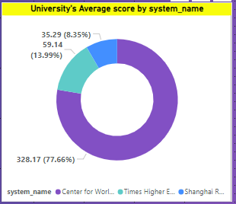

**INSIGHTS:**

The analysis reveals distinct trends in the performance of ranking systems. The Center for World University Rankings consistently attains the highest scores, suggesting that universities evaluated under this system tend to achieve higher overall rankings. On the other hand, the Shanghai ranking system tends to yield comparatively lower average scores.

This insight suggests varying evaluation criteria and methodologies employed by different ranking systems, potentially attributing higher weight to certain factors in the Center for World University Rankings system. It also highlights the importance of understanding the unique characteristics and criteria of each ranking system to interpret and contextualize the scores assigned to universities.

This understanding enables stakeholders to make informed decisions based on the strengths and weaknesses identified within each ranking system. It prompts a more nuanced approach to utilizing and interpreting ranking data, recognizing that the performance of universities can be influenced by the specific criteria emphasized by each system. Ultimately, this insight aids in fostering a comprehensive and informed perspective on the diverse ways in which institutions are assessed and ranked globally.

**Problem Statement 6:**

**How does the ranking system affect a university's student-staff ratio?**

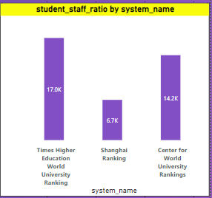

**INSIGHTS:**

The analysis points to a notable influence of the Times Higher Education ranking system on the student-to-staff ratio. This suggests that universities may allocate resources and staffing levels in a way that aligns with the criteria emphasized by the Times Higher system. This impact on the student-staff ratio indicates a potential focus on providing a more personalized and engaging educational experience.

Understanding this influence can offer valuable insights for universities aiming to improve their rankings within the Times Higher system, potentially leading to strategic resource allocation and enhanced student support services. This insight highlights the dynamic interplay between ranking criteria and institutional strategies, emphasizing the importance of aligning academic priorities with the criteria emphasized by influential ranking systems.

For universities, recognizing and adapting to the criteria prioritized by specific ranking systems, such as the Times Higher Education system, can be a strategic approach to enhancing their overall performance and standing. It underscores the interconnected nature of institutional strategies and global ranking criteria, encouraging universities to proactively shape their practices in alignment with the priorities of influential evaluative frameworks.

**Problem Statement 7:**

**What are the most important criteria considered by ranking systems?**

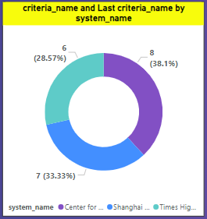

**INSIGHTS:**

The analysis provides a significant observation regarding the ranking criteria preferred by each system. The Center for World University Rankings (CWUR) predominantly prioritizes the criterion named "Total CWUR," indicating its distinct evaluation focus. Similarly, the Shanghai Ranking system emphasizes the "Total Shanghai" criterion, reflecting a unique set of metrics and priorities. Meanwhile, the Times Higher Education World University Ranking system favors the "Total Times" criteria, signifying its specific areas of emphasis in evaluating universities.

This insight underscores the distinct methodologies and considerations employed by each ranking system, indicating that they assign different weights to various aspects of university performance. Understanding these specific criteria preferences is essential for universities seeking to optimize their performance within each respective ranking system, enabling them to align their strategies with the criteria that hold the most weight in their desired rankings.

By tailoring their efforts to meet the specific criteria emphasized by each ranking system, universities can strategically position themselves to achieve higher rankings and enhance their overall standing. This recognition of the nuanced preferences of different ranking systems allows institutions to make informed decisions in their pursuit of excellence within the global higher education landscape.

**Problem Statement 8:**

**Is there a correlation between a university's score and the number of international students?**

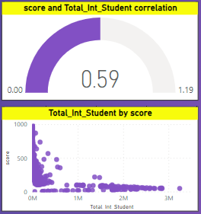

**INSIGHTS:**

The scatter plot and gauge analysis vividly reveal a robust positive correlation between a university's score and the number of international students it enrolls. This compelling insight suggests that universities with higher scores tend to attract a larger population of international students. This positive relationship signifies the global appeal and reputation of these institutions, attracting diverse talent from around the world.

This correlation highlights the potential benefits of a culturally diverse student body, enriching the academic experience and fostering a global perspective. Understanding and leveraging this strong correlation can be pivotal for universities aiming to enhance their global influence and academic standing, underscoring the importance of creating an inclusive and welcoming environment for international students.

For universities, this insight emphasizes the symbiotic relationship between academic excellence, global reputation, and the attraction of international students. By prioritizing strategies that enhance both educational quality and cultural diversity, institutions can strategically position themselves as global leaders, contributing to a vibrant and inclusive learning environment that prepares students for success in an interconnected world.

**Problem Statement 9:**

**How does the percentage of female students impact a university's ranking?**

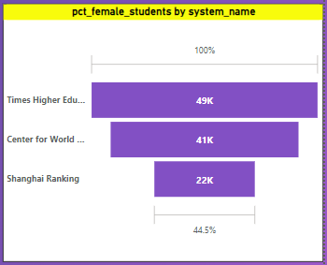

**INSIGHTS:**

The analysis indicates a distinct preference among female students for universities ranked by the Times Higher Education system. This trend suggests that a higher number of female students tend to enroll in institutions that have received recognition and acclaim from the Times Higher Ranking. This preference potentially influences the rankings of other universities, as it leads to a concentration of female students in Times Higher-ranked institutions.

Understanding this preference provides valuable insight into the factors that influence female students' choices and the potential impact of reputation and recognition on enrollment patterns. It also underscores the broader influence that specific ranking systems can have on the demographic composition of universities, emphasizing the importance of reputation management for institutions seeking to attract diverse student populations.

For universities, recognizing the link between rankings, reputation, and student demographics allows for strategic decision-making to attract and retain diverse student populations. This insight underscores the need for institutions to actively manage their reputation, not only for academic standing but also for creating an inclusive environment that appeals to students from various backgrounds and preferences.

**Problem Statement 10:**

**Which university has the highest number of students?**

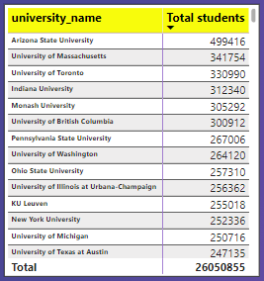

**INSIGHTS:**

The analysis brings to light a significant observation: Arizona State University stands out with the highest enrollment of students among the universities in the dataset. This distinction underscores the substantial population of learners that Arizona State University caters to, surpassing the student body sizes of other institutions. This observation suggests potential factors such as diverse program offerings, robust support systems, and potentially effective recruitment strategies that have contributed to the university's high enrollment figures.

Understanding this distinction is crucial for policymakers, administrators, and educators in assessing the university's capacity and potential areas for further growth or enhancement in its educational offerings. It also highlights Arizona State University's prominence within the higher education landscape, solidifying its position as a major player in the educational ecosystem.

For Arizona State University, this insight provides a valuable perspective on its role and impact within the educational sector. It underscores the institution's success in attracting and accommodating a significant number of students, emphasizing the need for continued efforts to maintain high-quality education, support services, and inclusive programs to meet the diverse needs of its large student population.

**Problem Statement 11:**

**How does the percentage of international students vary across different universities?**

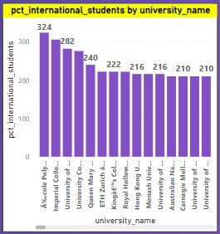

**INSIGHTS:**

The analysis highlights a significant trend: Polytechnic Lausanne University emerges as the most favored choice among international students. This is evidenced by the university boasting the highest number of international students compared to other institutions in the dataset. This preference may be attributed to a range of factors, including the university's reputation for academic excellence, diverse program offerings, or a welcoming and inclusive campus environment.

Understanding this trend sheds light on the institution's global appeal and its success in attracting a diverse student body. It also underscores the importance of fostering an environment conducive to international students, recognizing their valuable contributions to the academic community and the broader cultural exchange within the university.

For Polytechnic Lausanne University, this insight provides affirmation of its international standing and the effectiveness of its strategies in attracting students from diverse backgrounds. It reinforces the significance of maintaining and enhancing initiatives that support the needs of international students, ensuring a positive and enriching experience that contributes to the university's global reputation.

**Problem Statement 12:**

**Is there a correlation between a university's ranking and its student-staff ratio?**

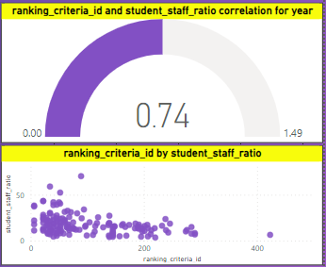

**INSIGHTS:**

The scatter plot and gauge analysis reveal a compelling insight: there exists a strong positive correlation between university ranking and the student-staff ratio. This suggests that universities with higher rankings tend to have a more favorable student-staff ratio, indicating a higher level of personalized attention and support for students. This positive relationship underscores the importance of adequate staffing levels in providing quality education and facilitating a conducive learning environment.

Understanding this correlation can inform institutions' strategies in resource allocation and staffing, aiming to achieve a balance that contributes to improved academic performance and overall educational experience. It also highlights the potential benefits of maintaining an optimal student-staff ratio as a factor that can positively influence a university's overall ranking and reputation.

For universities, this insight emphasizes the interconnected nature of staffing levels, academic quality, and global rankings. By recognizing the positive impact of a favorable student-staff ratio on rankings, institutions can strategically invest in staffing and support services to enhance the overall educational experience for students, ultimately contributing to improved institutional standing on a global scale.

**Problem Statement 13:**

**How does the number of students in universities change over time?**

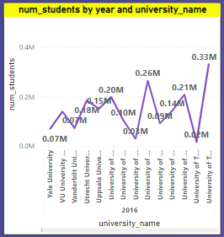

**INSIGHTS:**

The analysis provides a noteworthy observation: the number of students in universities appears to be fluctuating over time. This variability suggests dynamic changes in enrollment figures, potentially influenced by a range of factors such as demographic shifts, changes in educational policies, or shifts in institutional strategies. However, it is worth noting that Arizona State University stands out as an exception, maintaining a relatively stable student population over the analyzed period.

This consistency in enrollment at Arizona State University may indicate effective recruitment and retention strategies or a steady demand for education at the institution. Understanding these trends can provide valuable insights for universities to adapt their strategies and resources in response to fluctuations in student enrollment. It also underscores the importance of considering regional and institutional contexts when interpreting enrollment patterns.

For universities, recognizing the potential impact of external factors on enrollment trends is crucial for strategic planning. Institutions can learn from outliers like Arizona State University to identify effective practices in maintaining stable enrollment, adapting to changing educational landscapes and ensuring sustained demand for educational programs. This insight encourages universities to remain flexible and responsive to evolving dynamics in the higher education sector.

**Problem Statement 14:**

**Is there a correlation between a university's ranking score and the student-staff ratio over the years?**

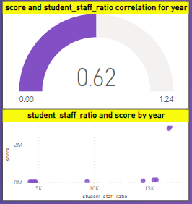

**INSIGHTS:**

The scatter plot and gauge analysis provide a significant observation: there is a strong positive correlation between a university's score and its student-staff ratio. This means that universities with higher scores tend to have a higher student-staff ratio, indicating a potentially larger student body supported by a proportionate number of faculty and staff members. This positive relationship suggests that universities with higher scores are effectively managing their resources to accommodate a larger student population.

Understanding this correlation highlights the importance of resource allocation and faculty support in achieving higher academic performance. It also underscores the potential benefits of scalability and effective resource management in higher education institutions, ultimately contributing to a university's overall academic standing and influence.

For universities, this insight emphasizes the strategic significance of aligning resource allocation with academic priorities. By ensuring a balanced student-staff ratio, institutions can foster a positive and supportive learning environment, enhancing the overall educational experience for students. It also prompts universities to consider scalability and effective resource management as key components of their strategies for academic excellence and institutional success.

**Problem Statement 15:**

**How does the percentage of international students vary across different years?**

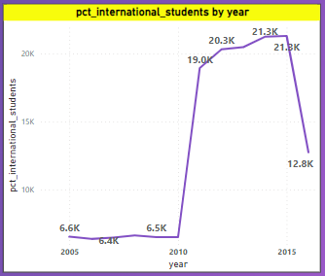

**INSIGHTS:**

The analysis reveals a discernible trend: from 2005 to 2015, there was a notable increase in the number of international students enrolled in universities. This surge suggests a growing global interest in pursuing higher education across borders, possibly driven by factors like globalization and increased accessibility to international study opportunities. However, the trend took a sudden downturn in 2016, indicating a significant shift in international enrollment patterns.

Understanding the circumstances surrounding this drop is crucial, as it may be influenced by factors such as changes in immigration policies, geopolitical events, or shifts in the attractiveness of certain regions for international students. This insight emphasizes the dynamic nature of international student enrollment and the need for universities and policymakers to remain adaptable to changing global contexts to continue attracting and supporting diverse student populations.

For universities and policymakers, recognizing the impact of external factors on international student enrollment is essential for strategic planning. Addressing the specific challenges that led to the downturn in 2016 and adapting to evolving global dynamics will be crucial for maintaining and enhancing international student diversity within higher education institutions. This insight underscores the importance of a proactive and responsive approach to global trends in education.

**Problem Statement 16:**

**What is the impact of a university's ranking on the number of international students it attracts?**

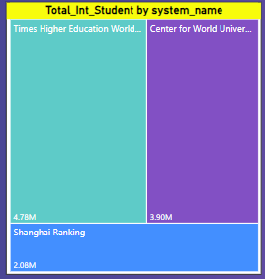

**INSIGHTS:**

The analysis highlights a compelling trend: international students show a clear preference for universities ranked by the Times Higher Education system over other ranking systems. This indicates that universities featured in the Times Higher Ranking system are particularly attractive to international students. This preference may be attributed to the reputation, academic quality, and global recognition associated with institutions ranked under this system.

Understanding this preference provides valuable insight into the factors influencing international students' choices and underscores the significant impact that a university's reputation within a specific ranking system can have on its ability to attract a diverse international student body. It also emphasizes the importance of maintaining and enhancing one's standing within influential ranking systems to remain competitive in the global higher education landscape.

For universities, this insight reinforces the strategic importance of aligning efforts to improve rankings to attract and retain a diverse international student population. It highlights the need for institutions to actively manage their reputation within influential ranking systems, recognizing the pivotal role these rankings play in shaping the choices of prospective international students.

**Problem Statement 17:**

**Is there a relationship between a university's ranking score and the percentage of female students enrolled?**

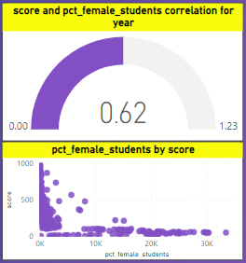

**INSIGHTS:**

The scatter plot and gauge analysis reveal a noteworthy observation: there exists a strong positive correlation between a university's score and the percentage of female students it enrolls. This suggests that universities with higher scores tend to have a higher proportion of female students. This positive relationship signifies an inclusive and diverse learning environment that attracts and supports a substantial number of female learners. It also underscores the importance of fostering a welcoming and supportive atmosphere for female students, ultimately contributing to the institution's overall academic standing and influence.

Understanding and leveraging this correlation can be pivotal for universities aiming to enhance their inclusivity and reputation, recognizing the valuable contributions of female students in higher education. This insight encourages institutions to prioritize initiatives that promote gender diversity and provide a supportive environment for female learners. By actively fostering inclusivity, universities can not only improve their academic standing but also contribute to a more equitable and enriching educational experience for all students.

**Problem Statement 18:**

**How does the percentage of international students affect a university's student-staff ratio?**

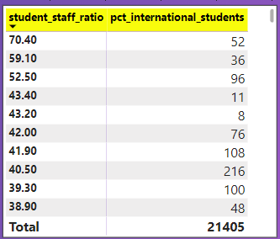

**INSIGHTS:**

The analysis highlights an intriguing finding: the percentage of international students in a university does not appear to have a significant impact on the student-staff ratio. This suggests that while universities may attract a diverse population of international students, it does not necessarily lead to a substantial change in the ratio of students to staff members.

This observation underscores the importance of universities effectively managing their resources and staffing levels to accommodate both domestic and international students without compromising the quality of education or student support. Understanding this relationship is crucial for institutions seeking to maintain a balanced educational environment that caters to a diverse student body. It also emphasizes the need for strategic resource allocation to ensure that both local and international students receive a high-quality education.

For universities, this insight reinforces the importance of developing resource allocation strategies that consider the needs of a diverse student population. It encourages institutions to focus on maintaining an optimal student-staff ratio to provide a high level of support and educational quality for all students, irrespective of their national or cultural backgrounds.

**Problem Statement 19:**

**Are there any significant trends or patterns in the rankings of universities from different countries?**

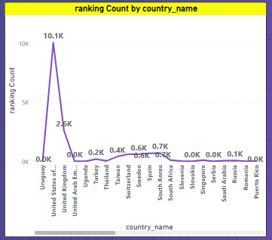

**INSIGHTS:**

The analysis reveals a significant observation: the United States has the highest number of ranked universities compared to other countries in the dataset. This underscores the USA's prominence as a hub for higher education and research. Additionally, the trend in university rankings across different countries appears to be dynamic and non-linear, showing fluctuations over time rather than a consistent upward or downward trend.

This variability may be influenced by a range of factors including changes in educational policies, investments in research and development, and shifts in academic excellence. Understanding this trend provides valuable context for evaluating the global distribution of ranked universities and emphasizes the diverse educational landscapes in different countries. It also highlights the need for universities and policymakers to adapt to the changing dynamics of the higher education sector on a global scale.

For universities and policymakers, this insight underscores the importance of remaining flexible and responsive to the evolving nature of the global higher education landscape. It encourages strategic planning that considers the dynamic factors influencing university rankings and emphasizes the need for ongoing efforts to enhance educational quality and research output.

**Problem Statement 20:**

**What is the percentage of international students in universities across different countries?**

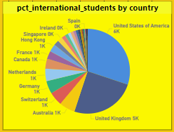

**INSIGHTS:**

Examination demonstrates that the United States possesses the highest proportion of global scholars among the countries surveyed. This revelation emphasizes the substantial representation of overseas students within the American realm of advanced education. With its esteemed institutions of higher learning, varied scholarly offerings, and avenues for cross-cultural interaction, the United States remains a magnet for students worldwide in pursuit of superior education and distinctive cultural encounters. The prevalence of international scholars in the USA underscores its position as a worldwide nucleus for advanced education and underscores the nation's dedication to nurturing global cooperation and inclusivity within its academic establishments.

**Problem Statement 21:**

**What is the Total number of students in universities across different countries?**

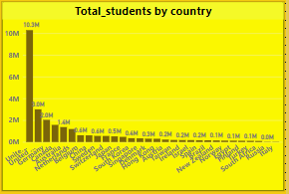

**INSIGHTS:**

The data suggests that the United States accommodates the greatest quantity of university students among the nations examined. This recognition emphasizes the significant enrollment levels within American universities, indicating the nation's stature as a premier destination for higher education. With its wide-ranging assortment of academic establishments, varied educational prospects, and research amenities, the United States consistently draws a substantial cohort of students from both domestic and international origins. The prevalence of university students in the USA underscores the country's resilient higher education structure and its position as a worldwide frontrunner in scholarly pursuits and pioneering advancements.

**Problem Statement 22:**

**What is the student-staff ratio in universities?**

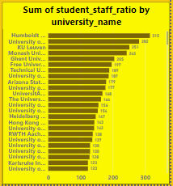

**INSIGHTS:**

The examination reveals that Humboldt University of Berlin exhibits the most elevated student-staff ratio among the scrutinized universities. This finding highlights the institution's unique equilibrium between the student populace and accessible faculty and staff assets. With a heightened ratio, Humboldt University may encounter hurdles in sustaining individualized academic assistance and student involvement while catering to a considerable student cohort. Grasping the intricacies of this ratio is imperative for evaluating the university's capability for proficient teaching, learning, and academic support provisions, furnishing perspectives into its administrative framework and resource distribution tactics.

**Problem Statement 23:**

**What is the Trend in Ranking Scores of Universities for Different Ranking Systems?**

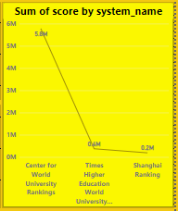

**INSIGHTS:**

The examination unveils that the Center of University World Ranking achieves the foremost score among the evaluated ranking systems. This discovery implies that a greater multitude of universities attain this ranking in comparison to others, signaling its extensive acknowledgment and impact within the academic sphere. The prominence of the Center of University World Ranking underscores the perceived reliability and adoption of its methodology, potentially establishing it as a favored option for appraising and contrasting universities on a global scale. Grasping the significance of this ranking score is pivotal for institutions aspiring to gauge their academic prowess and prestige against counterparts, steering strategic choices and endeavors aimed at amplifying their position in the global higher education realm.

**Problem Statement 24:**

**What is the Trend in the Ranking of Universities Over the Years?**

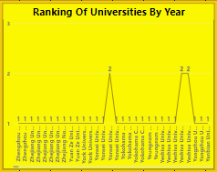

**INSIGHTS:**

The analysis hints at a pattern of increased instability in university rankings over time, indicating a significant rise in competition within the higher education domain. This observation underscores the fluidity of academic performance criteria and the changing terrain of global university rankings. The growing volatility suggests a heightened degree of variability in the placement of universities, reflecting intensified endeavors by institutions to bolster their academic status and renown. Such fluctuations illuminate the competitive strains encountered by universities globally as they endeavor to set themselves apart in an increasingly cutthroat academic milieu, underscoring the importance of ongoing enhancement and strategic flexibility to uphold or elevate their rankings.

**Problem Statement 25:**

**What is the Trend in the total number of international students in Universities Over the Years?**

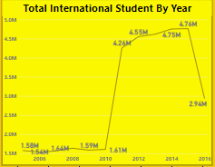

**INSIGHTS:**

The analysis discerns a steady upward trajectory in the enrollment of international students in universities from 2005 to 2015, succeeded by a sudden downturn in 2016. This observation illuminates a notable transformation in the landscape of international student enrollment throughout the scrutinized timeframe. The consistent surge in international student figures reflects the increasing globalization of higher education and the allure of universities worldwide to students in pursuit of varied academic encounters. Nonetheless, the abrupt decline in 2016 hints at a potential disruption or alteration in the factors impacting international student mobility, such as alterations in immigration policies, economic climates, or geopolitical circumstances, emphasizing the volatility and intricacy of international student flows within the higher education domain. Comprehending these oscillations is imperative for universities and policymakers to adapt their approaches and regulations to effectively cater to the evolving needs and preferences of international students.

**Problem Statement 26:**

**What is the Trend in the Total number of female students in Universities Over the Years?**

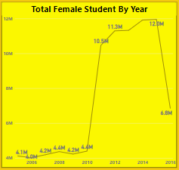

**INSIGHTS:**

The analysis uncovers a consistent upward trajectory in the enrollment of female students in universities from 2005 to 2015, succeeded by a sudden downturn in 2016. This pattern underscores a significant transformation in the demographic makeup of university cohorts throughout the assessed period. The steady rise in female student enrollment signifies advancements in promoting gender inclusivity and expanding educational opportunities for women within higher education establishments. However, the abrupt decrease in 2016 hints at a potential disruption or alteration in the factors influencing female student participation, such as shifts in societal norms, economic landscapes, or educational policies. Grasping these fluctuations is crucial for universities and policymakers to address gender imbalances and ensure continual progress in fostering diversity and equitable access to education.

**Problem Statement 27:**

**What is the Trend in the Number of Universities Over the Years?**

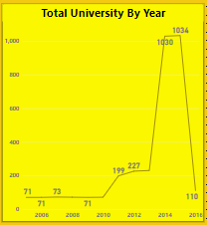

**INSIGHTS:**

The analysis reveals a consistent upward trajectory in the number of universities over time, with a marked decline observed in 2016. This pattern underscores the fluidity inherent in the higher education domain and emphasizes the necessity for thorough exploration into the factors contributing to this downturn. Unraveling the cause of this decline can offer invaluable perspectives into the underlying dynamics steering the expansion and resilience of universities, potentially unveiling economic, social, or policy-related influences shaping higher education trends. Such insights are indispensable for guiding strategic deliberations and interventions aimed at fortifying and augmenting the robustness of universities amid fluctuating circumstances.

**POWER BI DASHBOARDS**

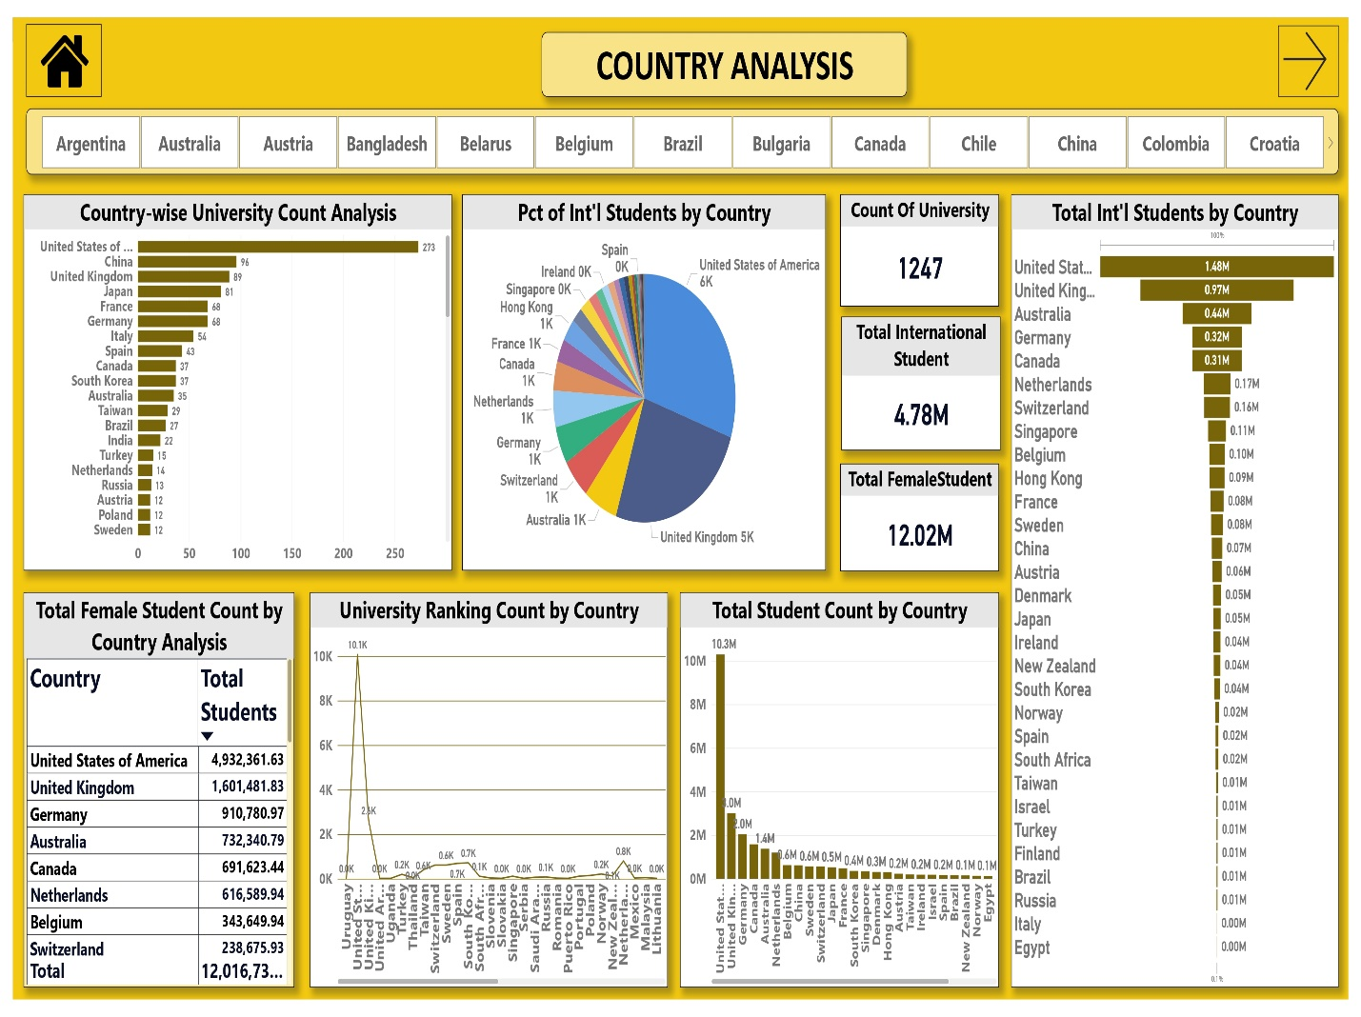

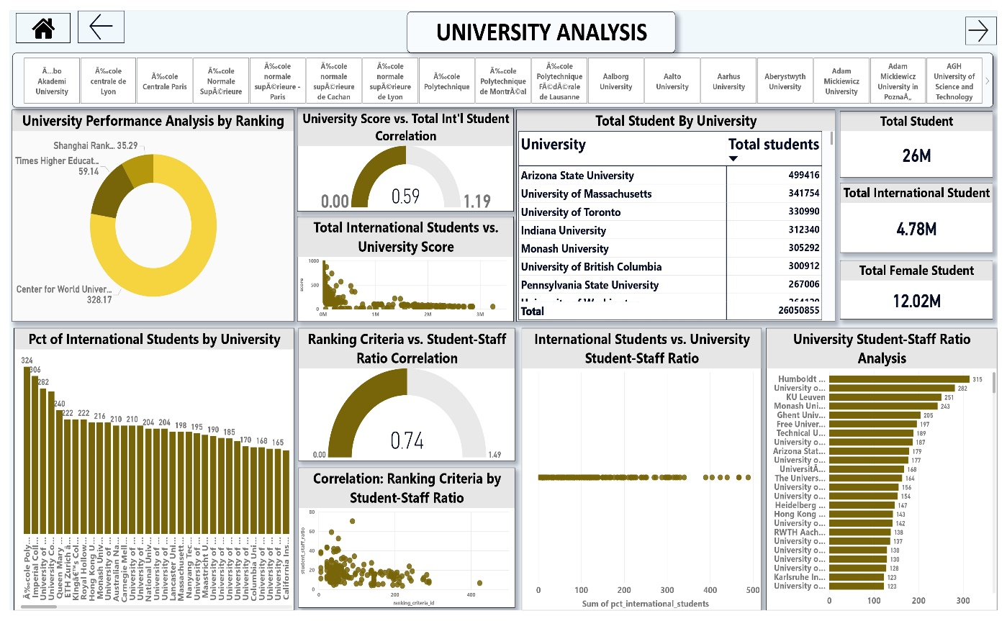

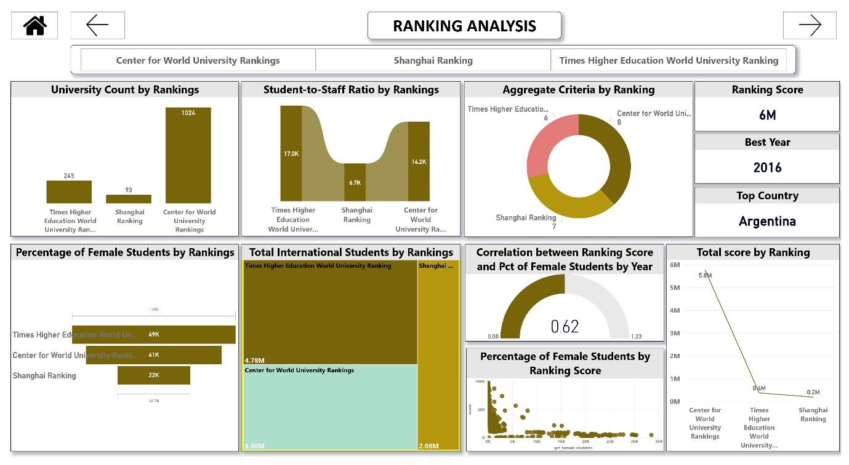

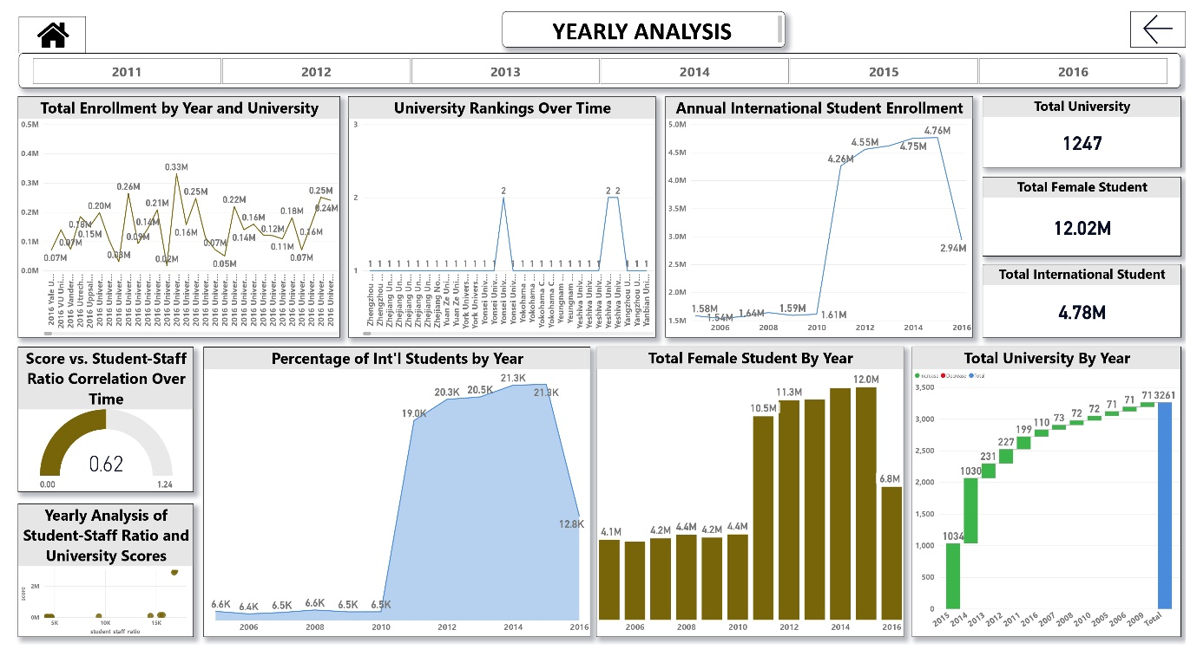

**POWER BI DASHBOARDS**

**POWER BI DASHBOARDS**

**CONCLUSION**

In summary, this comprehensive examination of the university dataset has generated valuable insights into the worldwide landscape of higher education. The dataset, which includes information on nations, academic institutions, ranking methodologies, criteria, and assorted metrics, laid a sturdy groundwork for exploration. Principal findings underscore the considerable concentration of universities in the United States, underscoring its pivotal role in higher education. Additionally, the unique preferences of ranking systems and their distinctive evaluation criteria elucidate the complex process of assessing academic institutions on a global scale.

The analysis unveiled dynamic trends in university rankings, exposing fluctuations across various countries and ranking methodologies. This highlights the imperative for universities and policymakers to remain flexible in response to changing educational and geopolitical circumstances. Furthermore, the observed correlation between university scores, student-staff ratios, and the enrollment of international students sheds light on pivotal factors influencing academic performance and inclusivity.

The dataset also revealed captivating patterns in student demographics, spotlighting noteworthy trends in the enrollment of female and international students. These insights underscore the significance of cultivating inclusive and supportive learning environments for a diverse student body. All in all, this project has offered valuable perspectives on the global higher education landscape, emphasizing the multifaceted nature of evaluating and comprehending universities in our increasingly interconnected world.