Data Analysis on Spotify tracks on 2022-23

SQL project to analysed and answer interesting questions about Spotify . The data used in this project is provided by Spotify collecting from Kaggle. It contains about

1.47 Lakh records from January 2022 to May 2023.

**BUSINESS PROBLEMS**

**Q1. Give me Top 10 Favourite Song by Daily Ranking**

**Q2. Give me Top 10 Favourite Artist Name by Daily Ranking**

**Q3. Return Top 10 Song which I can recommend as Fitness freak Q4. Return Top 5 Emerging artist of 2022 to current date**

**Q5. Recommend Top 10 Song for Weekend**

**Q6. Return every week & respective trending song for that week**

**Q7. Return Artist Name and 'Count of days' when they have two or more than two songs in top 200 song list.**

**Q8. Check if there any association between No. of artist per song and Popularity of songs**

**Q9. Provide No. of artist in each continent and respective country**

**Q.10. Provide no. of songs belongs to each continent and country produced by individual singers**

**Raw Data –** [**Link**](https://drive.google.com/drive/folders/1R0rRAtyt83Lhw80aVMkel5vQEcRQr9L7?usp=drive_link) **Clean Data –** [**Link**](https://drive.google.com/drive/folders/1R0rRAtyt83Lhw80aVMkel5vQEcRQr9L7?usp=drive_link)

**Data Dictionary**

The dataset encapsulates 21 information-rich columns, meticulously cleaned and primed for analysis. The possibilities for insightful analysis utilizing this dataset are extensive.

This data set consist about 181K records.

* **Song Rank :** Rank of that song out of 200 that day
* **Title of the Song :** Song name
* **Artist Name :** Singer of that song
* **Date :** Date consist of 1st Jan 2022 to 31st May 2023
* **Nationality of each artist :** From which Nation that Artist belongs
* **Artist's Continent :** From which Continent that Artist belongs
* **Unique Song ID :** Every song has unique Song ID
* **URL Link to the Song :** Direct link of that song from Spotify
* **Danceability:** Describes how suitable a track is for dancing
* **Energy:** Represents a perceptual measure of intensity and activity. Energetic tracks feel fast, loud and noisy.
* **Loudness:** The overall loudness of a track in decibels (dB)
* **Speechiness:** Detects the presence of spoken words in a track.
* **Acousticness:** Describes whether a track uses only or primarily instruments that produce sound through acoustic means.
* **Instrumentalness:** Predicts whether a track contains no vocals.
* **Valence:** Describes the musical positiveness of a track

**SPOTIFY STAR SCHEMA**

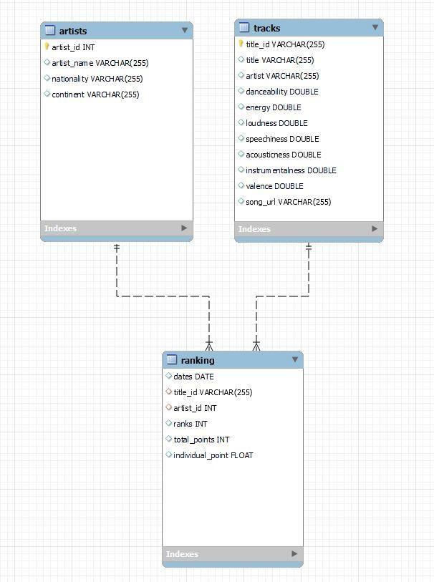

**NORMALISED DATA IN TABLES FORMS**

**CREATING Song TABLE**

CREATE TABLE tracks (

title_id VARCHAR(255) PRIMARY KEY, title VARCHAR(255),

artist VARCHAR(255), danceability FLOAT(25), energy FLOAT(25), loudness FLOAT(25), speechiness FLOAT(25), acousticness FLOAT(25),

instrumentalness FLOAT(25), valence FLOAT(25),

song_url VARCHAR(255)

);

**CREATING artist TABLE**

CREATE TABLE artists( artist_id int PRIMARY KEY, artist_name VARCHAR(255), nationality VARCHAR(255), continent VARCHAR(255)

);

**CREATING ranking TABLE**

CREATE TABLE ranking( dates DATE,

title_id VARCHAR(255), artist_id INT,

ranks INT, total_points INT,

individual_point FLOAT,

FOREIGN key (title_id) REFERENCES tracks(title_id), FOREIGN key (artist_id) REFERENCES artists(artist_id)

);

**Q1. Give me Top 10 Favourite Song by Daily Ranking**

WITH cte AS ( SELECT

t.title,

COUNT(DISTINCT r.dates) AS song_of_the_day FROM

ranking r

JOIN tracks t ON r.title_id = t.title_id WHERE

r.ranks = 1 GROUP BY

1

# ORDER BY

2 desc LIMIT

10

# ) SELECT

title FROM

cte;

**Q2. Give me Top 10 Favourite Artist Name by Daily Ranking**

WITH cte AS ( SELECT

a.artist_name,

COUNT(DISTINCT r.dates) -- COUNT(DISTINCT r.dates) AS

song_of_the_day FROM

ranking r

JOIN artists a ON a.artist_id = r.artist_id WHERE

r.ranks = 1 GROUP BY

1

# ORDER BY

2 desc LIMIT

10

# ) SELECT

artist_name FROM

cte;

**Q3. Return Top 10 Song which I can recommend as Fitness freak**

# SELECT

t.title,

COUNT(DISTINCT r.dates),

MIN(r.ranks)

# FROM

ranking r

JOIN tracks t ON r.title_id = t.title_id WHERE

energy > 0.8

AND loudness > -500 GROUP BY

1

# ORDER BY

2 desc,

3

# LIMIT

10;

**Q4. Return Top 5 Emerging artist of 2022 to current date**

CREATE TEMPORARY TABLE monthly_artists_points SELECT

DATE_FORMAT(r.dates, '%Y-%m') AS yearmonth, r.artist_id,

SUM(r.individual_point) AS points FROM

ranking r GROUP BY 1, 2

# ORDER BY 1 ASC, 3 DESC; SELECT

sub.yearmonth, sub.artist_id, a.artist_name

# FROM(

SELECT

yearmonth, artist_id, points, RANK() OVER(

PARTITION BY yearmonth ORDER BY points desc

) AS rnk FROM

monthly_artists_points

) sub

JOIN artists a ON sub.artist_id = a.artist_id WHERE

rnk = 1;

**Q5. Recommend Top 10 Song for Weekend**

SELECT t.title

# FROM (

SELECT

title_id,

COUNT(title_id) AS counts, SUM(total_points) AS all_points

# FROM(

SELECT

CASE WHEN date_format(dates, '%W') IN ('Saturday', 'Sunday') THEN "Yes"

ELSE "No"

END AS weekend, title_id, total_points

FROM ranking WHERE

# CASE

WHEN date_format(dates, '%W') IN ('Saturday', 'Sunday') THEN "Yes"

ELSE "No" END = "Yes"

) sub GROUP BY 1

ORDER BY 3 desc

# LIMIT 10

) sub2

JOIN tracks t ON sub2.title_id = t.title_id;

**Q6. Return every week & respective trending song for that week**

# SELECT

start_of_week, t.title

FROM (

SELECT

* FROM (

SELECT

*,

# RANK() OVER(

PARTITION BY yearweek ORDER BY

total_points desc

) AS rnk FROM

(

# SELECT

yearweek, title_id,

MIN(dates) start_of_week, AVG(all_points) AS total_points

# FROM

(

# SELECT

*,

SUM(total_points) OVER( PARTITION BY yearweek, title_id

# ORDER BY

yearweek

) AS all_points FROM

(

concat('0', week(dates))

# SELECT

*, concat(

YEAR(dates), '-',

# CASE

WHEN week(dates) < 10 THEN

ELSE week(dates) END

) AS yearweek FROM

(

# SELECT

DISTINCT dates, title_id,

ranks,

total_points FROM

ranking WHERE

dates > '2022-01-01'

AND dates <= '2023-05-27' ORDER BY

1,

3

) sub

) sub2

) sub3 GROUP BY

yearweek, title_id

# ORDER BY 1,

2,

4 desc

) sub4

) sub5 WHERE

rnk = 1

) sub6

JOIN tracks t ON sub6.title_id = t.title_id ORDER BY

1;

**Q7. Return Artist Name and 'Count of days' when they have two or more than two songs in top 200 song list.**

# SELECT

a.artist_name, COUNT(sub.dates) AS days

# FROM (

SELECT

dates, artist_id,

COUNT(title_id) AS cnt FROM

ranking GROUP BY

1,

2

# ORDER BY 1,

2

) sub

JOIN artists a ON sub.artist_id = a.artist_id WHERE

sub.cnt >= 2 GROUP BY

1

# ORDER BY

2 desc;

**Q8. Check if there any association between No. of artist per song and Popularity of songs**

SELECT

SUM(

CASE

WHEN cnt = 1 THEN 1

# ELSE 0 END

) AS '#of_artists1', SUM(

# CASE

WHEN cnt = 2 THEN 1

# ELSE 0 END

) AS '#of_artists2', SUM(

# CASE

WHEN cnt = 3 THEN 1

# ELSE 0 END

) AS '#of_artists3', SUM(

# CASE

WHEN cnt = 4 THEN 1

# ELSE 0 END

) AS '#of_artists4', SUM(

# CASE

WHEN cnt = 5 THEN 1

# ELSE 0 END

) AS '#of_artists5', SUM(

# CASE

WHEN cnt = 6 THEN 1

# ELSE 0 END

) AS '#of_artists6' FROM

(

# SELECT

dates, title_id,

COUNT(artist_id) AS cnt FROM

ranking WHERE

ranks <= 10 -- 5% of GROUP BY

1,

2

# HAVING

COUNT(artist_id)

# ORDER BY 1

) sub;

**Q9. Provide No. of artist in each continent and respective country**

SELECT

continent, nationality,

COUNT(artist_id) AS no_of_artists FROM

artists WHERE

continent <> 'Unknown' GROUP BY

1,

2

ORDER BY

1 asc,

2 asc;

**Q.10. Provide no. of songs belongs to each continent and country produced by individual singers**

# SELECT

continent, nationality,

COUNT(t.title_id) AS no_of_songs FROM

tracks t

LEFT JOIN ranking r ON t.title_id = r.title_id LEFT JOIN artists a ON r.artist_id = a.artist_id

# WHERE

a.continent IS NOT NULL

AND a.nationality IS NOT NULL AND a.continent <> 'Unknown' AND a.nationality <> 'Unknown'

# GROUP BY 1,

2

# ORDER BY 1,

3 desc;