**Tutorial – 1**

1. Write a program to print your profile.

**Code:**

import java.util.*;

class profile

{

    public static void main(String[] args){

        System.out.println("Name:"+"Viraj Chhayani");

        System.out.println("Class:"+"4CEA");

        System.out.println("Enrollment No:"+"21SOECE11011");

        System.out.println("Roll no:"+10);

        System.out.println("Marks:"+950);

        System.out.println("Bday:"+"18/09/2003");

    }

}

**Output Screenshot:**

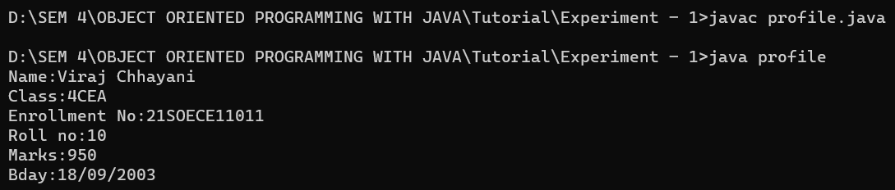

1. Write a program to print 1 to 10 numbers.

**Code:**

public class number

{

    public static void main(String[] args)

    {

        for(int i = 1; i <= 10; i++)

        {

            System.out.println(i);

        }

    }

}

**Output Screenshot:**

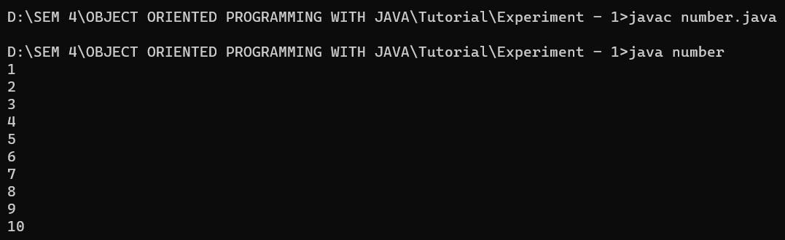

1. Write a program to print odd numbers between 1 to 20.

**Code:**

import java.util.*;

class odd

{

    public static void main(String[] args)

    {

        for (int i = 1; i < 20; i++)

        {

            if (i % 2 != 0)

            {

                System.out.println(i);

            }

        }

    }

}

**Output Screenshot:**

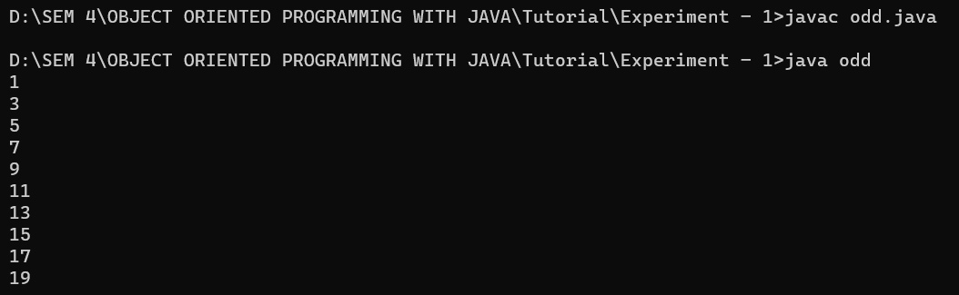

1. Write a program to find the simple interest and print it.

**Code:**

import java.io.*;

class interest

{

    public static void main(String args[])

    {

        float P = 10000, R = 5, T = 5;

        float SI = (P * T * R) / 100;

        System.out.println("Simple interest = " + SI);

    }

}

**Output Screenshot:**

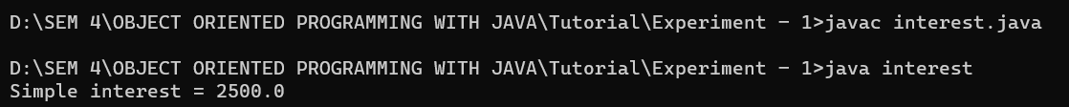

1. Write a program to demonstrate the use of switch statement.

**Code:**

class switchcase

{

    public static void main(String[] args)

    {

        int number = 44;

        String size;

        switch (number)

        {

            case 29:

                size = "Small";

                break;

            case 42:

                size = "Medium";

                break;

            case 44:

                size = "Large";

                break;

            case 48:

                size = "Extra Large";

                break;

            default:

                size = "Unknown";

                break;

        }

        System.out.println("Size: " + size);

    }

}

**Output Screenshot:**

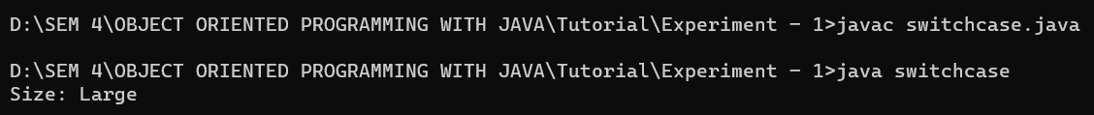

1. WAP to input any number n and print the product of all its digits.

For e.g. if n=235 then print 5*3*2=30

**Code:**

import java.util.*;

import java.lang.*;

class product

{

    public static void main (String[] args)

    {

        Scanner sc = new Scanner(System.in);

        System.out.println("Enter the number: ");

        int num = sc.nextInt();

        int n = num;

        int product = 1;

        while(n>0)

        {

            int digit = n%10;

            product *= digit;

            n/=10;

        }

        System.out.println("Product of digits of the number "+num+" is "+product+" .");

    }

}

**Output Screenshot:**

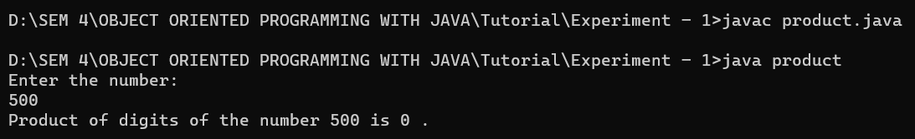

1. Write a program to find the simple interest and print it.

**Code:**

**Output Screenshot:**

1. Write a program to find the simple interest and print it.

**Code:**

**Output Screenshot:**

1. Write a program to find the simple interest and print it.

**Code:**

**Output Screenshot:**