TECHNICAL VALIDATION & HANDOFF
Heston and Double-Heston Models
Leakage, overfitting, validity, accuracy, parameter and continuation reference
Prepared for: Power-options project team
Version date: 06 August 2026
Scope: Single Heston and Double Heston only
Evidence status: VALIDATED_WITH_DISCLOSED_LIMITATIONS — 60/60 independent checks passed
Locked input: a8a56dd7b17074d8fa32f88936c8b404456f22f296d9dc4665faf3b13621f1d3
Decision Keep the current locked Single Heston as the historical winner. Do not promote the present Double Heston. This is a reproducibility-qualified conclusion, not a guarantee of future performance.
Critical honesty boundary The historical test period was previously viewed during earlier development, and next-session surface scores use realized target spot plus listed target strike/expiry coordinates. Future locked NSE dates are required for pristine forward confirmation.

1. Executive verdict
The audit found no critical inconsistency in data lineage, chronological splitting, candidate selection, state propagation, pricing, implied-volatility inversion, no-arbitrage bounds, prediction coverage, or saved metrics. All 60 independent checks passed, and all five existing automated test modules exited successfully.
Question | Evidence-backed answer
Was test data used to fit or select the saved candidates? | No row-level evidence of that pathway was found. Candidates are train-only; selection is validation-only.
Is zero overfitting proven? | No. A finite historical experiment cannot prove zero overfitting, especially after the test graph has been viewed.
Which model wins historically? | Single Heston. On 8,814 identical finite rows: RMSE 0.044200 vs 0.045510 for Double.
Should Double Heston be used now? | Not as the preferred model. It loses overall, wins only 2/11 stocks, and all 55 candidates are boundary-near.
Is this a pure unseen-day forecast? | No. It forecasts the conditional volatility surface using realized target spot and observed target contract coordinates.

Source: Independent recomputation in `outputs/heston_handoff/independent_heston_audit_checks.csv`.

2. Scope, exclusions and authenticity
This handoff covers only Single Heston and Double Heston. It does not begin neural-network training, PINN development, data augmentation, Kaggle replacement, PostgreSQL mutation, or a new NSE download.
Item | Verified value
Model-input file | outputs/019fc8a0/model_input_option_prices.csv
SHA-256 | a8a56dd7b17074d8fa32f88936c8b404456f22f296d9dc4665faf3b13621f1d3
Rows in clean release file | 572,512
Rows flagged model-ready | 215,636
Stocks in model-ready subset | 11
Original row key | symbol | trade date | exact expiry | option type | strike
Original source files | raw/nse_fo_bhavcopies/<year>/...csv.zip
Missing referenced raw files | 0

Authenticity means the evaluated rows resolve to local raw NSE FO bhavcopy paths and the locked file hash. This audit does not independently certify NSE's exchange infrastructure or redownload every bhavcopy from the internet.

3. Chronology and information boundary
- Dates are split 70% train, 15% validation and 15% test independently within each stock.
- All Single- and Double-Heston candidate training dates precede the first validation date for the same stock.
- Candidate selection is recomputable using validation data only; validation and test row keys are disjoint.
- Every saved origin date strictly precedes its target date; the observed calendar gap is one to four days.
- Exact expiry_date and days-to-expiry values are preserved. Historical Tuesday, Wednesday and Thursday expiries remain distinct; no weekday rule rewrites them.
- Origin-state tables contain no target option price or target implied-volatility label.
What 'no leakage found' means The saved row-level artifacts reproduce a valid train → validation selection → test scoring path. It does not prove that a researcher never looked at aggregated test results. The project record explicitly says the test graph was viewed earlier.

4. Implemented model equations and parameter meaning

4.1 Single Heston
Under the risk-neutral measure, the implemented one-factor model uses stochastic variance v(t):
Price process dS(t)/S(t) = (r − q)dt + √v(t) dW_S(t)
Variance process dv(t) = κ[θ − v(t)]dt + σ√v(t) dW_v(t), with d⟨W_S,W_v⟩ = ρdt
Parameter | Meaning | Implementation role
κ (kappa) | Mean-reversion speed | Propagates origin variance toward θ and shapes the characteristic function.
θ (theta) | Long-run variance | Positive structural level; annualized volatility scale is √θ.
σ (sigma) | Volatility of variance | Controls smile curvature and variance uncertainty.
ρ (rho) | Spot/variance correlation | Controls skew; constrained inside (−0.98, 0.98).
v0 | Date-specific variance state | Fitted at origin, propagated to target. Training median is descriptive, not the live forecast state.

The Feller diagnostic is 2κθ − σ² > 0. Pricing uses a Little-Heston-trap characteristic function with 64-point Gauss-Laguerre integration, put-call parity for puts, and Black-Scholes inversion for implied volatility.

4.2 Double Heston
The implemented Double Heston characteristic function is the product of two constrained Heston-factor characteristic functions, represented additively in log-characteristic exponents. The instantaneous variance is decomposed into slow and fast states.
Two variance factors dv_i(t) = κ_i[θ_i − v_i(t)]dt + σ_i√v_i(t)dW_vi(t), for i ∈ {slow, fast}; total state = v_slow + v_fast.
- Operational parameter count is ten: eight structural parameters plus v0_slow and v0_fast.
- Slow/fast ordering is enforced by κ_slow < κ_fast.
- Both factors must satisfy separate Feller conditions.
- The joint correlation disk is constrained by ρ_slow² + ρ_fast² < 1.
- Each factor state propagates exactly as θ_i + [v_i(origin) − θ_i] exp(−κ_i Δcalendar/365).

5. Selected Single-Heston parameter set
Symbol | Candidate | κ | θ | σ | ρ | v0 median | Val RMSE
ADANIENSOL | half_a | 9.996663 | 0.402712 | 2.822393 | -0.173073 | 0.151467 | 0.049179
ADANIGREEN | half_a | 3.981365 | 0.999666 | 2.806315 | -0.074662 | 0.167640 | 0.077256
ADANIPOWER | main | 9.996659 | 0.560397 | 3.039316 | -0.055311 | 0.325296 | 0.023363
CESC | half_a | 5.506302 | 0.879373 | 3.095346 | 0.134853 | 0.039588 | 0.073465
JSWENERGY | main | 9.996663 | 0.426153 | 2.903374 | -0.122050 | 0.098113 | 0.044995
NHPC | half_a | 9.996663 | 0.258595 | 2.261676 | 0.012605 | 0.045768 | 0.042614
NTPC | half_a | 9.996663 | 0.120830 | 1.545998 | -0.094111 | 0.056204 | 0.048292
POWERGRID | main | 9.996663 | 0.155460 | 1.753598 | -0.114274 | 0.029378 | 0.046688
SJVN | main | 9.996443 | 0.434051 | 2.930124 | -0.001738 | 0.127590 | 0.044968
TATAPOWER | main | 9.996663 | 0.175414 | 1.862741 | 0.030042 | 0.064200 | 0.052841
TORNTPOWER | half_b | 9.996663 | 0.395235 | 2.796071 | -0.113463 | 0.056940 | 0.050559

Source: Sanitized catalog `outputs/heston_handoff/single_heston_selected_parameter_catalog.csv`.
Operational warning The v0 median above summarizes training states. For each forecast origin, use the origin-specific fitted v0 and propagate it; do not substitute the median as a universal live state.

6. Selected Double-Heston parameter set

6.1 Slow factor
Symbol | Candidate | κ slow | θ slow | σ slow | ρ slow | v0 slow med
ADANIENSOL | training_half_a | 4.755650 | 0.353849 | 1.821515 | 0.567525 | 0.045393
ADANIGREEN | training_half_a | 3.813725 | 0.171570 | 1.137861 | -0.949681 | 0.029927
ADANIPOWER | full_start_3 | 4.998340 | 0.845936 | 2.892500 | -0.531453 | 0.078482
CESC | training_half_a | 0.051704 | 0.150343 | 0.013593 | -0.001108 | 0.005843
JSWENERGY | full_start_1 | 4.830192 | 0.336053 | 1.790856 | 0.650200 | 0.026803
NHPC | training_half_a | 0.063574 | 0.135629 | 0.129923 | -0.944830 | 0.004114
NTPC | training_half_b | 4.997313 | 0.081178 | 0.895853 | 0.650635 | 0.022222
POWERGRID | full_start_3 | 4.995617 | 0.153755 | 1.232828 | -0.735950 | 0.011819
SJVN | full_start_1 | 1.063320 | 0.150794 | 0.563266 | -0.949680 | 0.016240
TATAPOWER | full_start_1 | 0.051665 | 0.030971 | 0.056253 | -0.948730 | 0.006149
TORNTPOWER | full_start_3 | 4.850334 | 0.254662 | 1.561242 | 0.641609 | 0.033945

6.2 Fast factor
Symbol | Candidate | κ fast | θ fast | σ fast | ρ fast | v0 fast med
ADANIENSOL | training_half_a | 9.917287 | 0.206907 | 2.013533 | -0.760214 | 0.093458
ADANIGREEN | training_half_a | 3.927227 | 0.827656 | 2.536069 | -0.000001 | 0.095305
ADANIPOWER | full_start_3 | 9.997614 | 0.153734 | 1.208556 | 0.787016 | 0.209173
CESC | training_half_a | 5.762406 | 0.847978 | 3.109475 | -0.000000 | 0.024120
JSWENERGY | full_start_1 | 9.869913 | 0.235272 | 2.142738 | -0.691422 | 0.047385
NHPC | training_half_a | 3.360026 | 0.660608 | 2.095670 | -0.000007 | 0.030068
NTPC | training_half_b | 9.997454 | 0.066465 | 1.146657 | -0.691616 | 0.030299
POWERGRID | full_start_3 | 5.113148 | 0.109849 | 1.054234 | 0.600222 | 0.013167
SJVN | full_start_1 | 4.253820 | 0.842980 | 2.663736 | -0.000002 | 0.053298
TATAPOWER | full_start_1 | 9.996651 | 0.174263 | 1.856621 | -0.000001 | 0.053749
TORNTPOWER | full_start_3 | 9.781598 | 0.209969 | 2.015034 | -0.698837 | 0.039619

Source: Sanitized catalog `outputs/heston_handoff/double_heston_selected_parameter_catalog.csv`.
Do not interpret these as uniquely identified economics All 55 Double-Heston candidates are boundary-near, and training-half/start-value fits disagree materially. Similar prices can be produced by different parameter combinations.

7. Calibration and selection protocol
Stage | Single Heston | Double Heston
Structural candidates | 3 per stock: full train + alternating train halves A/B | 5 per stock: 3 full-train starts + train halves A/B
Training objective | Vega-scaled robust price residuals, equal date weighting | Same principle; two variance states per training surface
Selection | Minimum validation pooled IV RMSE; alphabetical tie break | Minimum validation mean stock-session IV RMSE; pooled RMSE then name tie breaks
Test use | Scoring only after selection | Scoring only after selection; identical common rows with Single
Failure handling | Finite selected predictions | 4 invalid test IV rows retained separately; no imputation

Optimization convergence alone is not evidence of unique recovery. The controlled tests show that prices can be recovered accurately even when structural parameters are materially displaced by small noise, especially for Double Heston.

8. Accuracy on the locked historical evaluation
Experiment | Model | Rows | IV RMSE | IV MAE | Bias | R²
Original next-session | Single Heston | 8,818 | 0.044469 | 0.028048 | −0.004604 | 0.814899
Original next-session | Prior-session median IV | 8,818 | 0.068079 | 0.042060 | −0.031587 | 0.566172
Identical common rows | Single Heston | 8,814 | 0.044200 | 0.027957 | −0.004502 | 0.816578
Identical common rows | Double Heston | 8,814 | 0.045510 | 0.028264 | −0.005601 | 0.805544

The stock-session bootstrap interval for Double minus Single RMSE is [0.000607, 0.001993], entirely positive. Lower is better; this favors Single Heston.
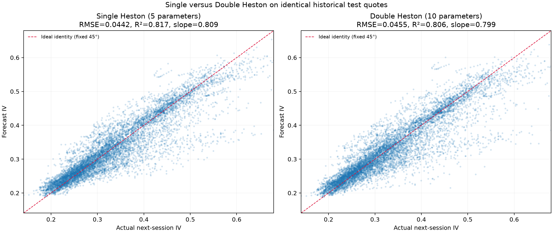
Figure 1. Identical-row actual IV versus Single- and Double-Heston forecasts.
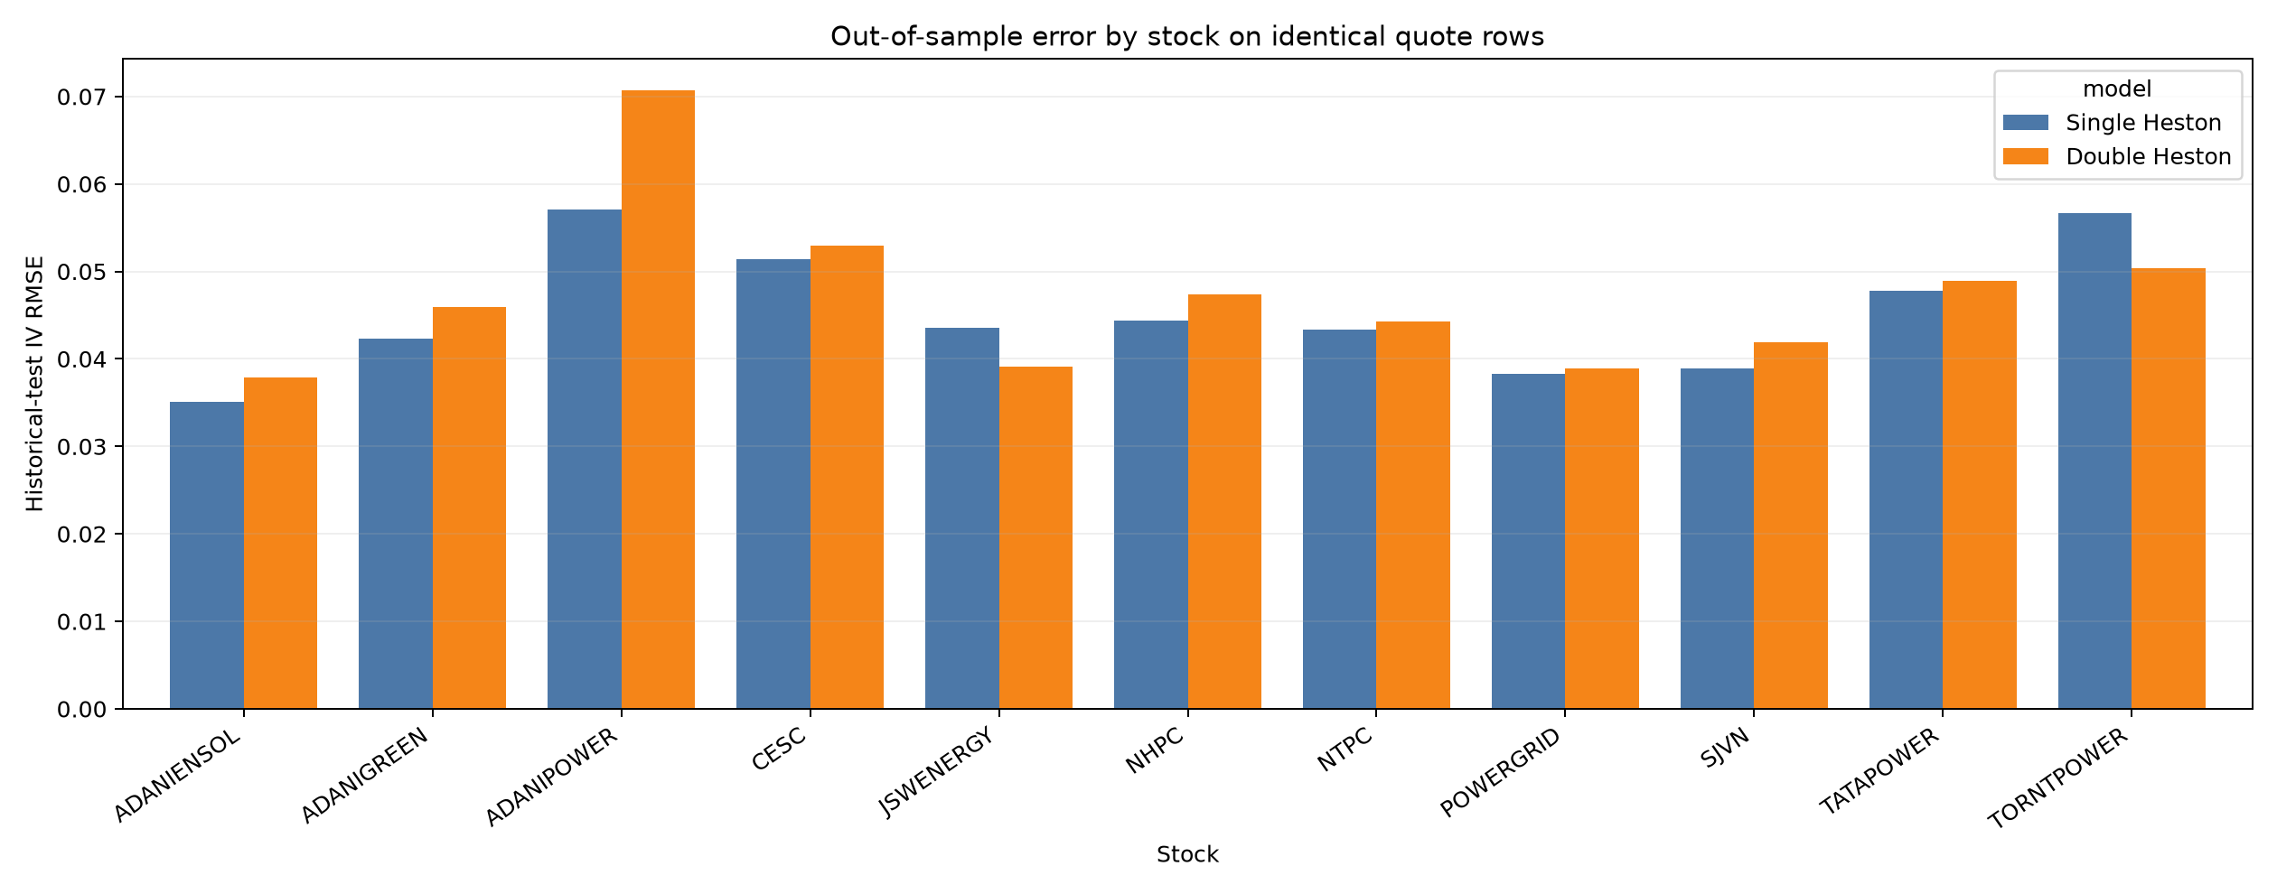
Figure 2. Per-stock test IV RMSE on the identical finite comparison universe.

8.1 Per-stock comparison
Symbol | Rows | Single RMSE | Double RMSE | Double−Single | Winner
ADANIENSOL | 410 | 0.035058 | 0.037827 | +0.002770 | Single
ADANIGREEN | 1336 | 0.042358 | 0.045958 | +0.003599 | Single
ADANIPOWER | 183 | 0.057109 | 0.070736 | +0.013627 | Single
CESC | 221 | 0.051420 | 0.052918 | +0.001499 | Single
JSWENERGY | 596 | 0.043534 | 0.039108 | -0.004426 | Double
NHPC | 605 | 0.044355 | 0.047366 | +0.003012 | Single
NTPC | 1633 | 0.043370 | 0.044258 | +0.000888 | Single
POWERGRID | 1436 | 0.038244 | 0.038862 | +0.000617 | Single
SJVN | 142 | 0.038933 | 0.041864 | +0.002931 | Single
TATAPOWER | 1936 | 0.047752 | 0.048878 | +0.001127 | Single
TORNTPOWER | 316 | 0.056687 | 0.050364 | -0.006323 | Double

Source: `outputs/single_double_heston_comparison/single_double_test_metrics.csv`.

9. Leakage and overfitting challenge tests
Challenge | Result | Interpretation
Three-fold strike crossfit | 4,709 unique held-out quotes; Heston RMSE 0.030028 | No same-row memorization in the sampled surfaces.
Within-surface centered R² | 0.617874 | Less impressive than pooled R² 0.903410; much pooled fit comes from same-day level calibration.
Flat same-day anchor | RMSE 0.040577 | Heston beats a flat surface.
Quadratic same-day smile | RMSE 0.014712 | Simple flexible smile beats Heston for same-day strike interpolation.
Prior available Heston state | RMSE 0.042245 | Removing same-day state information reduces performance.
Shuffled state | RMSE 0.068991 | Correct state timing matters.
Single half-sample fits | 39 boundary flags across 22 fits | Structural parameters are not fully stable.
Double candidates | 55/55 boundary-near | Severe identifiability/constraint-pressure warning.

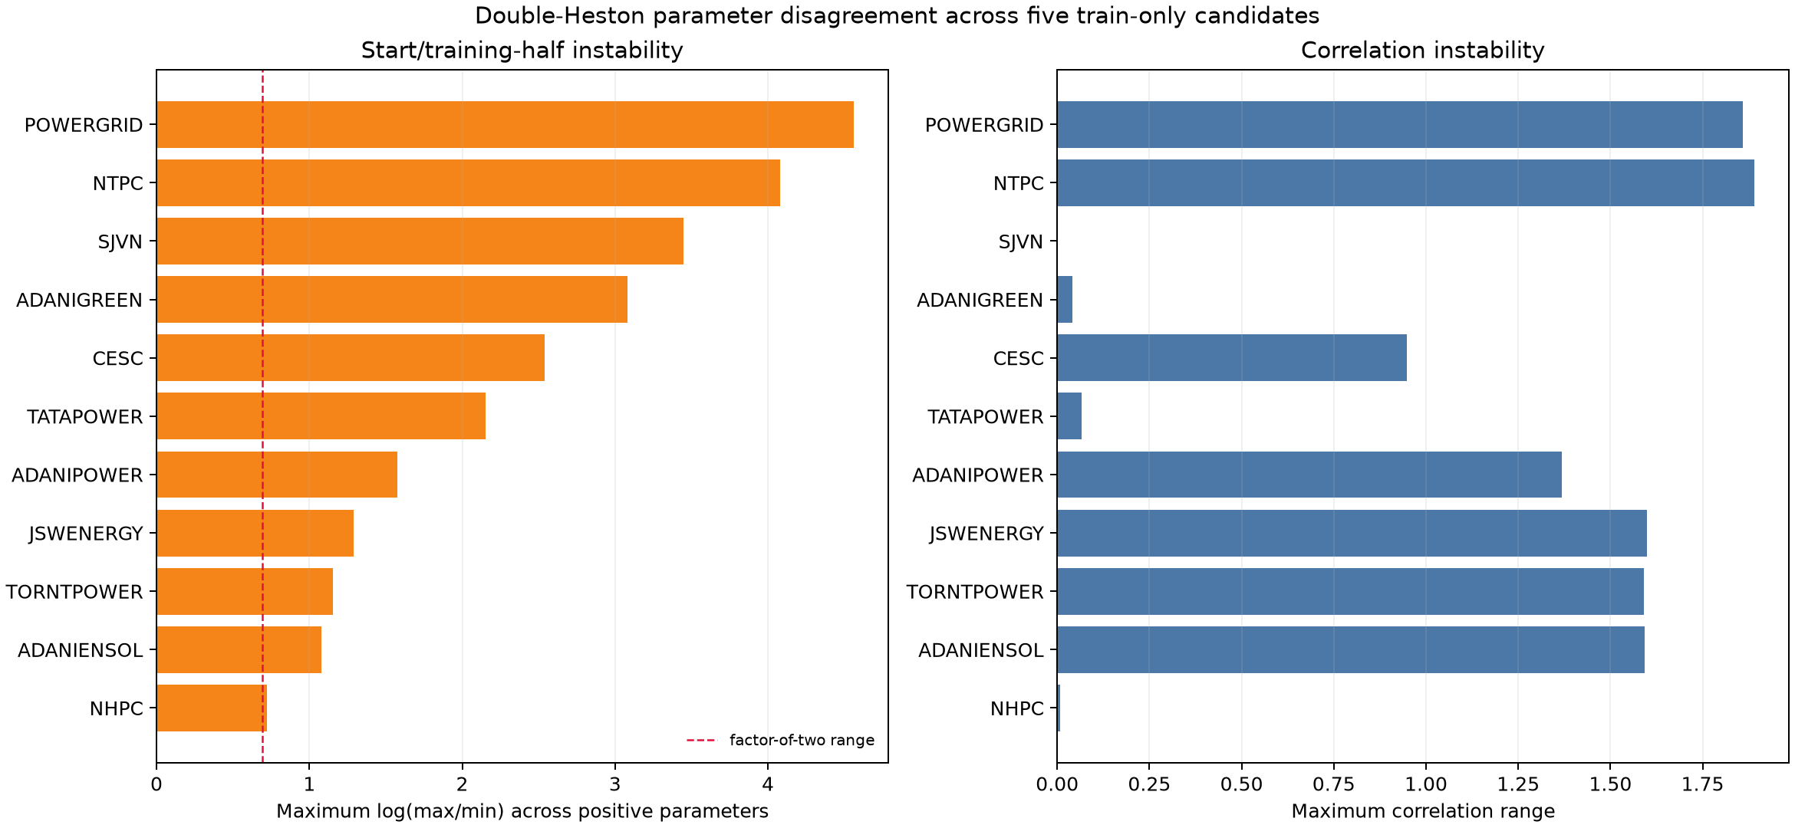
Figure 3. Double-Heston disagreement across five train-only candidates per stock.
The parameter-instability chart measures disagreement across optimizer starts and disjoint training halves. It is not a confidence interval and should not be interpreted as statistical uncertainty coverage.

10. Controlled synthetic recovery
Model / condition | Known-data recovery | Price error | Parameter sensitivity
Single, exact prices | Max relative error 3.222e-10 | RMSE 2.817e-11 | Three starts converge to effectively exact recovery
Single, 1% price noise | Recovered structural set remains close | RMSE 0.022329 | Non-zero displacement; use price fit and stability together
Double, exact prices | Max structural error 1.189e-05 | RMSE 3.679e-07 | Implementation can recover a known clean solution
Double, 1% price noise | Max structural error 28.875% | RMSE 0.026107 | Material non-identifiability despite small pricing loss

Meaning These tests validate pricing/calibration mechanics under controlled conditions. They do not validate that real NSE data are generated by Heston dynamics, nor do they make the historical parameter estimates unique.

11. Invalid rows, coverage and honesty controls
- The Single-Heston source test universe contains 8,818 unique rows.
- Double Heston returns finite IV for 8,814 rows (99.9546% coverage).
- Four invalid Double-Heston implied-volatility rows are retained in a separate failure file and are not imputed or silently replaced.
- Candidate selection uses only validation quote keys where all five Double candidates are finite; validation failures are also retained separately.
- All stored Single/Double prices reprice from the saved equations within 2×10⁻⁹, and stored IV values invert those prices within 2×10⁻¹⁰.
Symbol | Row key | Recorded result
NTPC | NTPC|2026-05-19|2026-05-26|CE|450.00 | invalid IV
NTPC | NTPC|2026-06-19|2026-06-30|CE|460.00 | invalid IV
NTPC | NTPC|2026-06-22|2026-06-30|CE|460.00 | invalid IV
NTPC | NTPC|2026-07-21|2026-07-28|CE|460.00 | invalid IV

Source: `outputs/single_double_heston_comparison/double_heston_test_prediction_failures.csv`.

12. Retrospective generalization adjustment
A later validation-only guard improved the historical Single-Heston test RMSE from 0.044469 to 0.036590, with slope improving from 0.806598 to 0.878963. Corrections were accepted for NHPC, NTPC, POWERGRID, TATAPOWER.
Do not present this as pristine out-of-sample validation retrospective historical-test comparison; the original test graph was viewed before the improvement was designed, so future NSE sessions are required for pristine forward confirmation
For teammate continuation, the corrected model may be carried as a locked challenger, but its first credible confirmation must use dates that were not visible when the rule was designed.

13. Privacy and data-exposure review
Exposure class | Finding | Required action
Credentials/secrets | No API-key, password, AWS-key or private-key pattern found in reviewed model code/reports. | Continue secret scanning before any public release.
Personal/machine metadata | Two raw machine artifacts contain an absolute local path with the workstation username. | Do not share them verbatim; use sanitized catalogs and this scrubbed report.
Raw NSE rows | This report contains no raw option-price table and no embedded source dataset. | Share the data separately under the project's access policy.
Model parameters | All selected parameters are intentionally disclosed for teammate continuation. | Treat them as project IP if required by team policy.

The final DOCX is metadata-scrubbed after generation. The context Markdown uses project-relative paths only.

14. Locked continuation protocol
- Freeze `single_heston.py`, `double_heston.py`, `forecast_single_heston_next_day.py`, `compare_single_double_heston.py`, selected parameter catalogs, and all checksum manifests.
- Do not alter candidate starts, bounds, filters, correction thresholds, or evaluation rows using the previously viewed historical test.
- Acquire authentic future NSE sessions strictly after 03 August 2026 and retain raw-source hashes and exact expiry dates.
- Run the same model-ready filter and record every exclusion reason. Never fill or fabricate a failed model IV.
- At each target, construct the origin state using origin-date information only; then propagate over the exact calendar gap.
- Generate Single and Double predictions on identical row keys, conditional on the same target spot/contract coordinates if preserving the current evaluation convention.
- Report pooled RMSE/MAE/bias/R², mean stock-session RMSE, forecast-on-actual slope, per-stock results, coverage and all failure rows.
- Bootstrap by stock-session, not individual option row, because strikes within a session are dependent.
- Promote Double only after a preregistered future window shows a clear improvement and parameter stability no longer depends strongly on start/half sample.

14.1 Recommended preregistration
Decision item | Lock before future scoring
Primary metric | Mean stock-session IV RMSE on identical finite rows
Uncertainty | 95% stock-session cluster bootstrap of Double minus Single RMSE
Coverage floor | At least 99.9%; every invalid row documented
Promotion rule | Double interval entirely below zero and per-stock performance not concentrated in only one or two names
Stability rule | Substantially fewer boundary-near fits plus lower start/half-sample parameter ranges
No-retuning rule | One locked run on the preregistered future window

15. Reproducibility commands and file map
Run from the project root with the environment that provides NumPy, pandas, SciPy and Matplotlib:
python3 test_single_heston.py
python3 test_heston_overfit_audit.py
python3 test_heston_next_day_forecast.py
python3 test_heston_generalization.py
python3 test_double_heston.py
python3 audit_heston_handoff.py
Role | Project-relative path
Authentic model input | outputs/019fc8a0/model_input_option_prices.csv
Single core | single_heston.py
Single next-session | forecast_single_heston_next_day.py
Single overfit audit | audit_single_heston_overfitting.py
Double core | double_heston.py
Single/Double comparison | compare_single_double_heston.py
Independent handoff audit | audit_heston_handoff.py
Machine audit matrix | outputs/heston_handoff/independent_heston_audit_checks.csv
Sanitized parameters | outputs/heston_handoff/*_selected_parameter_catalog.csv
Context Markdown | outputs/heston_handoff/HESTON_DOUBLE_HESTON_TEAM_CONTEXT.md

16. Known limitations
- No finite historical test can prove zero overfitting or a global optimum.
- The historical test period was previously viewed during Single-Heston development; it is not pristine final holdout evidence.
- Next-session scoring is conditional on realized target spot and the target session's listed strike/expiry coordinates.
- Double Heston underperforms Single Heston on the identical historical rows and has severe parameter-boundary/identifiability warnings.
- The retrospective Single-Heston recalibration must be confirmed on future locked NSE dates before being called forward validated.
- The model universe is the 11 stocks with model-ready data, not every possible power-sector security.
- Calibration uses a filtered liquid/parity-consistent option subset; results do not automatically generalize to stale, illiquid or rejected quotes.
- Corporate-action adjustments and expiry changes are inherited from the locked clean-release pipeline; this audit validates the fields and lineage, not every corporate-action announcement independently.
- The baseline is useful but limited. Future work should retain it and may add stronger predeclared baselines without using the evaluation window to choose them.
- R² is descriptive and scale-sensitive; use RMSE, calibration slope, coverage, session clustering and stability together.

17. Audit-check appendix
Category | Independent check | Status | Observed
source | input sha256 matches locked NSE model input | PASS | a8a56dd7b17074d8fa32f88936c8b404456f22f296d9dc4665faf3b13621f1d3
source | model ready row count is locked | PASS | 215636
source | model input row keys unique | PASS | 0
source | model input contains 11 power stocks | PASS | 11
source | model ready filter reproduces locked subset | PASS | all=572512, ready=215636
source | source paths are NSE bhavcopies | PASS | 0
source | referenced raw NSE files exist locally | PASS | 0
expiry | expiry distance matches saved days | PASS | 0
expiry | maturity is exact days divided by 365 | PASS | 4.931506591976387e-11
expiry | multiple historical expiry weekdays preserved | PASS | Monday, Thursday, Tuesday
chronology | single candidates strictly precede validation | PASS | 0
chronology | single origin strictly precedes target | PASS | 0
chronology | single saved split matches independent 70 15 15 | PASS | 0
chronology | single validation and test keys disjoint | PASS | 0
selection | single validation selection recomputed | PASS | 11
selection | single selection declares validation only | PASS | 0
selection | single has three train only candidates per stock | PASS | 3
lineage | single test rows resolve to source | PASS | 0
lineage | single test values match source rows | PASS | 0
equation | single variance propagation recomputed | PASS | 1.1102230246251565e-16
equation | single saved prices reprice exactly | PASS | 1.1368683772161603e-12
equation | single saved IV inverts saved prices | PASS | 5.703770789011742e-13
validity | single prices within no arbitrage bounds | PASS | 0
constraints | all single candidates Feller valid | PASS | 0.02495313693270962
constraints | all single candidates within declared bounds | PASS | 33 candidates
metrics | single selected heston metrics recomputed | PASS | 9.367506770274758e-17
metrics | single prior session expiry median iv metrics recomputed | PASS | 8.326672684688674e-17
chronology | double candidates strictly precede validation | PASS | 0
selection | double has five train only candidates per stock | PASS | 5
selection | each double validation key has all five candidates | PASS | 5
selection | double validation selection recomputed | PASS | 11
selection | double selection declares validation only | PASS | 0
constraints | all double candidates satisfy both Feller conditions | PASS | 3.28336959995474e-05
constraints | all double candidates have ordered factors | PASS | 0
constraints | all double candidates satisfy joint correlation disk | PASS | 0.9496814173760569
overfit | double boundary near candidates recorded | PASS | 55
equation | double variance propagation recomputed | PASS | 1.1102230246251565e-16
equation | double saved prices reprice exactly | PASS | 6.821210263296962e-13
equation | double saved IV inverts saved prices | PASS | 1.1843370728570335e-10
validity | double prices within no arbitrage bounds | PASS | 0
coverage | single test universe has 8818 rows | PASS | 8818
coverage | double common and failure rows partition single universe | PASS | common=8814, failures=4, universe=8818
coverage | double invalid rows are documented not imputed | PASS | 4
lineage | single and double use identical common rows | PASS | 8814
metrics | single heston comparison metrics recomputed | PASS | 7.632783294297951e-17
metrics | double heston comparison metrics recomputed | PASS | 8.326672684688674e-17
metrics | double minus single cluster bootstrap recomputed | PASS | 0.0
overfit | historical bootstrap favors single Heston | PASS | 95% interval [0.00060695, 0.00199293]
overfit | single three fold strike crossfit metrics recomputed | PASS | 3.469446951953614e-18
leakage | all strike crossfit leakage checks pass | PASS | 11/11
overfit | quadratic same day smile beats single Heston | PASS | quadratic=0.014712; Heston=0.030028
overfit | single half sample boundary flags recorded | PASS | 39
honesty | generalized single result labeled retrospective | PASS | retrospective historical-test comparison; the original test graph was viewe…
honesty | conditional evaluation scope explicit | PASS | ['CONDITIONAL_ON_REALIZED_TARGET_SPOT_AND_QUOTES']
controlled | single exact synthetic recovery | PASS | 3.221947400236205e-10
controlled | single one percent noise sensitivity recorded | PASS | 0.1241260944772804
controlled | double exact synthetic recovery | PASS | 1.1886345312058081e-05
controlled | double one percent noise sensitivity recorded | PASS | 0.28874634698904245
privacy | no credential patterns in reviewed code and reports | PASS | []
privacy | raw machine artifacts with local paths identified | PASS | ['outputs/single_heston_next_day_forecast/parameter_candidates_train_only.c…

Source: Full details, severities and untruncated observations are in `independent_heston_audit_checks.csv`.

18. Glossary
Term | Definition in this project
Origin | The last observed NSE session whose state is allowed to enter a target forecast.
Target | The next observed session being scored.
Conditional surface forecast | Forecast IV at target spot and target-listed strike/expiry coordinates, without using target option prices.
Structural parameters | κ, θ, σ and ρ for each variance factor.
State parameters | v0 for Single; v0_slow and v0_fast for Double, fitted per origin session.
Feller gap | 2κθ − σ²; positive under the declared constraint.
Boundary-near | A diagnostic that a fitted candidate lies close to one or more imposed parameter limits.
Leakage | Information from validation/test labels influencing fitting, selection or state construction earlier than allowed.
Retrospective | Designed or interpreted after some test results were already viewed.

Handoff status The teammate can reproduce the saved experiments and continue with future locked validation. The report does not authorize calling the current results production-ready or leakage-proof in an absolute sense.

