Mobile Shop – APP Development

Contents
Web Screens 3
User Form 3
Mobile Screens 5
Loging Screen 5
Main Screen 5
API Required 7

Web Screens

User Form

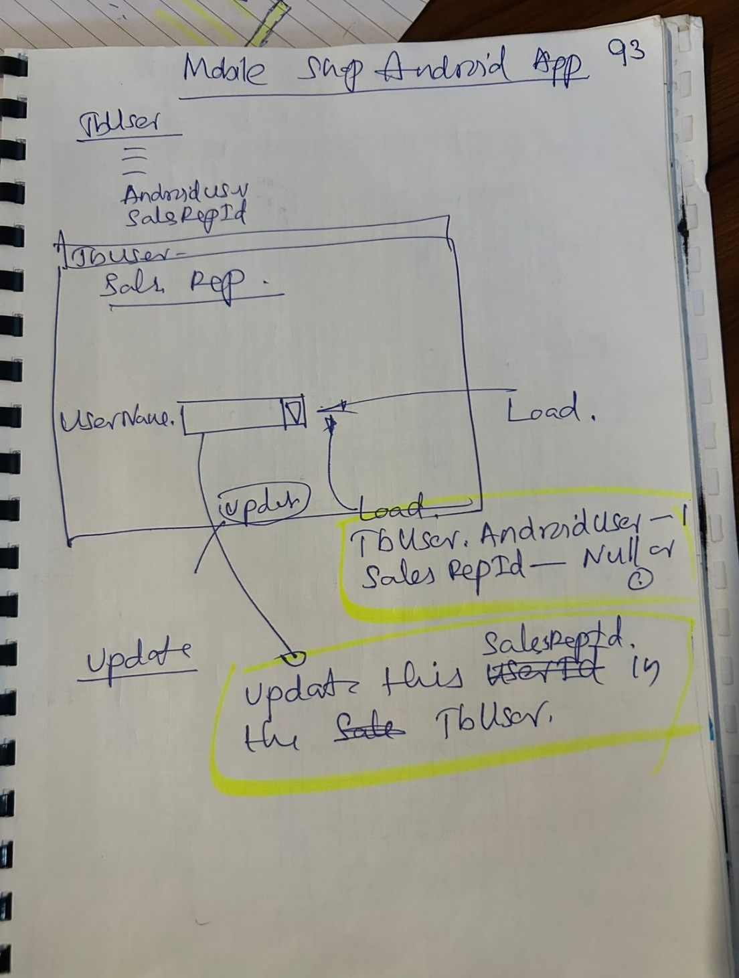

Mobile Screens

Loging Screen ( MS1 )

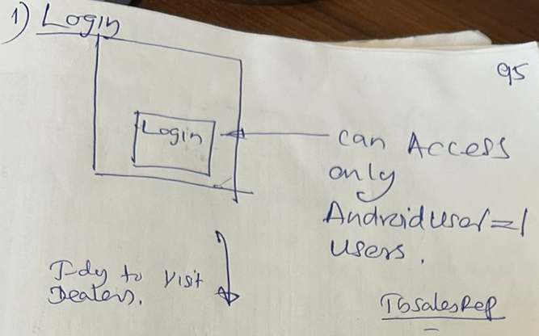

Main Screen ( MS2)

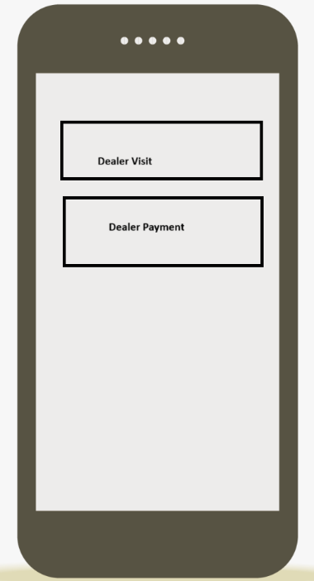

When MS2 . Dealer Visit Pressed

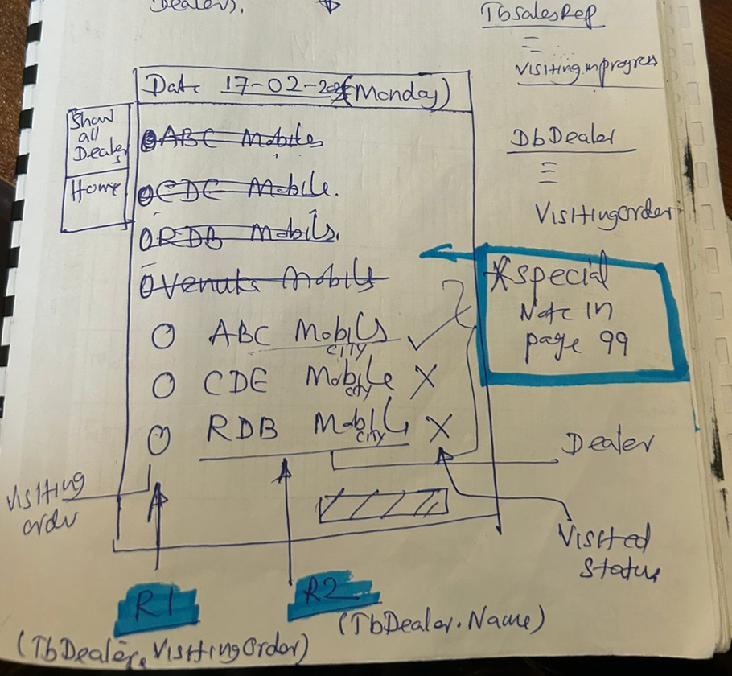

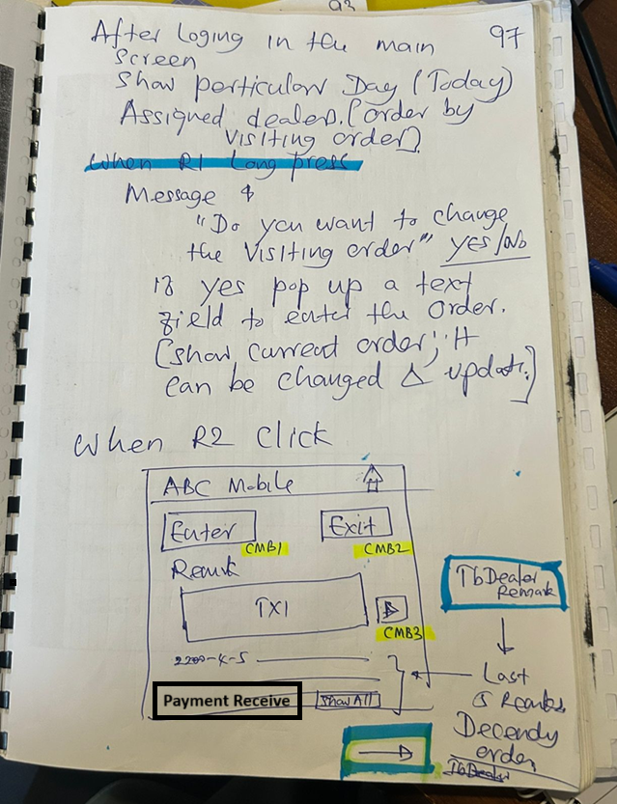
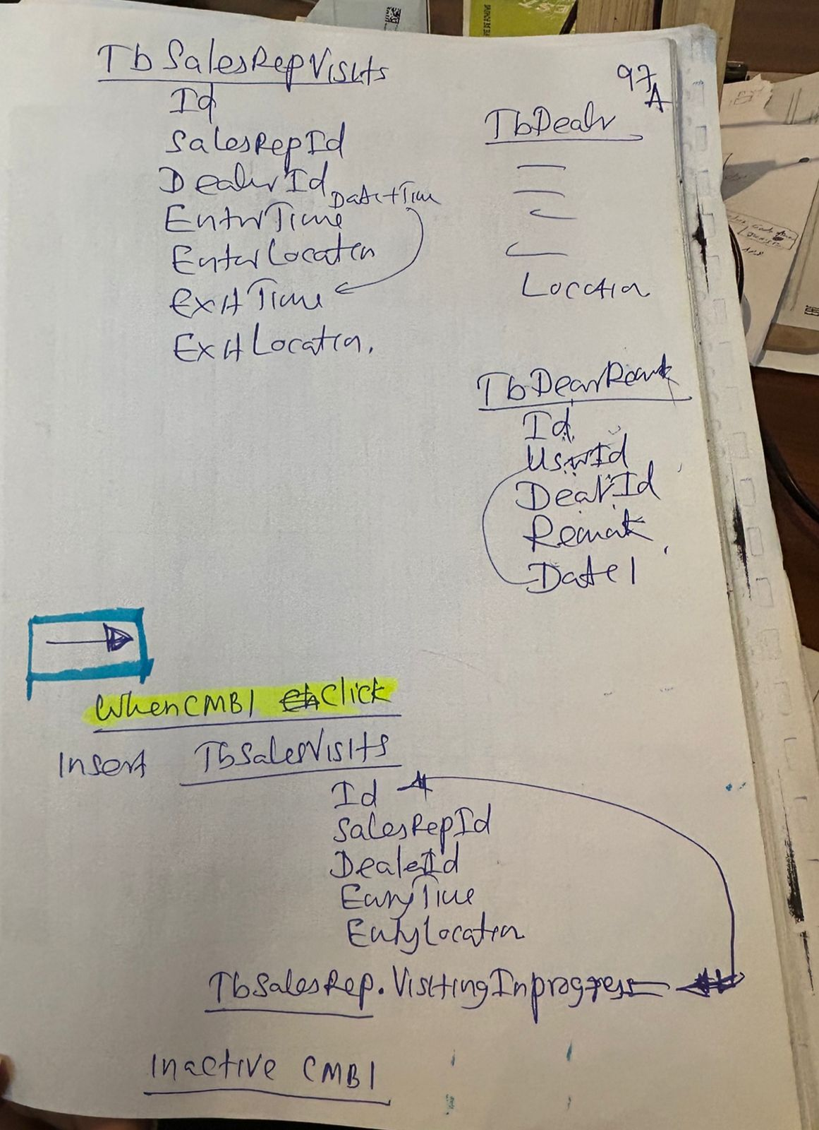
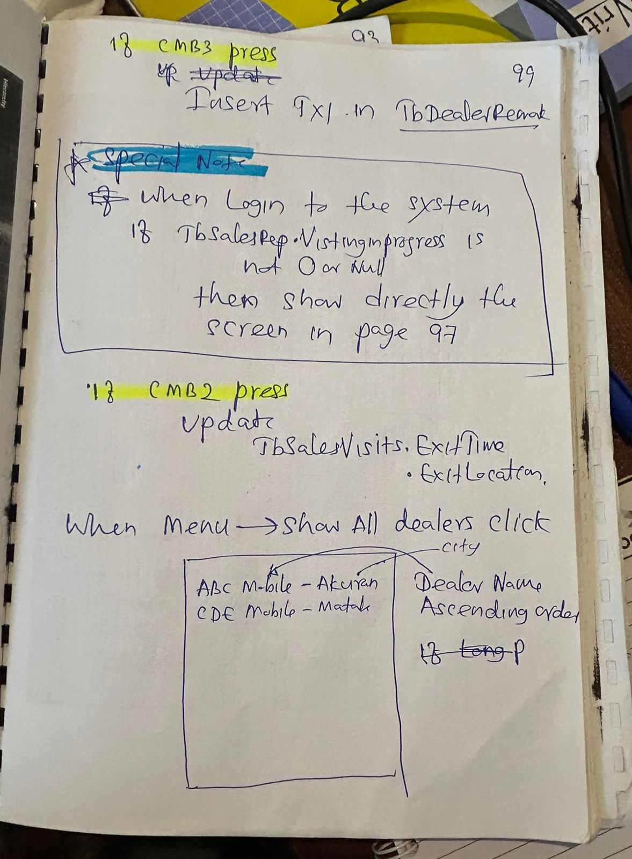
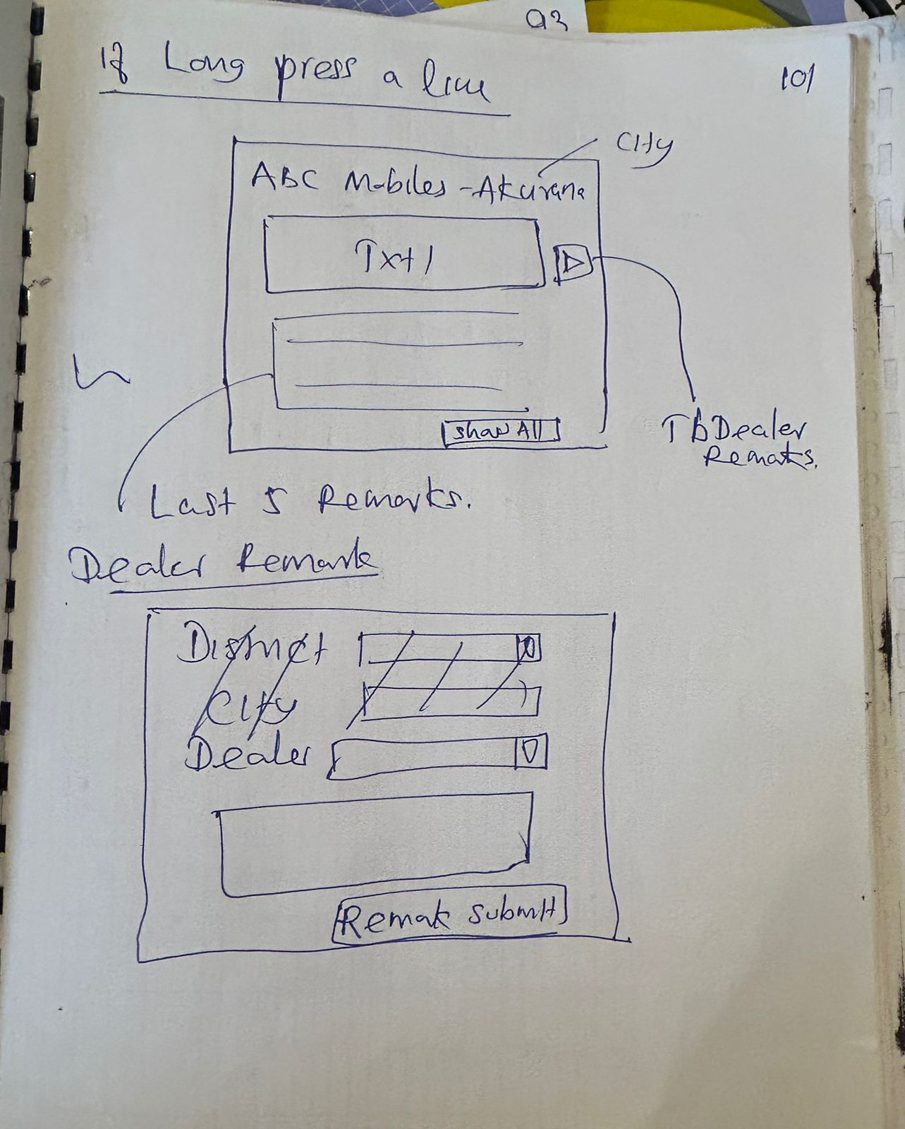

API Required

- UserAuthentication ( UserId, Password, ValidationStatus OUT, UserLeval OUT, ErrorDescription OUT )

