1. Prerequisites:
   1. AWS account
   2. Visual studio 2013
   3. IRIS dataset CSV file
2. Configuring Visual Studio with AWS explorer (Important!!!)
   1. When the code in Visual Studio consumes the API’s of AWS SDK, it uses the User profile configured in the AWS explorer
   2. There are 2 ways to get the AWS SDK (Refer: [SDK for .NET](https://aws.amazon.com/sdk-for-net/))
      1. By the Nuget Package Manager
      2. By the windows installer (Get it [here](https://sdk-for-net.amazonwebservices.com/latest/AWSToolsAndSDKForNet.msi) )
   3. Once the SDK is successfully installed, you should get a option of AWS Explorer in the View menu items 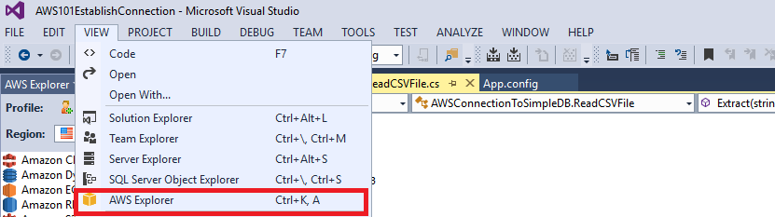
   4. And you should have the explorer in the left pane of Visual studio 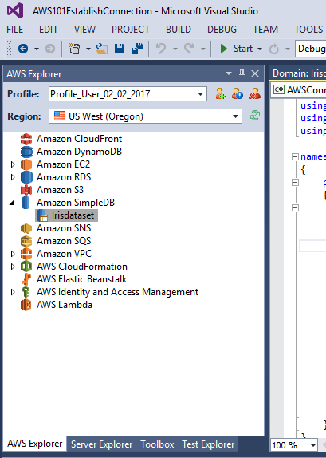
   5. We can use different profiles as per different requirements
   6. Go to AWS Console 🡪IAM 🡪 Users 🡪 Add User
      1. In the Set user details, enter name and select the option of ‘**Programmatic access’** in Access type
      2. Next you will be prompted to add user to a group. click on Create Group
      3. And you will be prompted for group name and the policies to attach to the group. Policies to be attached can be – **AdministratorAccess (access to all resources). Select the now newly created group for this user**
      4. **Next Review the user and click on ‘Create User’ button**
      5. **On the successful creation, you will be prompted to save a csv file with the user credentials and keys required for access. Save this file because there will be no other way to extract this information**
   7. **Back to Visual Studio, you will now have the required information to create a profile**
   8. **In the AWS explorer, click on the New profile icon** 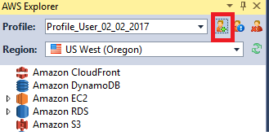
   9. **You will be prompted to enter the details for this new profile** 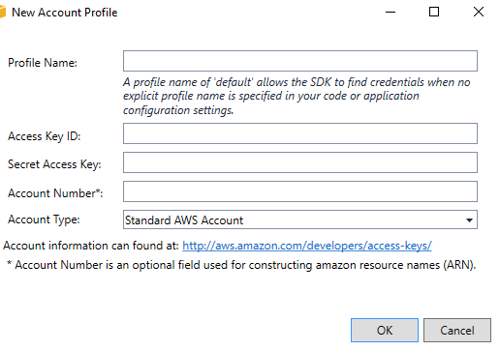
   10. **Enter the details from the CSV you stored after creating the AWS user. The profile name can be anything meaningful. Retrieve the Access Key ID and Secret Access Key form the csv and paste it here**
3. **Now you are good to go with consumption of the API’s**
4. **Create a new Empty AWS project.**
5. **In Visual Studio, File 🡪 New Project 🡪 Visual C# 🡪 AWS Sample Projects 🡪 AWS Empty Project. Give a name to the project and hit ‘OK’**
6. **Creating a Aws project adds the required DLL’s to the project. This is the only difference between AWS application and Simple console application**
7. **I am attaching the code to be copied in the project created**



I have mentioned the websites which were used for reference in creating the code. The tasks performed by the code are :

* Read the CSV file and store the contents in a variable
* Connect to the AWS SimpleDB services and check the Domains (Tables)
* If the domain is not existing then Create a domain
* After creation of the domain, insert values at of the csv into it
* The CSV file contains 150 entries but the free Aws account allows you to have only 100 entries
* I would advise to go ahead with the deletion of any entry or getting entries by name or in SQL query manner