# Create programmatic access user.

## In search bar, type “iam”, and then click on IAM service.

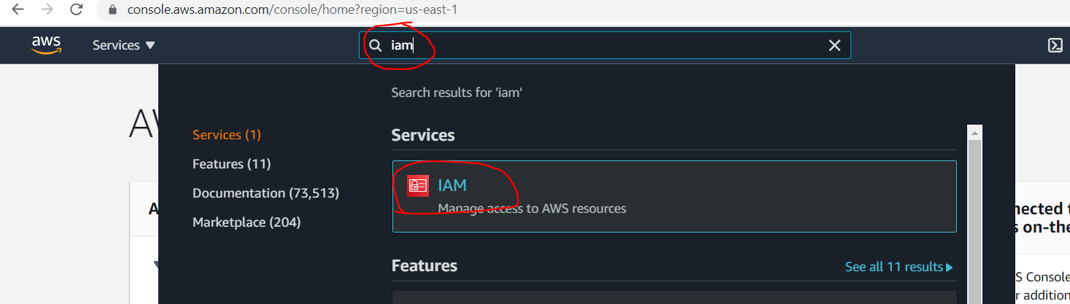

## IAM dashboard will open, click on “Users” on left side panel.

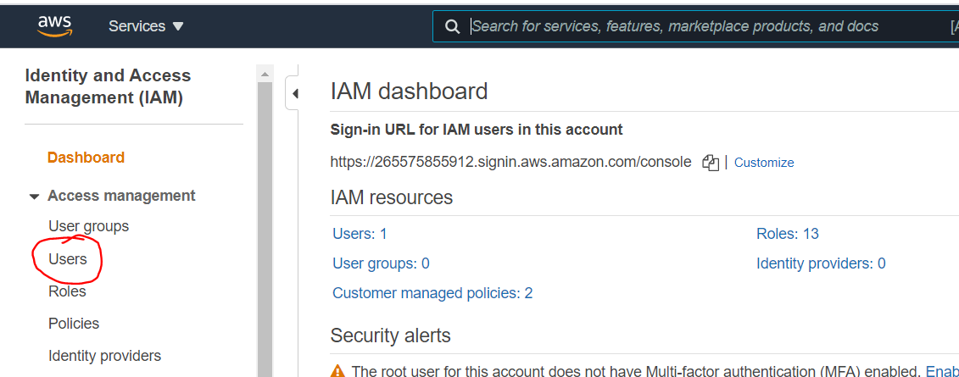

## Click on “Add user” button.

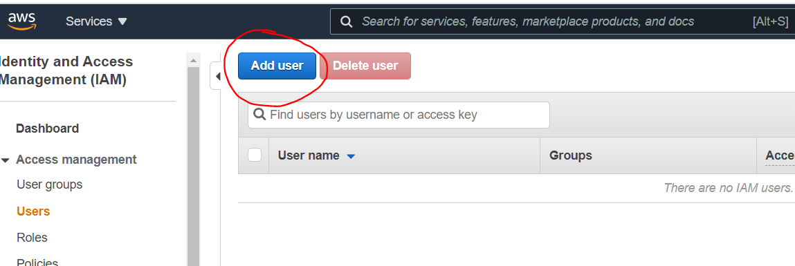

## Type username as “terraform”, tick on “Programmatic access” checkbox and then click on “Next”.

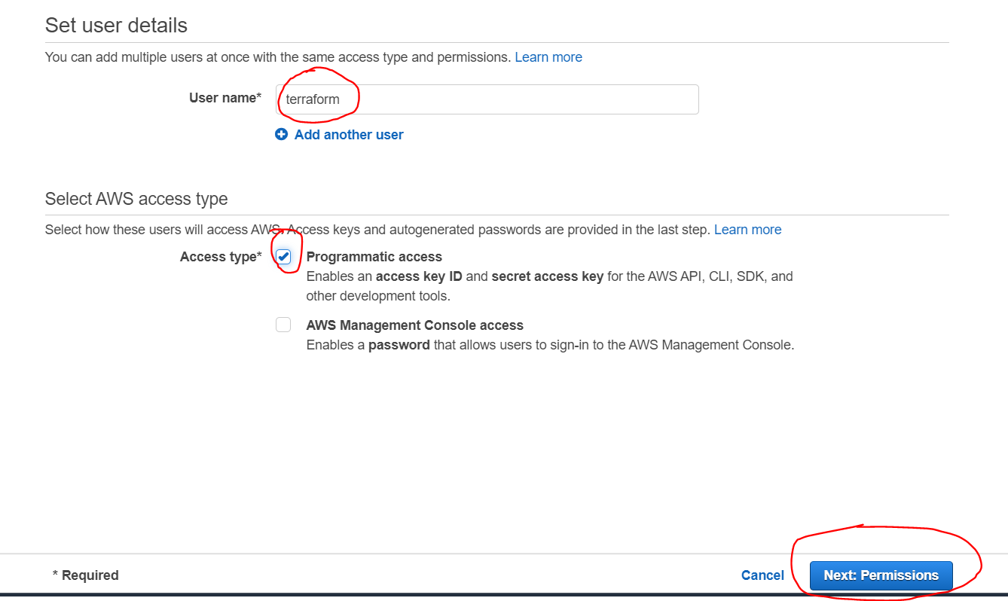

## Click on “Attach existing policies directly”, tick “AdministratorAccess” checkbox, and then click on “Next”

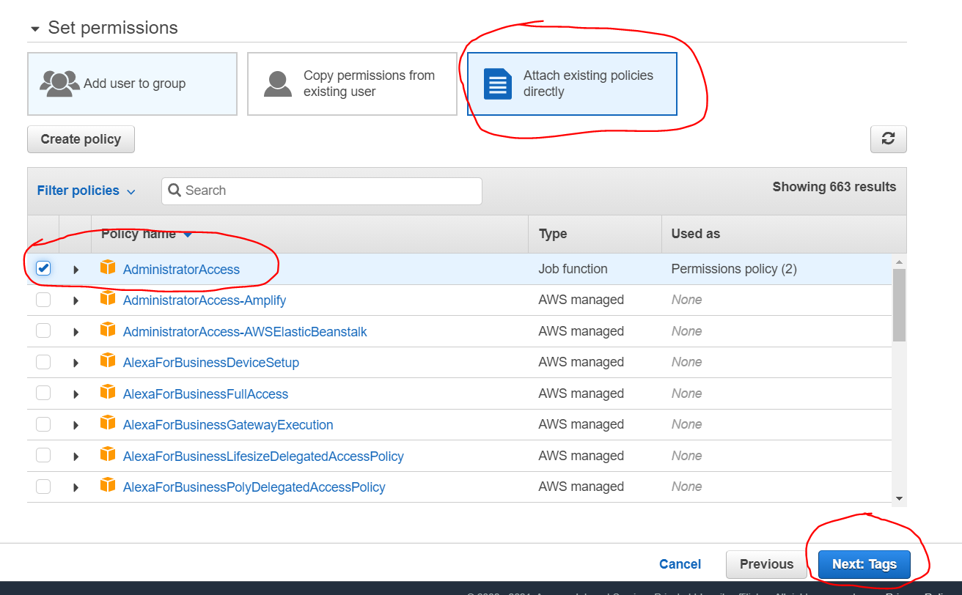

## Click on “Next”

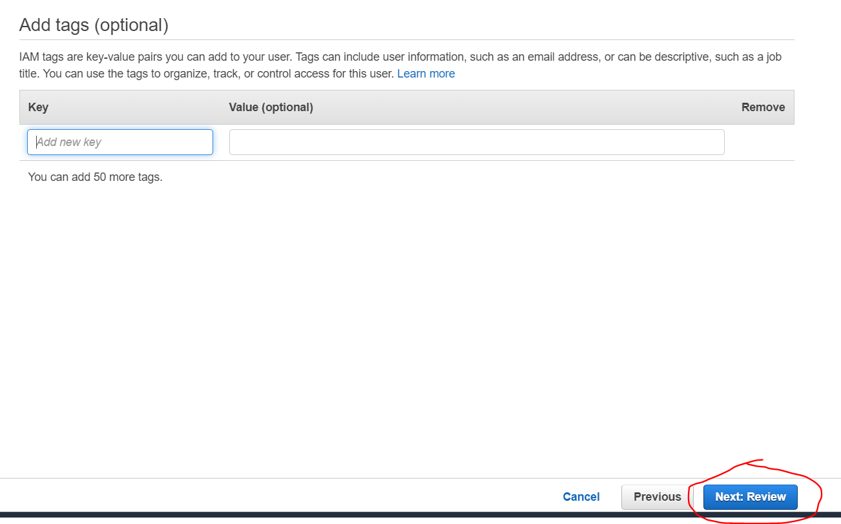

## Click on “Create user”

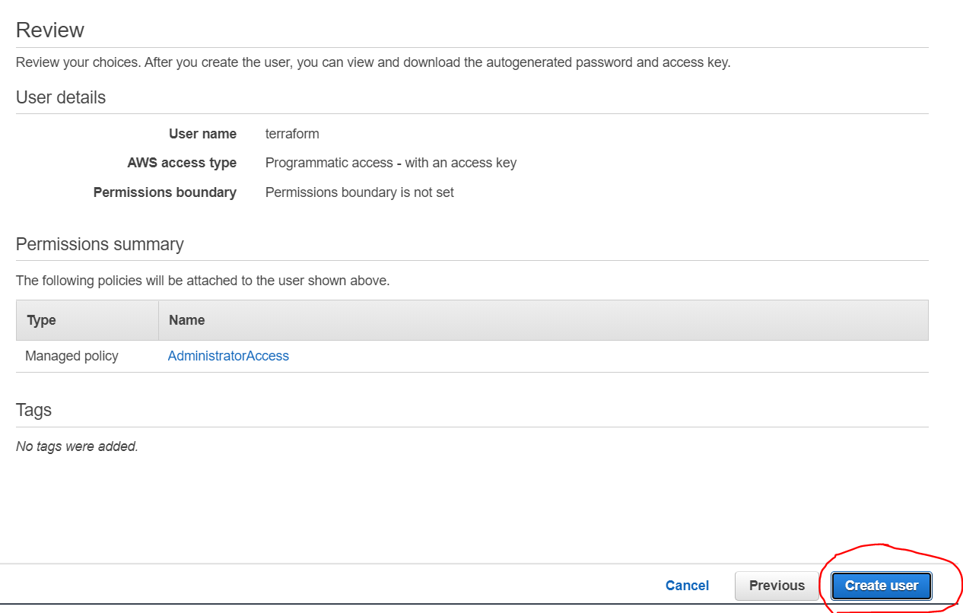

## Click on “Download .csv”

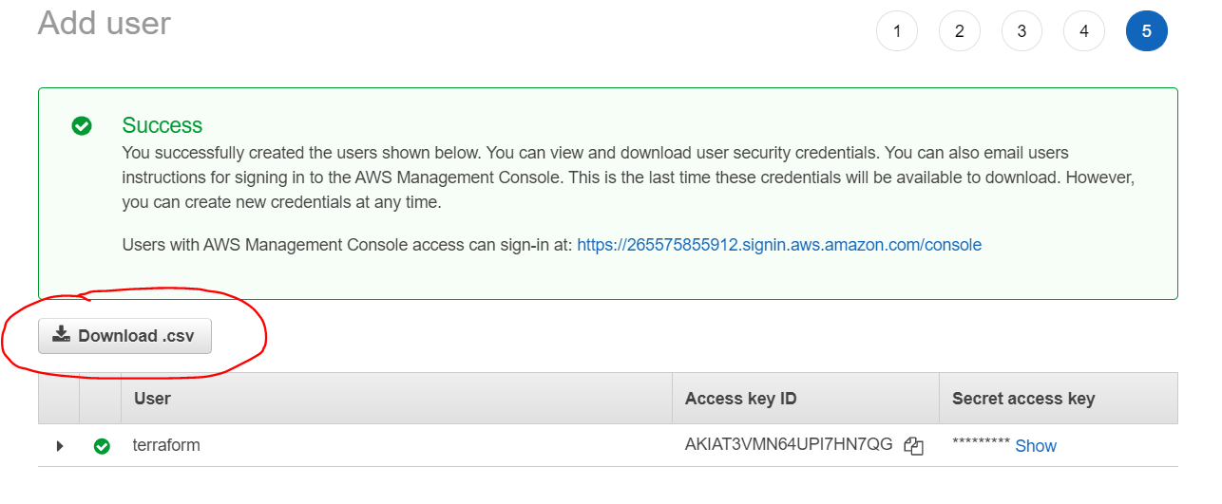

## This downloaded csv will have access key and secret key for authentication.

## Login on ec2 instance, and configure credential.

