**Lab Practical #01:**

Study of basic networking commands and IP configuration.

**Practical Assignment #01:**

1. Perform and explain various networking commands listed below:
   1. ipconfig
   2. ping
   3. getmac
   4. systeminfo
   5. traceroute / tracert
   6. netstat
   7. nslookup
   8. hostname
   9. pathping
   10. arp

## ipconfig

### Description:

Ipconfig is used to display and manage network configuration settings like IP Address, DNS server address etc.

Ipconfig is Useful to check if a device has an IP or to troubleshoot connectivity issues.

|  |  |  |
| --- | --- | --- |
| No. | Option | Description |
| 1 | /all | Displays full configuration information. |
| 2 | /release | Releases the IP address for the specified adapter. |
| 3 | /renew | Renews the IP address for the specified adapter. |
| 4 | /flushdns | Clears the DNS Resolver cache. |
| 5 | /displaydns | Displays the contents of the DNS Resolver cache. |

### Implementation:

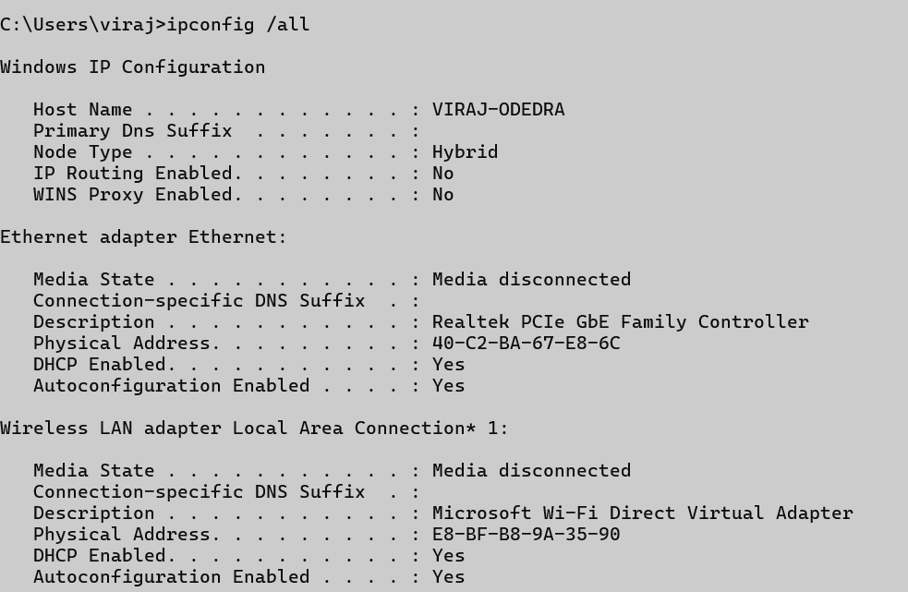

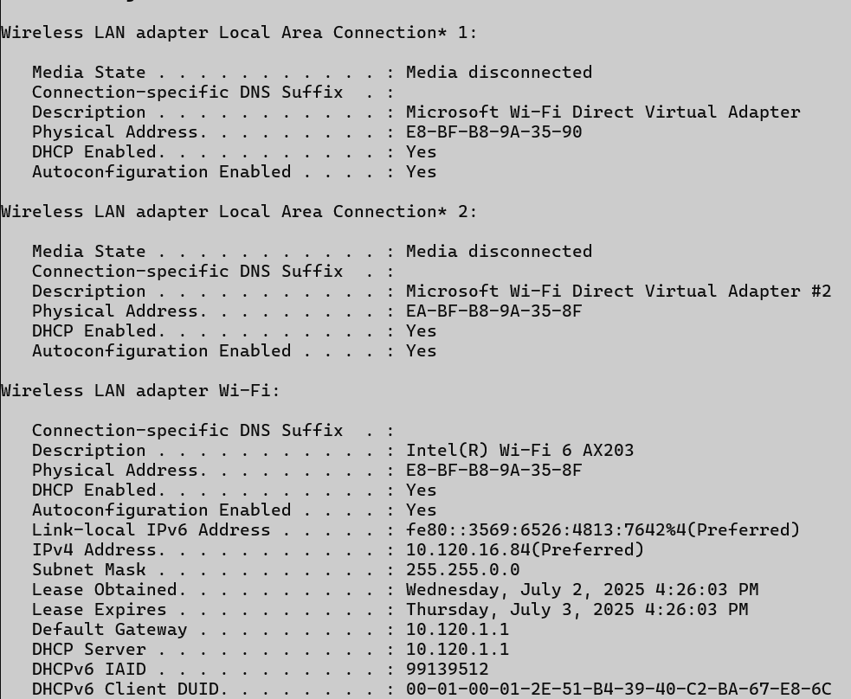

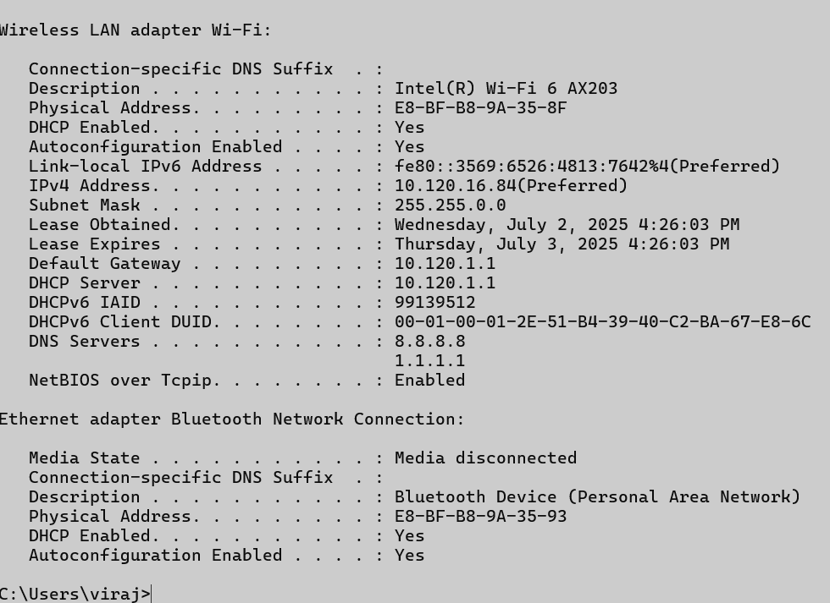

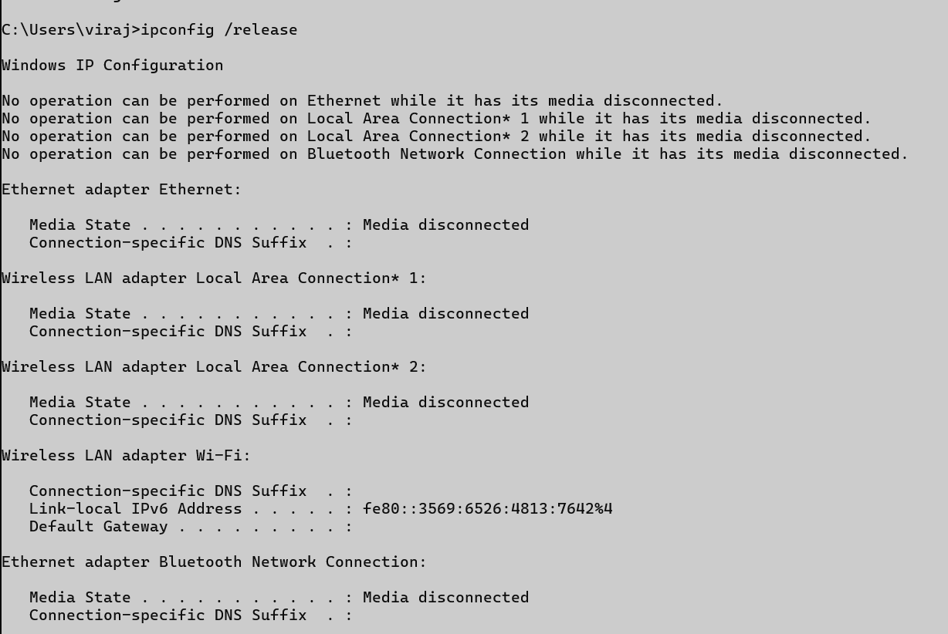

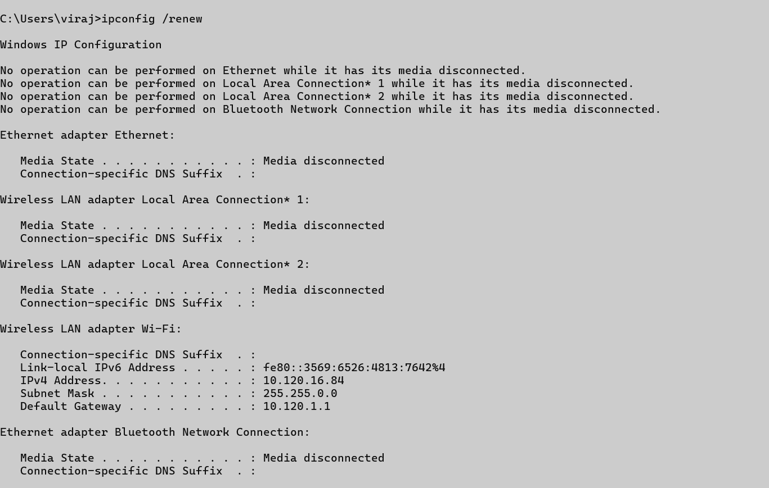

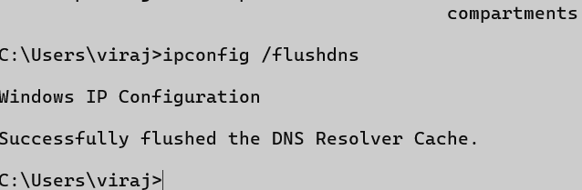

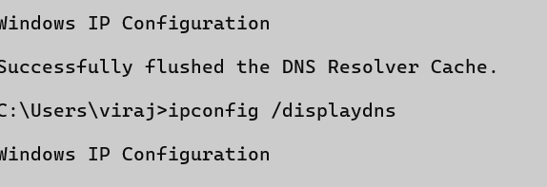

## ping

### Description:

The ping command is a network utility used to test the reachability of a host (like a website or another computer) on an IP network. It sends ICMP (Internet Control Message Protocol) echo request packets to the target and waits for a reply. The command helps measure round-trip time and packet loss, indicating network connectivity and latency. It's commonly used for troubleshooting and diagnosing network issues.

|  |  |  |
| --- | --- | --- |
| No. | Option | Description |
| 1 | -t | Pings the target until stopped manually. |
| 2 | -n count | Specifies the number of Echo Request messages to send. |
| 3 | -l size | Sends packets with a custom byte size. |
| 4 | -4 | Forces using IPv4. |
| 5 | -6 | Forces using IPv6. |

### Implementation:

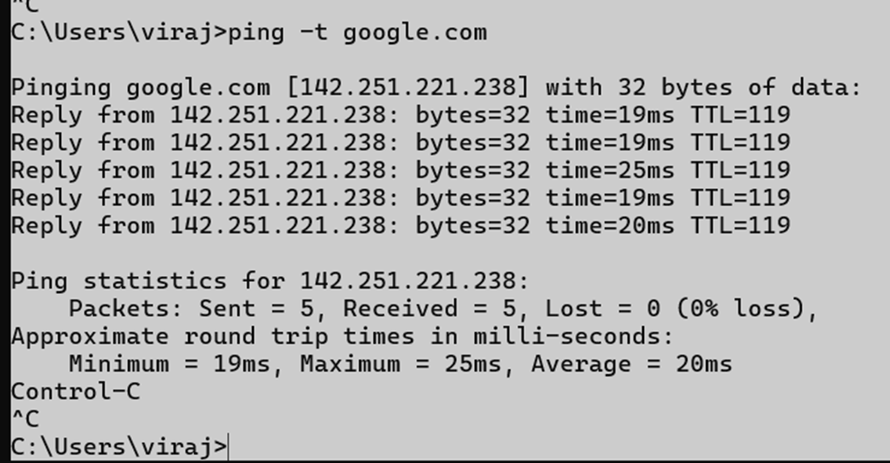

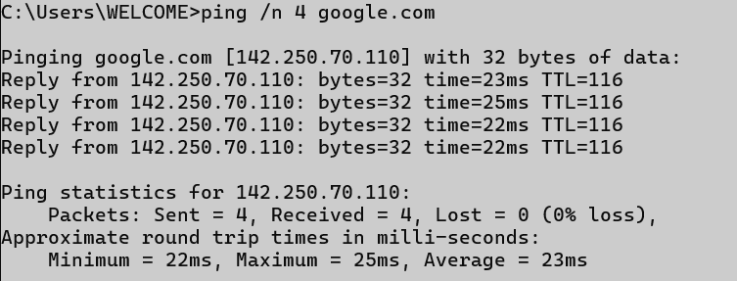

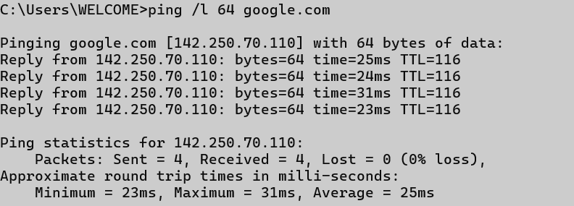

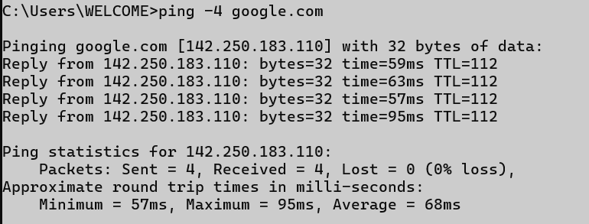

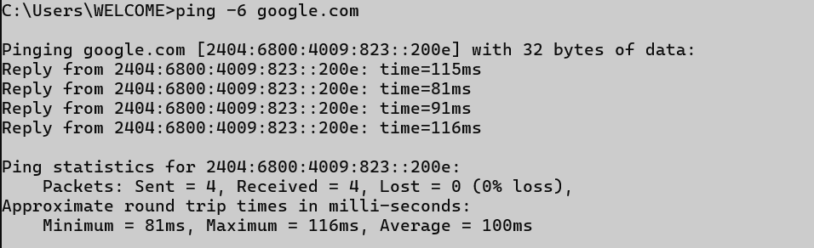

## getmac

### Description: The getmac command displays the MAC (Media Access Control) addresses of a computer’s network interfaces. It shows the physical address and the associated network transport name. This is useful for identifying devices on a network.

|  |  |  |
| --- | --- | --- |
| No. | Option | Description |
| 1 | /v | Shows verbose output with more details. |
| 2 | /fo table | Displays output in table format. |
| 3 | /fo list | Displays output in list format. |
| 4 | /fo csv | Displays output in CSV format. |
| 5 | /nh | Hides the column headers in the output. |

### Implementation :

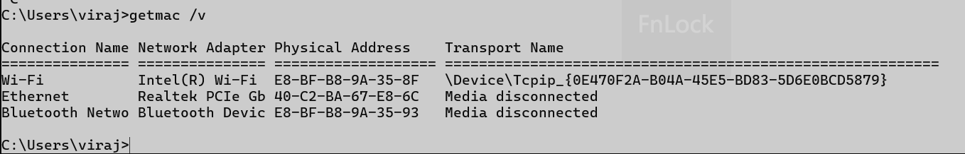

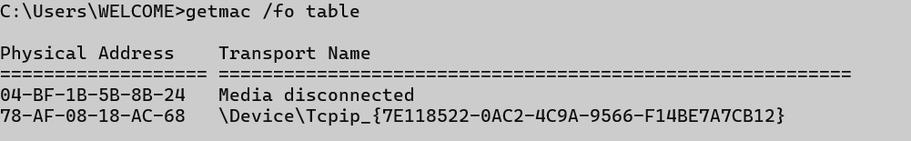

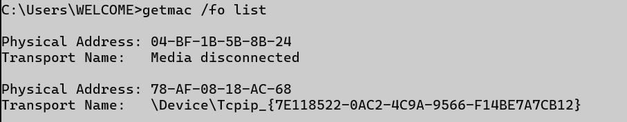

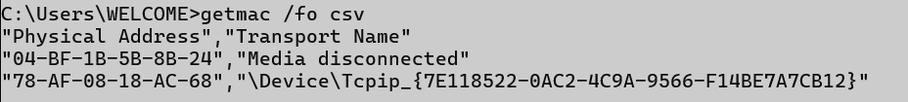

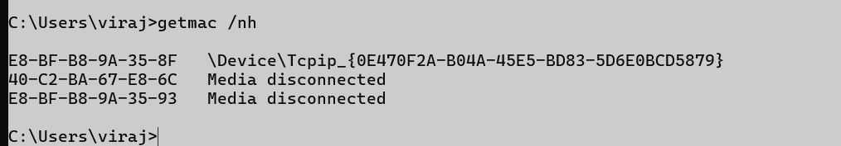

## systeminfo:

**Description** : The systeminfo command displays detailed information about a computer's system configuration. It includes OS version, hardware details, memory, network info, and more. This helps in system diagnostics and troubleshooting.

|  |  |  |
| --- | --- | --- |
| No. | Option | Description |
| 1 | (no option) | Shows all system information. |
| 2 | /s | Specifies the remote system to connect to (hostname or IP address). |
| 3 | /u | Specifies the user context to use for the connection. |
| 4 | /p | Specifies the password for the user account provided in /U. If omitted, it will prompt. |
| 5 | /fo | Displays the output in given format. |

Implementation :

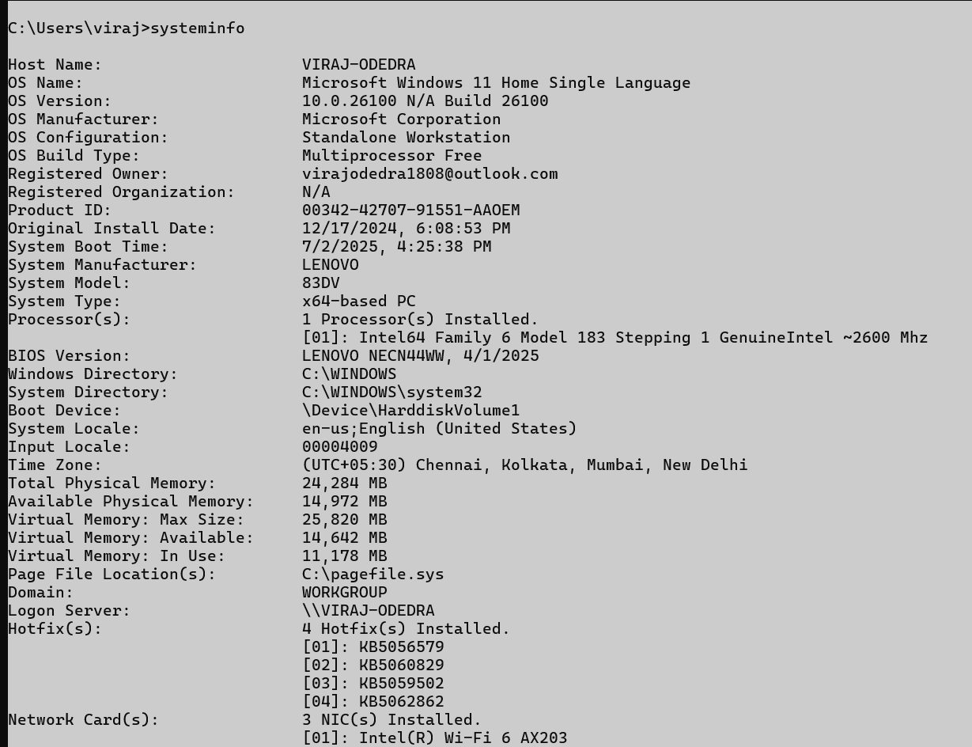

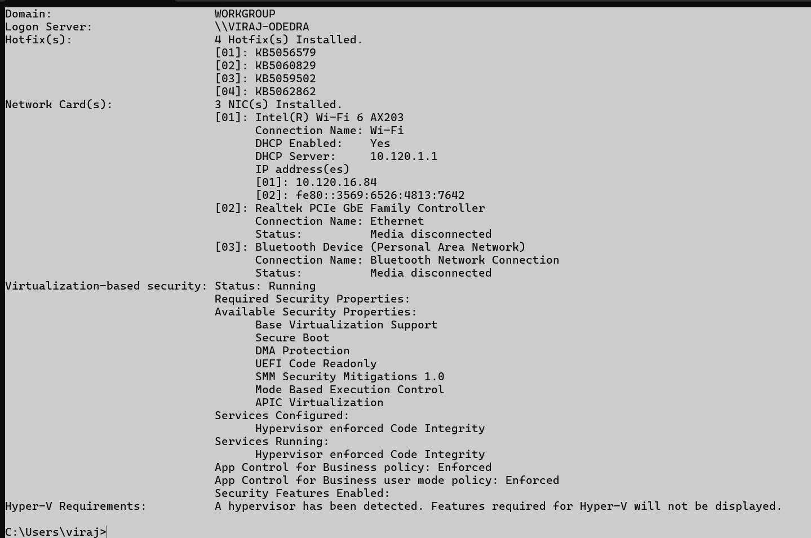

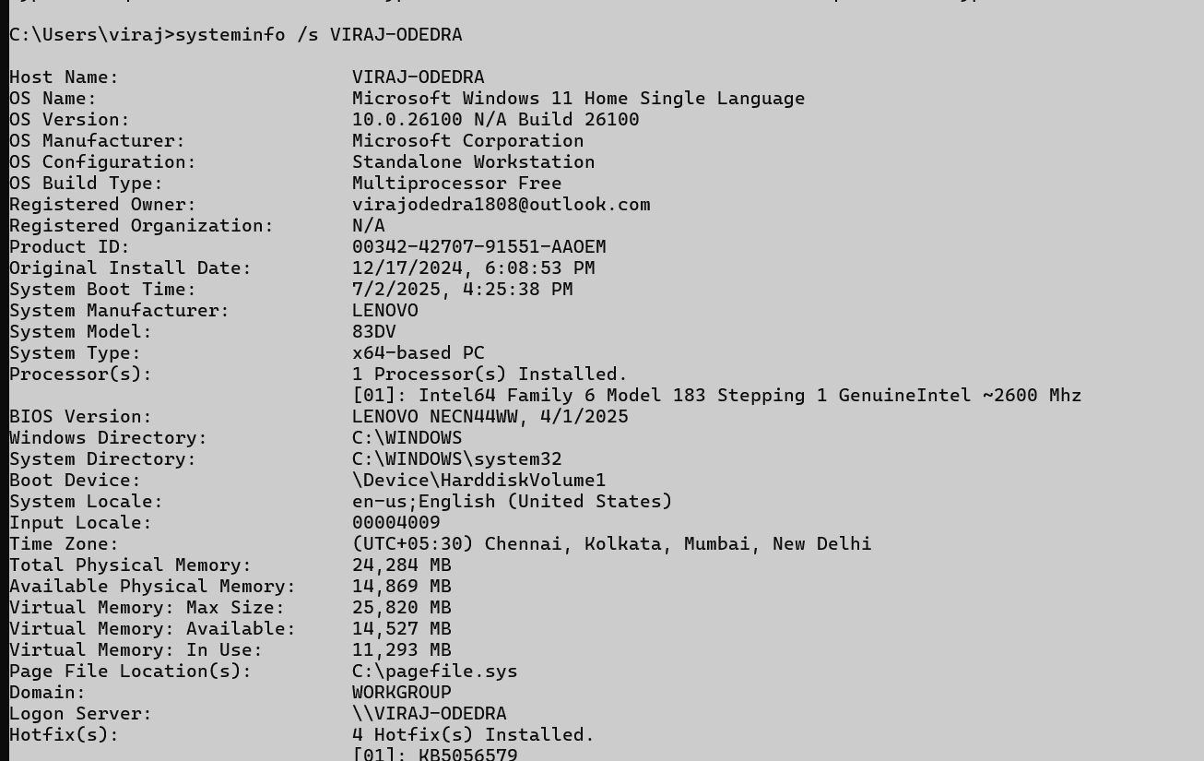

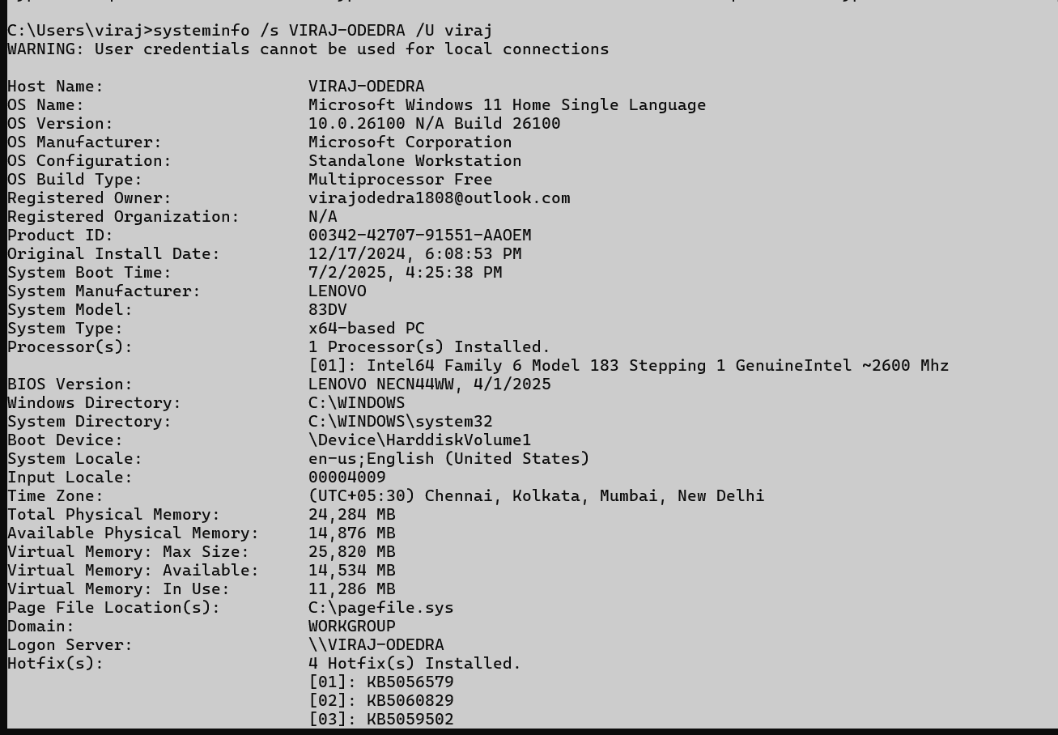

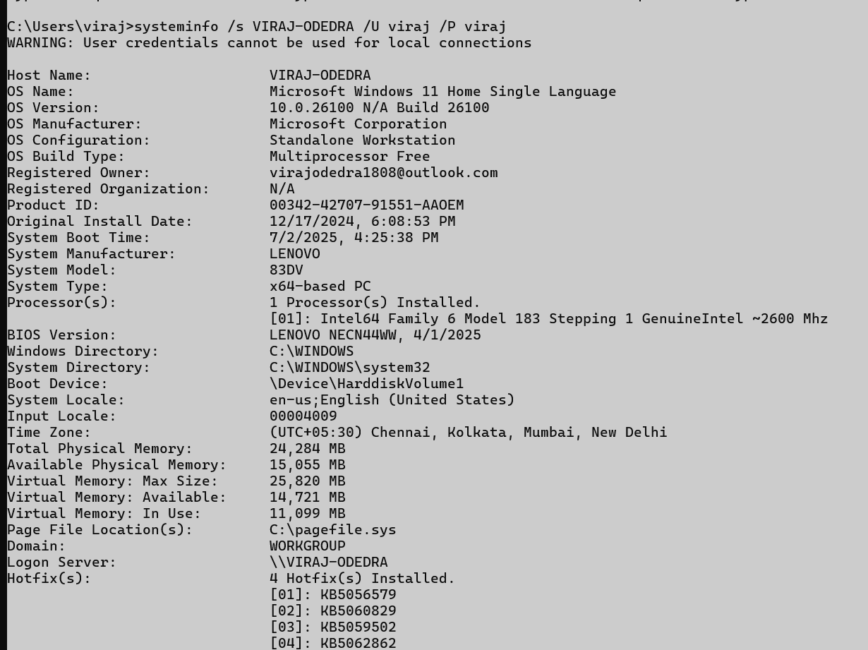

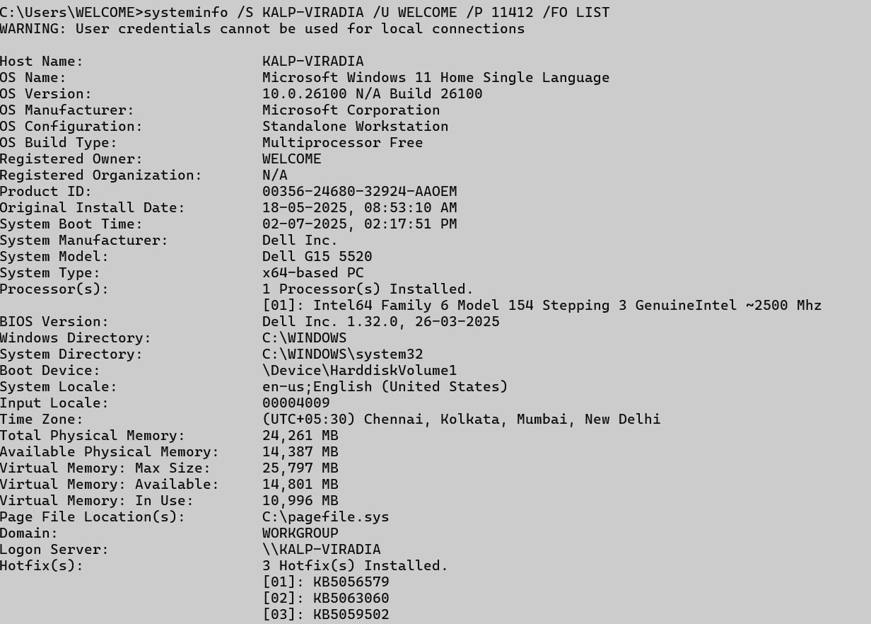

## traceroute / tracert

**Description:**

The tracert (Windows) command shows the path data packets take to reach a destination across a network. It lists all the intermediate routers (hops) between your computer and the target. This helps identify where delays or failures occur in the network route.

|  |  |  |
| --- | --- | --- |
| No. | Option | Description |
| 1 | -d | Prevents resolving IPs to hostnames. |
| 2 | -h <max> | Sets the maximum number of hops. |
| 3 | -w <timeout> | Sets the timeout in milliseconds. |
| 4 | -4 | Forces using IPv4. |
| 5 | -6 | Forces using IPv6. |

**Implementation:**

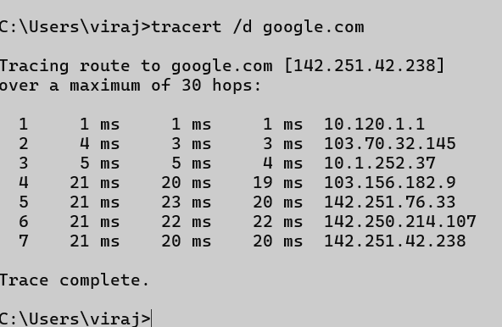

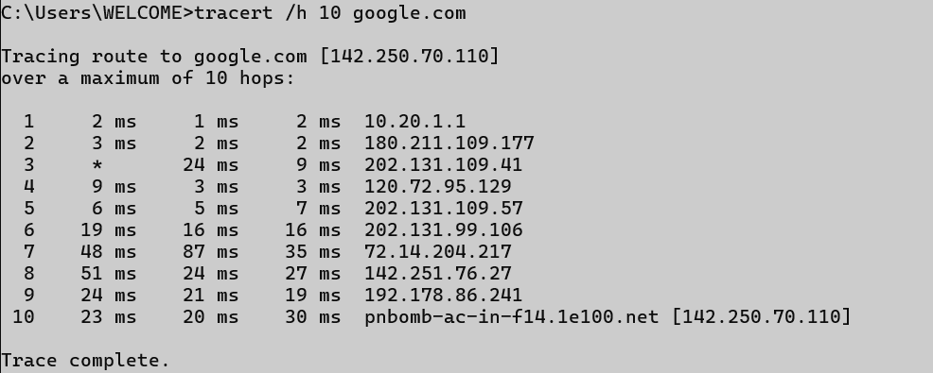

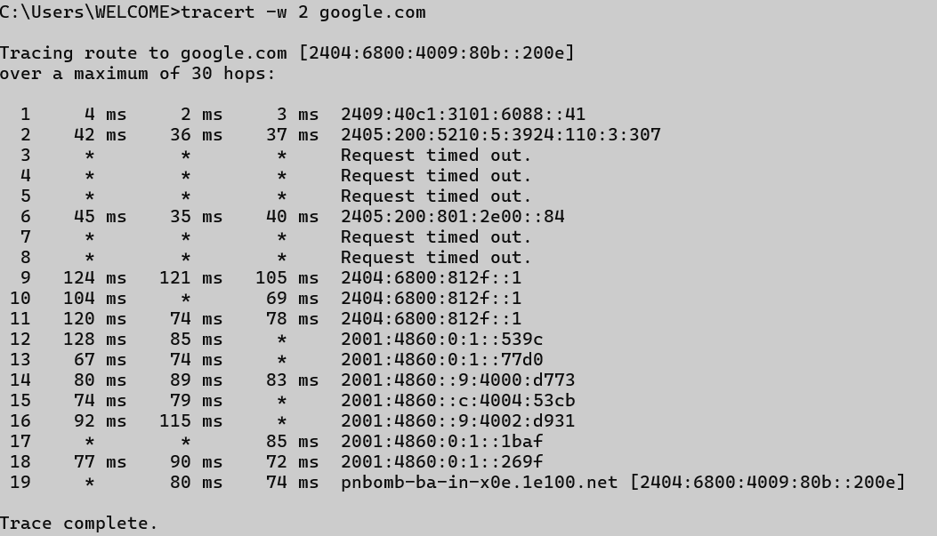

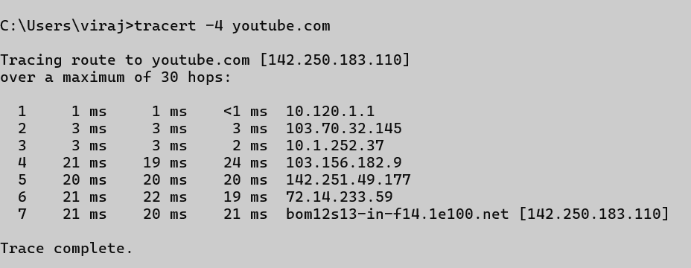

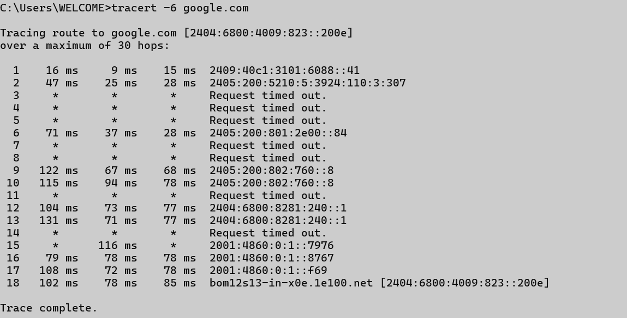

## netstat:

**Description:**

netstat displays network connections, routing tables, interface statistics, and more. It's used to monitor incoming and outgoing network traffic and diagnose network issues. It helps identify active connections and listening ports on a system.

|  |  |  |
| --- | --- | --- |
| No. | Option | Description |
| 1 | -a | Displays all connections and listening ports. |
| 2 | -n | Displays addresses and port numbers numerically. |
| 3 | -o | Displays owning process ID associated with each connection. |
| 4 | -e | Displays Ethernet statistics. |
| 5 | -s | Displays per-protocol statistics. |

**Implementation:**

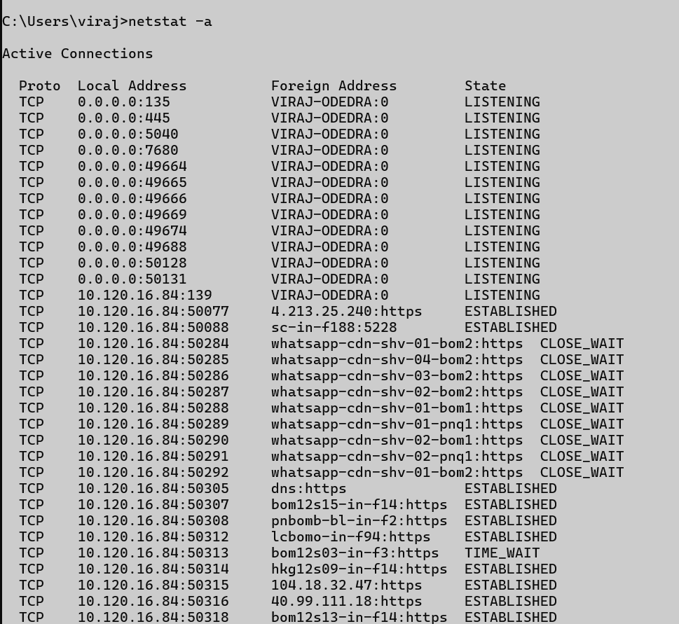

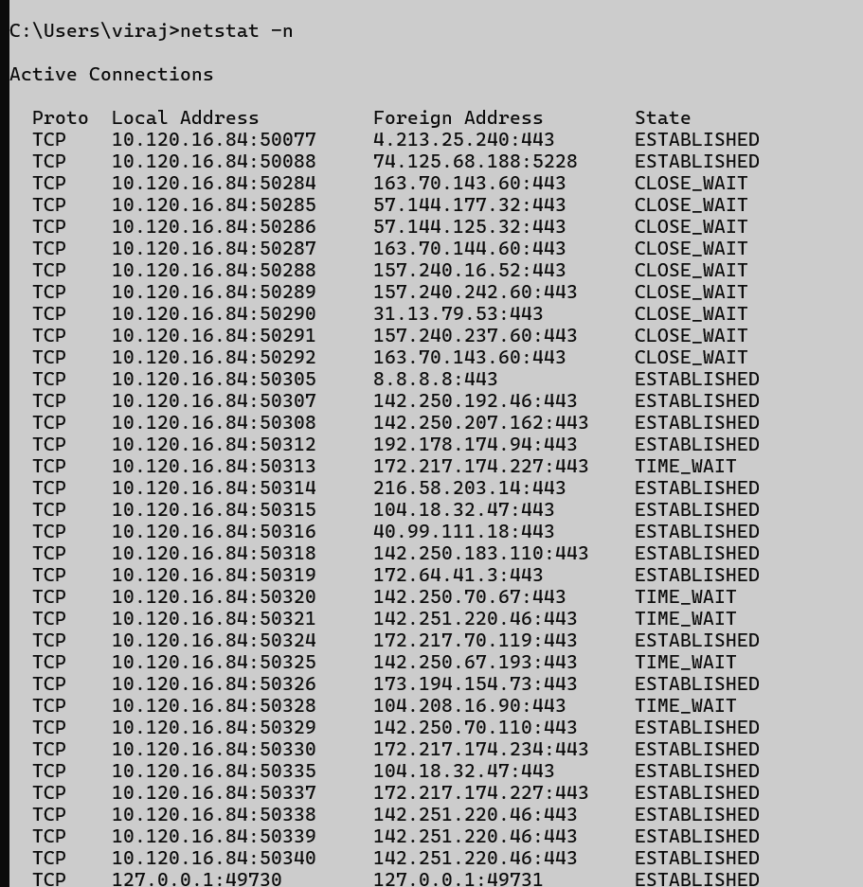

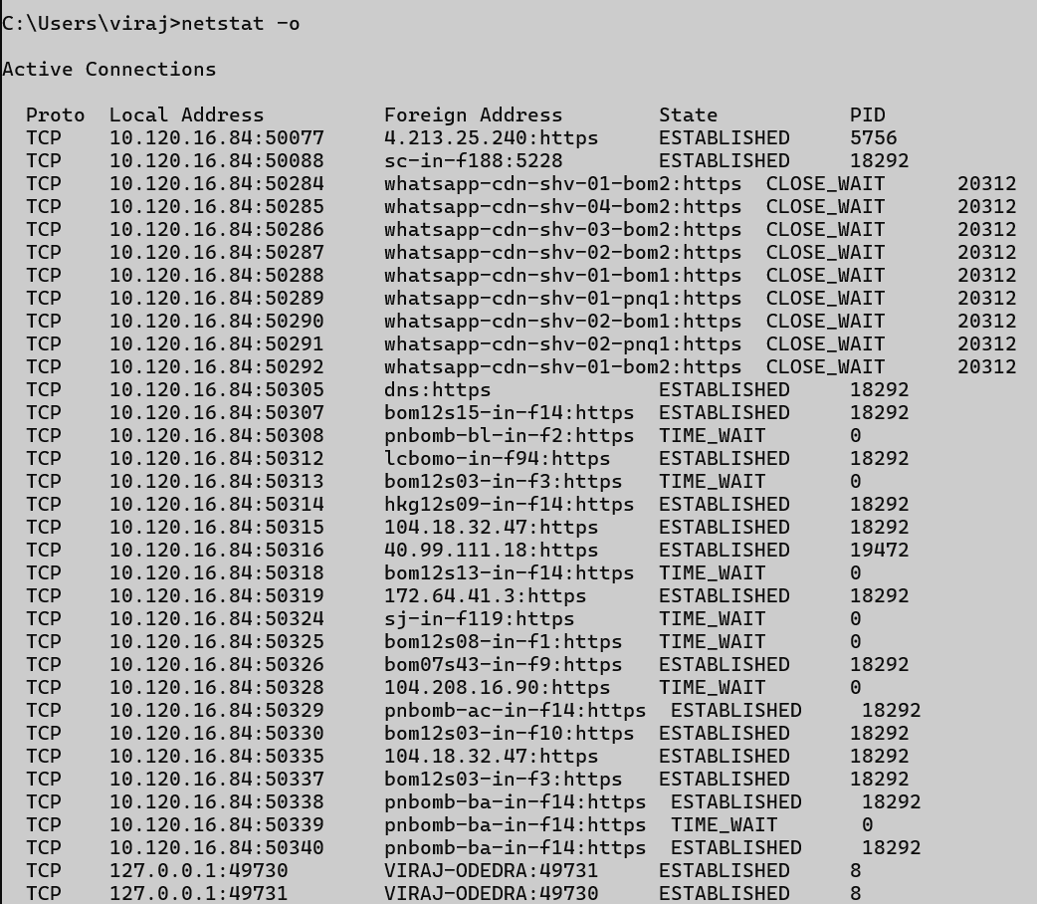

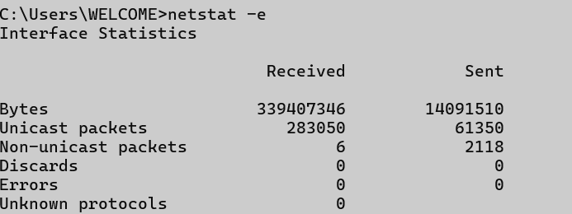

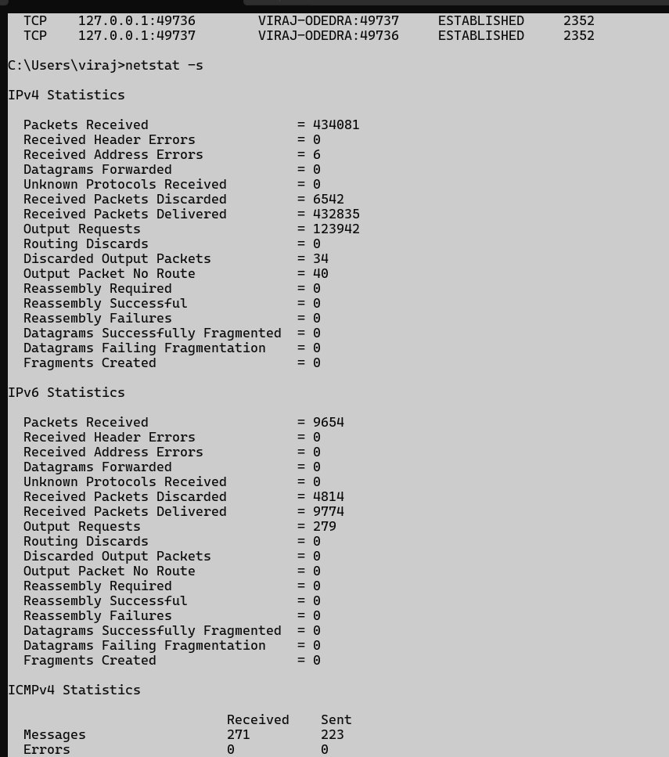

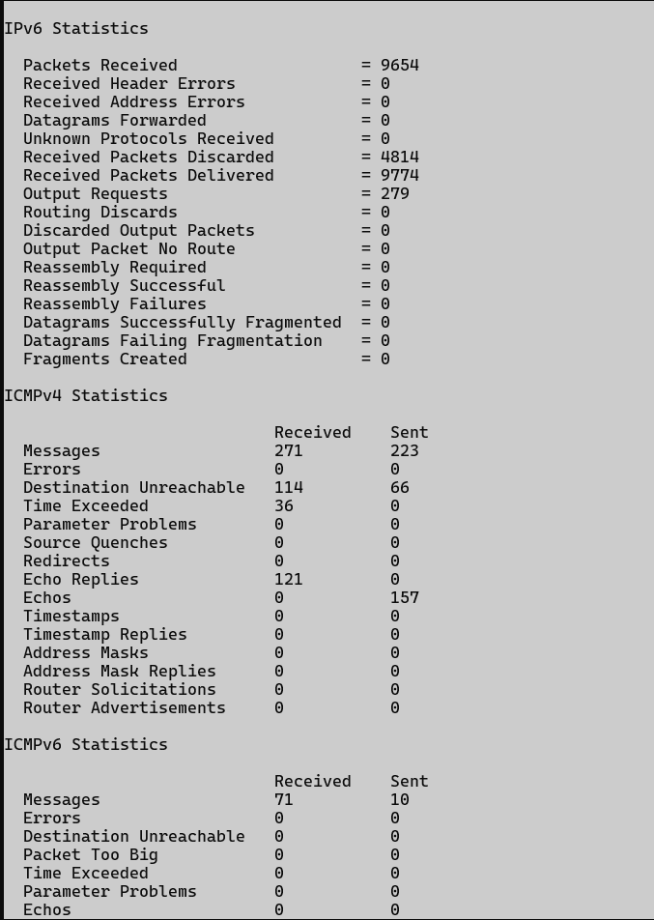

## nslookup:

**Description:** The nslookup command is used to query Domain Name System (DNS) servers for information about domain names and IP addresses. It helps troubleshoot DNS-related issues by showing how a domain name is resolved to an IP address. It can also provide mail server and other DNS record details.

|  |  |  |
| --- | --- | --- |
| No. | Option | Description |
| 1 | <domain> | Retrieves IP address for the domain. |
| 2 | <IP> | Retrieves domain name for the given IP (reverse lookup). |
| 3 | set type=MX | Retrieves Mail Exchange records. |
| 4 | set type=NS | Retrieves Name Server records. |
| 5 | server <IP> | Specifies DNS server for the query. |

**Implmentation :**

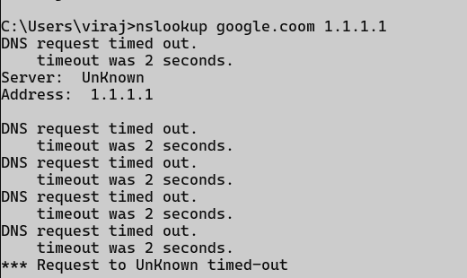

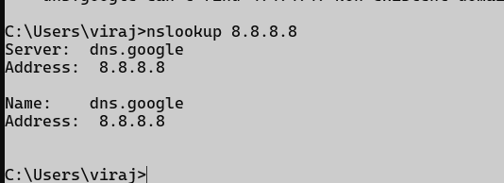



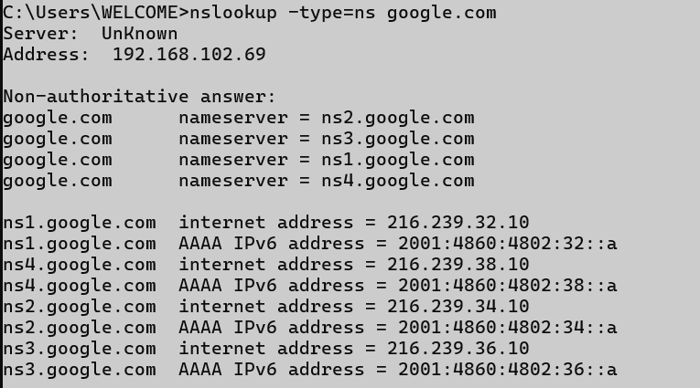

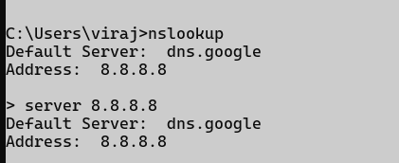

## hostname

**Description:** The hostname command displays the name of the current computer (host) on a network. It's used to view or set the system’s hostname. This name helps identify the device within a network.

|  |  |  |
| --- | --- | --- |
| No. | Option | Description |
| 1 | **hostname** | **Prints current hostname.** |

**Implementation:**

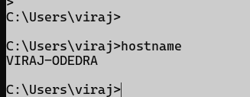

## pathping:

**Description:**

The pathping command is a network diagnostic tool that combines the functions of ping and tracert. It shows the route to a destination and provides detailed statistics on packet loss at each hop.

This helps identify network bottlenecks or failures over time. It's more thorough but takes longer to complete than ping or tracert.

|  |  |  |
| --- | --- | --- |
| No. | Option | Description |
| 1 | **-n** | **Prevents resolving hostnames.** |
| 2 | **-h <max>** | **Sets maximum number of hops.** |
| 3 | **-g <host-list>** | **Specifies loose source route along host list.** |
| 4 | **-p <ms>** | **Wait time between pings.** |
| 5 | **-q <num>** | **Number of queries per hop.** |

**Implementation:**

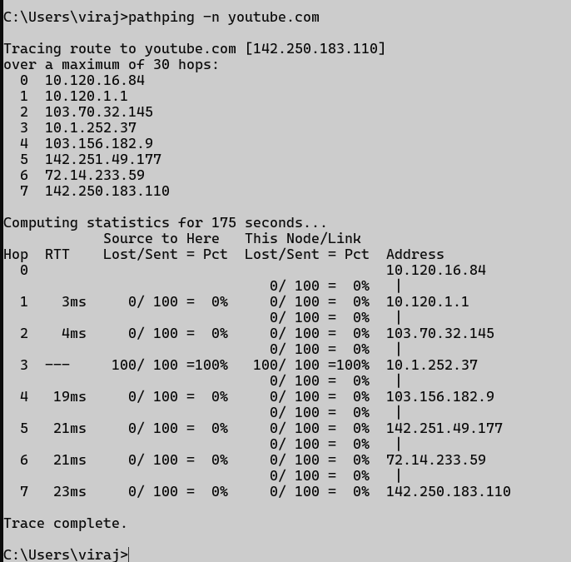

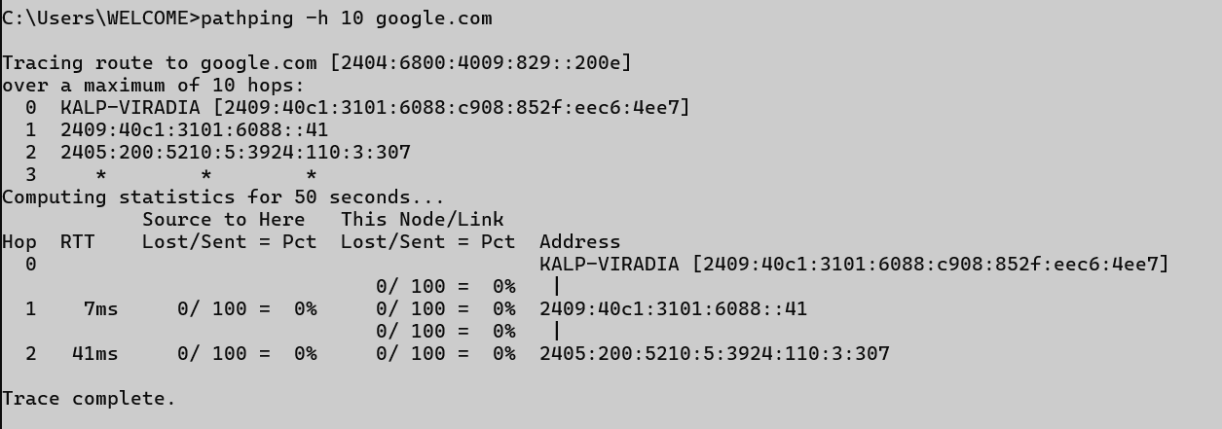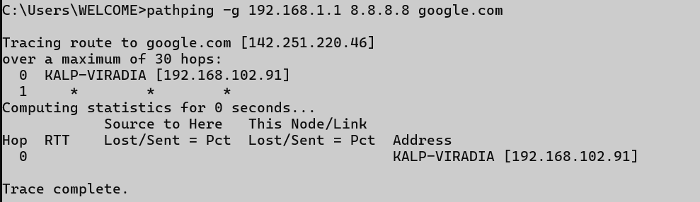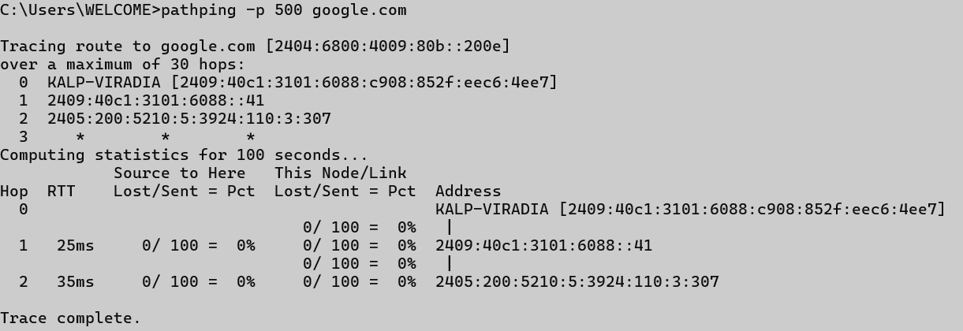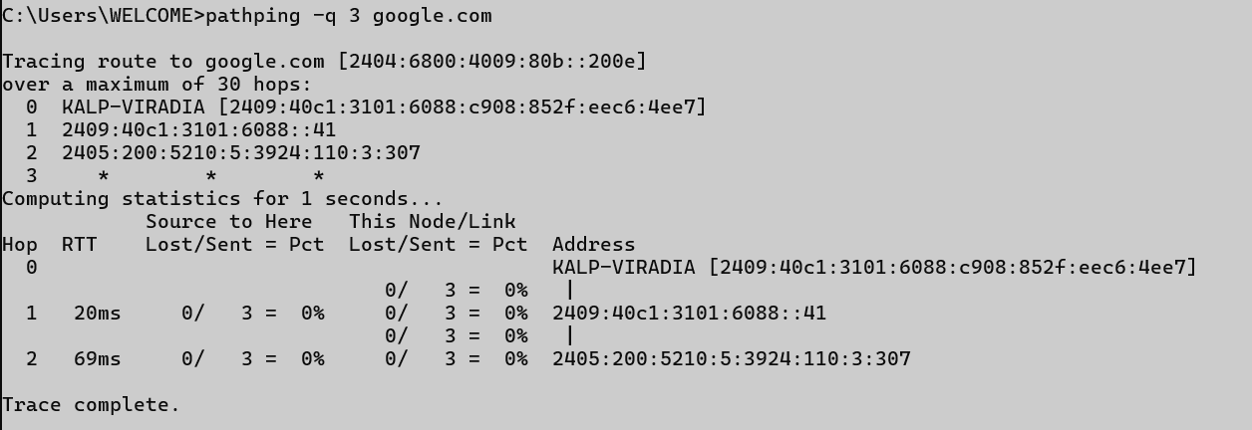

## arp

**Description** : The arp (Address Resolution Protocol) command displays and modifies the ARP cache, which maps IP addresses to MAC addresses on a local network. It's useful for diagnosing network issues related to address resolution. You can use it to view, add, or delete ARP entries.

|  |  |  |
| --- | --- | --- |
| No. | Option | Description |
| 1 | -a | Displays current ARP entries. |
| 2 | -g | Displays current ARP entries (same as -a). |
| 3 | -d <IP> | Deletes ARP entry for the specified IP address. |
| 4 | -s <IP> <MAC> | Adds a static ARP entry. |
| 5 | -v | Shows verbose output. |

**Implementation:**

