**Lab Practical #03:**

Study of different types of network cables & connectors and crimping a LAN.

**Practical Assignment #03:**

1. List various networks cable. Also, write short description.
2. Difference between guided and unguided media.
3. Give cross-wired cable and straight through cable diagram (Color Code wise).

## List various networks cable and connectors. Also, write short description.

1. **Network Cable Name:** 
   * **Description**:

Used in LANs. UTP (Unshielded Twisted Pair) is common in homes/offices. STP (Shielded Twisted Pair) includes shielding to prevent interference.

* + **Diagram**:

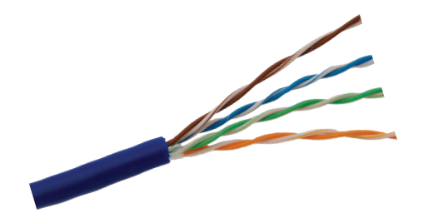

1. **Coaxial Cable:**

* **Description**:

Contains a core conductor surrounded by insulation, shielding, and outer jacket. Used in cable TV and early Ethernet.

* **Diagram**:

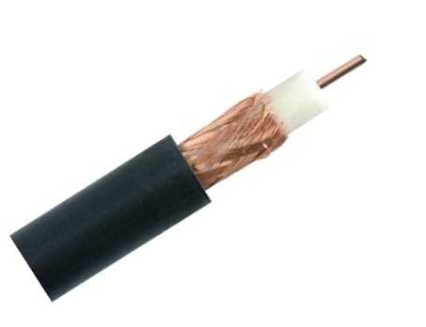

1. **Fiber Optic Cable:**

* **Description**:

Transmits data as light. Offers very high speed and long-distance transmission. Immune to electromagnetic interference.

* **Diagram:**

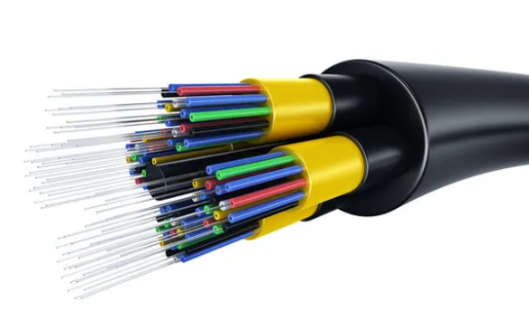

1. **Difference between guided and unguided media.**

|  |  |  |
| --- | --- | --- |
| **No.** | **Guided Media** | **Unguided Media** |
| 1 | Uses physical path (cables) to transmit signals. | Transmits signals wirelessly through air. |
| 2 | Examples: Twisted Pair, Coaxial, Fiber Optic. | Examples: Radio waves, Microwaves, Infrared. |
| 3 | High security and less susceptible to interference. | More vulnerable to interference and signal loss. |
| 4 | Installation cost is higher. | |  | | --- | |  |   Cheaper and easier to deploy over large areas. |
| 5 | Directional; point-to-point or point-to-multipoint. | Mostly omnidirectional broadcast. |

## Give cross-wired cable and straight through cable diagram (Color Code wise).

1. Cross-wired Cable Diagram (Color Code)

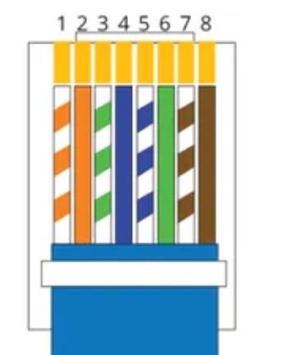

1. Straight Through Cable Diagram (Color Code)

