Question 1.i Minimax Algorithm [3 Marks]

Min

Max

The minimax algorithm calculates the utilities of non-terminal nodes given the utilities of terminal nodes in the game tree. For the given game tree above the first mover is a maximiser. The table below shows the chosen utilities for non-terminal nodes and an explanation.

|  |  |
| --- | --- |
| Node | Explanation |
| H | H is a minimiser hence 4 is chosen from the child utility value of 4 and 5. |
| I | I is a minimiser hence 0 is chosen from the child utility value of 1 and 0. |
| D | D is a maximiser hence 4 is chosen from the child utility value of 4 and 0. |
| J | J is a minimiser hence 8 is chosen from the child utility value of 8 and 9. |
| K | K is a minimiser hence 6 is chosen from the child utility value of 6 and 7. |
| E | E is a maximiser hence 8 is chosen from the child utility value of 8 and 6. |
| B | B is a minimiser hence 4 is chosen from the child utility value of 4 and 8. |
| L | L is a minimiser hence 3 is chosen from the child utility value of 3 and 7. |
| M | M is a minimiser hence 2 is chosen from the child utility value of 2 and 8. |
| F | F is a maximiser hence 3 is chosen from the child utility values of 3 and 2. |
| N | N is a minimiser hence 1 is chosen from the child utility value of 1 and 9. |
| O | O is a minimiser hence 0 is chosen from the child utility value of 0 and 2. |
| G | G is a maximiser hence 1 is chosen from the child utility values of 1 and 0. |
| C | C is a minimiser hence 1 is chosen from the child utility value of 1and 3. |
| A | A is a maximiser hence 4 is chosen from the child utility value of 4 and 1. |

Question 1.ii Alpha- Beta Pruning Algorithm [3 Marks]

Alpha-Beta pruning algorithm is an improved version of the Minimax algorithm, the algorithm prunes out branches of tree, so they don’t have to be examined to make the correct decision on the utility of the node.

Starting at the root the tree will be examined in a depth-first order.

|  |  |
| --- | --- |
| Nodes | Explanation |
| h | H is a minimizer hence 4 is chosen as the utility because 4 is less than 5 . |
| i | By examining the first child of I we can work out a bound for it which will be ≤1, as node D is a maximiser we can prune the right side of I as D will optimally choose node H (Utility=4). |
| D | D is a maximiser hence 4 is chosen as a utility. |
| J | J is a minimiser hence 8 is chosen as the utility because 8 is less than 9. |
| E | E is a maximiser hence a bound can be worked out which will be ≥8  but as B is a minimizer the right branch of E can be pruned because B will always choose Node D (utility=4) due to { 4 < (≥8) }. |
| L | L is a minimizer then by examining the first child of L, the right child can be pruned as the bound for L will work out to be ≤3 and the game tree will never reach this child as node A being a maximiser is better off branching through node B because { 4 > (≤3)}. |
| M | M is a minimizer then by examining the first child of M, we calculate the bound for M to be ≤2 which leads to the right child being pruned as F being a maximiser will choose node L because { (≤3) > (≤2)}. |
| f | F is a maximiser hence bound will be ≤3. |
| C | C is a minimiser and bound calculated it for it will be <3 which means the right branch for node C can be pruned as Node A being a maximiser will optimally choose Node B because { 4 > (≤3) }. |
| A | A is a Maximiser hence 4 will be chosen as the utility. |

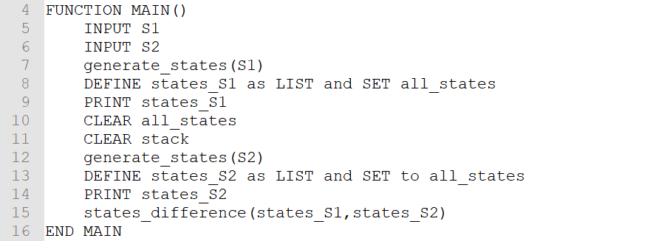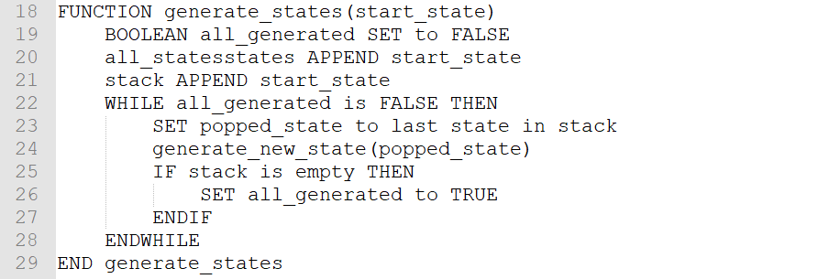Question 2.i Eight Puzzle [3 marks]

