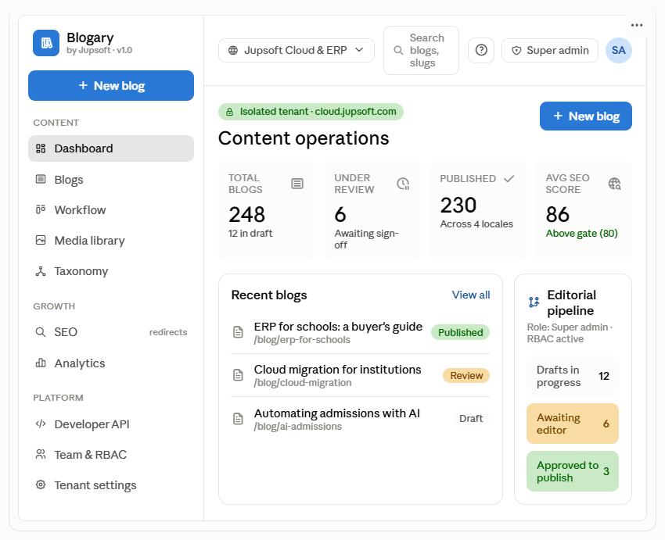
That's the corrected version. Here's what changed and why, so you can hand specific direction to the developer:
Branding
- Header now leads with Blogary, with "by Jupsoft" as the endorsement line underneath — matching the standalone-endorsed decision. The old "JUPSOFT CMS" label buried the product; now the product name is the identity and Jupsoft is the credibility anchor.
Menu
- Grouped into Content / Growth / Platform instead of one flat list — a director or writer can now scan to the right area instead of reading twelve equal items.
- "301 Redirects" folded under SEO — too technical to sit as its own top-level item; it's an SEO concern.
- "Blogs" used consistently — dropped the "Articles" wording so one term is used everywhere.
- Removed the duplicate sidebar "New Blog" — one primary action, not three.
Design
- One accent colour (blue) for primary actions instead of the earlier green/amber mix; semantic colours (amber = review, green = approved) now only signal workflow state, so colour carries meaning instead of noise.
- "How to Use" moved into a quiet help icon in the top bar, out of the main action row.
- Realistic populated data instead of six zeros — a dashboard should be designed for the normal state, not the empty one. (Your dev should still design a proper first-run/empty state separately — but the default mockup shouldn't be all zeros.)
- Added an Avg SEO score card showing the 80 gate from your PRD — it makes the SEO-gate requirement visible on the landing screen, which is a genuine product differentiator worth surfacing.
Two honest flags for the developer, beyond the visual polish:
- Fix the domain decision. blogary.jupsoft.com (subdomain of jupsoft.com) reads as an internal tool and undercuts the standalone positioning. For an endorsed standalone, the app should live at its own domain — app.blogary.com / api.blogary.com — with "by Jupsoft" as brand endorsement, not as the URL. This is a positioning decision, not a dev preference, so it's worth you settling explicitly.
- The empty state still needs its own design. The developer's screenshot was actually the zero-data state. That state matters — but it should guide a new tenant ("Create your first blog, invite your team, connect your first site") rather than just showing "0" six times. Ask for it as a deliberate onboarding screen.

