CERN-ST-2000-053
February, 2000

DESIGN AND CALCULATION OF AN EARTH ELECTRODE

J. Gomez
Abstract
People using electrical installations have to be protected against electrical shock. For purposes of protection a distinction is made between direct and indirect contact. Direct contact is contact with a live conductor. Protection is provided by the insulation of cables or the screening of live parts. An indirect contact happens when someone touches exposed metal parts which are not intended to carry current but have become live as a result of a fault. In this case metallic parts raise the metal to a dangerous potential (contact voltage). Here protection is provided by connecting the exposed metal part (i.e. the case of the electrical machine) to the earthing point of the installation. A protective device will disconnect the circuit as soon as a fault current flows to earth. The earth fault value will depend on the impedance of the path taken by the fault current, which is known as the earth fault loop. The resistance of the earth electrode plays an important role in the final impedance of the earth fault loop, especially when the neutral of the transformer is earthed without any impedance. A good earth electrode should have the lowest possible value compared with the rest of the earth loop (voltage divisor). If this can be achieved, the contact voltage will be limited and the current that trips the protections will be of a higher value. The maximum duration of a contact voltage is established according to IEC 60364-4 413.1.1.1. An important constraint in obtaining a good resistance value for the earth electrode is the resistivity of the soil.

SOIL RESISTIVITY
The resistivity of a given type of soil will vary by several orders of magnitude as a result of small changes in the moisture content, salt concentration, and soil temperature. A broad variation of resistivity occurs as a function of soil types. Knowledge of exactly what type of soil we have at a given site will help to design in a precise manner the earth electrode.

Table 1: Resistivity values of the earthing medium
Medium | Resistivity (Ωm)
 | Minimun | Average | Maximun
City, industrial area |  | 1000 | 10 000
Surface soil, loam | 1 |  | 50
Clay | 2 |  | 100
Sand and gravel | 50 |  | 100
Surface limestone | 100 |  | 10 000
Limestone | 5 |  | 4000
Shale | 5 |  | 100
Sandstone | 20 |  | 2000
Granite, basalt |  | 10 000
Decomposed gneiss | 50 |  | 500
Freshwater lake |  | 200 | 200 000
Sea water | 20 | 100 | 200
Pastoral, low hills, rich soil |  | 30
Marsh | 2 | 100
Pastoral, medium hills |  | 200
Fill, ash, cinder | 6 | 25 | 70
Rocky soil, steep hills | 10 | 500 | 1000
Clay, shale, gumbo | 3 | 40 | 200
Gravel, sandstone, with little clay or loam, granite | 500 | 1000 | 10 000
Sandy, dry, typical coastal country | 300 | 500 | 5000

PRINCIPAL TYPES OF EARTH ELECTRODE (ADVANTAGES AND DISADVANTAGES)

Type | Advantages | Disadvantages
Ring ground | Easy to design and to install (especially around an existing facility). Readily available. Can be extended to reach water table. | Not useful where large rock formations are near surface.
Horizontal bare wires (radials) | Can achieve low resistance where rock formations prevent use of vertical rods. | Subject to resistance fluctuations with soil drying.
Horizontal grid (bare wire) | Minimum surface potential gradient. Easy to install if done before construction. Can achieve low resistance contact in areas where rock formations prevent the use of vertical rods.  Can be combined with vertical rods to stabilize resistance fluctuations. | Subject to resistance fluctuations with soil drying if vertical rods not used.
Vertical rods | Simple design. Easiest to install particularly around an existing facility. Hardware readily available. Can be extended to reach water table. | Not useful where large rock formations are near surface. Step voltage on earth surface can be excessive under high fault currents.
Plates | Can achieve low resistance contact in limited area. | Most difficult to install.
Incidental electrodes (pipes, foundations, buried tanks) | Can show very low resistance. | Little or no control over future alterations. Must be employed with other electrodes.

CALCULATION OF EARTH RESISTANCE
For this purpose a straightforward design based on graphs is proposed.
- General points:
- Choose the configuration of the earth electrode according to the shape of the facility.
- Calculate the resistance to earth for the configuration.
- Check if the calculated resistance meets the design goal.
- Complete the design to include all necessary interconnections.
- Steps to calculate the earth electrode:
- Starting data: configuration, resistivity, length and diameter of rods.
- Determine the resistance of one of the ground rods from Fig. 1. Start by drawing a line between the chosen diameter ‘d’ and the length ‘l’. Then indicate the crossing point in ‘q’. From this point place a line between ‘q’ and the resistivity and read the resistance at the point where the line crosses ‘R’.
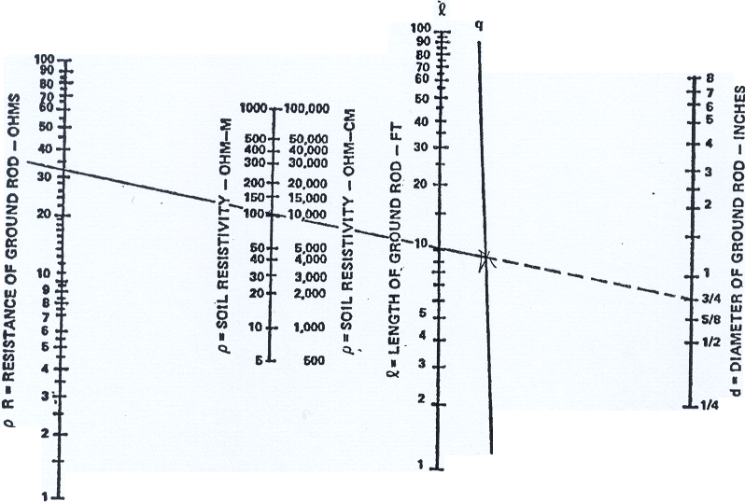
Figure 1: Nomograph for determining the resistance to earth of a single ground rod.

- Because we are going to place more than one rod there will be a lower resistance which will be estimated according to Fig. 3.
If the rods are distributed in a grid pattern, as will frequently be done for substations, use Fig. 2 to estimate the net resistance instead of Fig. 3.
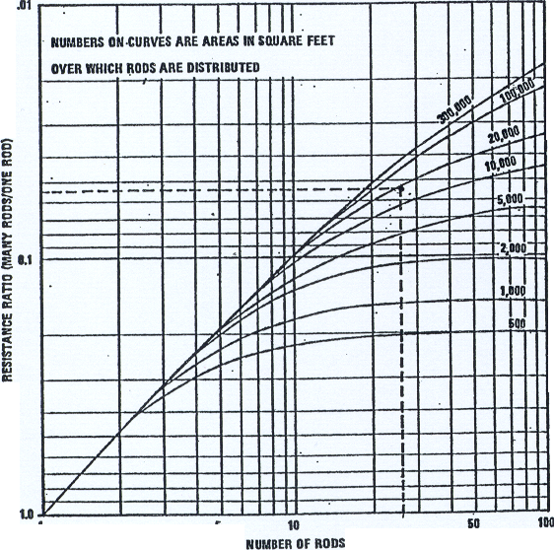
Figure 2: Graph of multiple rod resistance ratio.
Conversion values:
1 foot = 30.4 cm 1 inch = 2.54 cm
Example:
To illustrate this, let us assume that a 30 m × 48 m (100 ft × 160 ft) rectangular configuration like that shown in Fig. 3 is initially chosen. Assume that the soil resistivity measurements made during the site survey showed an average resistivity of 10 000 ohm-cm for the area. In addition, the site survey indicated that all rock formations are at depths greater than 10 feet; the water table (layer containing a big amount of flowing water) never drops more than 5 feet below grade; and the frost line extends only to 1 foot below ground level.
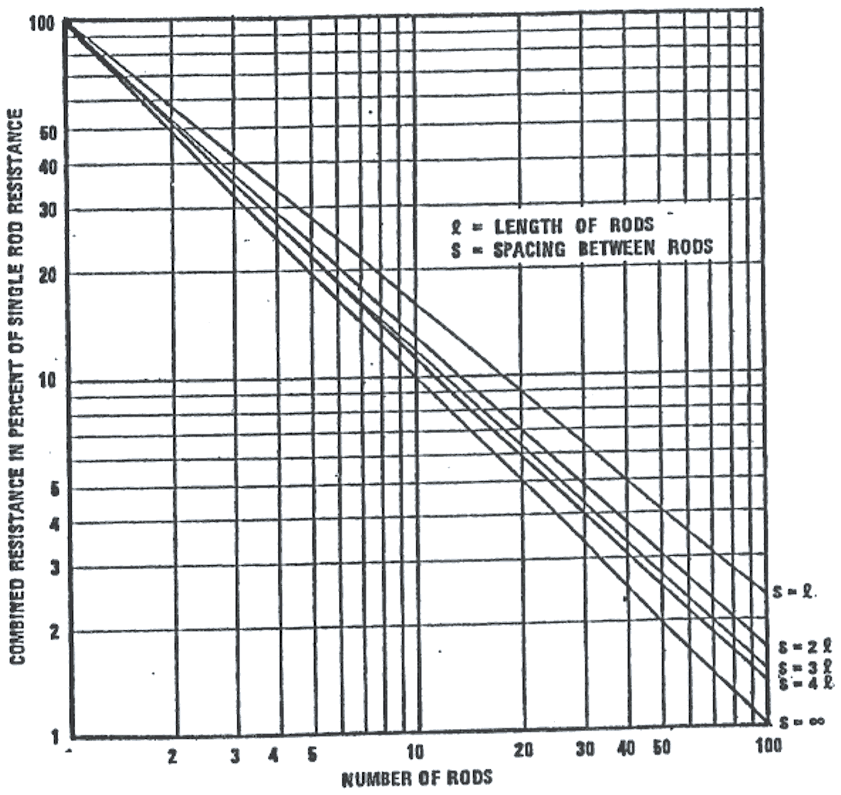
Figure 3: Effective resistance of ground rods when arranged in a straight line or a large circle.

Therefore, 3 m (10 ft) ground rods are initially selected for evaluation. (Minimum rod diameter 14.8 mm or 3/4 inch.)
First in Fig. 2 we place a straight edge between the point marked 3/4 on line ‘d’ and the point marked 10 ft on line ‘l’. Indicate on line ‘q’ where the straight edge crosses. Next, place the straight edge between the point just marked on ‘q’ and the 10 000 ohm-cm point on the vertical line marked as resistivity. Then read the resistance as 32 ohm-cm at the point where the straight edge crosses the vertical line tagged resistance.
In order to prevent interactions between rods (placing rods too close increases the expected resistance) we assume an initial spacing of 7 m (20 m) or twice the rod length. Figure 1 shows that 26 rods are needed to encircle the building. Then we use Fig. 3 to determine the relative lowering of resistance of one rod that is produced by 26 rods in parallel. The answer is 5.5%.
The resistance of the 26 rods in a 10 000 ohm-cm soil is:
R = 32 x 0.055 = 1.76 ohms.
Figure 3 applies to ground rods placed in a straight line or around the perimeter of a site whose dimensions are large with respect to the rod spacing. If the rods are distributed in a grid use Fig. 2.
For this example, we have an area of 16 000 square feet (1450 m²) and 26 rods distributed in it, so the graph shows a multiplier of 0.056.
R = 32 x 0.056 = 1.9 ohms.
This calculation method does not consider the interconnecting cable between rods because the effect produced by the rod on the earth resistance is more important than the one produced by 7 m of bare cable. If the distance between rods is bigger then 7 m should be considered.
Wire resistance should be considered in parallel with the rods.
For this purpose we can use two formulas:
- Buried straight rod or wire
h = depth of burial (cm)
L = total length (cm)
r = ohm-cm
R = 0.366 r/L (log (L/d) + log (L/4h) + 0.34) h < 0.4L
- Buried circle of wire
R = 0.366 r/L (log (L/d) + log (L/4h) + 0.81) h > 0L
- Vertical rod
R = 0.366 r/L (log (3L/d)
When a vertical rod is driven through a high-resistivity superficial layer into a lower resistivity subsoil, an adjustment can be made to the resistance to earth expression by substituting a reduced ‘effective length’ of the ground rod. L′ will be the effective length.
L′ = L – h (1 – (r2/r1)) where L is the length of the rod, r1 is the resistivity of the upper layer, r2 is the resistivity of the subsoil, and h is the depth of the upper layer.

DESIGN GUIDELINES
- Where bedrock (meaning an underground layer formed by rocks) or other obstacles prevent the effective use of vertical rods, horizontal wires, grids, or radials should be used.
- When other alternatives are not possible or are not cost-effective, chemical enhancement (salting) is frequently the only choice left.
- The nominal spacing between rods should be between one and two times the length of the rod; however, it is necessary for a ground rod to be placed near each lightning down conductor, so spacings should be limited to not more than 15.2 m.
- The rods and interconnecting cable comprising the earth electrode subsystem should be positioned between 0.6 m and 1.8 m outside the dripline of the building or structure to insure that rain, snow, and other precipitation wets the earth around the rods.
- Where two or more structures or facilities are located in the same general area (less than 60 m away) and are electrically interconnected with signal, control, and monitor circuits, either provide a common earth electrode subsystem or interconnect the separate earth electrode subsystems with two buried bare cables.
- To minimize voltage differentials between the two structures, the facilities should effectively share a common earth electrode subsystem. Separate structures spaced closer than 6 m should have a common earth electrode subsystem installed that encircles both facilities.
- Structures or facilities having no interconnecting cables and separated by a distance greater than 60 m generally do not require their earth electrode subsystems to be interconnected.
- Metallic structures near the earth electrode subsystem should be connected to reduce the danger of potential differences during lightning or fault protection; their connection will also reduce the resistance to earth of the electrode subsystem.
- To minimize resistance variations caused by surface drying of the soil and by the freezing of the soil during winter, connections, interconnecting cables, and tops of ground rods should be buried at least 0.3 m below grade level and the interconnecting cable at least 0.45 m below grade level.
- Access to the earth electrode subsystem should be provided through the installation of one or more grounding wells at each site. Removable access covers must be provided.
- More than one grounding well may be necessary depending upon the size of the facility, the extent of the electrode subsystem, and the degree of accessibility to the electrodes.
- Locate at least one of the ground wells in an area with access to open soil so that resistance checks of the earth electrode subsystem can be made once the building is in use.
Bibliography
[1] Grounding, bonding, and shielding for electronic equipments and facilities – US Department of Defense handbook.
[2] Grounding principle and practices II – Establishing grounds, Jensen Claude.
[3] Guide de protections des reseaux industriels, Christophe Preve.
[4] Puesta a tierra de equipos eléctricos, Francisco Ruiz Vasallo.

