- What are three conclusions we can make about Kickstarter campaigns given the provided data?
Answer:
- Based on the stack chart of outcomes in parent category, we can say that most successful parent categories based on proportion of successful vs failed vs canceled vs live are Film &Video, Music, and Theater categories. While most failed categories are food, games, and publishing.
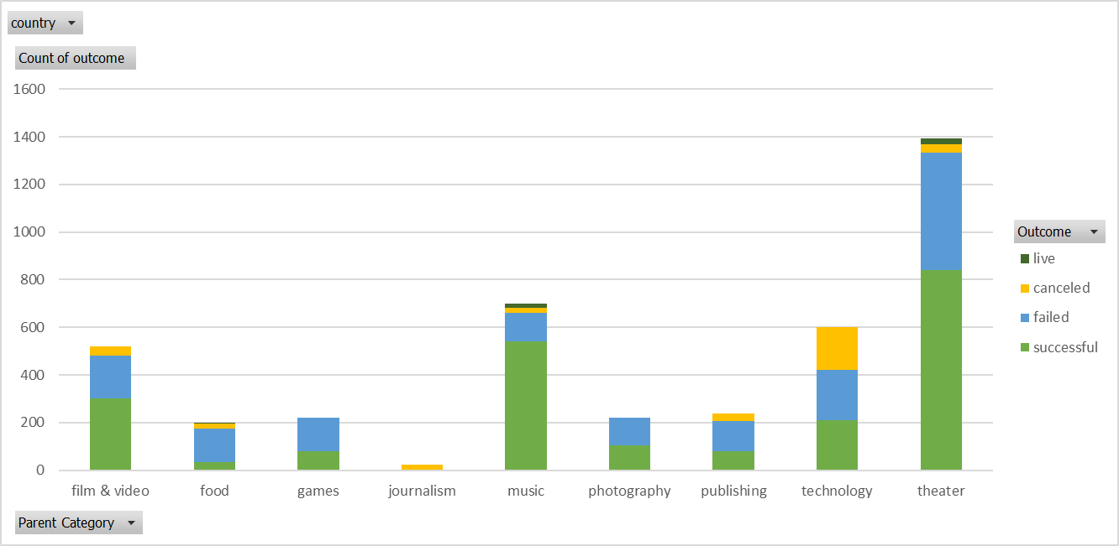
- Based on stack chart of subcategory, we can say that plays subcategory has most number of successful outcomes and rock, documentary, classical music, hardware, nonfiction, pop, rock, shorts, tabletop games, television subcategories have only successful outcomes.
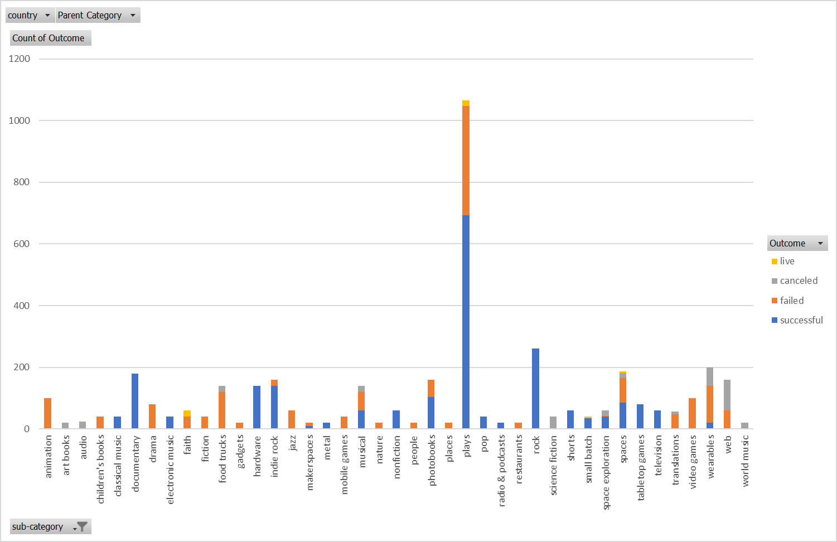
- Based on the line graph on launched date, Direction of trendline for successful outcome is downward. It means more successful outcomes in the start of the year and as month pass by successful outcomes decrease. While trendline of failed and canceled outcomes stays around its mean value.
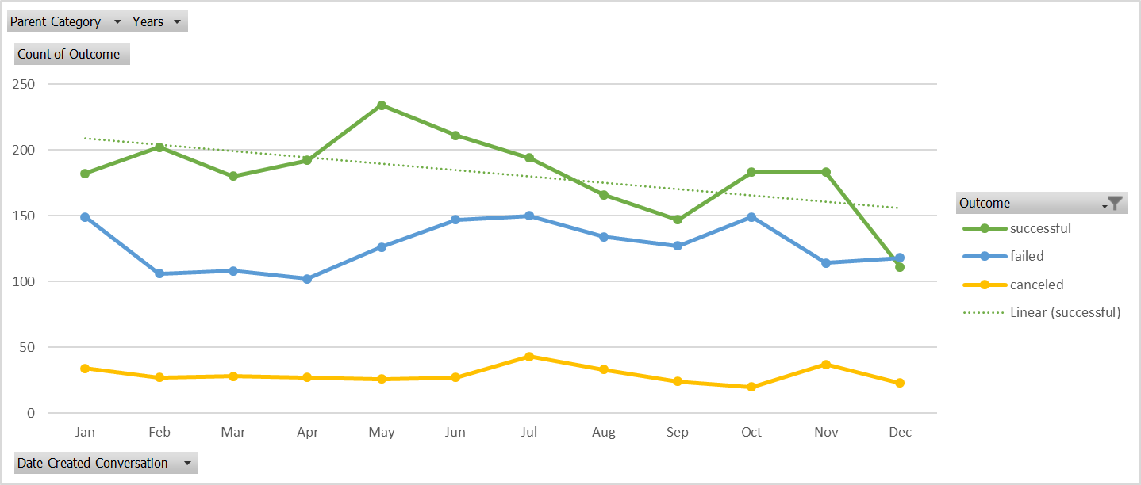
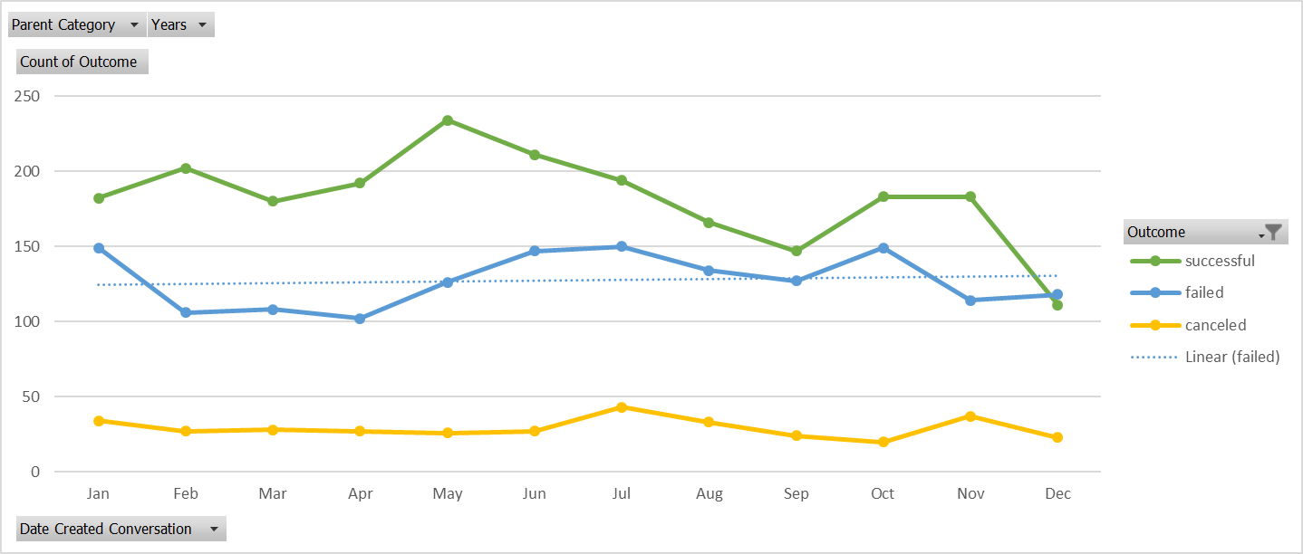
- What are some of the limitations of this dataset?
Answer:
- The main limitation of this dataset is that some categories have more data such as film and video while some categories have limited amount of data such as journalism have only canceled project. Similar Photography have only successful and failed outcomes. It may suggest that this dataset may not be complete. There are some missing data.
- What are some other possible tables/graphs that we could create?
Answer:
- There are many tables/graphs can be created by the data. Such as
  - Project distribution by country
  - Project distribution for goal and pledged amount
  - The relationship between project goal and success rate/Failure rate
  - The relationship between pledged amount and success rate/Failure rate.

