#Linked List in python
class node:
def __init__(self):
self.data = None
self.next = None

class linkedList:
def __init__(self):
self.head = None
self.tail = None
self.size = 0

def insert(self, data):
newnode = node()
newnode.data = data
x = self.head
if(self.head==None):
self.head = newnode
self.size = self.size +1
else:

while x.next is not None:
x = x.next
x.next = newnode
self.size = self.size +1

def delete(self,data):
current = self.head
while (current.data != data and current is not None):
prev = current
current = current.next
if(current==None):
print("Data not found")
elif(current==self.head):
self.head = current.next
self.size = self.size -1
elif(current==self.tail):
self.tail = prev
prev.next = None
self.size = self.size -1
else:
prev.next = current.next
self.size = self.size -1

def display(self):
x = self.head
if(self.head==None):
print("Empty Linked List")
else:
while x.next is not None:
print (x.data)
x = x.next
print(x.data)

#Menu
linked = linkedList()
x=0
while(x!=4):
x = int(input("Enter 1 to Insert at the end or 2 to delete particular data 3 to display"))
if(x==1):
data = int(input("Enter data to be inserted"))
linked.insert(data)
elif(x==2):
data = int(input("Enter data to be Deleted"))
linked.delete(data)
elif(x==3):
linked.display()
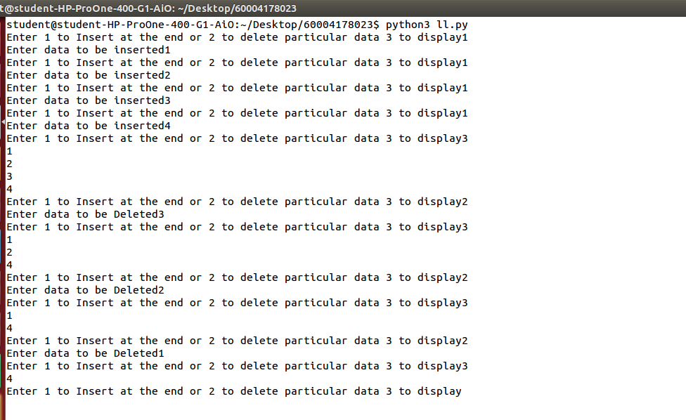
STACK
#Linked List in python
class node:
def __init__(self):
self.data = None
self.next = None

class linkedList:
def __init__(self):
self.top = None
self.tail = None
self.size = 0

def push(self, data):
newnode = node()
newnode.data = data
x = self.top
if(x is None):
self.top = newnode
newnode.next = None
else:
newnode.next = x
self.top = newnode
self.size = self.size +1

def pop(self):
current = self.top
if(current is not None):
self.top = current.next
self.size = self.size -1
else:
print("Underflow")

def display(self):
x = self.top
if(self.top==None):
print("Empty stack")
else:
while x.next is not None:
print (x.data)
x = x.next
print(x.data)

#Menu
linked = linkedList()
x=0
while(x!=4):
x = int(input("Enter 1 to push or 2 to pop 3 to display"))
if(x==1):
data = int(input("Enter data to be pushed"))
linked.push(data)
elif(x==2):
linked.pop()
elif(x==3):
linked.display()
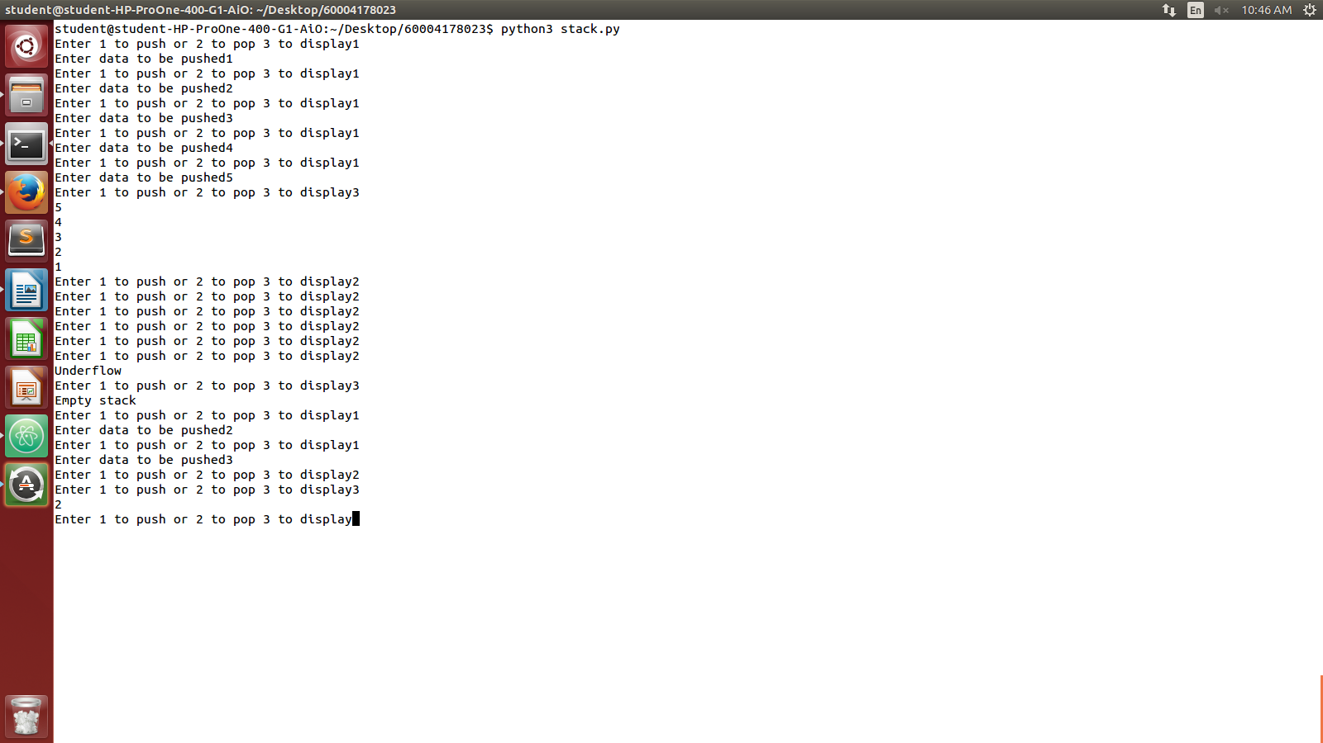
QUEUE
#Linked List in python
class node:
def __init__(self):
self.data = None
self.next = None

class linkedList:
def __init__(self):
self.rear = None
self.front = None
self.size = 0

def enqueue(self, data):
newnode = node()
newnode.data = data
x = self.rear
if(x is None):
self.rear = newnode
self.front = newnode
newnode.next = None
else:
x.next = newnode
self.rear = newnode
self.size = self.size +1

def dequeue(self):
current = self.front
if(current is not None):
self.front = current.next
self.size = self.size -1
else:
print("Queue out of elements")

def display(self):
x = self.front
if(x==None):
print("Nothing to display")
else:
while x.next is not None:
print (x.data)
x = x.next
print(x.data)

#Menu
linked = linkedList()
x=0
while(x!=4):
x = int(input("Enter 1 to enqueue or 2 to dequeue 3 to display"))
if(x==1):
data = int(input("Enter data to be enqueue"))
linked.enqueue(data)
elif(x==2):
linked.dequeue()
elif(x==3):
linked.display()
