Exception Handling:

import sys
try:
num1=int(input("Enter a number: "))
num2=int(input("Enter second number: "))
num3=num1/num2
except ZeroDivisionError:
print("Don't enter 0 :(")
except ValueError:
print("Numbers only :/")
else:
print("Your output: ")
print(num3)
a={1,2,'3'}
for x in a:
try:
reciprocal=1/x
except TypeError:
print("Enter integer value ")
else:
print("Your output: ")
print(reciprocal)
finally:
print("Okay,Goodbye")

Output:
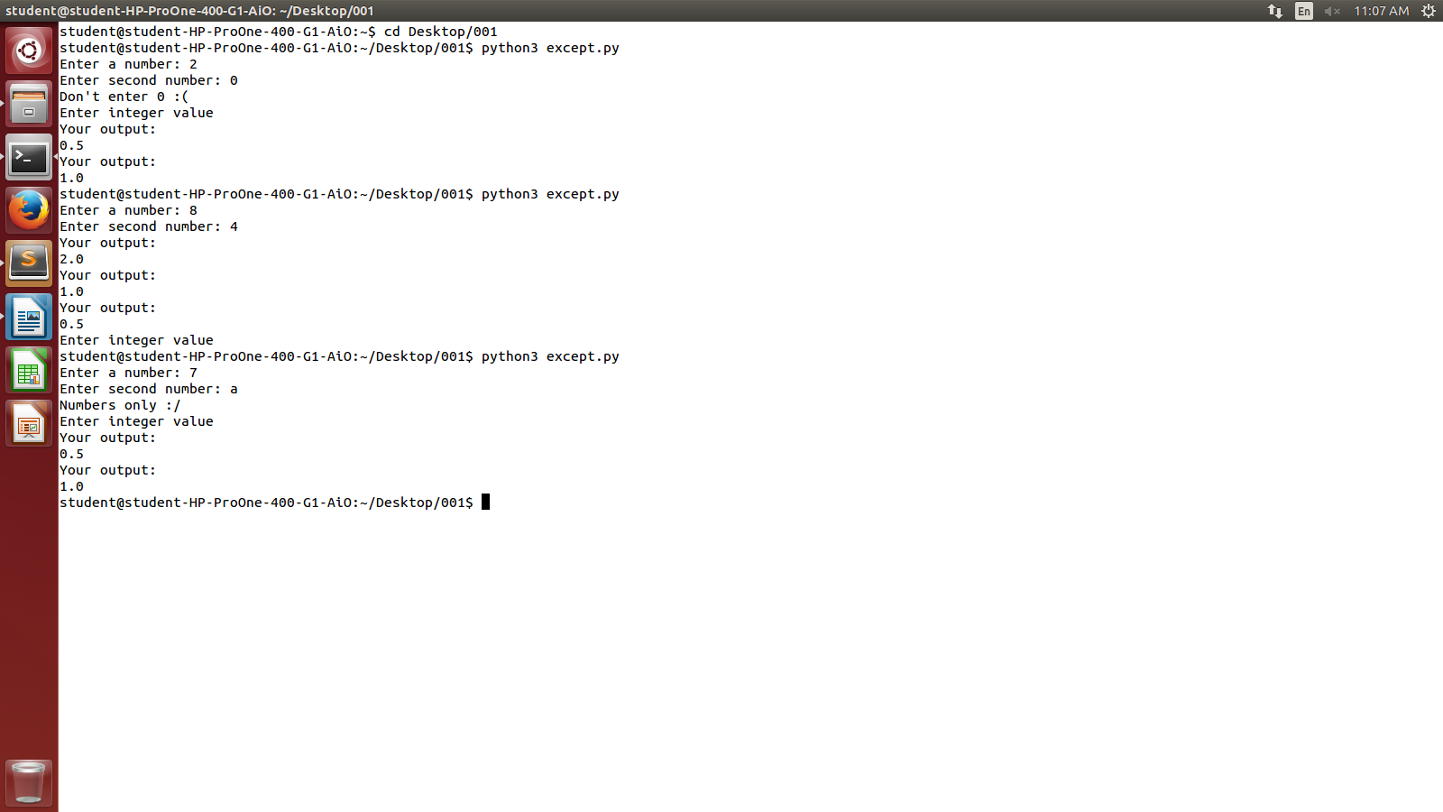

class Error(Exception):
pass
class ValueTooSmall(Error):
pass
class ValueTooLarge(Error):
pass

num=49
while(True):
try:
print("")
value=int(input("Enter a value pls: "))
if (value == num):
print("On point ")
elif (value>num):
raise ValueTooLarge
else:
raise ValueTooSmall

except ValueTooLarge:
print("Enter a Smaller Value ")
except ValueTooSmall:
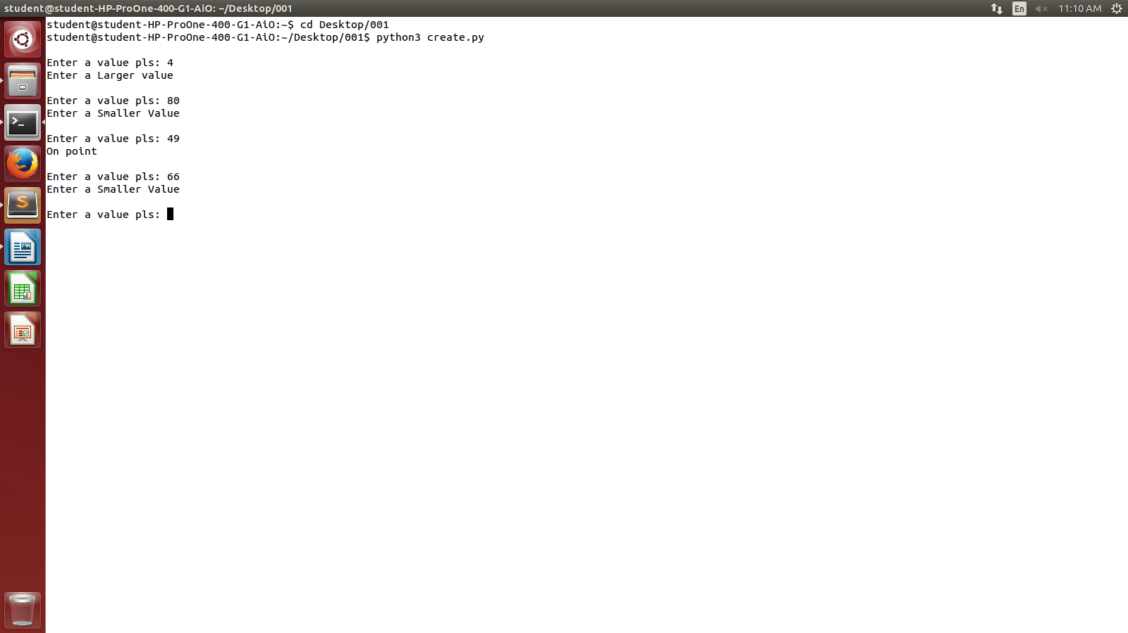
print("Enter a Larger value ")

