Experiment 1:

x = 1
while x==1:
var1 = input("Enter a string")
var2 = input("Enter another string")
var3 = var1+var2
choice = int(input("Enter 1 to find something\n2. to split the string\n3. to Replace characters\n 4. to perform Join Operation\n"))
if (choice==1):
inputChar = input("Enter the character")
intChoice = int(input("Enter 1 to reverse search for an occurance of a character\n2 to check if the string starts with the given alphabet\n3 to use index function"))
if (intChoice==1):
print ("The output is ")
print (var3.rfind(inputChar))
elif (intChoice==2):
print (var3.startswith( inputChar ))
else:
print ("The output is ")
print (var3.rindex(inputChar))
elif (choice==2):
print (var3.split(" "))
elif (choice==3):
inputChar = input("Enter the character to replace")
inputChar2 = input("Enter the character")
print (var3.replace(inputChar, inputChar2))
elif(choice == 4):
inputChar = input("Enter a seperator")
print(var3.join(inputChar))
x = int(input("Enter 1 to Continue"))

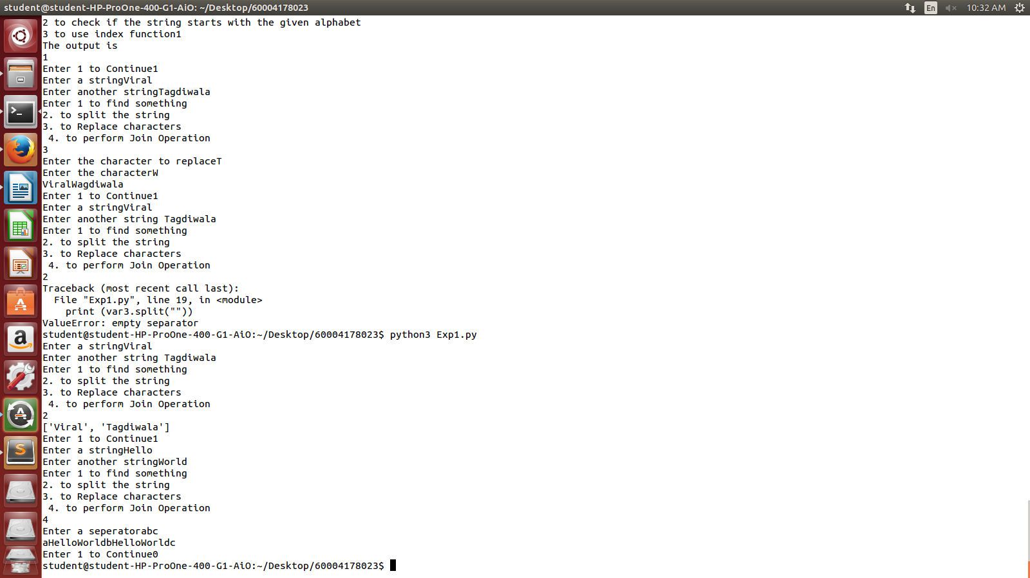
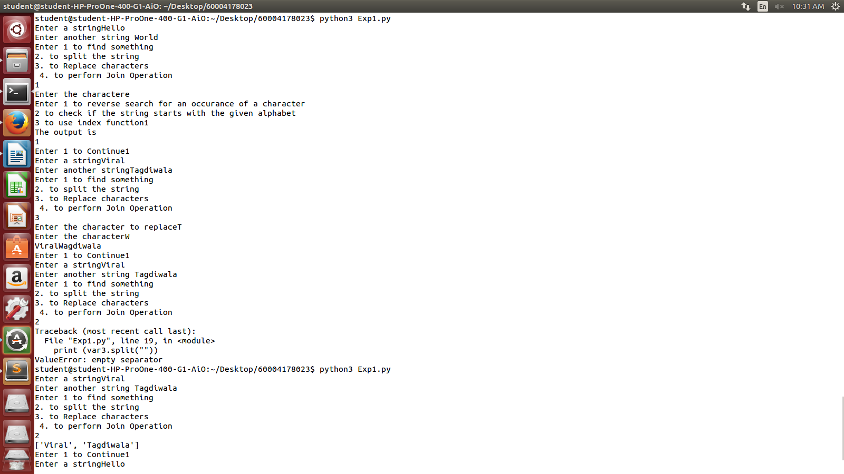

colors = ['red', 'blue', 'green']
print ("First element " + colors[0])
print ("Third Element " + colors[2])
print ("Length: ")
print (len(colors))
colors.append("Yellow")
print("After append operation")
print ("Fourth Element " + colors[3])
print ("Length: ")
print (len(colors))
colors.insert(2,"Pink")
print("After insert operation")
print ("Third Element " + colors[2])
print ("Length: ")
print (len(colors))
colors.remove("Pink")
print("After remove operation")
print ("Third Element " + colors[2])
print ("Length: ")
print (len(colors))
numbers = [1,2,23,19,5,6,7,8,9,10]
sum = 0
for num in numbers:
sum += num
print("The sum is ")
print(sum)
print("After sorting...")
numbers.sort()
print(numbers)

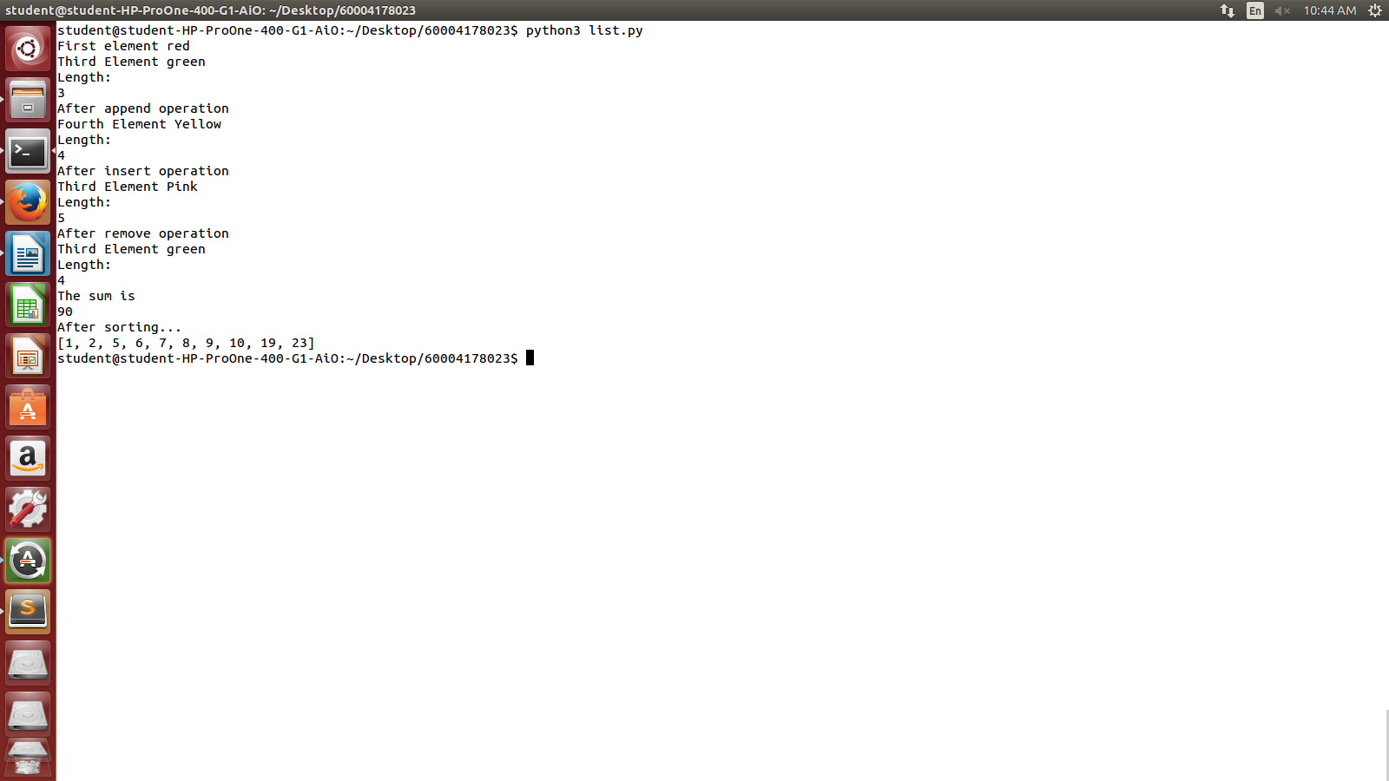

colors = ('red', 'blue', 'green')
print ("First element " + colors[0])
print ("Third Element " + colors[2])
print ("Length: ")
print (len(colors))
numbers = (1,2,23,19,5,6,7,8,9,10)
print(numbers)
sum = 0
for num in numbers:
sum += num
print("The sum is ")
print(sum)
x = input("Enter a color to search")
if x in colors:
print("Element Found!")
else:
print("Element not found")
print("Slicing 1:3 in numbers...")
print(numbers[1:3])

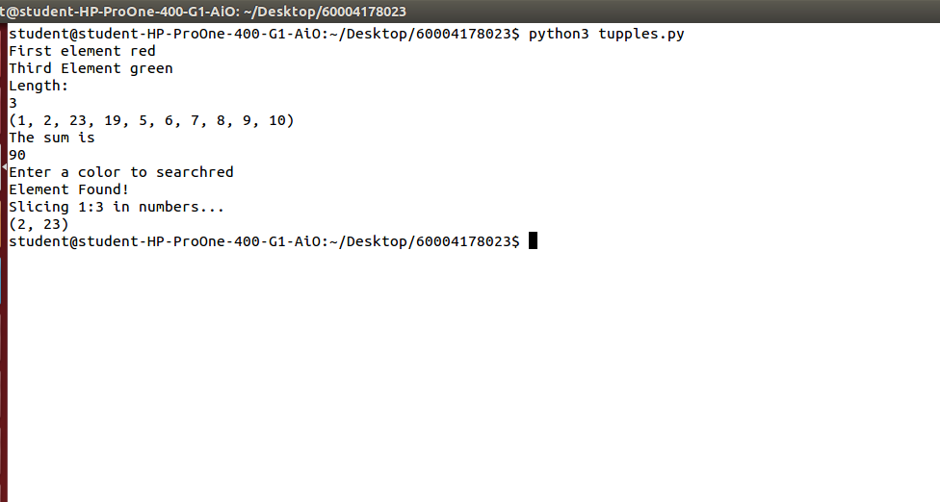

normal_set = {"a", "b","c"}
normal_set.add("d")
print("Normal Set")
print(normal_set)
frozen_set = frozenset(["e", "f", "g", "c"])
print("Frozen Set")
print(frozen_set)
##Operations on sets
print("Adding h to normal set")
normal_set.add("h")
print(normal_set)
print("Performing union between normal set and frozen set")
print (normal_set.union(frozen_set))
print("Performing intersection between normal set and frozen set")
print (normal_set.intersection(frozen_set))
print (frozen_set.intersection(normal_set))
print("Performing difference between normal set and frozen set")
print (normal_set.difference(frozen_set))
print (frozen_set.difference(normal_set))
print("Performing symmetric difference between normal set and frozen set")
print (normal_set.symmetric_difference(frozen_set))
print (frozen_set.symmetric_difference(normal_set))
if normal_set.isdisjoint(frozen_set):
print("The sets have nothing in common\n")

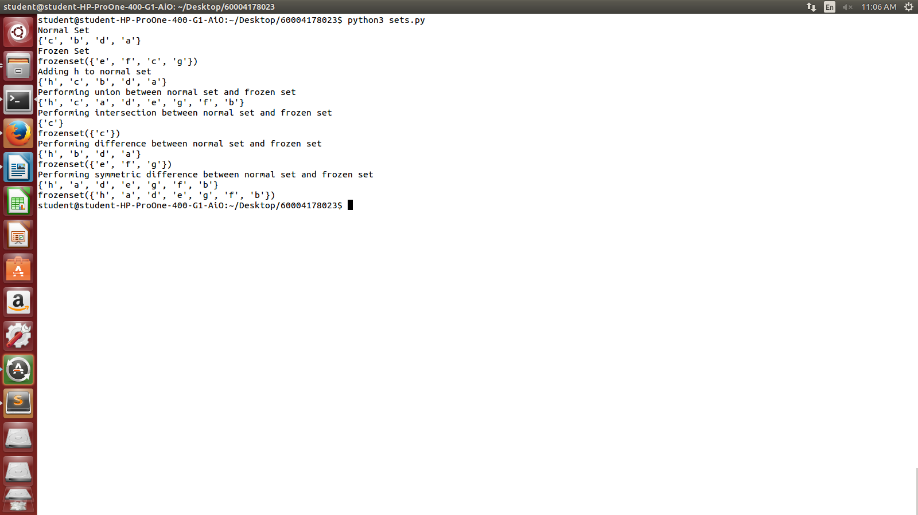

dict = {'Name': 'Viral', 'Age': 19}
print ("dict['Name']: ", dict['Name'])
print ("dict['Age']: ", dict['Age'])
print ("Length : %d" % len (dict))
print ("Equivalent String : %s" % str (dict))
dict2 = dict.copy()
print ("New Dictionary : ",dict2)
print ("Value of keys: %s" % dict.keys())
print ("Values : ", list(dict.values()))
print (dict)
print("After updating..")
dict['Name'] = "Milond"
dict['Age'] = 99
print ("Value of keys: %s" % dict.keys())
print ("Values : ", list(dict.values()))
print (dict)
print ("Value : %s" % dict.get('Age'))
print ("Value : %s" % dict.get('Education'))
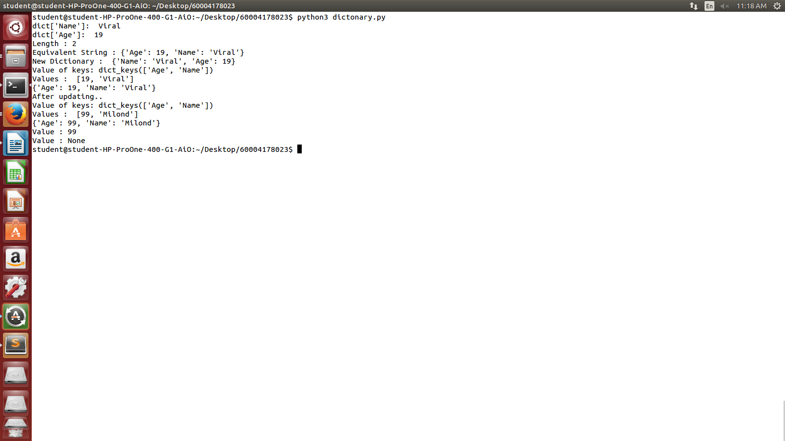
num = 0
x = int(input("Enter Number"))

for i in range(1,x):

for j in range (x,i,-1):
print(" ", end="")

num = int((i*(i+1))/2)

for k in range(0,i):
print(int(num), end="")
num = num -1

print("")

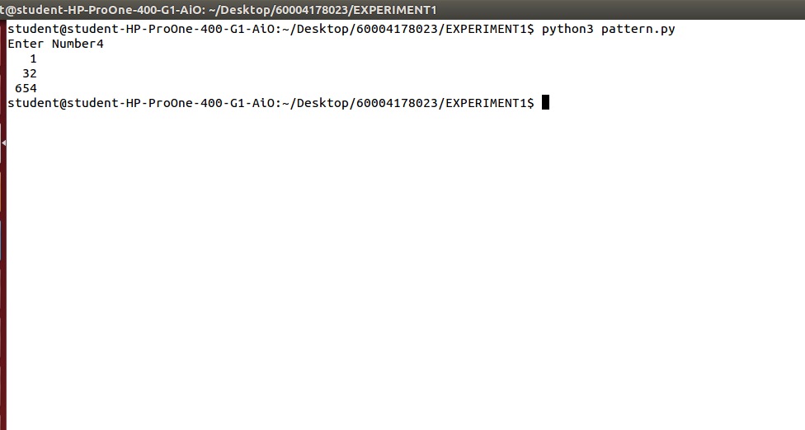
num = 0
x = int(input("Enter Number"))
for i in range(1,x):
for j in range (x,i,-1):
print(" ", end="")
for k in range(0,i):
print("*", end="")
num = num -1
print("")
for i in range(x,0,-1):
for j in range (i,x):
print(" ", end="")
for k in range(i,0,-1):
print("*", end="")
num = num -1
print("")

